1f.

- I drop table cse532.facilitycertification in the beginning of the file. If no table is found, an error will print in the terminal.

- You must place the “Health_Facility_Certification_Information.csv” under the same directory as “**createfacilititycertificationtable.sql**” to load data successfully.

1g. I drop indexes in the beginning of the “**createindexes.sq**l” file. If no indexes with the same name are found, errors will print in the terminal.

3. “**noerzips.sql**”

- I took the substring for the zip codes that have more than five digits.

For example: 12345-5678 becomes 12345

- I also only look at the zip codes that are both in the Facility table and the USZip table.

Which there is a total of 773 unique valid zip codes.

4. Indexes: I use the command “time db2 -vtf noerzips.sql” to estimate the time took to run each query.

nearester query before indexing: 0.479 seconds

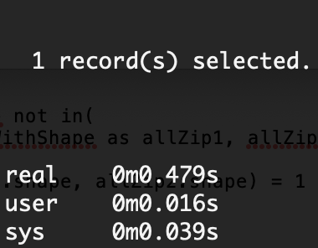

nearester query after indexing: about 0.363 seconds

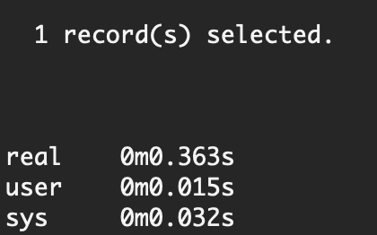

noerzips query before indexing: about 41 seconds

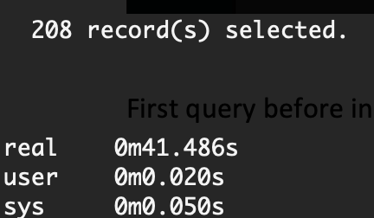

noerzips query after indexing: about 4.986 seconds

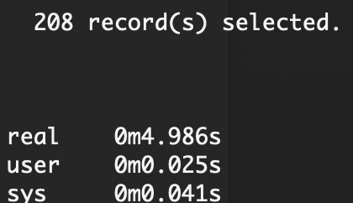

5. There are two files I wrote for this part: **mergezip1.sql** and **mergezip.sql**

**- Mergezip1.sql** creates the “cse532.neighborRelationship” table and the “cse532.resultTable” table. I used “ST_Intersects” to find all neighbors for the zipcodes that have population less than the average population (which is 12,216) and store the relationship in the first table. Then, I stored all zipcodes that have population greater than 12,216 in the second table.

- **Mergezip.sql** creates a stored procedure that goes through the “cse532.neighborRelationship” table one by one using Log(n) runtime to sum up all the zipcode population around a target zip code (the zip code that had population less than avg) and insert a new row in the “cse532.resultTable”.

To run the query: (The first query takes around 10 minutes, third takes around 4 minutes)

1. db2 -tf mergezip1.sql

2. db2 -td@ -f mergezip.sql

3. db2 call "merge_zip(?)"

4. db2 select * from cse532.resultTable

Example result:

