ReadMe:

Bingling Dong

CSE532 HW5

I used *Oxygen Editor: XPath/XQuery builder view* for this assignment.

Problem 1a:

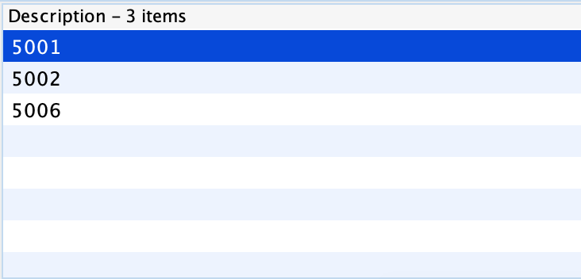

Problem 1b:

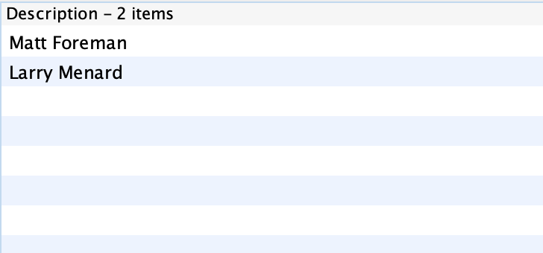

Problem 2:

I don’t think rounding to two decimal places is necessary for this part because the prices provided are already in two decimal and we are only doing multiplication so the totalcost will always be in two decimal places.

