# 数据库系统开发实验

姓名：卜梦煜 学号：1120192419 班级：07111905

## 实验名称

售后服务管理系统数据建模

## 实验目的

通过本实验，掌握Power Designer数据建模的方法，掌握物理模型、逻辑模型的联系、区别、转换，掌握将Power Designer的物理模型导入SQL Server数据库管理系统的方法。

## 实验内容

根据售后服务管理需求的内容，使用Power Designer数据建模工具创建售后服务的数据模型，并将其中的物理模型生成到SQL Server数据库管理系统。

## 数据模型

根据售后服务管理需求的内容，建立表结构如下：

（1）公司（公司编号，公司名称，公司负责人，电话）

（2）雇员（员工编号，姓名，性别，电话，上司的员工号）

（3）客户服务专员（员工编号，姓名，性别，电话，上司的员工号，售后电话）

（4）技术支持工程师（员工编号，姓名，性别，电话，上司的员工号）

（5）现场服务工程师（员工编号，姓名，性别，电话，上司的员工号）

（6）售后服务记录表（服务编号，顾客编号，产品编号，合同编号，客户服务专员编号，技术支持工程师编号，现场服务工程师编号，服务类型，评估结果，服务内容，下次服务编号）

（7）顾客（顾客编号，姓名，性别，电话）

（8）工厂（工厂编号，工厂名称，工厂负责人，电话）

（9）产品（产品编号，工厂编号，产品名称，产品类型，产品价格）

（10）合同（合同编号，顾客编号，产品编号，合同开始日期，合同有效期，合同类型）

（11）购买表（顾客编号，产品编号，合同编号，购买日期）

## 实验步骤

（1）使用SQL Server Management Studio创建Contract数据库。

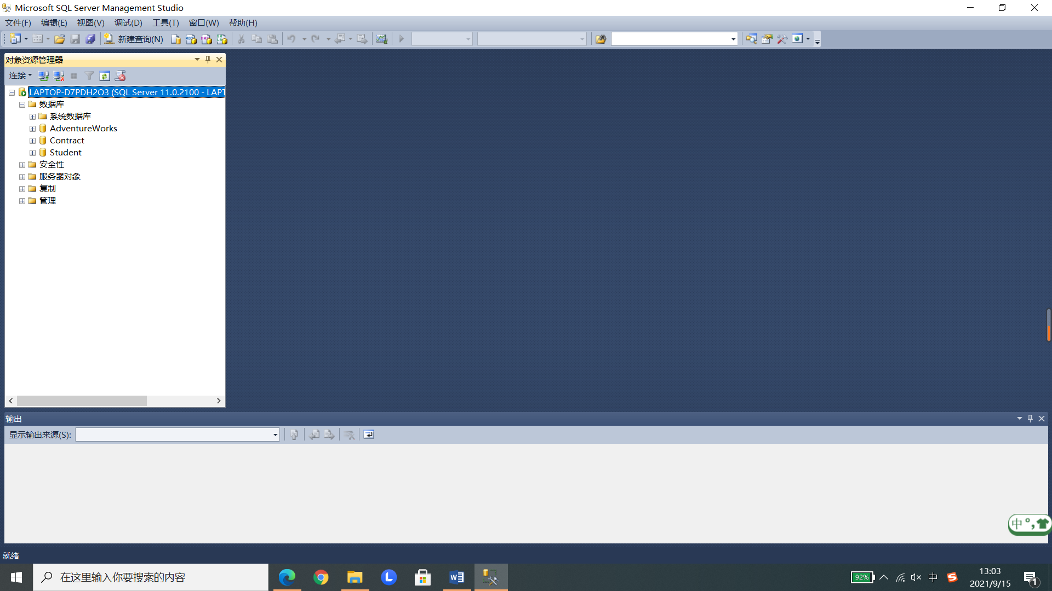

（2）根据建立的数据模型，使用Power Designer建立售后服务系统的逻辑模型，并加上实体之间的联系。

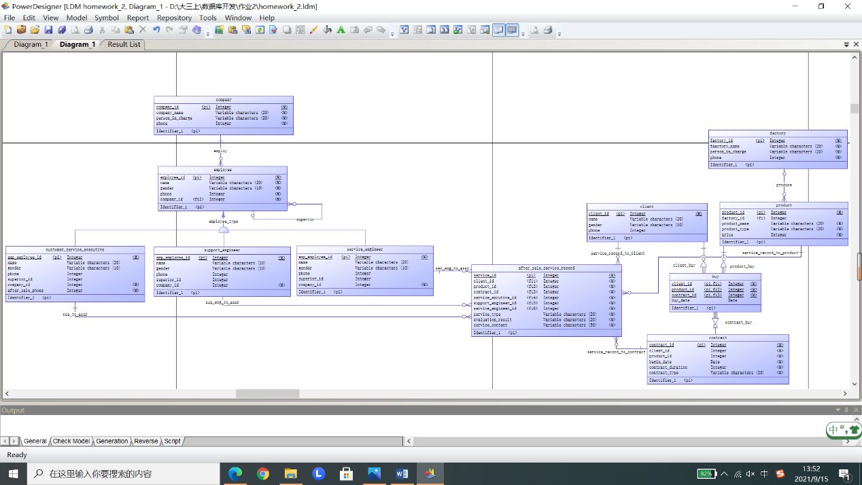

（3）点击Tool-Generate Physical Data Model，将逻辑模型转化成对应的物理模型。

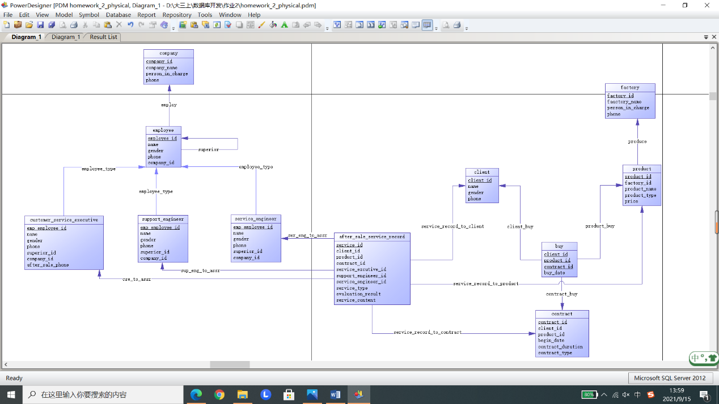

（4）点击Database-Configure Connections-Add Data Resource，创建通过SQL Server登录的连接到Contract数据表的数据源AfterSale。

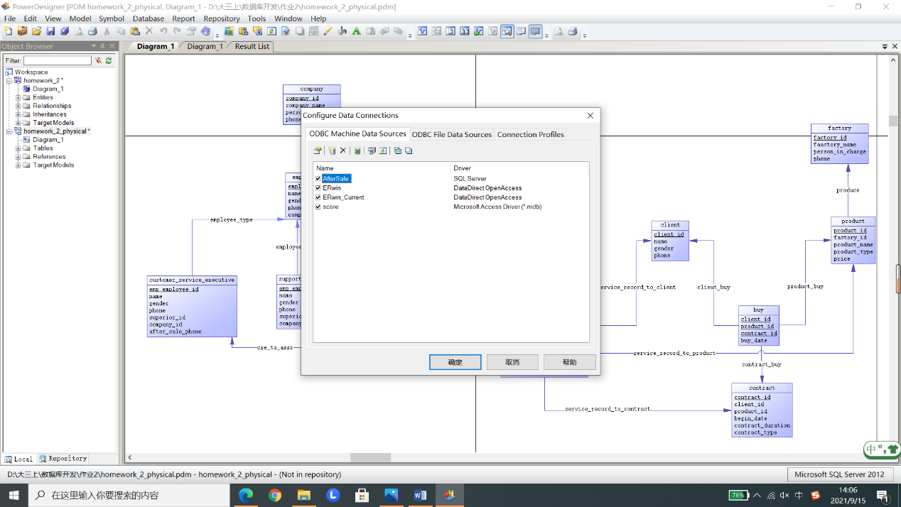

（5）点击Database-Generate Database，利用（4）中创建的数据源AfterSale，将物理模型建立的表导入Contract数据库。

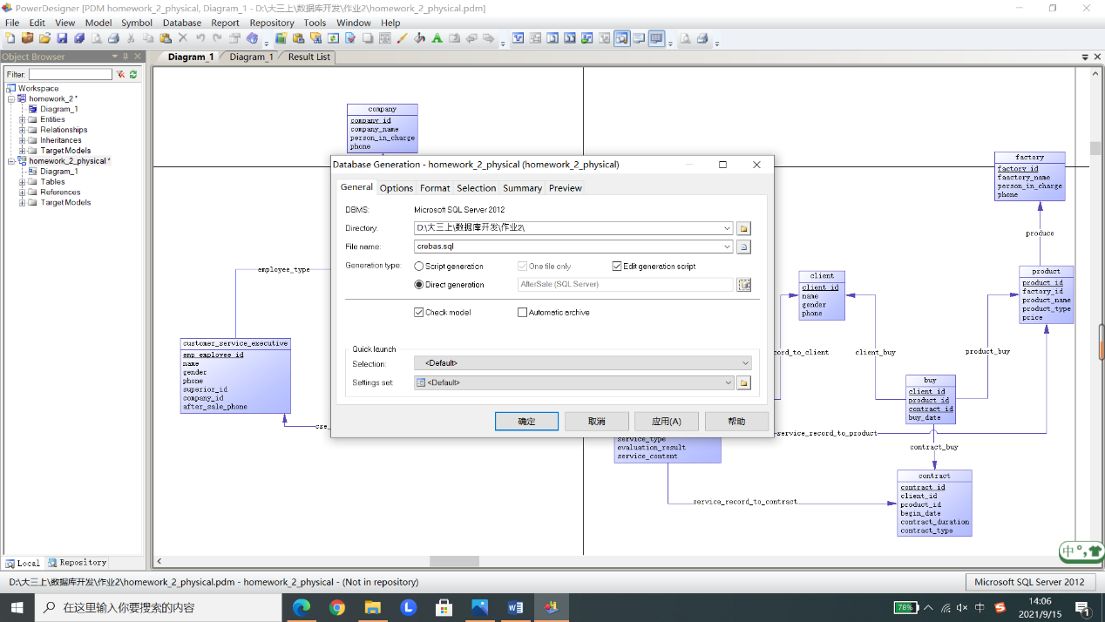

在SQL Server中验证所有表都已经成功导入Contract数据库。

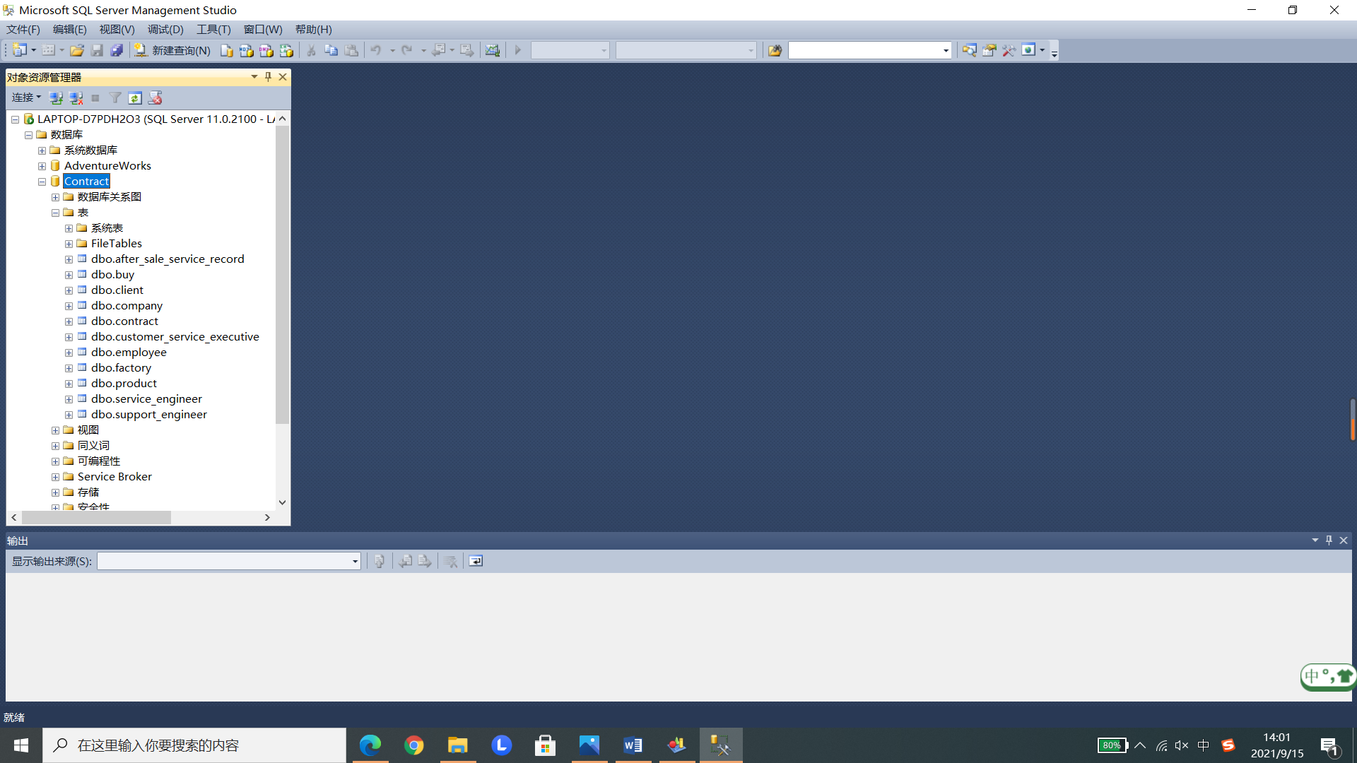

## 回答问题

**（1）如何实现售后服务中的产品服务期限的？**

客户服务专员根据用户提供的用户编号、产品编号、合同编号在购买表中做验证是否有对应的购买记录，通过验证后建立售后服务记录，根据合同编号查询合同表中的合同开始日期和合同有效期，据此判断是否到达产品服务期限。

**（2）如何记录售后服务的产品信息？**

添加售后服务记录时，会将售后服务产品的产品编号填入表中，而根据产品编号又可以在产品表找到该产品的信息，由此记录售后服务的产品信息。

**（3）如何记录技术服务工程师（包括服务专员）的信息？**

定义“客户服务专员”、“技术支持工程师”、“技术服务工程师”为“雇员”下的三个派生实体，三者拥有不同的访问、修改权限，通过向对应种类的雇员表中添加信息即可记录技术服务工程师（包括服务专员）的信息。

**（4）一个完整的服务信息（如维修一个磁盘可能包括第一次打电话咨询、维修等由多**

**个小服务组成一个大服务）是如何记录的？**

服务信息表中记录了客户编号、产品编号、合同编号，并可以由这三个属性定位某个用户的某个产品的维修，因此可在服务信息表中添加一个“下次服务编号（next_service_id）”属性，并建立从“售后服务信息表”到“售后服务信息表”的递归联系，外键为“下次服务编号”，然后就可以通过递归查询找到某个产品的所有小服务的记录。

## 附录

（1）从物理模型转变成的SQL语句：

/*==============================================================*/

/* DBMS name: Microsoft SQL Server 2012 */

/* Created on: 2021/9/15 20:12:52 */

/*==============================================================*/

if exists (select 1

from sys.sysreferences r join sys.sysobjects o on (o.id = r.constid and o.type = 'F')

where r.fkeyid = object_id('after_sale_service_record') and o.name = 'FK_AFTER_SA_CSE_TO_AS_CUSTOMER')

alter table after_sale_service_record

drop constraint FK_AFTER_SA_CSE_TO_AS_CUSTOMER

go

if exists (select 1

from sys.sysreferences r join sys.sysobjects o on (o.id = r.constid and o.type = 'F')

where r.fkeyid = object_id('after_sale_service_record') and o.name = 'FK_AFTER_SA_SER_ENG_T_SERVICE_')

alter table after_sale_service_record

drop constraint FK_AFTER_SA_SER_ENG_T_SERVICE_

go

if exists (select 1

from sys.sysreferences r join sys.sysobjects o on (o.id = r.constid and o.type = 'F')

where r.fkeyid = object_id('after_sale_service_record') and o.name = 'FK_AFTER_SA_SERVICE_R_CLIENT')

alter table after_sale_service_record

drop constraint FK_AFTER_SA_SERVICE_R_CLIENT

go

if exists (select 1

from sys.sysreferences r join sys.sysobjects o on (o.id = r.constid and o.type = 'F')

where r.fkeyid = object_id('after_sale_service_record') and o.name = 'FK_AFTER_SA_SERVICE_R_CONTRACT')

alter table after_sale_service_record

drop constraint FK_AFTER_SA_SERVICE_R_CONTRACT

go

if exists (select 1

from sys.sysreferences r join sys.sysobjects o on (o.id = r.constid and o.type = 'F')

where r.fkeyid = object_id('after_sale_service_record') and o.name = 'FK_AFTER_SA_SERVICE_R_PRODUCT')

alter table after_sale_service_record

drop constraint FK_AFTER_SA_SERVICE_R_PRODUCT

go

if exists (select 1

from sys.sysreferences r join sys.sysobjects o on (o.id = r.constid and o.type = 'F')

where r.fkeyid = object_id('after_sale_service_record') and o.name = 'FK_AFTER_SA_SUP_ENG_T_SUPPORT_')

alter table after_sale_service_record

drop constraint FK_AFTER_SA_SUP_ENG_T_SUPPORT_

go

if exists (select 1

from sys.sysreferences r join sys.sysobjects o on (o.id = r.constid and o.type = 'F')

where r.fkeyid = object_id('buy') and o.name = 'FK_BUY_CLIENT_BU_CLIENT')

alter table buy

drop constraint FK_BUY_CLIENT_BU_CLIENT

go

if exists (select 1

from sys.sysreferences r join sys.sysobjects o on (o.id = r.constid and o.type = 'F')

where r.fkeyid = object_id('buy') and o.name = 'FK_BUY_CONTRACT__CONTRACT')

alter table buy

drop constraint FK_BUY_CONTRACT__CONTRACT

go

if exists (select 1

from sys.sysreferences r join sys.sysobjects o on (o.id = r.constid and o.type = 'F')

where r.fkeyid = object_id('buy') and o.name = 'FK_BUY_PRODUCT_B_PRODUCT')

alter table buy

drop constraint FK_BUY_PRODUCT_B_PRODUCT

go

if exists (select 1

from sys.sysreferences r join sys.sysobjects o on (o.id = r.constid and o.type = 'F')

where r.fkeyid = object_id('customer_service_executive') and o.name = 'FK_CUSTOMER_EMPLOYEE__EMPLOYEE')

alter table customer_service_executive

drop constraint FK_CUSTOMER_EMPLOYEE__EMPLOYEE

go

if exists (select 1

from sys.sysreferences r join sys.sysobjects o on (o.id = r.constid and o.type = 'F')

where r.fkeyid = object_id('employee') and o.name = 'FK_EMPLOYEE_EMPLOY_COMPANY')

alter table employee

drop constraint FK_EMPLOYEE_EMPLOY_COMPANY

go

if exists (select 1

from sys.sysreferences r join sys.sysobjects o on (o.id = r.constid and o.type = 'F')

where r.fkeyid = object_id('employee') and o.name = 'FK_EMPLOYEE_SUPERIOR_EMPLOYEE')

alter table employee

drop constraint FK_EMPLOYEE_SUPERIOR_EMPLOYEE

go

if exists (select 1

from sys.sysreferences r join sys.sysobjects o on (o.id = r.constid and o.type = 'F')

where r.fkeyid = object_id('product') and o.name = 'FK_PRODUCT_PRODUCE_FACTORY')

alter table product

drop constraint FK_PRODUCT_PRODUCE_FACTORY

go

if exists (select 1

from sys.sysreferences r join sys.sysobjects o on (o.id = r.constid and o.type = 'F')

where r.fkeyid = object_id('service_engineer') and o.name = 'FK_SERVICE__EMPLOYEE__EMPLOYEE')

alter table service_engineer

drop constraint FK_SERVICE__EMPLOYEE__EMPLOYEE

go

if exists (select 1

from sys.sysreferences r join sys.sysobjects o on (o.id = r.constid and o.type = 'F')

where r.fkeyid = object_id('support_engineer') and o.name = 'FK_SUPPORT__EMPLOYEE__EMPLOYEE')

alter table support_engineer

drop constraint FK_SUPPORT__EMPLOYEE__EMPLOYEE

go

if exists (select 1

from sysindexes

where id = object_id('after_sale_service_record')

and name = 'ser_eng_to_assr_FK'

and indid > 0

and indid < 255)

drop index after_sale_service_record.ser_eng_to_assr_FK

go

if exists (select 1

from sysindexes

where id = object_id('after_sale_service_record')

and name = 'sup_eng_to_assr_FK'

and indid > 0

and indid < 255)

drop index after_sale_service_record.sup_eng_to_assr_FK

go

if exists (select 1

from sysindexes

where id = object_id('after_sale_service_record')

and name = 'cse_to_assr_FK'

and indid > 0

and indid < 255)

drop index after_sale_service_record.cse_to_assr_FK

go

if exists (select 1

from sysindexes

where id = object_id('after_sale_service_record')

and name = 'service_record_to_contract_FK'

and indid > 0

and indid < 255)

drop index after_sale_service_record.service_record_to_contract_FK

go

if exists (select 1

from sysindexes

where id = object_id('after_sale_service_record')

and name = 'service_record_to_product_FK'

and indid > 0

and indid < 255)

drop index after_sale_service_record.service_record_to_product_FK

go

if exists (select 1

from sysindexes

where id = object_id('after_sale_service_record')

and name = 'service_record_to_client_FK'

and indid > 0

and indid < 255)

drop index after_sale_service_record.service_record_to_client_FK

go

if exists (select 1

from sysobjects

where id = object_id('after_sale_service_record')

and type = 'U')

drop table after_sale_service_record

go

if exists (select 1

from sysindexes

where id = object_id('buy')

and name = 'contract_buy_FK'

and indid > 0

and indid < 255)

drop index buy.contract_buy_FK

go

if exists (select 1

from sysindexes

where id = object_id('buy')

and name = 'product_buy_FK'

and indid > 0

and indid < 255)

drop index buy.product_buy_FK

go

if exists (select 1

from sysindexes

where id = object_id('buy')

and name = 'client_buy_FK'

and indid > 0

and indid < 255)

drop index buy.client_buy_FK

go

if exists (select 1

from sysobjects

where id = object_id('buy')

and type = 'U')

drop table buy

go

if exists (select 1

from sysobjects

where id = object_id('client')

and type = 'U')

drop table client

go

if exists (select 1

from sysobjects

where id = object_id('company')

and type = 'U')

drop table company

go

if exists (select 1

from sysobjects

where id = object_id('contract')

and type = 'U')

drop table contract

go

if exists (select 1

from sysobjects

where id = object_id('customer_service_executive')

and type = 'U')

drop table customer_service_executive

go

if exists (select 1

from sysindexes

where id = object_id('employee')

and name = 'employ_FK'

and indid > 0

and indid < 255)

drop index employee.employ_FK

go

if exists (select 1

from sysindexes

where id = object_id('employee')

and name = 'superior_FK'

and indid > 0

and indid < 255)

drop index employee.superior_FK

go

if exists (select 1

from sysobjects

where id = object_id('employee')

and type = 'U')

drop table employee

go

if exists (select 1

from sysobjects

where id = object_id('factory')

and type = 'U')

drop table factory

go

if exists (select 1

from sysindexes

where id = object_id('product')

and name = 'produce_FK'

and indid > 0

and indid < 255)

drop index product.produce_FK

go

if exists (select 1

from sysobjects

where id = object_id('product')

and type = 'U')

drop table product

go

if exists (select 1

from sysobjects

where id = object_id('service_engineer')

and type = 'U')

drop table service_engineer

go

if exists (select 1

from sysobjects

where id = object_id('support_engineer')

and type = 'U')

drop table support_engineer

go

/*==============================================================*/

/* Table: after_sale_service_record */

/*==============================================================*/

create table after_sale_service_record (

service_id int not null,

client_id int not null,

product_id int not null,

contract_id int not null,

service_excutive_id int not null,

support_engineer_id int not null,

service_engineer_id int not null,

service_type varchar(20) not null,

evaluation_result varchar(20) not null,

service_content varchar(50) not null,

constraint PK_AFTER_SALE_SERVICE_RECORD primary key nonclustered (service_id)

)

go

/*==============================================================*/

/* Index: service_record_to_client_FK */

/*==============================================================*/

create index service_record_to_client_FK on after_sale_service_record (

client_id ASC

)

go

/*==============================================================*/

/* Index: service_record_to_product_FK */

/*==============================================================*/

create index service_record_to_product_FK on after_sale_service_record (

product_id ASC

)

go

/*==============================================================*/

/* Index: service_record_to_contract_FK */

/*==============================================================*/

create index service_record_to_contract_FK on after_sale_service_record (

contract_id ASC

)

go

/*==============================================================*/

/* Index: cse_to_assr_FK */

/*==============================================================*/

create index cse_to_assr_FK on after_sale_service_record (

service_excutive_id ASC

)

go

/*==============================================================*/

/* Index: sup_eng_to_assr_FK */

/*==============================================================*/

create index sup_eng_to_assr_FK on after_sale_service_record (

support_engineer_id ASC

)

go

/*==============================================================*/

/* Index: ser_eng_to_assr_FK */

/*==============================================================*/

create index ser_eng_to_assr_FK on after_sale_service_record (

service_engineer_id ASC

)

go

/*==============================================================*/

/* Table: buy */

/*==============================================================*/

create table buy (

client_id int not null,

product_id int not null,

contract_id int not null,

buy_date datetime null,

constraint PK_BUY primary key nonclustered (client_id, product_id, contract_id)

)

go

/*==============================================================*/

/* Index: client_buy_FK */

/*==============================================================*/

create index client_buy_FK on buy (

client_id ASC

)

go

/*==============================================================*/

/* Index: product_buy_FK */

/*==============================================================*/

create index product_buy_FK on buy (

product_id ASC

)

go

/*==============================================================*/

/* Index: contract_buy_FK */

/*==============================================================*/

create index contract_buy_FK on buy (

contract_id ASC

)

go

/*==============================================================*/

/* Table: client */

/*==============================================================*/

create table client (

client_id int not null,

name varchar(20) null,

gender varchar(10) null,

phone int null,

constraint PK_CLIENT primary key nonclustered (client_id)

)

go

/*==============================================================*/

/* Table: company */

/*==============================================================*/

create table company (

company_id int not null,

company_name varchar(20) not null,

person_in_charge varchar(20) not null,

phone int not null,

constraint PK_COMPANY primary key nonclustered (company_id)

)

go

/*==============================================================*/

/* Table: contract */

/*==============================================================*/

create table contract (

contract_id int not null,

client_id int not null,

product_id int not null,

begin_date datetime not null,

contract_duration int not null,

contract_type varchar(20) not null,

constraint PK_CONTRACT primary key nonclustered (contract_id)

)

go

/*==============================================================*/

/* Table: customer_service_executive */

/*==============================================================*/

create table customer_service_executive (

emp_employee_id int not null,

name varchar(20) null,

gender varchar(10) null,

phone int null,

superior_id int null,

company_id int not null,

after_sale_phone int not null,

constraint PK_CUSTOMER_SERVICE_EXECUTIVE primary key nonclustered (emp_employee_id)

)

go

/*==============================================================*/

/* Table: employee */

/*==============================================================*/

create table employee (

employee_id int not null,

name varchar(20) not null,

gender varchar(10) not null,

phone int not null,

superior_id int null,

company_id int not null,

constraint PK_EMPLOYEE primary key nonclustered (employee_id)

)

go

/*==============================================================*/

/* Index: superior_FK */

/*==============================================================*/

create index superior_FK on employee (

superior_id ASC

)

go

/*==============================================================*/

/* Index: employ_FK */

/*==============================================================*/

create index employ_FK on employee (

company_id ASC

)

go

/*==============================================================*/

/* Table: factory */

/*==============================================================*/

create table factory (

factory_id int not null,

factory_name varchar(20) not null,

person_in_charge varchar(20) not null,

phone int not null,

constraint PK_FACTORY primary key nonclustered (factory_id)

)

go

/*==============================================================*/

/* Table: product */

/*==============================================================*/

create table product (

product_id int not null,

factory_id int null,

product_name varchar(20) not null,

product_type varchar(20) not null,

price int not null,

constraint PK_PRODUCT primary key nonclustered (product_id)

)

go

/*==============================================================*/

/* Index: produce_FK */

/*==============================================================*/

create index produce_FK on product (

factory_id ASC

)

go

/*==============================================================*/

/* Table: service_engineer */

/*==============================================================*/

create table service_engineer (

emp_employee_id int not null,

name varchar(20) null,

gender varchar(10) null,

phone int null,

superior_id int null,

company_id int not null,

constraint PK_SERVICE_ENGINEER primary key nonclustered (emp_employee_id)

)

go

/*==============================================================*/

/* Table: support_engineer */

/*==============================================================*/

create table support_engineer (

emp_employee_id int not null,

name varchar(20) null,

gender varchar(10) null,

phone int null,

superior_id int null,

company_id int not null,

constraint PK_SUPPORT_ENGINEER primary key nonclustered (emp_employee_id)

)

go

alter table after_sale_service_record

add constraint FK_AFTER_SA_CSE_TO_AS_CUSTOMER foreign key (service_excutive_id)

references customer_service_executive (emp_employee_id)

go

alter table after_sale_service_record

add constraint FK_AFTER_SA_SER_ENG_T_SERVICE_ foreign key (service_engineer_id)

references service_engineer (emp_employee_id)

go

alter table after_sale_service_record

add constraint FK_AFTER_SA_SERVICE_R_CLIENT foreign key (client_id)

references client (client_id)

go

alter table after_sale_service_record

add constraint FK_AFTER_SA_SERVICE_R_CONTRACT foreign key (contract_id)

references contract (contract_id)

go

alter table after_sale_service_record

add constraint FK_AFTER_SA_SERVICE_R_PRODUCT foreign key (product_id)

references product (product_id)

go

alter table after_sale_service_record

add constraint FK_AFTER_SA_SUP_ENG_T_SUPPORT_ foreign key (support_engineer_id)

references support_engineer (emp_employee_id)

go

alter table buy

add constraint FK_BUY_CLIENT_BU_CLIENT foreign key (client_id)

references client (client_id)

go

alter table buy

add constraint FK_BUY_CONTRACT__CONTRACT foreign key (contract_id)

references contract (contract_id)

go

alter table buy

add constraint FK_BUY_PRODUCT_B_PRODUCT foreign key (product_id)

references product (product_id)

go

alter table customer_service_executive

add constraint FK_CUSTOMER_EMPLOYEE__EMPLOYEE foreign key (emp_employee_id)

references employee (employee_id)

go

alter table employee

add constraint FK_EMPLOYEE_EMPLOY_COMPANY foreign key (company_id)

references company (company_id)

go

alter table employee

add constraint FK_EMPLOYEE_SUPERIOR_EMPLOYEE foreign key (superior_id)

references employee (employee_id)

go

alter table product

add constraint FK_PRODUCT_PRODUCE_FACTORY foreign key (factory_id)

references factory (factory_id)

go

alter table service_engineer

add constraint FK_SERVICE__EMPLOYEE__EMPLOYEE foreign key (emp_employee_id)

references employee (employee_id)

go

alter table support_engineer

add constraint FK_SUPPORT__EMPLOYEE__EMPLOYEE foreign key (emp_employee_id)

references employee (employee_id)

go