Cagayan De Oro PHINMA Education
College Network

  - Introduction
A Grading and Attendance System (GAS) is a digital tool that helps schools track student attendance and academic performance in a faster and more organized way. Instead of manually checking attendance or computing grades, the system does it automatically through apps, biometrics, and built-in grading features. It also generates clear reports and can connect with online learning platforms. When created using Python, the system becomes flexible, efficient, and easy to customize. With this system, teachers save time, avoid mistakes and gain useful insights. Students can also easily access their attendance records, grades, and overall performance anytime, making the system reliable and convenient for both teachers and students.

  - Statement of Problem

The current method of marking student's attendance are pen and paper, log book and while recording grades uses gadgets, most of the time it is written on paper first before recording. While widely used, this approach faces several problem.

- Moderate to High risk of human error- Instructor of students may have recorded grades accidentally or on the wrong time leading to a miscalculation.

- Possibility of the Lost or damage – Paper records or logs can be affected by the
Stains or just being misplaced, torn or by an external factors
.
- environment time is of the essence, the need of paper may add additional time to obtain.

Objective of the Study

- To help teachers save time by reducing repetitive manual tasks.
- To give students quick and accessible way to monitor their attendance and grade

Cagayan de Oro PHINMA Education Page
- To provide students with tools that motivate them to take charge of all their learning.
- To Eliminate common errors caused by manual grading and recordkeeping.
- To create a safe and organized digital space for all school information.

- Scope and Limitation Scoop
- Student Management
- The system allows teacher to add and store student information including student ID and fullname.it also provides the functionality to view and list all of all registered students.
- Grade Recording and viewing
- Teachers can records grade for each students per subject. The system can display all recorded grades, enabling teachers and administrators to monitor students performance.
- Attendance Training
- The system can recorded daily attendance with date and status (present or Absent). Attendance records can be viewed to tract individual or class attendance over time.
- Data Storage
- All data related to students grades, and attendance is stored in local CVS files. This ensures that records are organized and retrievable when needed.
Limitations
- Limited Accessibility
- The system id desktop-based and can only be used in computer where it is installed.it connot be accessed remotely over the internet
- No advance Reporting
- The system displays grades and attendance but does not generate detailed reports, graphs or statistical summaries.
- Manual data Entry
- Teachers must manually input subjects and students records when recording grades or attendance. This manual process may lead to errors or incomplete records is not carefully managed.
- Data Security and Back-up
- All data stored locally in CSV files without encryption or backup mechanism. If the file or computer is lost or damage, there id risk of permanent data lost.

Cagayan de Oro PHINMA Education
System Requirements
Hardware Requirements
- Processor: Initial core i3
- Memory Ram:8gb
- Storage: Storage 477gb (18gb used)
- Monitor
- Keyboard
- Mouse
Software Requirements
- Opening System: window 10 or higher.
- Python.
- Visual code Studio.
- Command prompt, Power shell or terminal.
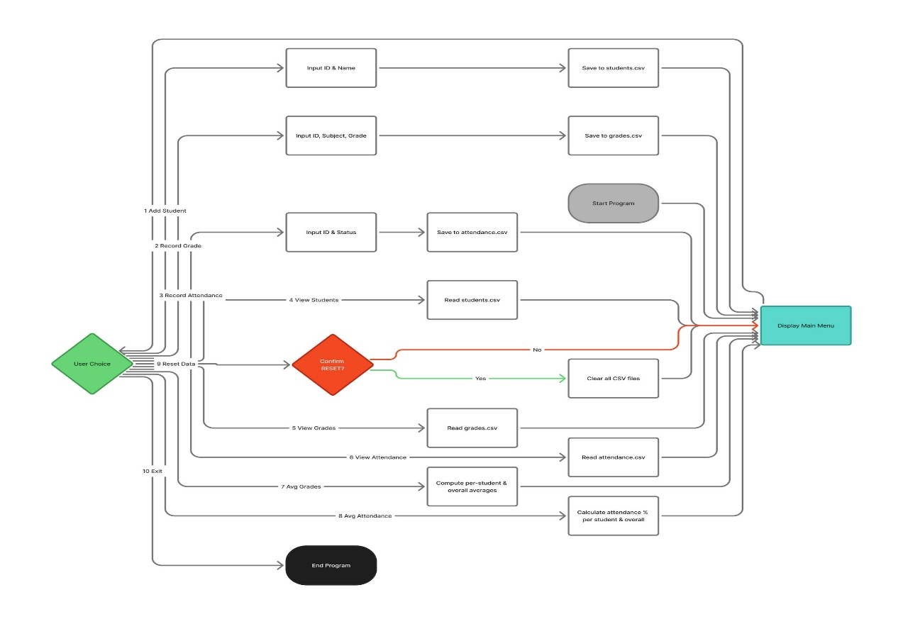
Flow Chart

