 kvm虚拟机也支持在线扩展磁盘功能,在线扩展有特定的使用环境，主要用于不能随便停用的生产环境中，本文以hadoop为例具体步骤如下：

1，查看现有磁盘

|  |  |
| --- | --- |
| 1  2  3  4  5  6  7  8  9  10  11  12  13 | [root@KVM test]# virsh list --all   Id    Name                           State  ----------------------------------------------------   1     win7                           running   17    hadoop1                        running   18    hadoop4                        running   20    hadoop2                        running   -     hadoop3                        shut off  [root@KVM test]# virsh domblklist hadoop1  Target     Source  ------------------------------------------------  vda        /images/test/hadoop1.qcow2  hdc        - |

2，创建一块qcow2虚拟磁盘

|  |  |
| --- | --- |
| 1  2  3 | [root@KVM test]# qemu-img create -f qcow2 hadoop1_add01.qcow2 5G  Formatting 'hadoop1_add01.qcow2', fmt=qcow2 size=5368709120 encryption=off cluster_size=65536  [root@KVM test]# |

[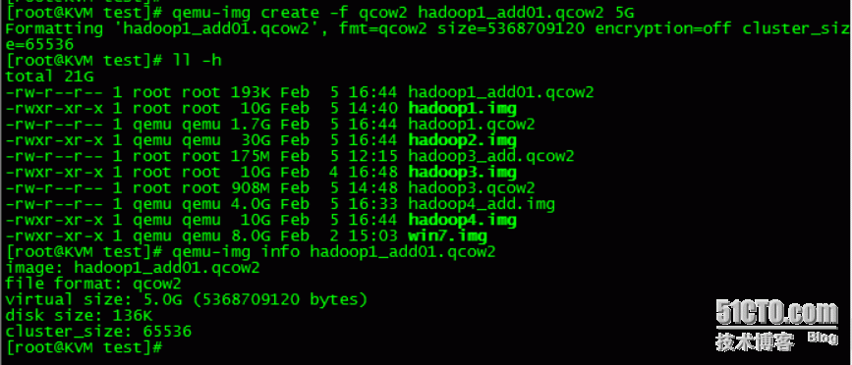](http://s3.51cto.com/wyfs02/M02/7A/C5/wKioL1a0YSaS9zkQAADshmPf3WA450.png)3，在线添加这台qcow2虚拟磁盘

|  |  |
| --- | --- |
| 1  2  3  4  5  6  7  8 | [root@KVM test]# virsh attach-disk hadoop1 /images/test/hadoop1_add01.qcow2 vdb --cache=none --subdriver=qcow2  Disk attached successfully  [root@KVM test]# virsh domblklist hadoop1  Target     Source  ------------------------------------------------  vda        /images/test/hadoop1.qcow2  vdb        /images/test/hadoop1_add01.qcow2  hdc        - |

[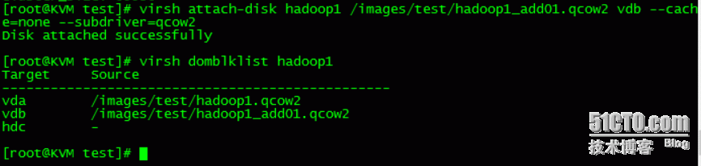](http://s5.51cto.com/wyfs02/M00/7A/C5/wKioL1a0YizibtGZAABeCpmwwdk206.png)4，进入虚拟机查看，如下图：

[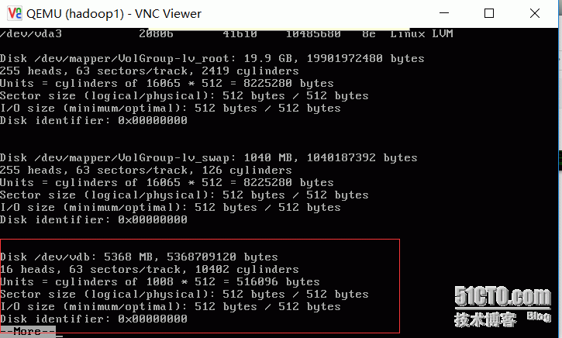](http://s1.51cto.com/wyfs02/M00/7A/C5/wKioL1a0Yn2hSA2zAABSB9swk_Q757.png)

5，然后进入系统里边划分区

fdisk /dev/vdb

[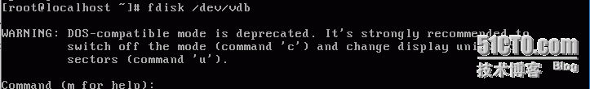](http://s3.51cto.com/wyfs02/M02/7A/C5/wKiom1a0Y4biAtfzAAAaEIuPcKI184.png)

[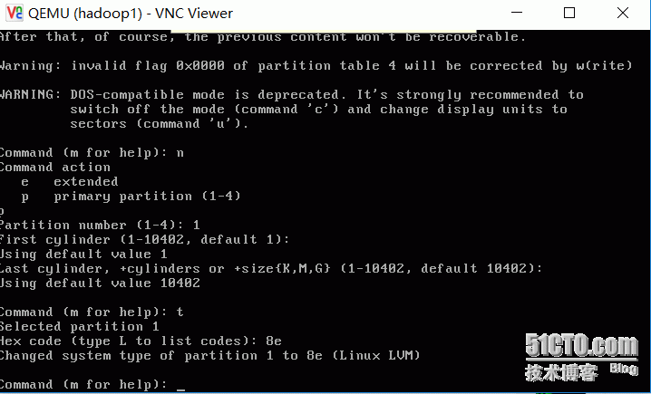](http://s4.51cto.com/wyfs02/M01/7A/C5/wKiom1a0Y06AqiANAABACXkO1jM598.png)

[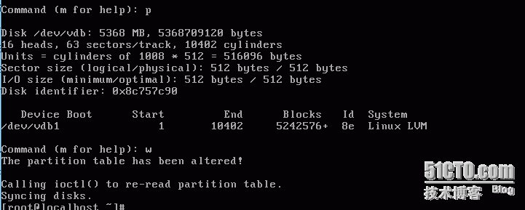](http://s4.51cto.com/wyfs02/M01/7A/C5/wKioL1a0Y6HzlILkAAAo0LWA1Yw548.png)

6,划分逻辑卷LVM省略，前边的可以参考。

7，修改虚拟机配置文件，把新增的磁盘配置写到虚拟机磁盘配置

 （1）查看当前虚拟机hadoop1的磁盘配置

|  |  |
| --- | --- |
| 1  2  3  4  5  6  7  8  9  10  11  12  13  14  15  16  17  18  19  20  21  22  23  24  25  26  27  28  29  30  31  32  33  34  35  36  37  38  39  40  41  42  43  44  45  46  47  48  49  50  51  52  53  54  55  56  57  58  59  60  61  62  63  64  65  66  67  68  69  70  71  72  73 | [root@KVM test]# virsh dumpxml hadoop1  <domain type='qemu' id='17'>    <name>hadoop1</name>    <uuid>919f0921-0736-ad5b-780b-a440de2f35cb</uuid>    <memory unit='KiB'>524288</memory>    <currentMemory unit='KiB'>524288</currentMemory>    <vcpu placement='static'>1</vcpu>    <os>      <type arch='x86_64' machine='rhel6.6.0'>hvm</type>      <boot dev='hd'/>    </os>    <features>      <acpi/>      <apic/>      <pae/>    </features>    <clock offset='utc'/>    <on_poweroff>destroy</on_poweroff>    <on_reboot>restart</on_reboot>    <on_crash>restart</on_crash>    <devices>      <emulator>/usr/libexec/qemu-kvm</emulator>      <disk type='file' device='disk'>        <driver name='qemu' type='qcow2' cache='none'/>        <source file='/images/test/hadoop1.qcow2'/>        <target dev='vda' bus='virtio'/>        <alias name='virtio-disk0'/>        <address type='pci' domain='0x0000' bus='0x00' slot='0x05' function='0x0'/>      </disk>      <disk type='file' device='disk'>        <driver name='qemu' type='qcow2' cache='none'/>        <source file='/images/test/hadoop1_add01.qcow2'/>        <target dev='vdb' bus='virtio'/>        <alias name='virtio-disk1'/>        <address type='pci' domain='0x0000' bus='0x00' slot='0x07' function='0x0'/>      </disk>      <disk type='block' device='cdrom'>        <driver name='qemu' type='raw'/>        <target dev='hdc' bus='ide'/>        <readonly/>        <alias name='ide0-1-0'/>        <address type='drive' controller='0' bus='1' target='0' unit='0'/>      </disk>      <controller type='usb' index='0' model='ich9-ehci1'>        <alias name='usb0'/>        <address type='pci' domain='0x0000' bus='0x00' slot='0x04' function='0x7'/>      </controller>      <controller type='usb' index='0' model='ich9-uhci1'>        <alias name='usb0'/>        <master startport='0'/>        <address type='pci' domain='0x0000' bus='0x00' slot='0x04' function='0x0' multifunction='on'/>      </controller>      <controller type='usb' index='0' model='ich9-uhci2'>        <alias name='usb0'/>        <master startport='2'/>        <address type='pci' domain='0x0000' bus='0x00' slot='0x04' function='0x1'/>      </controller>      <controller type='usb' index='0' model='ich9-uhci3'>        <alias name='usb0'/>        <master startport='4'/>        <address type='pci' domain='0x0000' bus='0x00' slot='0x04' function='0x2'/>      </controller>      <controller type='ide' index='0'>        <alias name='ide0'/>        <address type='pci' domain='0x0000' bus='0x00' slot='0x01' function='0x1'/>      </controller>      <interface type='bridge'>        <mac address='52:54:00:b6:bf:1f'/>        <source bridge='br0'/>        <target dev='vnet1'/>        <model type='virtio'/>        <alias name='net0'/>        <address type='pci' domain='0x0000' bus='0x00' slot='0x03' function='0x0'/>      </interface>      <serial type='pty'>        <source path='/dev/pts/2'/>        <target port='0'/>        <alias name='serial0'/>      </serial>      <console type='pty' tty='/dev/pts/2'>        <source path='/dev/pts/2'/>        <target type='serial' port='0'/>        <alias name='serial0'/>      </console>      <input type='mouse' bus='ps2'/>      <graphics type='vnc' port='5911' autoport='no' listen='0.0.0.0'>        <listen type='address' address='0.0.0.0'/>      </graphics>      <video>        <model type='cirrus' vram='9216' heads='1'/>        <alias name='video0'/>        <address type='pci' domain='0x0000' bus='0x00' slot='0x02' function='0x0'/>      </video>      <memballoon model='virtio'>        <alias name='balloon0'/>        <address type='pci' domain='0x0000' bus='0x00' slot='0x06' function='0x0'/>      </memballoon>    </devices>  </domain> |

 （2）把以下配置添加到/etc/libvirt/qemu/hadoop1.xml配置文件中

|  |  |
| --- | --- |
| 1  2  3  4  5  6  7 | <disk type='file' device='disk'>        <driver name='qemu' type='qcow2' cache='none'/>        <source file='/images/test/hadoop1_add01.qcow2'/>        <target dev='vdb' bus='virtio'/>        <alias name='virtio-disk1'/>        <address type='pci' domain='0x0000' bus='0x00' slot='0x07' function='0x0'/>      </disk> |

[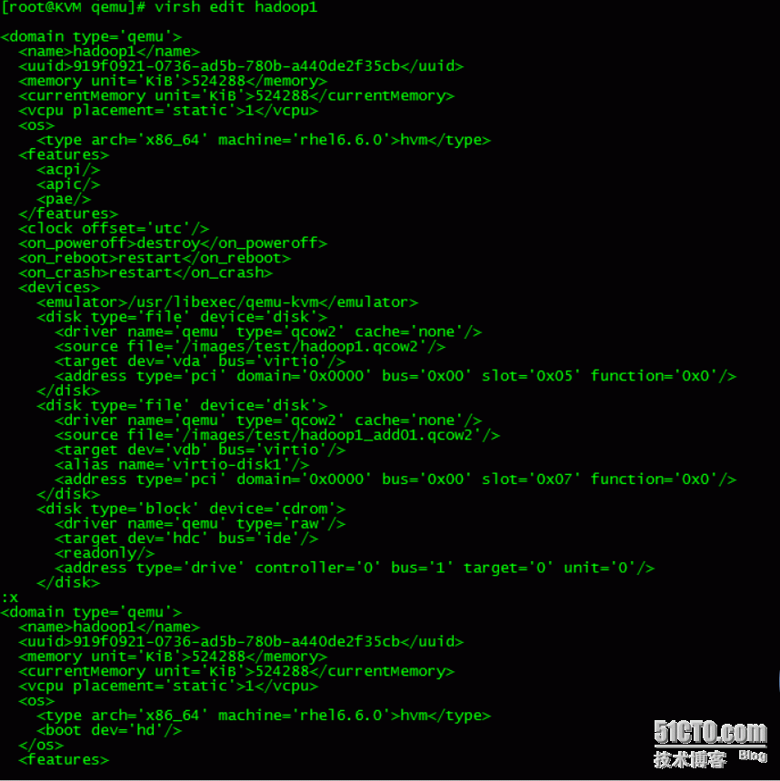](http://s1.51cto.com/wyfs02/M01/7A/C5/wKiom1a0Z2aD00LdAAGB6Cp_t9A795.png)[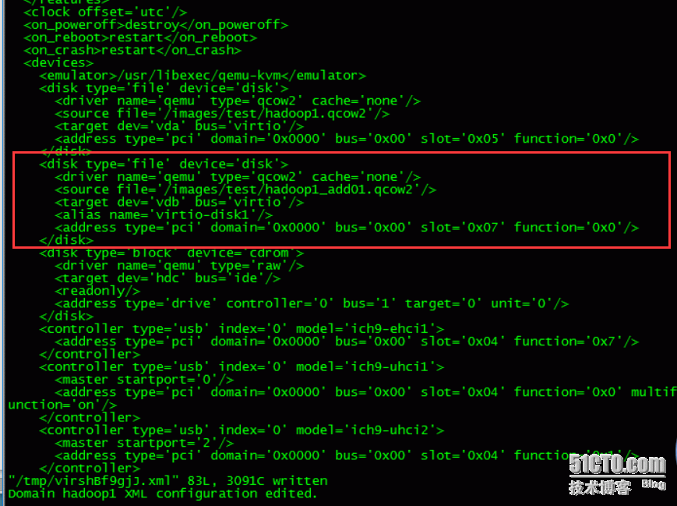](http://s1.51cto.com/wyfs02/M00/7A/C5/wKioL1a0aBjT1aLqAAFy6S32LMg936.png)

当把所有的配置文件写到虚拟机的配置信息后，及时重启也能生效。

本文出自 “[清风明月](http://liqingbiao.blog.51cto.com/)” 博客，请务必保留此出处<http://liqingbiao.blog.51cto.com/3044896/1741252>