**kvm虚拟机默认使用raw格式的镜像格式，性能最好，速度最快，它的缺点就是不支持一些新的功能，如支持镜像,zlib磁盘压缩,AES加密等。  要使用镜像功能，磁盘格式必须为qcow2。下面开始kvm虚拟机快照备份的过程**

1，查看现有磁盘镜像格式与转换

  （1）查看现有磁盘的格式

|  |  |
| --- | --- |
| 1  2  3  4  5 | [root@KVM test]# qemu-img info hadoop3.img  image: hadoop3.img  file format: raw  virtual size: 10G (10737418240 bytes)  disk size: 877M |

把raw格式转换成qcow2格式

  （2）关闭需要转换磁盘的虚拟机

|  |  |
| --- | --- |
| 1  2  3  4  5  6  7  8  9  10 | [root@KVM test]# virsh destroy hadoop3  Domain hadoop3 destroyed  [root@KVM test]# virsh list --all   Id    Name                           State  ----------------------------------------------------   1     win7                           running   6     hadoop2                        running   -     hadoop1                        shut off   -     hadoop3                        shut off   -     hadoop4                        shut off |

  （3）转换磁盘的格式

|  |  |
| --- | --- |
| 1 | [root@KVM test]# qemu-img convert -f raw -O qcow2 hadoop3.img hadoop3.qcow2 |

-f 源镜像的格式

-o 目标镜像的格式

查看转换后的格式，已经转换成了qcow2, 这里是拷贝一份，并将格式转成qcow2

|  |  |
| --- | --- |
| 1  2  3  4  5  6  7  8  9  10  11  12  13  14  15 | [root@KVM test]# qemu-img convert -f raw -O qcow2 hadoop3.img hadoop3.qcow2  [root@KVM test]# ll  total 14975352  -rwxr-xr-x 1 root root 10737418240 Feb  4 14:38 hadoop1.img  -rwxr-xr-x 1 qemu qemu 10737418240 Feb  4 16:51 hadoop2.img  -rwxr-xr-x 1 root root 10737418240 Feb  4 16:48 hadoop3.img  -rw-r--r-- 1 root root   923926528 Feb  4 16:51 hadoop3.qcow2  -rwxr-xr-x 1 root root 10737418240 Feb  4 15:11 hadoop4.img  -rwxr-xr-x 1 qemu qemu  8589934592 Feb  2 15:03 win7.img  [root@KVM test]# qemu-img info hadoop3.qcow2  image: hadoop3.qcow2  file format: qcow2  virtual size: 10G (10737418240 bytes)  disk size: 881M  cluster_size: 65536 |

2，修改虚拟机配置文件

|  |  |
| --- | --- |
| 1 | [root@KVM qemu]# virsh edit hadoop3 |

<domain type='qemu'>

  <name>hadoop3</name>

  <uuid>586b3cae-943f-e283-d8e7-ed72b01bfa34</uuid>

  <memory unit='KiB'>1048576</memory>

  <currentMemory unit='KiB'>1048576</currentMemory>

  <vcpu placement='static'>1</vcpu>

  <os>

    <type arch='x86_64' machine='rhel6.6.0'>hvm</type>

    <boot dev='hd'/>

  </os>

  <features>

    <acpi/>

    <apic/>

    <pae/>

  </features>

  <clock offset='localtime'/>

  <on_poweroff>destroy</on_poweroff>

  <on_reboot>restart</on_reboot>

  <on_crash>restart</on_crash>

  <devices>

    <emulator>/usr/libexec/qemu-kvm</emulator>

    <disk type='file' device='disk'>

      <driver name='qemu' type='qcow2' cache='none'/>

      <source file='/images/test/hadoop3.qcow2'/>

      <target dev='hda' bus='ide'/>

[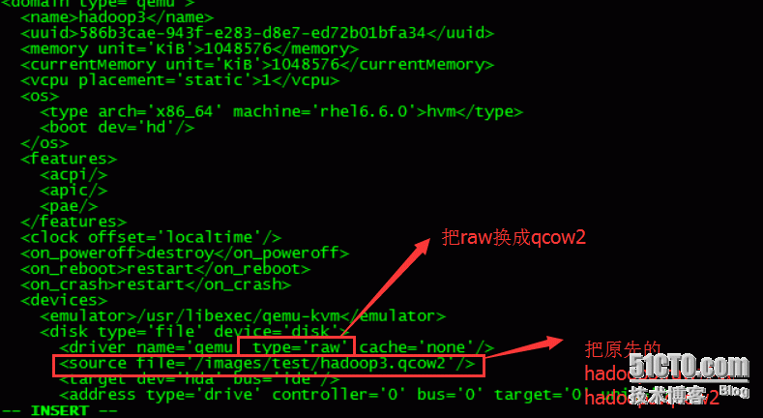](http://s4.51cto.com/wyfs02/M00/7A/C0/wKioL1azE4TAsI9XAADVfYGxlg8379.png)

3，对虚拟机进行快照管理

 (1)对hadoop3虚拟机创建快照

|  |  |
| --- | --- |
| 1  2 | [root@KVM qemu]# virsh snapshot-create hadoop3  Domain snapshot 1454577228 created |

 （2）查看虚拟机快照的版本

|  |  |
| --- | --- |
| 1  2  3  4 | [root@KVM qemu]# virsh snapshot-list hadoop3   Name                 Creation Time             State  ------------------------------------------------------------   1454577228           2016-02-04 17:13:48 +0800 shutoff |

 （3）查看当前虚拟机镜像快照的版本

|  |  |
| --- | --- |
| 1  2  3  4  5  6  7  8  9  10  11  12  13  14  15  16  17  18  19  20  21  22  23  24  25  26  27  28  29  30  31  32  33  34  35  36  37  38  39  40  41  42  43  44  45  46  47  48  49  50  51  52  53  54  55  56  57  58  59  60  61  62  63  64  65  66  67  68  69  70  71  72  73  74  75  76  77  78  79  80  81  82  83  84  85  86  87  88  89 | [root@KVM qemu]# virsh snapshot-current hadoop3  <domainsnapshot>    <name>1454577442</name>    <state>shutoff</state>    <parent>      <name>1454577228</name>    </parent>    <creationTime>1454577442</creationTime>    <memory snapshot='no'/>    <disks>      <disk name='hda' snapshot='internal'/>      <disk name='hdc' snapshot='no'/>    </disks>    <domain type='qemu'>      <name>hadoop3</name>      <uuid>586b3cae-943f-e283-d8e7-ed72b01bfa34</uuid>      <memory unit='KiB'>1048576</memory>      <currentMemory unit='KiB'>1048576</currentMemory>      <vcpu placement='static'>1</vcpu>      <os>        <type arch='x86_64' machine='rhel6.6.0'>hvm</type>        <boot dev='hd'/>      </os>      <features>        <acpi/>        <apic/>        <pae/>      </features>      <clock offset='localtime'/>      <on_poweroff>destroy</on_poweroff>      <on_reboot>restart</on_reboot>      <on_crash>restart</on_crash>      <devices>        <emulator>/usr/libexec/qemu-kvm</emulator>        <disk type='file' device='disk'>          <driver name='qemu' type='qcow2' cache='none'/>          <source file='/images/test/hadoop3.qcow2'/>          <target dev='hda' bus='ide'/>          <address type='drive' controller='0' bus='0' target='0' unit='0'/>        </disk>        <disk type='block' device='cdrom'>          <driver name='qemu' type='raw'/>          <target dev='hdc' bus='ide'/>          <readonly/>          <address type='drive' controller='0' bus='1' target='0' unit='0'/>        </disk>        <controller type='usb' index='0' model='ich9-ehci1'>          <address type='pci' domain='0x0000' bus='0x00' slot='0x04' function='0x7'/>        </controller>        <controller type='usb' index='0' model='ich9-uhci1'>          <master startport='0'/>          <address type='pci' domain='0x0000' bus='0x00' slot='0x04' function='0x0' multifunction='on'/>        </controller>        <controller type='usb' index='0' model='ich9-uhci2'>          <master startport='2'/>          <address type='pci' domain='0x0000' bus='0x00' slot='0x04' function='0x1'/>        </controller>        <controller type='usb' index='0' model='ich9-uhci3'>          <master startport='4'/>          <address type='pci' domain='0x0000' bus='0x00' slot='0x04' function='0x2'/>        </controller>        <controller type='ide' index='0'>          <address type='pci' domain='0x0000' bus='0x00' slot='0x01' function='0x1'/>        </controller>        <interface type='network'>          <mac address='52:54:00:fe:f5:a3'/>          <source network='default'/>          <address type='pci' domain='0x0000' bus='0x00' slot='0x03' function='0x0'/>        </interface>        <serial type='pty'>          <target port='0'/>        </serial>        <console type='pty'>          <target type='serial' port='0'/>        </console>        <input type='mouse' bus='ps2'/>        <graphics type='vnc' port='5913' autoport='no' listen='0.0.0.0'>          <listen type='address' address='0.0.0.0'/>        </graphics>        <video>          <model type='cirrus' vram='9216' heads='1'/>          <address type='pci' domain='0x0000' bus='0x00' slot='0x02' function='0x0'/>        </video>        <memballoon model='virtio'>          <address type='pci' domain='0x0000' bus='0x00' slot='0x05' function='0x0'/>        </memballoon>      </devices>    </domain>  </domainsnapshot> |

 （4)查看当前虚拟机镜像文件，快照文件的路径在**/var/lib/libvirt/qemu/snapshot/ 下**

|  |  |
| --- | --- |
| 1  2  3  4 | [root@KVM qemu]# ll /var/lib/libvirt/qemu/snapshot/hadoop3/  total 8  -rw------- 1 root root 3402 Feb  4 17:17 1454577228.xml  -rw------- 1 root root 3453 Feb  4 17:17 1454577442.xml |

4，恢复虚拟机快照

 （1）恢复虚拟机快照必须关闭虚拟机

|  |  |
| --- | --- |
| 1  2  3  4  5  6  7  8 | [root@KVM qemu]# virsh list --all   Id    Name                           State  ----------------------------------------------------   1     win7                           running   6     hadoop2                        running   -     hadoop1                        shut off   -     hadoop3                        shut off   -     hadoop4                        shut off |

 （2）确认恢复快照的时间，这里是恢复到1454577442

|  |  |
| --- | --- |
| 1  2  3  4  5 | [root@KVM qemu]# virsh snapshot-list hadoop3   Name                 Creation Time             State  ------------------------------------------------------------   1454577228           2016-02-04 17:13:48 +0800 shutoff   1454577442           2016-02-04 17:17:22 +0800 shutoff |

 （3）执行恢复，并确认恢复版本

|  |  |
| --- | --- |
| 1  2 | [root@KVM qemu]# virsh snapshot-revert hadoop3 1454577442  [root@KVM qemu]# virsh snapshot-current hadoop3 |

[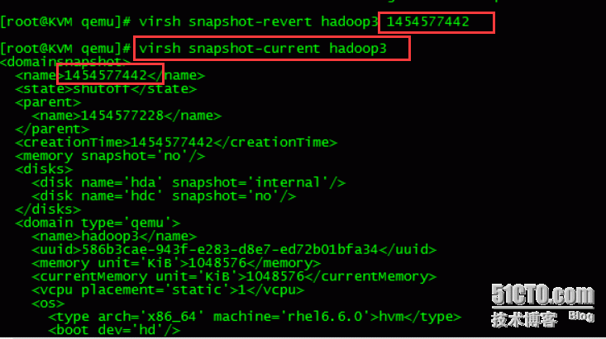](http://s5.51cto.com/wyfs02/M01/7A/C0/wKioL1azHULSJIq9AAC2ZR0eWkg549.png)

5，删除虚拟机快照

 （1）查看虚拟机快照

|  |  |
| --- | --- |
| 1  2  3  4  5  6  7  8  9  10 | [root@KVM test]# qemu-img info hadoop3.qcow2  image: hadoop3.qcow2  file format: qcow2  virtual size: 10G (10737418240 bytes)  disk size: 881M  cluster_size: 65536  Snapshot list:  ID        TAG                 VM SIZE                DATE       VM CLOCK  1         1454577228                0 2016-02-04 17:13:48   00:00:00.000  2         1454577442                0 2016-02-04 17:17:22   00:00:00.000 |

 (2)删除快照

|  |  |
| --- | --- |
| 1  2  3  4  5  6  7  8  9  10  11 | [root@KVM test]# virsh snapshot-delete hadoop3 1454577228  Domain snapshot 1454577228 deleted  [root@KVM test]# qemu-img info hadoop3.qcow2  image: hadoop3.qcow2  file format: qcow2  virtual size: 10G (10737418240 bytes)  disk size: 881M  cluster_size: 65536  Snapshot list:  ID        TAG                 VM SIZE                DATE       VM CLOCK  2         1454577442                0 2016-02-04 17:17:22   00:00:00.000 |

至此虚拟机快照从创建，查看，删除。如果有报错，再一一的进行拍错。

本文出自 “[清风明月](http://liqingbiao.blog.51cto.com/)” 博客，请务必保留此出处<http://liqingbiao.blog.51cto.com/3044896/1741125>