|  |
| --- |
| DIT5407 - Data Visualization and interface design |
| Report |
|  |

|  |
| --- |
| Iu Cheuk Ying  2020/5/19 |

Introduction

This project is going to making two charts for analyzing the Covid-19. Covid-19 is called Coronavirus disease 2019. It is a disease which starting to appear in Wuhan, China since Nov,2019. It has been spread to the world by travelling rapidly from Jan, 2020. Until 19 May 2020, there are already 4.8 million cases. There are more than 318,000 deaths in the world. Many of the countries were using different measures to help controlling Covid-19 to extend in their country. Hong Kong also do a lot on setting different policy and also Hong Kong People start wearing mask immediately to help to prevent spreading of Covid-19 in the social.

In the report below, two data are used to help to analyzing the situation of the Covid-19 in Hong Kong.

Data

Two data are using in this project:

* Gender

Gender data was finding from the government website. It is divided into male and female. The reason of choosing this data is because gender is important data in Hong Kong. This data can help to compare male or female whose are easier to get Covid-19. In this data, it can help to find out why the particular group of people have less chance to become confirmed cases. That can shrink the area scope to help finding the reason of the confirmed cases.

* Travel History

Travel History was also the data finding from government. It is using the country to do the finding. Hong Kong people loves to go traveling and study in oversea so there are a lot of import cases in this few month. Using this data can help to find which places was the import cases going to the most. That can help to know about which country may have more people to go and had the most serious Covid-19 number. That can help people to prevent to go to that kind of places in the latest month and help to design different policy to help to prevent more Covid-19 cases from other countries.

Type of the chart

* Pie chart

Pie chart is using for the gender data which it is dividing into two part. It shows that until 3 May 2020, female has 481 people are getting confirmed cases and male has 560 people are getting confirmed cases in Hong Kong. That means males has a higher number than the female confirmed cases. The reasons of using the pie char to represent this data is because, it can clear to see the comparing of the two data in a 100% circle. As it was using the same circle so it can easy to know which gender had more confirmed cases by comparing the color only.

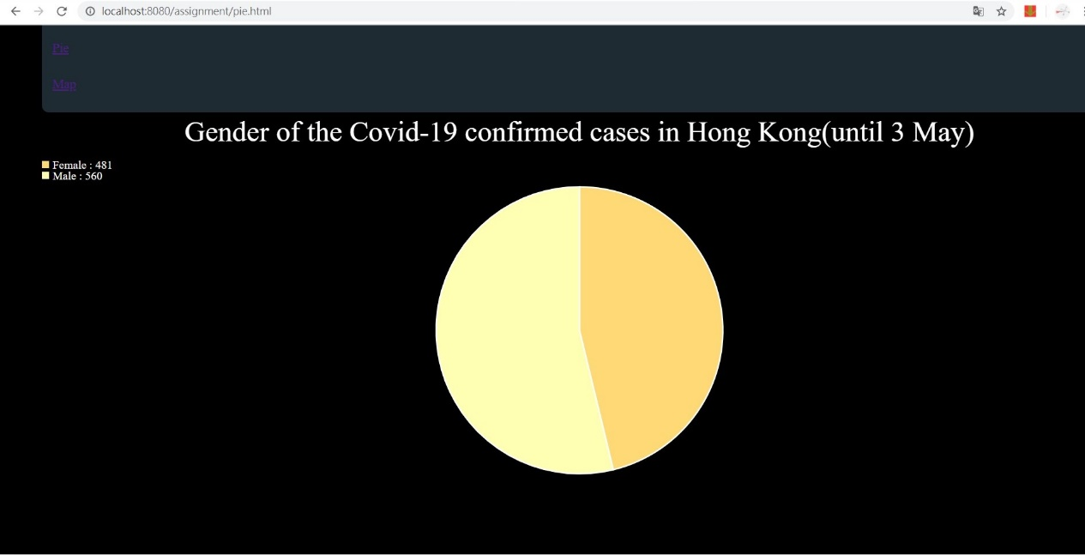

* World Map

World Map is using for the data of travel history which using the data of the imported country and the number of confirm cases. It shows that until 3 May 2020, UK has 404 which is the most of the total confirmed cases. World Map is using the id of the country name which to help to find which country need to be ported. Color is help to divided the number of the divided cases. It is dividing into 1, 10, 20, 50, 100, 200 and 400 which 400has the deeper color and 1 is the lighter color. 0 will be in black color. When the mouse moves to that country, a word dialog will be appearing at the right head corner. It will be including the country and the number of the import confirmed cases. Using color can easy to help to comparing which country are the import confirmed cases come from.

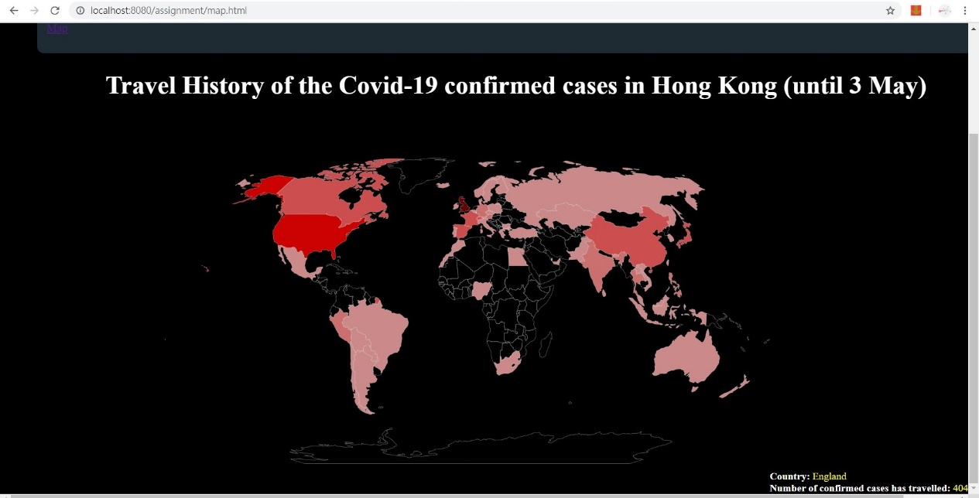

Self-reflection

In this project, I have made two charts for helping to find the data of gender and travel history about the Covid-19 in Hong Kong. Covid-19 is an important issue that happening in this few week. This project helps me to know more data about Covid-19.

On the other hand, I had learning a lot in this subject too. Using svg to drawing the chart, adding data to the char by JavaScript and d3. It really helps a lot on the data analyzing.

However, I really have a rush for doing this project. Time management really so important on doing different things. Time is really limited in this semester, many plans are having delay and changing at the end. I have not planning well on different workload, it makes everything become cashed together. That the reason why time manage is really an important thing in everything.

In this lesson and project, I really learn a lot. This project is my last project in the whole university life. I get a lot from the school, classmate and teacher. Knowledge, memory and everything. It is the last but not the end. Thank you for teaching me in these two years and make me learn many new knowledges from the lesson. Thank you!