|  |
| --- |
| Supervisor: Mr. Rex Lau |
| Student Name: Iu Cheuk Ying |
| Student Number: 160426110  2019/11/29 |

|  |
| --- |
| **Technological and Higher Education Institute of Hong Kong** |
| **Faculty of Design and Environment** |
| **BSc(Hons) in ICT** |
| **DIT5498 Final Year Project I (2019/2020)** |
|  |
| Interim Report |
|  |
| APP Making (with AI) – ShoPair |

**Table of Content**

1. Objectives
2. Introduction
3. System Requirements
4. Scope
5. Functions
6. Data Processed
7. Problem Analysis
8. Use Case Descriptions
9. Use Case Diagrams
10. Class Diagram
11. Sequence Diagrams
12. Detailed Design
13. Data Design
14. Software/Hardware Architectural Design
15. User Interface Design
16. Critical Evaluation
17. Difficulties
18. Changes in Project Schedule
19. Limitations of the Proposed System
20. Potential Difficulties & Suggested
21. Detailed Project Plan
22. References
23. Appendices
24. **Objectives**

The objective of this Project:

* Make an App to solve people need
* Using the knowledge that have been learn on class
* Learn the new technology to enrich the project

The objective of the App (ShoPair):

* To help the people to compare the price of the product they want to buy with object recognition
* To give a platform for the user to share the updated price for helping each other to have the newest information, especially the information from the small shops

The objective of this report:

* Make a detail plan for the project
* More detail information about the App
* Reflection on the processes which has been done in this few month (Sep - Nov)

1. **Introduction**

In this project, an app for shopping comparing will be made. The name of the app is called ShoPair. It is including partly of the words shopping and compare which wants to bring out the content of the app in a simple way.

Below are some App and website are having similar function for other category:

Expedia is a comparing app and web for people to comparing the hotel and flight price. However, it is only forces on traveling, not for local. Shopping and Travel is also important for people. Especially shopping, there are many things that people need to be needed in their daily life. So, a shopping comparing app will be as important as a travel comparing app.

Price.com is one of the similar products that are launching on the app store now. It is also a shopping comparing app. However, the category of the app is not comprehensive, the things that people will use in their daily life, like food, drink, tissue e.c.t, is not included in it. It also does not have an AI object recognition to convenient user to use it by taking the photo of the item.

People will like to know the price of the product in different store by walking and finding it out by themselves so they need a platform to including all the price of the product they want to buy.

People may not know the name of the product so the platform need to have a function of AI reorganization and also a searching system by keyword.

People may want to find the similar product so a recommend system will need for them to find more item they want.

Information from the small shops may not be included in the database so updating prices by the user themselves can help other to have the most update information from big or small shops.

That is the reason why this project should be done to let people having an App platform to compare the price before buying things. Helping them to buy the product in the cheapest price.

1. **System Requirements**
2. Scope

The App are making as a shopping comparing system. It including a main page which including the newest information, recent and top search.

Page of the product detail is a page that showing all the information of the product user find. Including the name, introduce of the product and also the comparing prices and the mapping of the places of where it can buy.

Searching page is set as a separate page for user to find the product they want easily. It including the searching system which is search by word.

Camera which is a page for the main fusion of the App which including the AI objective reorganization.

Login will be need for identity on the price compare given.

1. Functions
   * Login system for users
   * Login system for the shop
   * AI object recognize
   * Searching system
   * Mapping
   * API of the product online
   * Database for saving the product information
   * Server for managing
2. Data Processed

The system needs to process three data.

* Login

The user needs to sign up for helping to updating the recent cheapest price of the product. The simple information of the user like username, password and other information will be need to saved down in the database.

* AI object recognize

As the AI need to have information for learning on recognize the object. So, the database needs to contain some ready photo for the AI. The ready photo will be getting from online with API and saved in the database. More photo will be getting from the user while they use the App. The photo that the user take will also be saved into the database.

* Price and other information of the product

Some of the data will be using the API to get from the other website, after getting the data like the price and where it can buy (with map), they will be saved into the database for using as comparing part.

The users can help to input new prices for the app, it will also be saved in the database for updating the newest cheapest price of the product and help other to know where it can buy.

1. **Problem Analysis**
2. Use Case Descriptions

* Public

Public is the user that do not create any account in the app. They can still use the function searching and take photo for the AI searching of the app to find the product that they want. The App will search and check if the product is included in the database. If yes, the product will show. If no, the word no record will be shown.

* Users

Users is the user that already register and can login to use the App. They can also use the search and ai search function that same as the public. However, they will have more function. They can login their account and help to update the price of the product which help to improve the database of the App.

* Database

Database is mainly for the saving and updating.

For the searching, the database will help to check the record of the product. If there are record, the database will send back the product information, product prices and where can it buy to the App page and show it to the user. If there are no record, the database needs to reply no data to the app so the server can show no record statement to the user.

For the login function, the database is main helping on saving the login username, password and also some information of the user. When the user registers the information will be sent into the database. When the user login, the database needs to help check the username and password. If it is correct, the user can login. If not, the login will be failed.

For product, as the users can help to update the prices and the places to buy for the product. The new data will be sent back to the database to save down and sent it back when the product is searching by the other user.

1. Use Case Diagrams

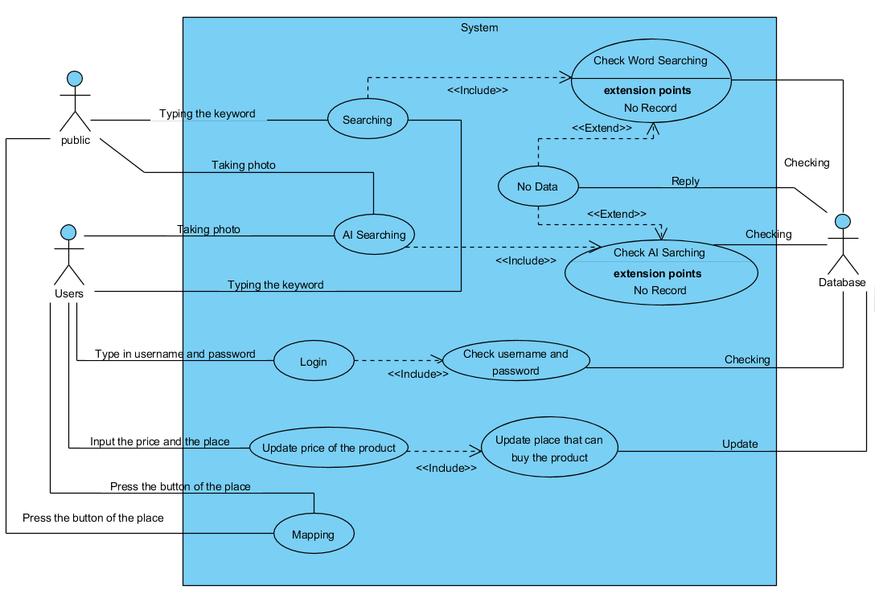

1. Class Diagram

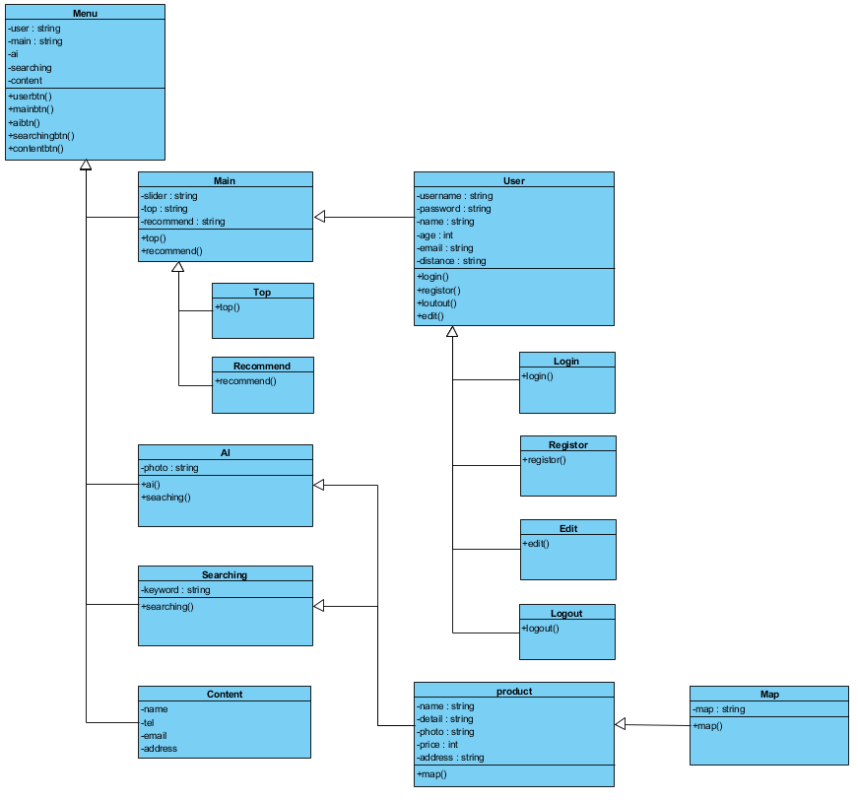

1. Sequence Diagrams

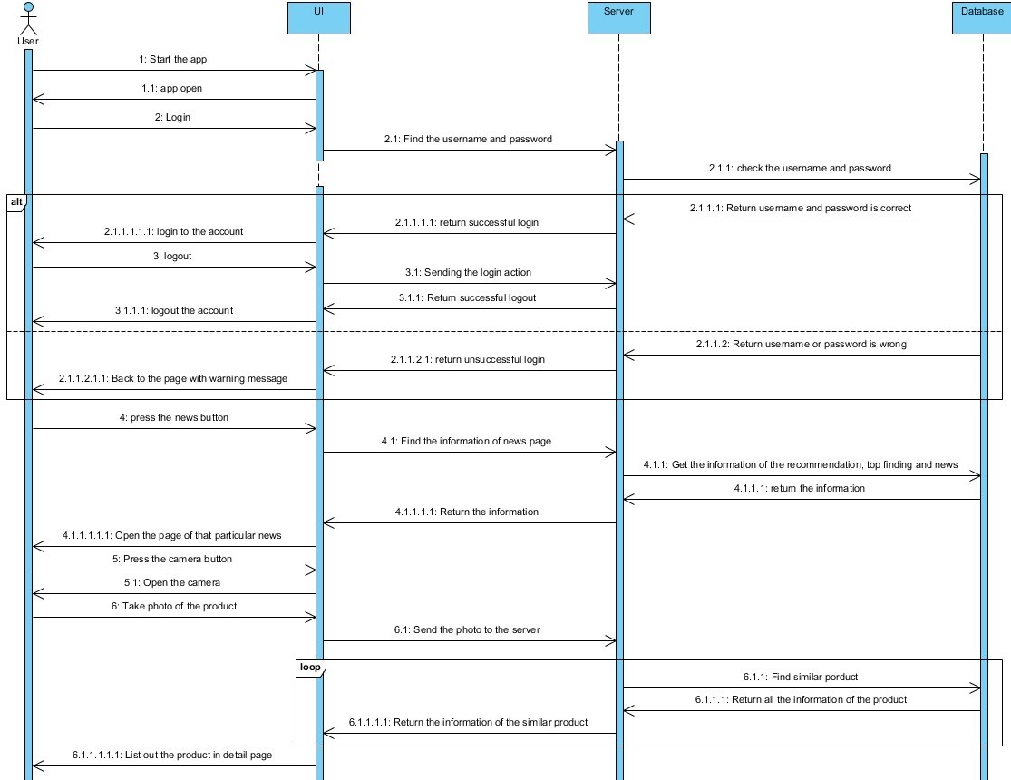

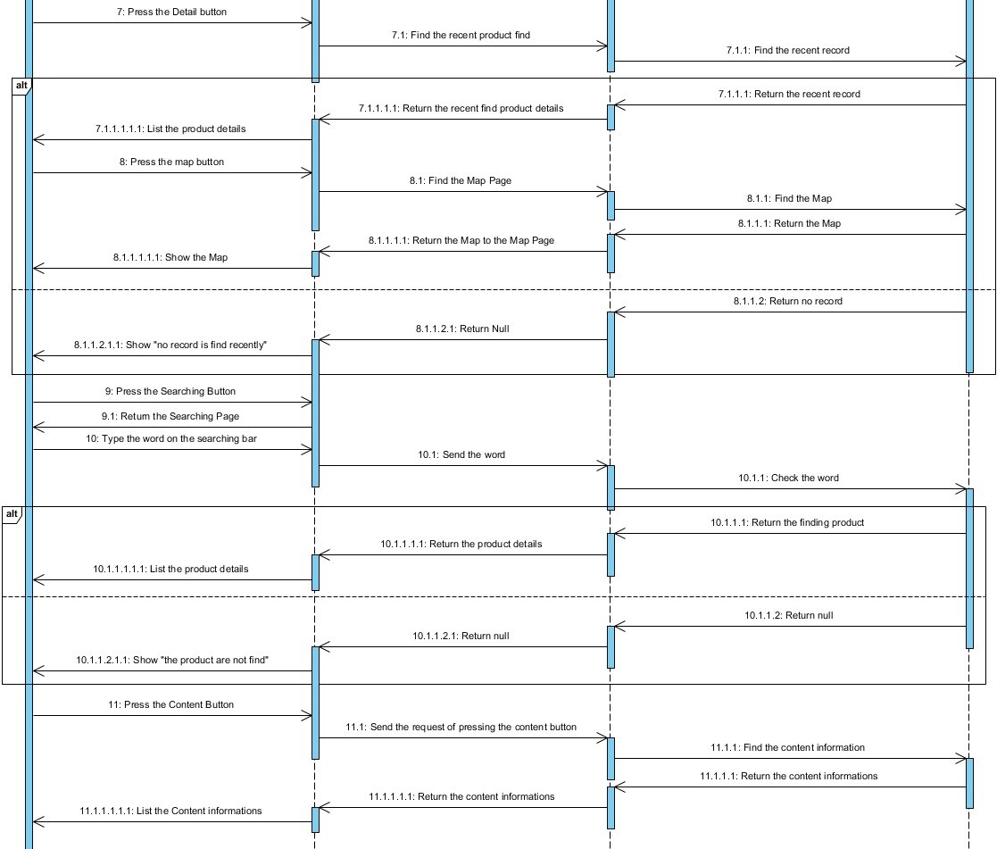

1. **Detailed design**
2. Data Design

* Login
  + - * 1. Username
        2. Password
        3. Name
        4. Age
        5. Email
* Product

1. Name
2. Detail
3. Price (more than one)
4. Place
5. Map (Latitude and Longitude)
6. Photo
7. Software/Hardware Architectural design
   * Android Studio for making the app UI and function.
   * AI is using python to do the object recognize.
   * Database is building the own database with API and google database for enrich it.
8. User Interface Design

* Main Page

In the main page, it will be including a slider which is for the newest promotion or recent top finding which to attract the user to look at the news. The design is using slider is because moving will be more attracting and also it can put a lot of slides in it without resize the banner.

After the slider, top finding product and also recommendation will be following. It can help to giving a choice for the users. Let the user know what is the most famous product that are searching from other recently. They may also find the thing that they want so to reduce the time of them to searching it.

SEARCH

NEWS

DETAIL

CONTENT

News Slider

Recommendation

Top Finding Product

Login

* AI Object Recognize Page

It is a page that with the camera function. It is for the users to use the AI Object Recognize. As some time, people are looking at the product which they may not know what is the name of the product or they want to find the similar product of it. They can choose to take a photo of that product and do the searching in the App so they can limit the time to searching the product name online before they use the App.

To let the users, know that it is the camera function the logo of the button is the picture of the camera.

Camera

* Product Detail Page

The product detail page will be including two part.

First part will be including all the information of the product. The photo of the produce, the name of the product, the detail information of the product, different compare prices from the other users or online API and also where can it buy.

SEARCH

NEWS

DETAIL

CONTENT

$

Address

$

Address

Photo

Login

Second part is a map. As it will including the address of where the product can be buying so map is included to help the users to find their way.

SEARCH

NEWS

DETAIL

CONTENT

MAP

Login

* Search Page

Searching page will be for the user to search the product by the product’s name or keyword. They may need have the item on hand so searching system by word should be included for them to find the product.

SEARCH

NEWS

DETAIL

CONTENT

Searching

Search

Details

Login

* Content Page

Content page is need to let the user to content when they find that there are any problem or question from the App.

SEARCH

NEWS

DETAIL

CONTENT

APP

INFORMATION

Login

1. **Critical Evaluation**
2. Difficulties

* Time

The project will work for a year. There may have a limited time for doing the whole app including the API, database, UI and server. The time manage need to be tight and follow straightly. It maybe the hardest things in this project.

* Knowledge

This is the first time using the ai function to do a project. There is limited knowledge on it. More information searching need to be done to help on this project. There will be difficulty to learn a new knowledge in the limited time.

1. Changes in Project Schedule

|  |  |
| --- | --- |
| Date (Month) | Work |
| September | * Idea Thinking |
| October | * Proposal   (Time is not enough for the App Making) |
| November | * App Making   1. User Interface   2. AI object recognize * Report |
| December | * Mid-term present (Still not confirm) * App Making   1. User Interface   2. AI object recognize   (More time is needed on the front-end) |
| January | * App Making   1. AI object recognize   2. Database   3. API of the product   4. Server |
| February | * App Making   1. Database   2. Server   3. API of the product |
| March | * App Making   1. Database   2. Server   3. API of the product |
| April | * App Testing   1. Bug Checking * Debug |
| May | * Debug * Report |
| June | * Final Present |

1. Limitations of the Proposed System
   * + - Available of API

As in this App need to used API for getting as much photo and information of the produce online so to give out a more correct information for the user. API will be a limitation on this App. As many of the API like the supermarket website, online shop website is not in public for other people to use. Finding API for the App will be the most difficult part.

* + - * Database of the product

Database of this App need to be big enough for the AI to learn as much as it can so to make sure the correction of the AI. More and more data will be need to store in the database. If API are not available, the database will need more time for developed. Information may need to be inputted by hand if needed. It will be using a lot of time on it to build up this database.

* + - * AI learning

As the App is including the AI object recognize, it will be the main part of the App too. However, AI may become a challenge, AI need to be learnt from the data that been input in the database. If more data, it will be more correct for the user. There maybe a lot of problem be happened while the AI learning. There maybe wrong information be learnt or not enough information for learning. It needs to be more be careful in this part so to make sure that there will not have too much mistake in it.

1. Potential Difficulties & Suggested

For the time management problem, the most important is to set a clear timetable which to help controlling the time of doing the project. Having a clear timeline can help to make sure the project is continuing and possessing.

For the new knowledge, information from the online is important. There are many different useful sources online which can really help on this project. The main thing is not to think it is so difficult which can help to stop the mind of giving up easily at the start. It can at least make sure the continuously of the project.

For the limitation of the system like API, big database and also AI learning. Finding as much information that can be find. There are many limitations maybe pop up, trying the best to find the solution is the only way that can be solving the problem. Finding help, searching online will also help on it.

1. **Detailed Project Plan**

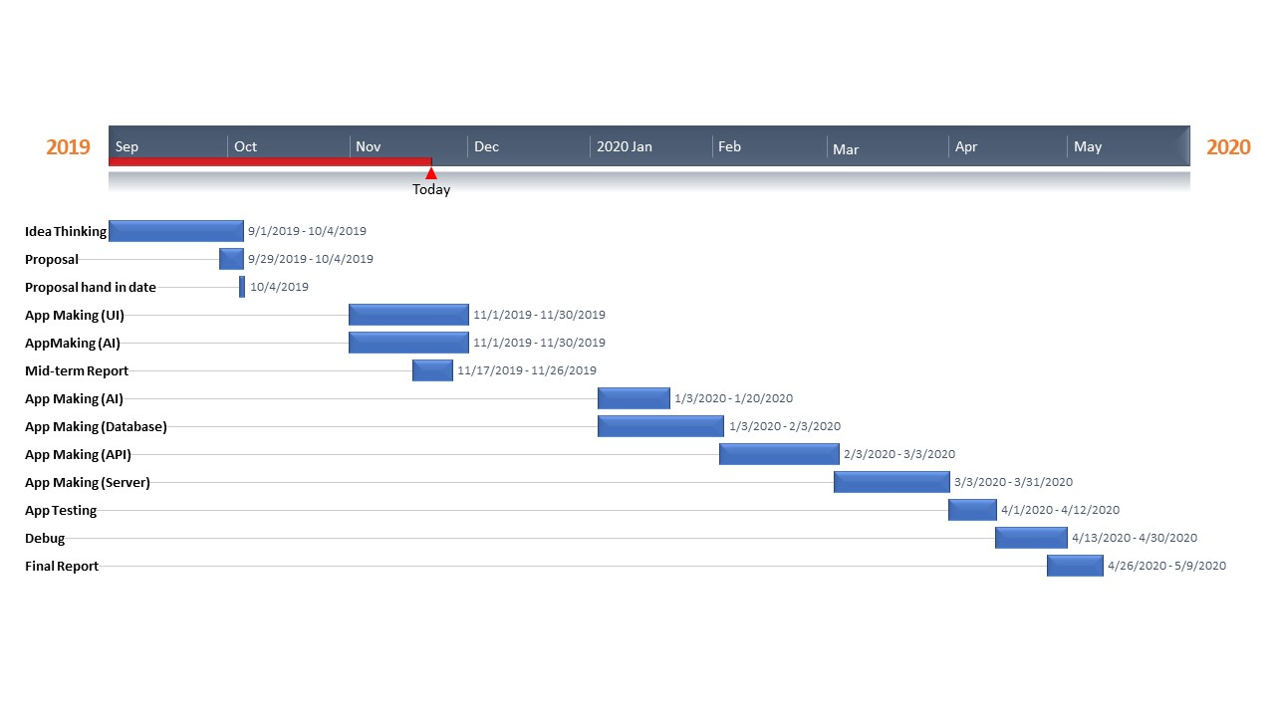

1. **References**

* Expedia. (2019). Retrieved November 29, 2019, from <https://www.expedia.com.hk/>
* Price.com.hk. (2019). Retrieved November 29, 2019, from <https://www.price.com.hk/>