Technological and Higher Education Institute of Hong Kong

Faculty of Design and Environment

BSc(Hons) in ICT

Final Year Project I (DIT5498)

Project Proposal
(2019/2020)

APP Making (with AI) – ShoPair

Supervisor: Mr Rex Lau

Second Reader:

Student Name: Iu Cheuk Ying

Student No: 160426110

Table of Content:

- Introduction to the Project Topic
- Objectives
- Significance
- Statement of problem to be solved

- Background
- Outline of Action Plan
- Outline of Method of Solution
- Schedule
- Methodology
- Outcome Measure

- Project Deliverables
- Software System
- Documentations

- Project Milestones

- Conclusion
- Limitations
- Implication
- Significance
- Recommendations

- Reference

- Extra Information
- Introduction
In this project, an app for shopping comparing will be made. The name of the app is called ShoPair. It is including partly of the words shopping and compare which wants to bring out the content of the app in a simple way.

  - Objective
The objective of this project is to help the people to compare the price of the product they want to buy in app with object recognition. At the same time, this project would like to give a platform for the user to share the updated price for helping each other to have the newest information, especially the information from the small shops.

Expedia is a comparing app and web for people to comparing the hotel and flight price. However, it is only forces on traveling, not for local. Shopping and Travel is also important for people. Especially shopping, there are many things that people need to be needed in their daily life. So, a shopping comparing app will be as important as a travel comparing app.

Price.com is one of the similar products that are launching on the app store now. It is also a shopping comparing app. However, the category of the app is not comprehensive, the things that people will use in their daily life, like food, drink, tissue e.c.t, is not included in it. It also does not have an AI object recognition to convenient user to use it by taking the photo of the item.

  - Significance
The significance of the app is let people to compare the price before buying things. It can help them to buy the product in the cheapest price.

  - Statement of problem to be solved
- People will like to know the price of the product in different store by walking and finding it out by themselves.
- People may not know the name of the product.
- People may want to find the similar product.
- Information from the small shops may not be included in the database.
- Background

  - Outline of Action Plan
A shopping comparing app (ShoPair) will be made. It is an app contain AI object recognize function which user can find product by using photo taking other than only typing the keyword. Inside the app will also contain the latest news, top finding, product details and mapping function. For sure price comparing function will be including in this app.

Function of the app:
- Login system for users
- Login system for the shop
- AI object recognize
- Searching system
- Mapping
- API of the product online
- Database for saving the product information
- Server for managing

  - Outline of Method of Solution
    - The app can help the user to check the price in every store before the user decide where they want to buy the product.
    - The AI recognize can help the user to use photo instead of wording to find the things that they want.
    - AI recognize can help to find the similar product so to give more suggestion for the user choice.
    - Users account will let the user to enter the updated cheapest price that they might see to enrich the database of the app.

  - Schedule

Time | Work
1 Month | - Idea Thinking
1 Week | - Proposal
3 Weeks | - App Making  - User Interface
1 Month | - App Making  - AI object recognize
1 Month | - App Making  - Database
1 Month | - App Making  - Server
1 Month | - App Making  - API of the product
2 Weeks | - App Testing  - Bug Checking
2 Weeks | - Debug
2 Weeks | - Report

  - Methodology
AI object recognize will be the main function that will be used for recognize the product that the user wants to do the price comparing. AI object recognize is using the photo taking, python coding for functioning on calculate the recognize on the product which with a database for saving all the recognize learning.
AI is a machine learning which is the simulation of human intelligence processes by machines. It includes learning the acquisition and rules of the information using, reasoning to definite conclusions and self-correction which used to perform a number of AI tasks.

  - Outcome Measure
    - Main Page

SEARCH
NEWS
DETAIL
CONTENT
News Slider
Recommendation
Top Finding Product
Login

    - AI Object Recognize Page

Camera

    - Product Detail Page

SEARCH
NEWS
DETAIL
CONTENT
$
Address
$
Address

Photo
Login
SEARCH
NEWS
DETAIL
CONTENT
MAP
Login

    - Search Page

SEARCH
NEWS
DETAIL
CONTENT
Searching
Search
Details
Login

    - Content Page

SEARCH
NEWS
DETAIL
CONTENT
APP
INFORMATION
Login
- Project Deliverables

  - Software System
    - Android Studio for making the app UI and function.
    - AI is using python to do the object recognize.
    - Database is building the own database with API and google database for enrich it.

- Project Milestones

Date (Month) | Work
September | - Idea Thinking
October | - Proposal  - App Making  - User Interface
November | - App Making  - User Interface  - AI object recognize  - Report
December | - Mid-term present
January | - App Making  - AI object recognize  - Database  - API of the product  - Server
February | - App Making  - Database  - Server  - API of the product
March | - App Making  - Database  - Server  - API of the product
April | - App Testing  - Bug Checking  - Debug
May | - Debug  - Report
June | - Final Present
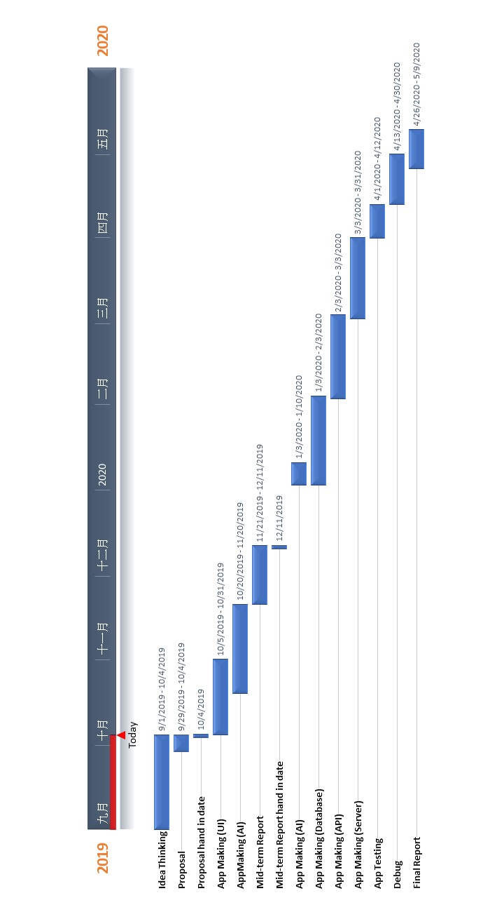
- Conclusion
Shopping is what people do every day. Buying the daily necessary or even buying something they wants, they will like to buy in the cheapest price. This App can help the user to compare the price any time in anywhere. People do not need to walk to different shop and compare the price by themselves. The App will be included AI object recognize function so to convenient the user when they are searching product that they want. The App will give a platform for the users to helping each other with posting the price that they might see in the small shops, to ensure there will be updated price inside the database.

  - Limitation
    - Time
The project will work for a year. There may have a limited time for doing the whole app including the API, database, UI and server. The time manage need to be tight and follow straightly. It maybe the hardest things in this project.

    - Knowledge
This is the first time using the ai function to do a project. There is limited knowledge on it. More information searching need to be done to help on this project. There will be difficulty to learn a new knowledge in the limited time.

  - Implication
The implication of the app is let people to compare the price before buying things. It can help them to buy the product in the cheapest price.

- Reference
- Expedia (2019). Retrieved from
https://www.expedia.com.hk/?eapid=0-18&affcid=hk.network.tag.3447

- Price.com (2019). Retrieved from https://www.price.com.hk/
- Extra Information
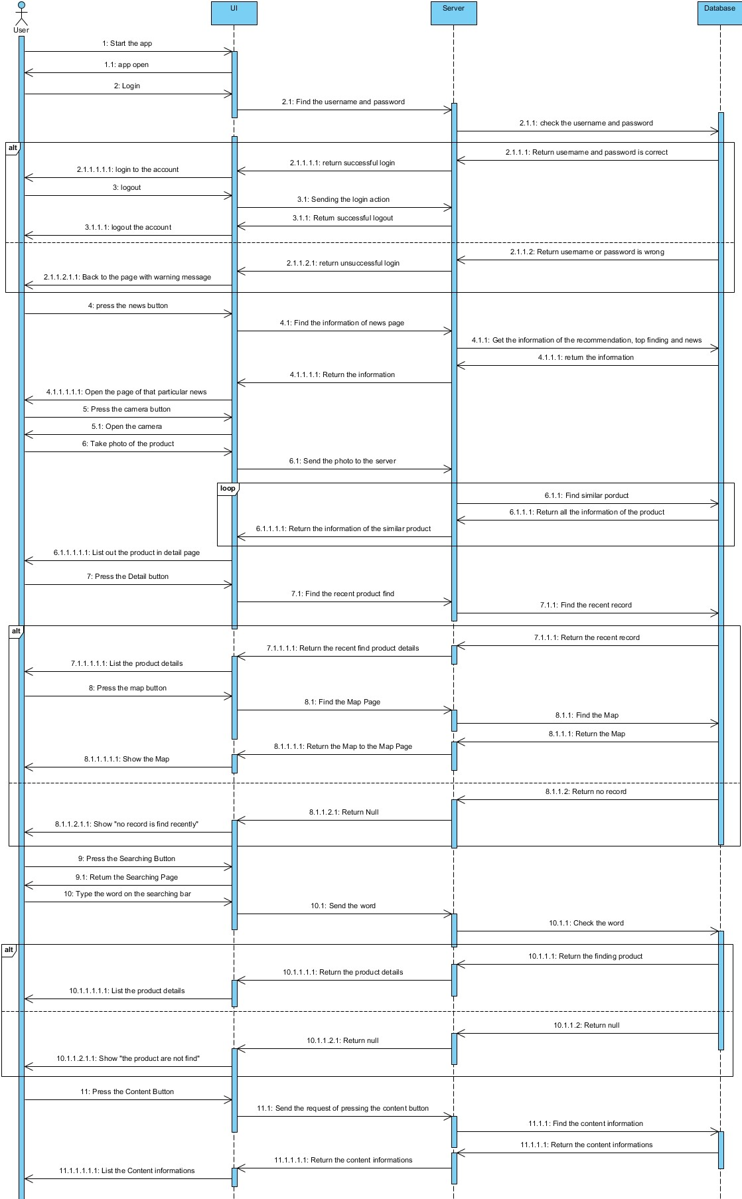
Student Signature : Date:

Supervisor Signature : Date:

Second-Reader Signature : Date:

External Body Signature (if relevant): Date:

Comments by Vetting Panel:

Project Coordinator: Date:

