Free-run timer and Periodic timer

MCU knowledge
BinhLV13, October 2025

Introduction
In the world of embedded systems, timers are perhaps the most essential peripherals, serving as the system's precise hardware clocking mechanism.
Unlike the main Central Processing Unit (CPU), which executes software instructions, timers operate asynchronously in the background, consuming minimal processing time while providing highly accurate timekeeping.

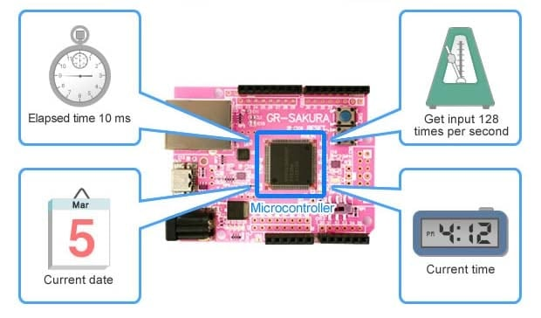
Figure 1. Types of Processing that Utilize a Timer
Modern Microcontroller Unit (MCU) typically integrate multiple versatile timer modules, each capable of being configured for specialized tasks. Although these modules are complex, they generally fall into two distinct operational modes based on their reset behavior: the Free-Run Timer and the Periodic Timer.
Understanding the difference between these two modes is crucial for building robust, time-critical applications, as they enable the MCU to transition from simple sequential execution to complex, real-time control.

Contents

1 Abbreviations and acronyms 3
2 Free-run timer 4
1.1 Overview 4
1.2 Key Characteristics and Functions 4
1.3 Common Uses 5
3 Periodic timer 6
2.1 Overview 6
2.2 Key Characteristics and Functions 6
2.3 Common Uses 7
4 Comparison 8
5 Code example 9
6 Reference 10
7 Revision history 11

Abbreviations and acronyms

Table 1. Abbreviations and acronyms
No. | Item | Description
1 | MCU | Microcontroller Unit.
2 | ARR | Auto-Reload Value.
3 | RTOS | Real-Time Operating System.
4 | ADC | Analog-to-Digital Converter.
5 | PWM | Pulse Width Modulation.

Free-run timer

Figure 2 provides the overview about the free-run timer.

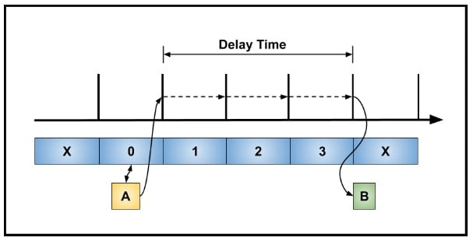
Figure 2. Free-run timer

Overview
A free-run timer (or free-running counter) on a MCU is a type of hardware timer peripheral that, once started, simply counts up continuously from zero until it reaches its maximum value, then overflows (resets to zero), and immediately begins counting again.
It essentially operates without a stop condition or a specific reload value that halts or resets its count (unlike a typical periodic timer).

Key Characteristics and Functions

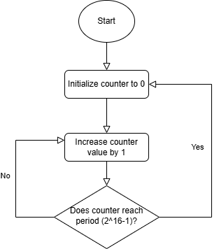
Figure 3. Free-run counter

- Continuous Counting: The timer counts clock cycles from its time base (often a divided system clock) without interruption.
- Overflow: When the counter reaches its maximum value (e.g., 2¹⁶-1 for a 16-bit timer), it rolls over to 0 and continues counting. This overflow can optionally trigger an interrupt. This loop described as Figure 3 (The loop will end when timer stopped).
- Time Reference: The free-run timer acts as a high-resolution, continuously running clock or timestamp within the MCU.

Common Uses
The free-run nature makes it ideal for measuring elapsed time and for synchronization tasks:
- Measuring Elapsed Time: By reading the counter's value at the beginning and end of an event, you can accurately calculate the time that has passed, even across multiple overflows.
- Input Capture: It's often used as the time base for an Input Capture unit. When an external event (like a rising or falling edge on a pin) occurs, the free-run timer's current value is captured (saved) into a register. This allows for precise measurement of external signal frequencies and pulse widths.
- Generating Non-Periodic Delays: Software can wait for the counter to reach a specific value relative to its current count to create precise, one-off time delays.

- Implementing Timeouts: It provides a reliable counter to check against to determine if a certain operation has exceeded its allotted time.

Periodic timer

Figure 4 provides the overview about the periodic timer.

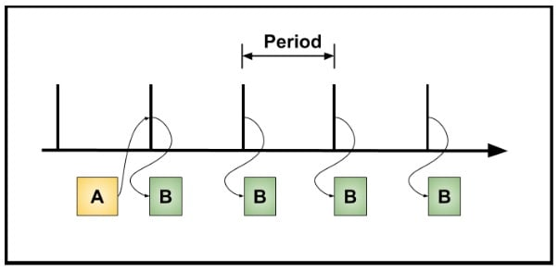
Figure 4. Periodic timer

Overview
A periodic timer on a MCU is a hardware peripheral configured to execute an action or trigger an interrupt at precise, regular time intervals.
It is the most common mode for general-purpose timing and acts as a reliable heartbeat for the microcontroller's time-based operations.

Key Characteristics and Functions

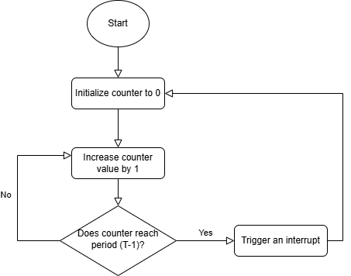
Figure 5. Periodic counter

The periodic timer mode is based on a counter and a compare/period register:
- Time-based Configuration: The main system clock is typically passed through a prescaler (a frequency divider). This prescaler slows down the clock to a more manageable rate, which determines the resolution (smallest time step) of the timer.
- Period Setup: The programmer writes a specific value, known as the period or ARR, into a dedicated register.
- Counting and Reset: A loop for The time period (T) is described as Figure 5 (The loop will end when timer stopped).
- Repetition: The process repeats automatically and precisely, creating a continuous, accurate stream of events separated by the defined time period.

Common Uses
Periodic timers are fundamental to most embedded systems for functions that must run reliably and on time, independent of the main program's execution speed:
- Task Scheduling (RTOS Tick): They generate the tick interrupt for a RTOS, allowing the operating system to switch between different software tasks at fixed intervals.
- Data Acquisition: They can periodically trigger other peripherals, such as an ADC, to sample sensor data at a fixed rate.

- Status Updates: They are used to update displays, blink status LEDs, or check the state of inputs at regular intervals.

Comparison

Table 2. Compare Free-run and Periodic timer
Feature | Free-run timer | Periodic timer
Primary Goal | Measure Elapsed Time (Timestamping) | Generate Regular Events (Time-based)
Counting Mode | Counts continuously from 0 up to its maximum value (e.g., 2¹⁶-1), then overflows (wraps around) back to 0. | Counts up to a specific, user-defined Period/Compare value, then resets to 0.
Reset/Reload | Resets only on a full overflow (or explicit software reset). | Resets automatically upon Compare Match (reaching the set period value).
Output/Event | The main event is the overflow interrupt (occurs at maximum possible time) or a snapshot of the current count via an Input Capture. | The main event is the Compare Match interrupt (occurs at a precise, short interval).
Event Time | Variable. The time until the next event (overflow) is fixed by the full timer size. | Fixed and highly accurate period determined by the user's Period setting.
Key Use Cases | - Timestamping events (Input Capture)  - Measuring arbitrary pulse widths or time intervals | - RTOS Tick (System heartbeat)  - Periodic Interrupts for task scheduling, like sampling sensors  - Generating PWM signals

Code example

Refer Verification-Freerun-and-Periodic-Timer.xlsx document for details about code example (included verification and debugging) for the free-run timer and periodic timer.

We will use the Discovery kit with STM32F407VG MCU (order code: STM32F407G-DISC) for this section.

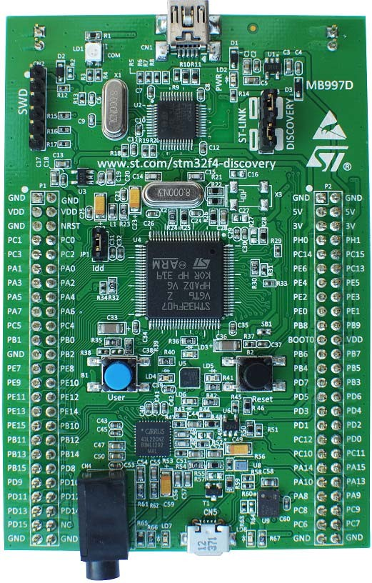
Figure 6. STM32F407G-DISC1 kit
Picture is not contractual.

Reference

Table 3. Reference list
No. | Item/Resource | Description
1 | UM1472 | Discovery kit with STM32F407VG MCU user manual.
2 | RM0090 | STM32F405/415, STM32F407/417, STM32F427/437 and  STM32F429/439 advanced Arm®-based 32-bit MCUs reference manual.
3 | DS8626 | Datasheet provides the description of the STM32F405xx and STM32F407xx lines of  microcontrollers.
4 | AN4013 | Application note which contains introduction to timers for STM32 MCUs (STM32F4 series).
5 | UM1725 | User manual: Description of STM32F4 HAL and low-layer drivers.

Revision history

Table 4. Document revision history
Date | Revision | Changes
22-Oct-2025 | 1 | Initial release.

