Watchdog Timer (WDT)

MCU knowledge
BinhLV13, November 2025

Introduction
The Sentinel of Reliability in Embedded Systems:
The Watchdog Timer is arguably the single most critical hardware component responsible for ensuring the reliability and robustness of a modern embedded system. Unlike standard timers that handle application timing tasks, the Watchdog Timer serves a singular, high-stakes function: acting as an independent electronic sentinel that constantly monitors the health and execution flow of the main microcontroller program.
This document serves as a comprehensive guide to understanding, configuring, and effectively utilizing Watchdog Timers in embedded development, with a specific focus on STM32 microcontroller. We will also find out some different and specialization on TRAVEO T2G microcontroller.
By mastering these concepts, developers will gain the knowledge necessary to create truly fault-tolerant and highly available embedded applications.

Contents

1 Abbreviations and acronyms 3
2 WDT overview 4
2.1 WDT application 5
2.2 WDT solutions 5
3 WDT operation 6
3.1 Standard mode 6
3.2 Window mode 7
4 IWDG and WWDG 9
4.1 Independent watchdog (IWDG) 9
4.1.1 Definition 9
4.1.2 Application benefits 9
4.1.3 How does it work 9
4.1.4 Registers list 10
4.2 Window watchdog (WWDG) 10
4.2.1 Definition 10
4.2.2 Application benefits 11
4.2.3 How does it work 11
4.2.4 Registers list 12
4.3 Key differences 12
5 WDT in TRAVEO T2G 14
5.1 Introduction 14
5.2 Basic WDT 14
5.2.1 Definition 14
5.2.2 Application benefits 14
5.2.3 How does it work 15
5.2.4 Registers list 16
5.3 Multi-Counter WDT (MCWDT) 17
5.3.1 Definition 17
5.3.2 Application benefits 17
5.3.3 How does it work 17
5.3.4 Registers list 18
6 Code example 19
7 Reference 22
8 Revision history 23

Abbreviations and acronyms

Table 1. Abbreviations and acronyms
No. | Item | Description
1 | MCU | Microcontroller Unit.
2 | WDT | Watchdog timer.
3 | WDG | Watchdog.
4 | IWDG | Independent watchdog.
5 | WWDG | Window watchdog.
6 | EWI | Early Wakeup Interrupt.
7 | LSI | Low-Speed Internal oscillator, which is a low-power, low-frequency clock source (typically around 32 kHz).
8 | APB1 | Advanced Peripheral Bus 1. It is a low-speed bus on STM32 microcontrollers that connects to various peripherals like USB, I2C, SPI, and lower-numbered timers.
9 | FAQs | Frequently Asked Questions.
10 | TRAVEO™ T2G / TRAVEO T2G / Traveo II | TRAVEO Generation 2 — a family of ARM® Cortex-M-based automotive MCUs designed to meet body, cluster, and gateway ECU needs with safety, security, and high integration.
11 | MCWDT | Multi-Counter Watchdog Timer (advanced, 3-counter watchdog).
12 | ILO | Internal Low-Speed Oscillator.
13 | ILO0 / ILO1 | Two independent internal low-frequency oscillators.
14 | LFCLK | Low-Frequency Clock.
15 | WCO | Watch Crystal Oscillator (32.768 kHz).
16 | LPECO | Low-Power External Crystal Oscillator.
17 | ECO | External Crystal Oscillator.
18 | RM | Reference manual.

WDT overview

A WDT is a built-in or standalone timer that acts as a fail-safe. It ensures high availability and autonomous recovery from unexpected software faults.

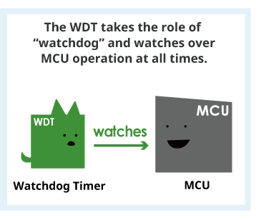
Figure 1. WDT watches over MCU

Here’s how it keeps systems running:
- Periodic "pings": The main software sends a signal to the WDT, periodically "kicking" it to let it know everything is OK.
- Timeout detection: If the software freezes or enters an infinite loop, it fails to kick the WDT within a set time.
- Automatic reset: When the timer expires, the WDT automatically triggers a system reset, bringing the device back online without human intervention (see Figure 2).

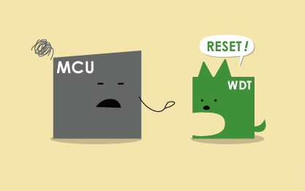
Figure 2. WDT trigger to reset MCU
The WDG (or the dog) needs to be refreshed (pet) or the system will be reset (bark)

WDT uses a number of methods (modes) to detect MCU faults. The Section 3: WDT operation is a description for WDT operation and features by mode.

WDT application
MCUs are used in all sorts of electronic devices, but whether a WDT is required or not depends on the “level of safety demanded by or deemed necessary for a specific application”.
Automotive devices are devices where MCU failure or malfunction could lead to life-threatening accidents. In water heaters and kitchen stoves, MCU failure or malfunction poses a fire risk.
In systems that impact human life or in applications where malfunction of electronic control can cause serious accidents, a WDT is required to ensure sufficient redundancy.
International standards such as ISO 26262 emphasize that the concept of “functional safety” is essential in “ensuring system safety if safety-related functions and parts fail.” Functional safety requires the installation of mechanisms (safety devices) for detecting issues such as part malfunction to lower risk to the level of acceptable risk.
Use of a WDT makes it possible to detect MCU program and other faults and design safety into the entire system.

WDT solutions
WDTs are available as hardware or software solutions: hardware-based WDTs use a dedicated counter, while software implementations use a timer interrupt based on the system clock.
Hardware-based WDTs can be internal to the MCU (see Figure 3) or external in a separate IC (see Figure 4).

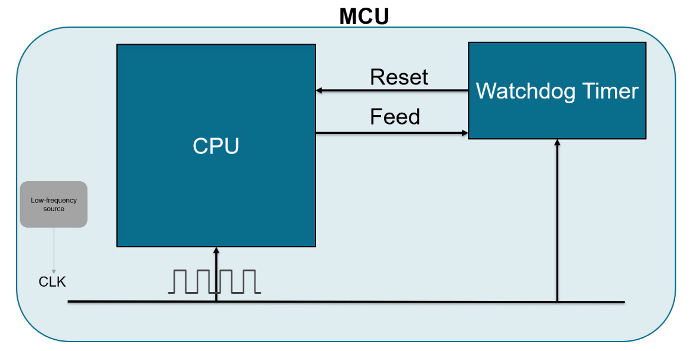
Figure 3. Hardware-based Internal WDT

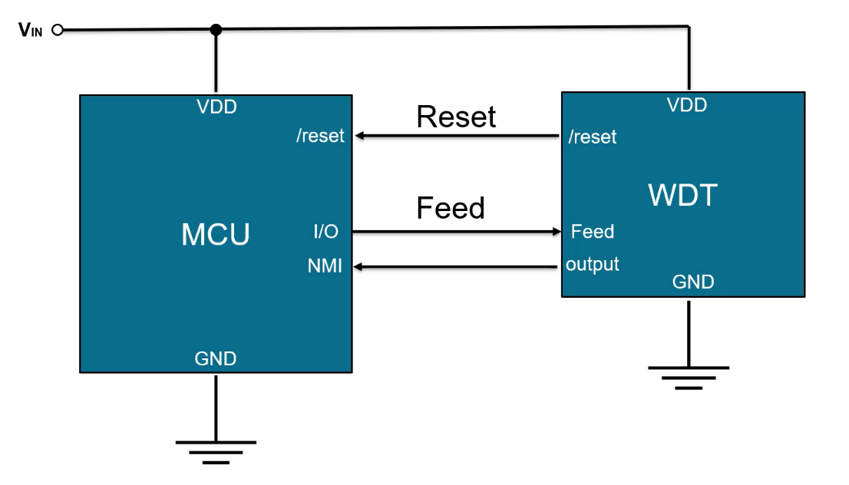
Figure 4. Hardware-based External WDT

Each design involves performance and cost tradeoffs:
- Internal WDTs: They are minimizing overall solution size and cost. However, they can have limitations related to design flexibility and system reliability.
- External WDTs: They are more reliable and independent of internal MCU software errors. They can also provide increased flexibility, but they result in larger and higher-cost solutions.
In most applications, internal WDTs provide an adequate level of reliability, but when maximum reliability is required, an external WDT may be the best choice.
In this document scope, the mainly objective focus on hardware-based internal WDT.

WDT operation

This section describes WDT operation and features by mode. And, explains the difference between standard mode and windowed mode of WDT.

Standard mode
Here are key points of this mode:
- Single pulse operation.
- Count to pre-defined limit.
- May miss MCU early fault if the MCU inputs multiple signals in the set time limit.

Now let’s use graphs to get a better understanding of the standard watchdog timer.
The standard watchdog timer features a single-pulse operation by counting to predefined limit. In the Figure 5, we have the count versus time on the top, watchdog timer input versus time in the middle, and reset versus time on the bottom.

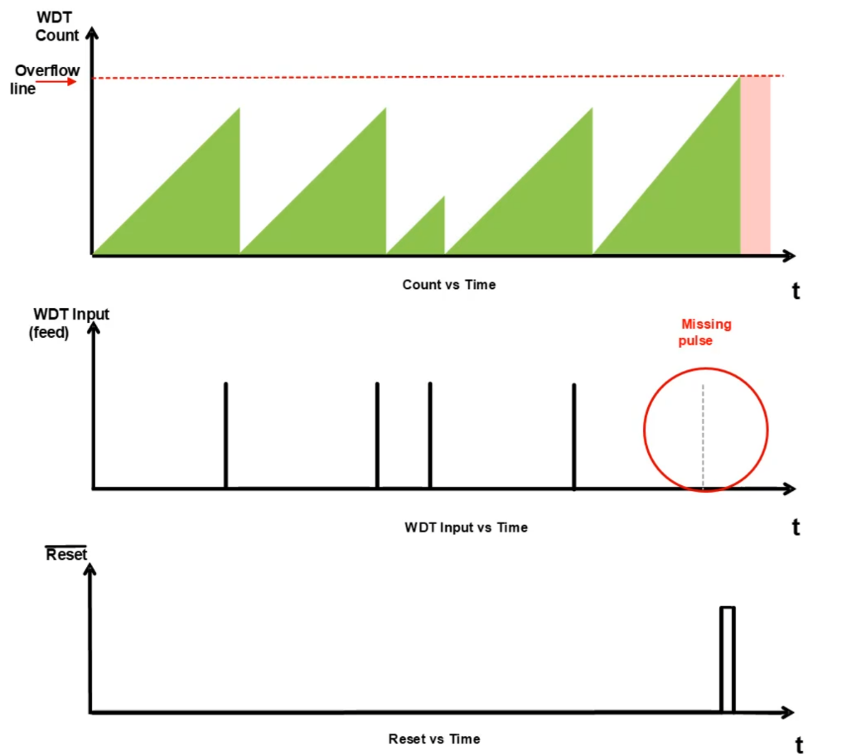
Figure 5. Standard WDT

In the top graph, the size of the triangle corresponds the count. In the standard time-out mode, the watchdog will properly output a reset when a pulse from the MCU is missing at the expected time, meaning an overflow. In the bottom graph, notice the reset signal is now high.
So a late fault is detected, but what about an early fault? This could be an issue if the timer of the watchdog has yet to reach the set count limit.

Window mode
Here are key points of this mode:
- Monitor configured min pulse and max pulse window.
- Detects missed and multiple input signals from MCU within set interval.
- Detect additional fault scenarios.

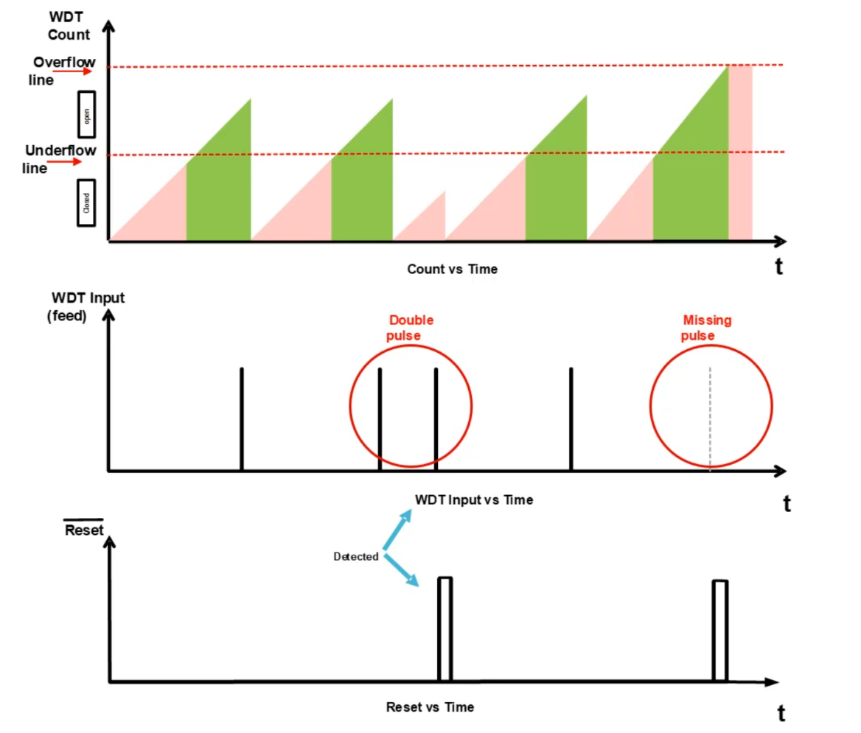
Figure 6. Windowed WDT

In the windowed watchdog timer, there is a set minimum and maximum window of period.
The graphs on Figure 6 show that both the double pulse and the missing pulse were detected. The red-shaded triangle indicates the closed window. In this example, the open window is set to start at about the 50% mark of the period. If an MCU sends a pulse within the first half, an early fault is detected. If the MCU does not send a pulse before the max period count is reached, a late fault is detected.
Notice how there are two instances in the bottom graph where the reset is set high. This was not the case in standard mode. The window watchdog timers are more accurate and reliable in complex systems for these reasons.

IWDG and WWDG

This section describes the WDG type for the whole STM32F4xx family MCU. There are two types of WDG: IWDG (Independent watchdog), WWDG (Window watchdog).

The devices have two embedded watchdog peripherals which offer a combination of high safety level, timing accuracy and flexibility of use. Both watchdog peripherals (Independent and Window) serve to detect and resolve malfunctions due to software failure, and to trigger system reset or an interrupt (window watchdog only) when the counter reaches a given timeout value.

The Section 4.3: Key differences gives the comparison between them.

Independent watchdog (IWDG)
This section provides information for getting started with IWDG.

4.1.1 Definition
The independent watchdog is based on a 12-bit downcounter and 8-bit prescaler. It is clocked from an independent 32 kHz internal RC (LSI) and as it operates independently from the main clock, it can operate in Stop and Standby modes. It can be used either as a watchdog to reset the device when a problem occurs, or as a free running timer for application timeout management. It is hardware or software configurable through the option bytes. The counter can be frozen in debug mode.

4.1.2 Application benefits
Here are key benefits of the IDWG:
- Totally independent process outside the main application
- Configurable timeout period thanks to the prescaler value
- Selectable hardware or software start
- Selectable low-power freeze in Standby or Stop modes

4.1.3 How does it work
The IWDG architecture is represented below:

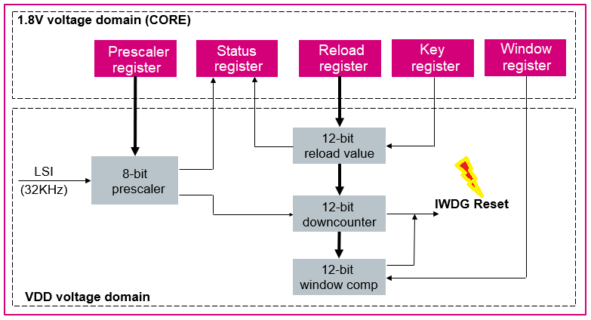
Figure 7. IWDG block diagram

As can be seen on the block diagram above, IWDG registers are located in the CORE voltage domain while its functions are in the VDD voltage domain. The 8-bit prescaler is used to divide the LSI oscillator frequency. When the IWDG is started, the 12-bit counter starts counting down from the reset value of 0xFFF. To refresh the IWDG counter, the Key value (0xAAAA) must be written in the Key register to reload the counter value. If the downcounter reaches the end of the count value (0x000), a system reset is generated.
For more details, check the dedicated IWDG chapter in the product reference manual.

4.1.4 Registers list
The peripheral registers have to be accessed by half-words (16 bits) or words (32 bits).

Table 2. IWDG registers
No. | Name | Description
1 | IWDG_KR | Key register
2 | IWDG_PR | Prescaler register
3 | IWDG_RLR | Reload register
4 | IWDG_SR | Status register

Window watchdog (WWDG)
This section provides information for getting started with WWDG.

4.2.1 Definition
The window watchdog is based on a 7-bit downcounter that can be set as free running. It can be used as a watchdog to reset the device when a problem occurs. It is clocked from the main clock. It has an early warning interrupt capability and the counter can be frozen in debug mode.

4.2.2 Application benefits
Here are key benefits of the WWDG:
- Best suited for applications which require the watchdog to react within an accurate time window.
- Configurable time-window thanks to the prescaler value
- Selectable hardware or software start
- Early Wakeup Interrupt (EWI) available before reset happens

4.2.3 How does it work
The diagram below illustrates how the WWDG operates. If the downcounter is reloaded too early or too late, the window watchdog will initiate a reset.

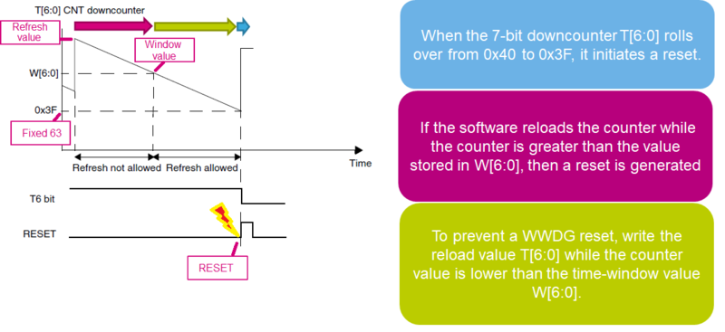
Figure 8. WWDG working

As can be seen on the following block diagram, the counter value and the window value are compared in order to evaluate the time to refresh the downcounter in the configurable window.

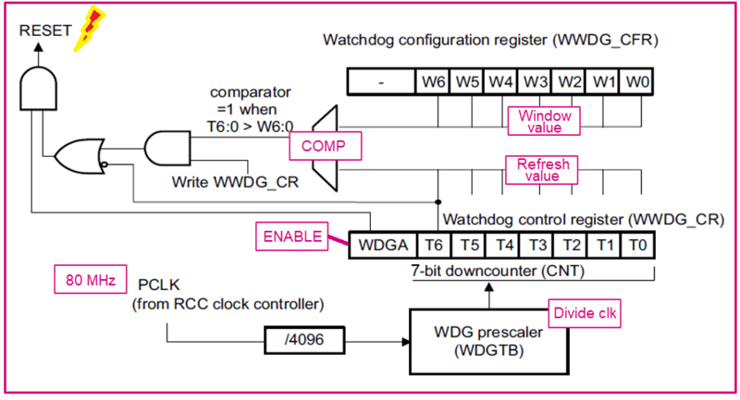
Figure 9. WWDG block diagram

4.2.4 Registers list
The peripheral registers have to be accessed by half-words (16 bits) or words (32 bits).

Table 3. WWDG registers
No. | Name | Description
1 | WWDG_CR | Control register
2 | WWDG_CFR | Configuration register
3 | WWDG_SR | Status register

Key differences
The IWDG and WWDG work in different ways.
Each has its own features, clock source, and use cases: The IWDG is simple and independent of the system clock, making it reliable in case of clock failures. The WWDG, on the other hand, provides finer control by enforcing refreshes within a timing window.
The table below shows their key differences.

Table 4. Compare IWDG vs WWDG
Feature | IWDG | WWDG
Clock Source | LSI (independent, low-speed internal oscillator) | APB1 (derived from system clock)
Refresh Flexibility | Can be refreshed any time before timeout | Must be refreshed within a valid time window
Timing Precision | Less precise (depends on LSI accuracy) | More precise (synchronized with system clock)
Use Cases | Safety-critical, low-power, fault recovery | Precise timing detection, catching early/late refresh
Disable Option | Only via system reset | Only via system reset
Power Consumption | Low (uses LSI oscillator) | Slightly higher (uses system clock)
Complexity | Simple to configure and use | More complex due to timing window constraints
Independence | Independent of system clock (runs even if main clock fails) | Depends on system clock; stops if system clock fails
Reset Trigger | If not refreshed before timeout | If refreshed too early, too late, or not refreshed at all

WDT in TRAVEO T2G

This section describes the watchdog timer for Infineon Traveo™ II family MCU (applicable for CYT2 series, CYT3 series, and CYT4 series devices)

Introduction
Traveo II supports two types of WDTs: a basic WDT and a multi-counter WDT (MCWDT). Both WDTs support window mode which allows defining an upper and lower time limit within which the watchdog timer must be served.

The basic WDT is activated by hardware after reset release. Its operation mode is set by the application software during the initial setting. It counts in Active, Sleep, DeepSleep, and Hibernate power modes.

The application software is responsible for activation of MCWDT and the configuration of its operation mode. It counts in Active, Sleep, and DeepSleep power modes.

Figure 10 shows the block diagram of the WDT. It includes both sub structures, the basic WDT, and the MCWDT.

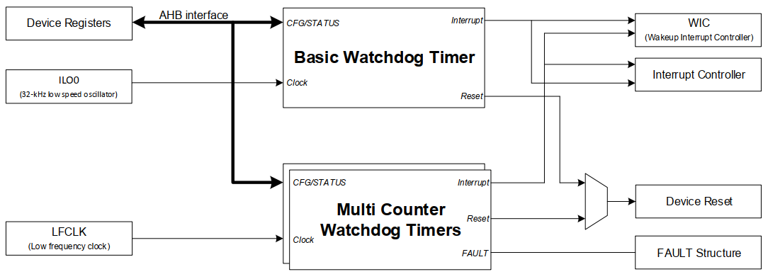
Figure 10. WDT block diagram

Basic WDT
This section provides information for getting started with basic WDT.

5.2.1 Definition
The basic WDT is a hardware, free-running 32-bit timer driven by the on-chip ILO0 clock (32.768 kHz) that detects faulty firmware execution by requiring periodic “service” (kick/clear). If not serviced within configured limits it issues a WARN interrupt, fault or triggers a system reset. It is enabled by hardware after reset and is always present on TRAVEO™ T2G devices.

5.2.2 Application benefits
Here are key benefits of the basic WDT:
- Safety / fail-safe recovery — forces reset when firmware hangs or enters an unexpected execution path, enabling recovery in safety-critical automotive body systems.
- Early warning / graceful handling — a configurable WARN interrupt lets firmware get a pre-warning to save state or attempt corrective action before a reset.
- Windowed servicing for robustness — window mode prevents both too-early and too-late servicing, catching timing faults or runaway loops that might otherwise repeatedly “pet” the WDT incorrectly.
- Wakeup capability — WDT warning interrupt can be used as a wakeup source (Sleep/DeepSleep/Hibernate), useful for low-power scheduled tasks.
- Hardware protection / tamper resistance — configuration registers are protected and require a specific unlock sequence, reducing accidental or unauthorized changes.

5.2.3 How does it work
The basic WDT architecture is represented below:

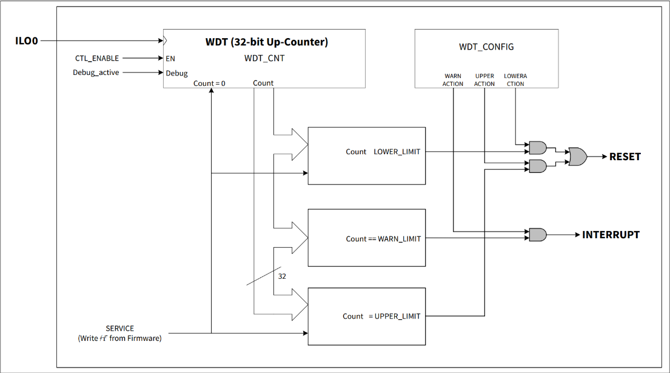
Figure 11. Basic WDT block diagram

Counter & clock:
- The basic WDT is a single 32-bit free-running counter driven by ILO0 = 32.768 kHz. The counter increments continuously when enabled. The full programmable period range (typical) is roughly 30.518 µs to 131,072 s, depending on limit settings.
Limits & actions (three thresholds):
- LOWER_LIMIT — used for window mode; if firmware services (clears) the WDT before the lower limit is reached, a reset can be generated (catching too-early kicks).
- WARN_LIMIT — when reached the WDT can fire a warning interrupt (pre-warning) so firmware can prepare.
- UPPER_LIMIT — if the counter reaches this value without being serviced, the configured action (commonly a reset) is taken.
- The combination of LOWER and UPPER creates the service window; actions for each limit are configured in the WDT_CONFIG register.
Modes of operation:
- Timeout mode (legacy) — only UPPER_LIMIT used to reset on timeout. WARN can be used as pre-warning.
- Window mode — both LOWER and UPPER limits enforced so servicing must happen within the defined window.
- Auto-service — the WDT can be set to auto-service (hardware clears it periodically); in that case it can be used as a periodic wakeup rather than a safety reset mechanism.
Power modes & wakeup:
- The basic WDT counts in Active, Sleep, DeepSleep and Hibernate (ILO0 and WDT logic are powered so it can even wake from Hibernate). A WDT reset moves the chip back to Active mode.
Register protection / unlocking:
- Basic WDT registers (CNT, CTL, LIMITS, CONFIG, SERVICE) are in a protected region. Changing them requires an unlock sequence (write WDT_LOCK=1 then =2) and re-locking (WDT_LOCK=3). After DeepSleep/Hibernate transitions, the registers re-lock. This prevents accidental reconfiguration.

5.2.4 Registers list
Table 5 shows list of Basic WDT registers. Refer Register RM documents for register level description of the user accessible registers in the device.

Table 5. Basic WDT registers
No. | Name | Description
1 | WDT_CTL | Watchdog counter control register
2 | WDT_LOWER_LIMIT | WDT lower limit register
3 | WDT_UPPER_LIMIT | WDT upper limit register
4 | WDT_WARN_LIMIT | WDT warn limit register
5 | WDT_CONFIG | WDT configuration register
6 | WDT_CNT | WDT count register
7 | WDT_LOCK | WDT lock register
8 | WDT_SERVICE | WDT service register
9 | WDT_INTR | WDT interrupt register
10 | WDT_INTR_SET | WDT interrupt set register
11 | WDT_INTR_MASK | WDT interrupt mask register
12 | WDT_INTR_MASKED | WDT interrupt masked register
13 | CLK_SELECT | Clock selection register
14 | CLK_ILO_CONFIG | ILO configuration
15 | RES_CAUSE | Reset cause observation register

Multi-Counter WDT (MCWDT)
This section provides information for getting started with Multi-counter WDT (MCWDT).

5.3.1 Definition
The MCWDT is an advanced watchdog module on the TRAVEO T2G MCU family that goes beyond a single counter: it provides multiple independent counters (two 16-bit + one 32-bit in a block) that can each be configured to monitor firmware or system operation, generate warning interrupts, faults or resets, and even act as wake-up sources.

5.3.2 Application benefits
Using the MCWDT brings a number of advantages, especially in automotive/embedded safety or robust systems applications:
- Granular monitoring across multiple tasks/subsystems: Since you have multiple counters, you can monitor different parts of your firmware or system separately (e.g., critical control loop vs communications vs background tasks). If one counter fails to be serviced, you can localise the fault.
- Configurable warning and fault actions: The MCWDT supports generating an interrupt (warning) ahead of the actual reset/fault condition. This gives the system a chance to flush data, log state, or attempt recovery rather than simply resetting immediately.
- Window mode support: Similar to the basic WDT, MCWDT supports windowed servicing (i.e., you must service between a lower and upper bound) to catch early or late servicing, which improves reliability in safety-critical contexts.
- Wake-up capability / power-mode support: MCWDT counters can operate (or at least monitoring can continue) in low-power/sleep modes and act as wake-up sources, which is useful for automotive body control, remote modules, etc.
- Functional safety / fault containment: In an ASIL-B environment (the TRAVEO T2G is targeted at body-control ASIL-B) this kind of fine-grained watchdog helps meet safety requirements by providing separate monitoring channels, fault escalation, and protected configuration. The datasheet mentions MCWDT as a feature.
- Flexibility in clocking/timeout ranges: Because each counter may select different low-frequency clocks and independently configured thresholds, you can tailor timeouts for short-term loops vs long-term supervision (e.g., an 8-hour watchdog vs a 100 ms loop watch).

5.3.3 How does it work
Here’s how the MCWDT module works in practice (with typical steps, configuration flows, and behavior) for TRAVEO T2G:

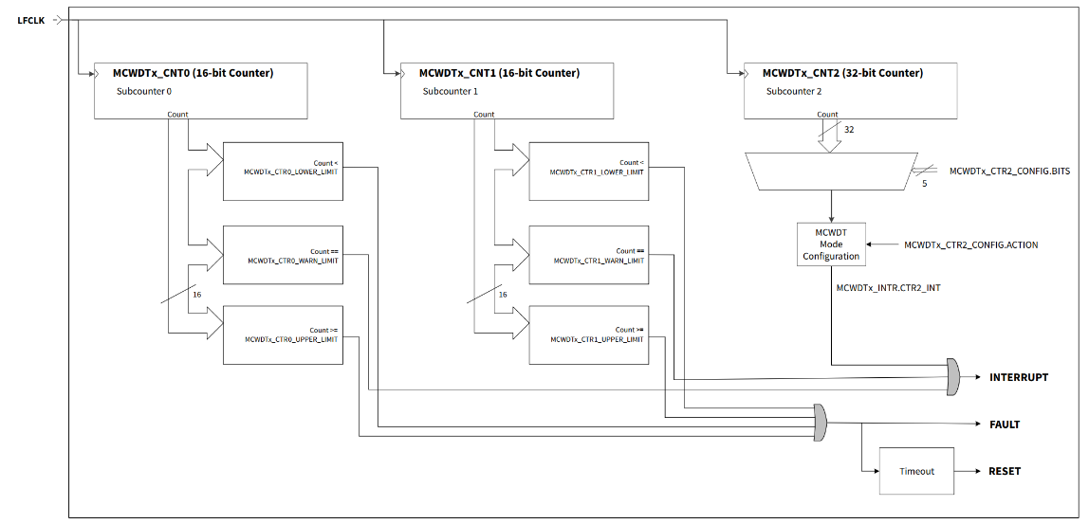
Figure 12. Multi-counter WDT block diagram

Architecture / basic blocks:
- A given MCWDT block includes 3 independent counters: two 16-bit counters (Counter0, Counter1) and one 32-bit counter (Counter2).
- Each counter has its own threshold(s) for warning and fault/reset. You can enable each counter and configure whether its fault action is simply an interrupt, a flag, or triggers a system reset.
- Clock source: MCWDT uses a low-frequency clock (LFCLK) such as ILO0, ILO1, WCO, LPECO, or ECO.
- The counters increment (count up) when enabled, and must be serviced (cleared or reset) before they reach their upper threshold. Some counters may support window mode (i.e., lower threshold as well) to detect both too early and too late servicing.
- The module supports warning interrupts: when a counter reaches its warning threshold but before its final timeout, it fires an interrupt. The firmware can service or take recovery action. If it continues to the fault threshold (timeout) without proper servicing, then the configured fault action occurs—often a reset.

5.3.4 Registers list
Table 6 shows list of MCWDT registers. Refer Register RM documents for register level description of the user accessible registers in the device.

Table 6. MCWDT registers
No. | Name | Description
1 | MCWDTx_CTL | MCWDT Subcounter 0/1 control register
2 | MCWDTx_LOWER_LIMIT | MCWDT Subcounter 0/1 lower limit register
3 | MCWDTx_UPPER_LIMIT | MCWDT Subcounter 0/1 upper limit register
4 | MCWDTx_WARN_LIMIT | MCWDT Subcounter 0/1 warn limit register
5 | MCWDTx_CONFIG | MCWDT Subcounter 0/1 configuration register
6 | MCWDTx_CNT | MCWDT Subcounter 0/1 count register
7 | MCWDT2_CTR2_CTL | MCWDT Subcounter 2 control register
8 | MCWDT2_CTR2_CONFIG | MCWDT Subcounter 2 configuration register
9 | MCWDT2_CTR2_CNT | MCWDT Subcounter 2 count register
10 | MCWDT2_LOCK | MCWDT lock register
11 | MCWDT2_SERVICE | MCWDT service register
12 | MCWDT2_INTR | MCWDT interrupt register
13 | MCWDT2_SET | MCWDT interrupt set register
14 | MCWDT2_MASK | MCWDT interrupt mask register
15 | MCWDT2_MASKED | MCWDT interrupt masked register
16 | CLK_SELECT | Clock selection register
17 | CLK_ILO_CONFIG | ILO configuration
18 | RES_CAUSE | Reset cause observation register

Code example

Refer these documents for details about code example (included verification and debugging): Verification-IWDG.xlsx for IWDG and Verification-WWDG.xlsx for WWDG.

We will use the Discovery kit with STM32F407VG MCU (order code: STM32F407G-DISC) for this section.

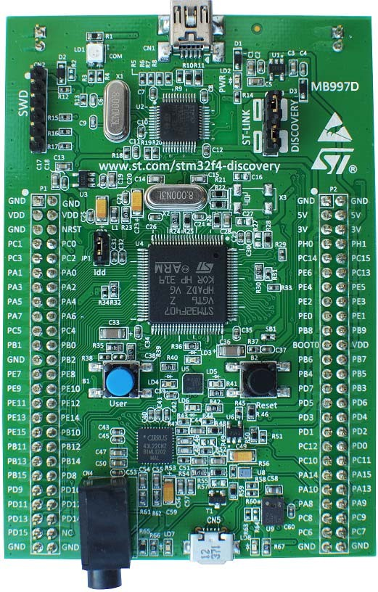
Figure 14. STM32F407G-DISC1 kit
Picture is not contractual.

With this section, you will understand how to use both IWDG and WWDG in STM32. We also see how to calculate prescalers, reload values, and implement refresh functions like HAL_IWDG_Refresh and HAL_WWDG_Refresh.

The table below shows project FAQs which will provide you useful information.

Table 7. Project FAQs
No. | Question | Answer
1 | Can WWDG provide a pre-reset interrupt (EWI) to perform cleanup before reboot? | Yes. Unlike IWDG, WWDG supports an Early Wakeup Interrupt (EWI). This allows the system to run a short routine—such as saving state or safely shutting down peripherals—just before the watchdog resets the MCU. IWDG doesn’t support this feature.
2 | What are the differences in counter resolution between IWDG and WWDG? | IWDG uses a 12-bit down-counter, allowing values from 0 to 4095. In contrast, WWDG uses a 7-bit counter, with values ranging from 0 to 127.
3 | How do power modes affect IWDG and WWDG behavior? | In low-power STOP mode, the WWDG stops automatically because it relies on the system clock, which is halted. IWDG, powered by its independent oscillator, continues running unless explicitly halted via options on certain STM32 families.
4 | Which watchdog offers more precise timing behavior? | WWDG offers better timing precision because it’s tied to the system clock (APB1). IWDG runs on its internal low-speed oscillator (LSI), which can vary in frequency, making its timing less accurate.
5 | Can I reset or disable the watchdog timers in software? | No. Both IWDG and WWDG cannot be disabled through code once activated. The only way to turn them off is through a complete device reset.

Reference

Table 8. Reference list
No. | Item/Resource | Description
1 | UM1472 | Discovery kit with STM32F407VG MCU user manual.
2 | RM0090 | STM32F405/415, STM32F407/417, STM32F427/437 and  STM32F429/439 advanced Arm®-based 32-bit MCUs reference manual.
3 | DS8626 | Datasheet provides the description of the STM32F405xx and STM32F407xx lines of  microcontrollers.
4 | UM1725 | User manual: Description of STM32F4 HAL and low-layer drivers.
5 | AN219944 | Application note: Using the watchdog timer in TRAVEO™ T2G family MCUs.

Revision history

Table 9. Document revision history
Date | Revision | Changes
03-Nov-2025 | 1 | Initial release.

