Inter-Processor Communication (IPC)

MCU knowledge
BinhLV13, May 2026

Introduction
Inter-Processor Communication (IPC) enables multiple processors or cores to exchange information, coordinate tasks, and share resources efficiently. It provides a structured framework for reliable communication and synchronization in multicore systems.
IPC supports data exchange and synchronization between processors performing different functions. It improves system scalability, maintainability, and deterministic operation in real-time applications..
IPC implements locking mechanisms to provide exclusive access to shared resources. This prevents race conditions, data corruption, and resource conflicts in multiprocessor environments.
IPC provides event-driven notification mechanisms that allow processors to signal task completion, data availability, or system events. This approach improves system responsiveness while reducing processor overhead.
IPC channels serve as dedicated communication paths for transferring commands, status information, and application data. They ensure efficient, reliable, and synchronized data exchange between processors.
IPC interrupts enable immediate processor-to-processor notifications for time-critical events. This mechanism provides faster response times and higher efficiency than polling-based communication methods.
IPC architecture typically consists of communication channels for data transfer and interrupt structures for event signaling. Together, they provide a complete framework for processor communication and synchronization.
IPC is a critical technology for multicore and heterogeneous systems, enabling efficient resource sharing, parallel processing, and coordinated system operation. It supports reliable execution across automotive, industrial, telecommunications, and embedded applications.

In this document’s scope, we will get started with IPC of the TRAVEO™ T2G B-H-8M MCU which included in KIT_T2G-B-H_LITE kit (Figure 1).

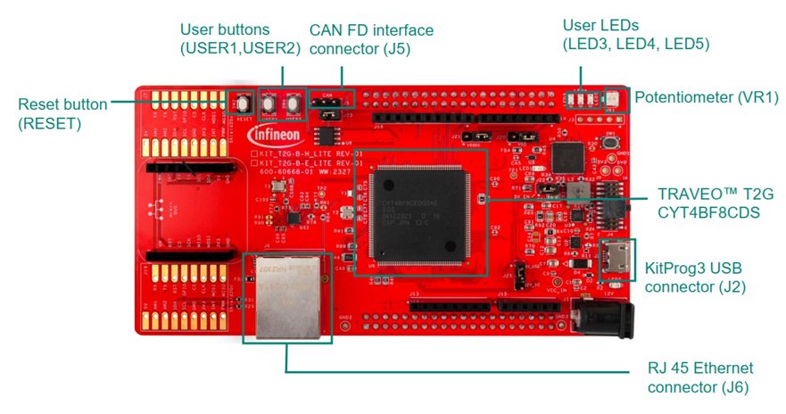
Figure 1. The KIT_T2G-B-H_LITE kit

Contents

1 Abbreviations and acronyms 4
2 CPU subsystem (CPUSS) 5
3 IPC Mechanism 6
3.1 IPC channel 6
3.2 IPC interrupt 7
3.3 IPC channels and interrupts 8
3.4 Implementing locks 9
3.5 Message passing 9
3.6 Registers 11
4 Verification and Debugging 12
5 Reference 14
6 Revision history 15

Abbreviations and acronyms

Table 1. Abbreviations and acronyms
No. | Item | Description
1 | CPUSS | CPU subsystem.
2 | IPC | Inter-processor communication.
3 | SMPU | Shared-Memory Protection Unit.
4 | SRAM | Static random-access memory.
5 | AHB | Advanced High-Performance Bus.
6 | FAQs | Frequently Asked Questions.

CPU subsystem (CPUSS)

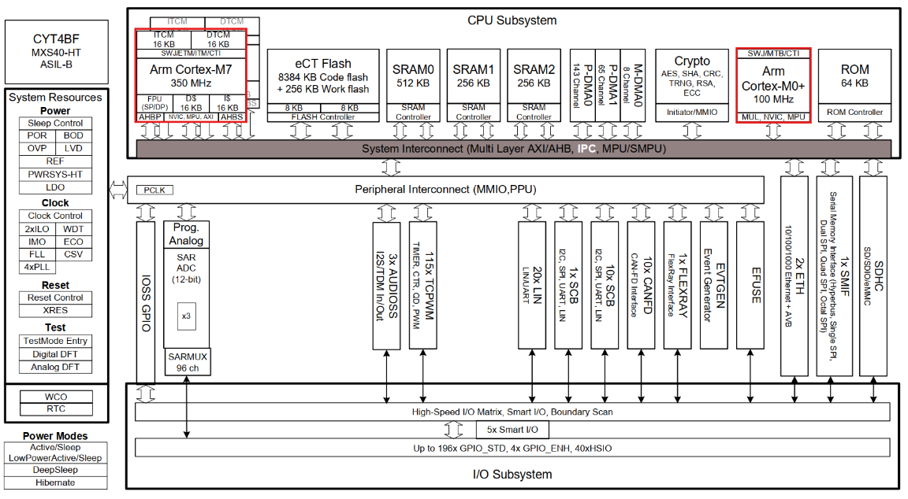
Figure 2. The TRAVEO™ T2G TVII-B-H-8M

The TRAVEO™ T2G TVII-B-H-8M (“Body Controller High”) microcontroller uses a heterogeneous CPU subsystem with dual high-performance 32-bit Arm® Cortex®-M7 cores (each 350 MHz) for main processing and a Cortex®-M0+ core (100 MHz) for peripheral/safety tasks. Each M7 core has separate 16 KB instruction and 16 KB data caches plus 16 KB instruction-TCM and 16 KB data-TCM. All cores share on-chip memories (code flash and 1 MB SRAM) and peripherals via a multi-layer AXI/AHB interconnect (CPUSS). Access to shared resources is arbitrated by the bus matrix and coordinated through dedicated IPC hardware. Shared resources like flash, SRAM and peripherals support exclusive access via an IPC mechanism (hardware semaphores). The Figure 2 above illustrates the CPU subsystem architecture.

Key CPU-subsystem features related to IPC include:
- CPU Cores: Two 350 MHz Cortex-M7 cores and one 100 MHz Cortex-M0+ core. Each M7 has 16 KB I$ and D$ caches and 16 KB ITCM/DTCM (to support deterministic real-time code/data).
- Shared Memory: A large code flash (≈8.4 MB) and 1 MB of SRAM (split across SRAM0/1/2 controllers) are shared by all cores. SRAM0 can be retained in low-power modes, enabling inter-core state retention.
- Interconnect & IPC: A multi-layer bus interconnect connects cores, DMA engines, and peripherals. The CPU subsystem (CPUSS) provides up to eight hardware IPC “channel” registers (each 32 bytes), with matching IPC interrupt registers. These IPC registers and associated hardware semaphores let any core exchange small messages or signals with another core, ensuring atomic updates and interrupt notification.
- Memory Protection: A Shared-Memory Protection Unit (SMPU) defines up to 16 protected regions to control access rights in shared SRAM. Each SMPU region can be assigned to specific masters, helping isolate tasks on different cores. (In addition, each core has its own MPU for local memory protection.)

Together, these elements enable robust inter-core communication. Hardware semaphores (part of the IPC controller) implement the IPC channels: a core writes to an IPC_STRUCTn register and triggers an IPC interrupt to the target core. The target core receives an interrupt (mapped via CPUSS system-int registers) to process the message.

IPC Mechanism

Inter-processor communication (IPC) provides the functionality for multiple processors to communicate and synchronize their activities. IPC hardware is implemented using two register structures:
- IPC Channel: Communication and synchronization between processors is achieved using this structure.
- IPC Interrupt: Each interrupt structure configures an interrupt line, which can be triggered by a 'notify' or 'release' event of any IPC channel.

IPC channel
An IPC channel is implemented as six hardware registers, as shown in Figure 3. The IPC channel registers are accessible to all processors in the system:
- IPC_STRUCTx_ACQUIRE: This register determines the lock feature of the IPC. The IPC channel is acquired by reading this register.
If the SUCCESS field returns a '1', the read acquired the lock. If the SUCCESS field returns a '0', the read did not acquire the lock.
Note that a single read access performs two functions:
– The attempt to acquire a lock.
– Return the result of the acquisition attempt (SUCCESS field).
The atomicity of these two functions is essential in a multi-core system with multiple CPUs.
The register also has bit fields that provide information about the processor that acquired it. When acquired, this register is released by writing any value into the IPC_STRUCTx_RELEASE register. If the register was already in an acquired state another attempt to read the register will not be able to acquire it.
- IPC_STRUCTx_NOTIFY: This register is used to generate an IPC notify event. Each bit in this register corresponds to an IPC interrupt structure. The notify event generated from an IPC channel can trigger multiple interrupt structures.
- IPC_STRUCTx_RELEASE: Any write to this register will release the IPC channel. This register also has a bit that corresponds to each IPC interrupt structure. The release event generated from an IPC channel can trigger multiple interrupt structures. To only release the IPC channel and not generate an interrupt, the user can write a zero into the IPC release register.
- IPC_STRUCTx_DATA0 and IPC_STRUCTx_DATA1: These two 32-bit registers are meant to hold data. They can be considered as the shared data memory for the channel. Typically, these registers will hold messages that need to be communicated between processors. If the messages are larger than the 32-bit size, the user can place a pointer in the IPC_STRUCTx_DATA0 or IPC_STRUCTx_DATA1 register.
- IPC_STRUCTx_LOCK_STATUS: This register provides the instantaneous lock status for the IPC channel. If the channel is acquired, this register provides details such as processor ID and protection context. The reading of lock status only provides an instantaneous status, which can be changed in the next cycle based on the activity of other processors on the channel.

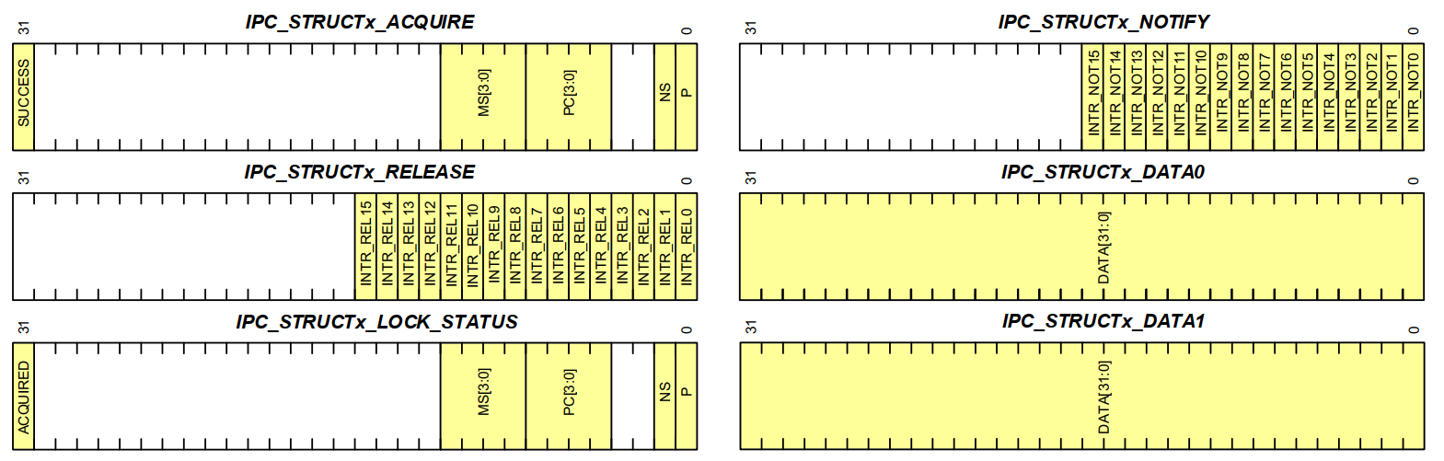
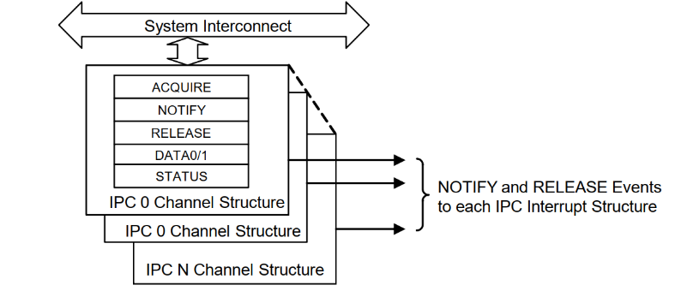
Figure 3. IPC channel structure

IPC interrupt
Each IPC interrupt line in the system has a corresponding IPC interrupt structure. An IPC interrupt can be triggered by a notify or a release event from any of the IPC channels in the system. The user can choose to mask any of the sources of these events using the IPC interrupt registers. Figure 4 shows the registers in an IPC
Interrupt structure:
- IPC_INTR_STRUCTx_INTR: This register provides the instantaneous status of the interrupt sources. Note that there are 16 notify and 16 release event bits in this registers. These are the notify and release events corresponding to the maximum 16 IPC channels. When a notify event is triggered in the IPC channel 0, the corresponding Notify0 bit is activated in the interrupt registers. A write of '1' to a bit will clear the interrupt.
- IPC_INTR_STRUCTx_INTR_MASK: The bit in this register masks the interrupt sources. Only the interrupt sources with their masks enabled can trigger the interrupt.
- IPC_INTR_STRUCTx_INTR_SET: A write of '1' into this register will set the interrupt.
- IPC_INTR_STRUCTx_INTR_MASKED: This register provides the instantaneous value of the pending interrupts after they are masked. The value in this register is the result of the logical AND of registers IPC_INTR_STRUCTx_INTR and IPC_INTR_STRUCTx_INTR_MASK.
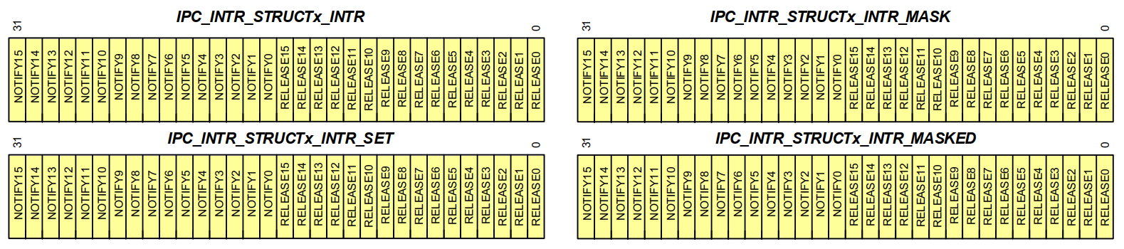
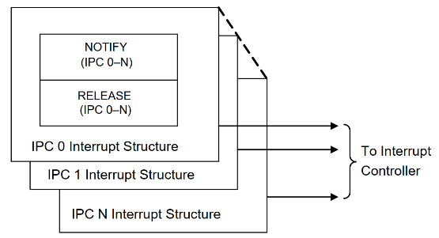
Figure 4. IPC interrupt structure

IPC channels and interrupts
The IPC block has a set of IPC interrupts associated with it. Each IPC interrupt register structure corresponds to an IPC interrupt line. This interrupt can trigger an interrupt on any of the processors in the system. The interrupt routing for processors are dependent on the device architecture.
Each IPC channel has a release and notify register, which can drive events on any of the IPC interrupts. Figure 5 shows an illustration of this relation between the IPC channels and the IPC interrupt structure.

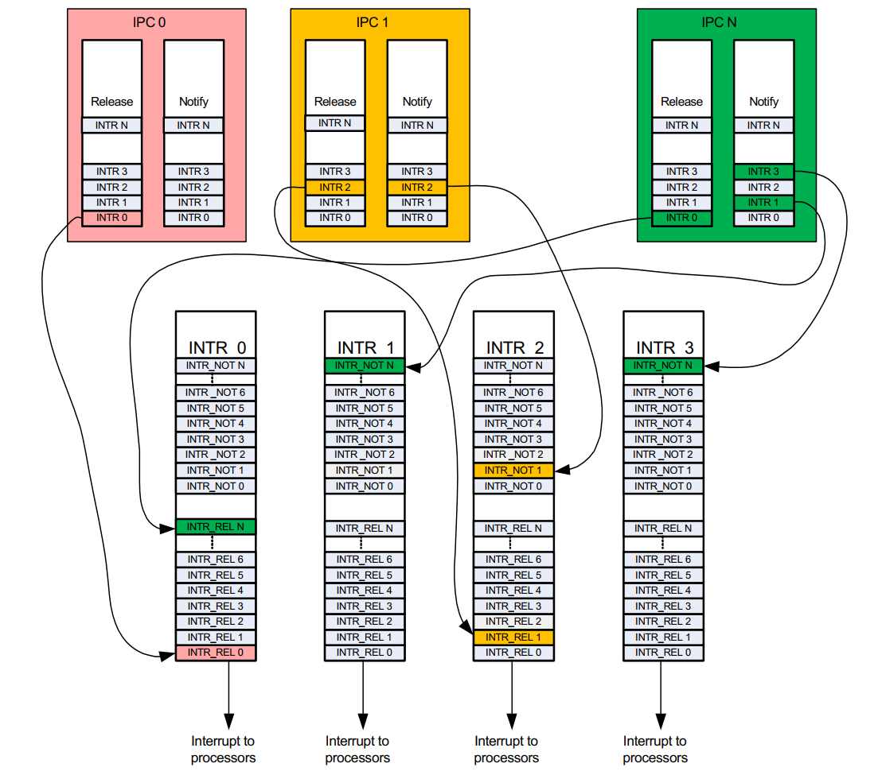
Figure 5. IPC channels and interrupts

Implementing locks
The IPC channels can be used to implement locks. Locks are typically used in multi core systems to implement some form of mutually exclusive access to a shared resource. When multiple processors share a resource, the processors are capable of acquiring and releasing the IPC channel. The processor can assume an IPC channel as
a lock. The semantics of this code is that the access to the shared resource is gated by the processor's ownership of the channel. The processors need to acquire the IPC channel before they access the shared resource.
A failure to acquire the IPC channel signifies a lock on the shared resource because another processor has control of it. Note that the IPC channel will not enforce who acquires or releases the channel. All processors can acquire or release the IPC channel and the semantics of the code must make sure that the processor that acquires the
channel is the one that releases it.

Message passing
IPC channels can be used to communicate messages between processors. In this use case, the channel is used in conjunction with the interrupt structures. The IPC channel is used to lock the access to the Data register. The IPC channel is acquired by the sender and used to populate the message. The receiver reads the message and then releases the channel. Thus, between the sender placing data into the channel and receiver reading it, the channel is locked for all other tasks. The sender uses a notify event on the receiver's IPC interrupt to denote a send operation. The receiver acts on this interrupt and reads the data from the data register. After the reception is complete, the receiver releases the channel and can also generate a release event to the sender’s IPC interrupt. Note that the action of locking the channel does not, in hardware, restrict access to the data register. This is a semantic that should be enforced by software.
Figure 6 portrays an example of a sender (Processor A) sending data to a receiver (Processor B). IPC interrupt A is configured to interrupt Processor A. IPC interrupt B is configured to interrupt Processor B.
- (1) The sender will attempt to acquire the IPC channel by reading the IPC_STRUCTx_ACQUIRE register until the SUCCESS bit is set. Then, the sender has ownership of the channel for data transmission.
- (2) After the IPC channel is acquired, the sender has control of the channel for communication and places message data up to 64 bits in the IPC_STRUCTx_DATA0 and IPC_STRUCTx_DATA1 registers.
- (3) Now that the message is placed in the IPC channel, the sender generates a notify event on the receiver's interrupt line. It does this by setting the corresponding bit in the IPC channel's IPC_STRUCTx_NOTIFY register. This event creates a notify event at IPC interrupt B. If the IPC channel's notify event was enabled by setting the mask bit in the IPC interrupt B, this will generate an interrupt in the receiver.
- (4) When it receives IPC interrupt B, the receiver can read the IPC_INTR_STRUCTx_INTR_MASKED register to understand which IPC channel had triggered the notify event. Based on this, the receiver identifies the channel to read and reads from the IPC channel's IPC_STRUCTx_DATA0 and IPC_STRUCTx_DATA1 registers. The receiver has now received the data sent by the sender. It needs to release the channel so that other processors/processes can use it.
- (5) The receiver releases the channel. It also optionally generates a release event on the sender's IPC interrupt A. This will generate a release event interrupt on the sender if the corresponding channel release event was not masked.
On receiving the release interrupt, the sender can act on the event based on the application requirement. It can either try and reacquire the channel for further transmission or go on to other tasks because the transmission is complete.

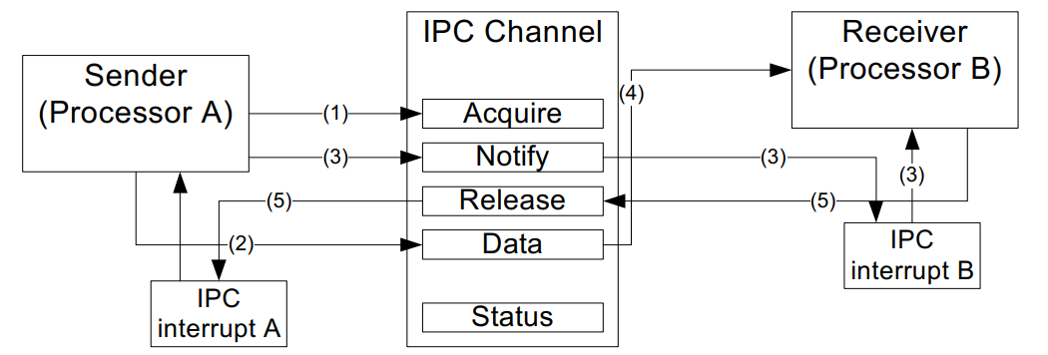
Figure 6. Sending mess ages using IPC

In the previous example, the size of the data being transmitted was just 32 bits. Larger messages can be sent as pointers. The sender can allocate a larger message structure in memory and pass the pointer in one of the 32-bit data registers. Figure 7 illustrates this usage. Note that the user code should implement the synchronization of the message read process.
- The implementation can stall the channel until the receiver has used up all the data in the message packet and the message packet can be rewritten. This is wasteful because it will stall other inter-processor communications as the number of IPC channels is limited.
- The receiver can release the channel as soon as it receives the pointer to the message packet. It implements the synchronization logic in the message packet as a flag, which the sender sets on write complete and receiver clears on a read complete.

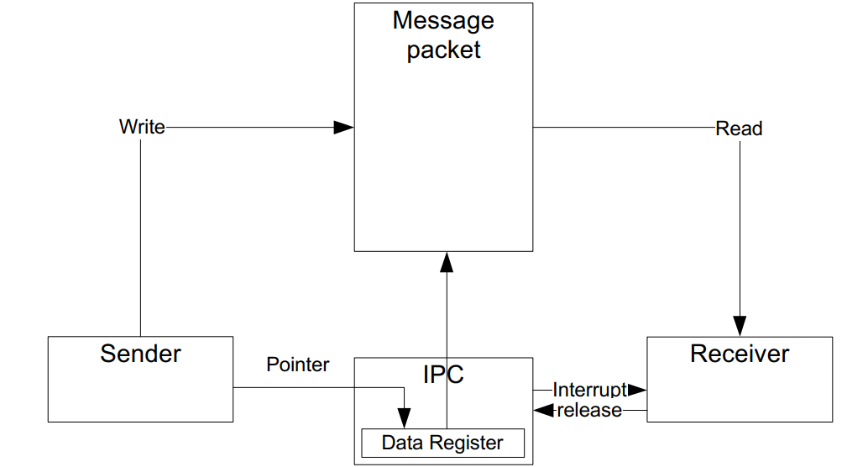
Figure 7. Communicating larger messages

Registers
The table below shows IPC registers list. Note: In IPC_STRUCTx or IPC_INTR_STRUCT, 'x' signifies the IPC instance.

Table 2. IPC registers
Register | Name | Description
IPC_STRUCTx_ACQUIRE | IPC Structure Lock  Acquire Register | This register is used to configure and acquire the lock.
IPC_STRUCTx_RELEASE | IPC Structure Lock  Release Register | This register is used to release the lock.
IPC_STRUCTx_NOTIFY | IPC Structure Notification  register | This register is used to generate notifications for the interrupt structure.
IPC_STRUCTx_DATA0 | IPC Structure Data  Register 0 | This field holds a 32-bit data element that is associated with the IPC structure.
IPC_STRUCTx_DATA1 | IPC Structure Data  Register 1 | This field holds a 32-bit data element that is associated with the IPC structure.
IPC_STRUCTx_LOCK_STATUS | IPC Structure Lock Status  Register | This register shows the status of the IPC (Lock Status, Access Mode, and so on).
IPC_INTR_STRUCTx_INTR | IPC Interrupt Status  Register | This register shows the status of the interrupts.
IPC_INTR_STRUCTx_INTR_SET | IPC Interrupt Set Register | Writing to this register sets the corresponding IPC_INTR_STRUCTx_INTR.
IPC_INTR_STRUCTx_INTR_MASK | IPC Interrupt Mask  Register | This is the mask bit for corresponding bit in IPC_INTR_STRUCTx_INTR.
IPC_INTR_STRUCTx_INTR_MASKED | IPC Masked Interrupt  Register | This register is the bitwise AND of INTR and INTR_MASK.

Verification and Debugging

Refer these documents for details about verification and debugging: Verification-IPC.xlsx.

This code example demonstrates the use of the inter-processor communication (IPC) driver to implement a message pipe in the MCU by using KIT_T2G-B-H_LITE kit (refer Figure 1).

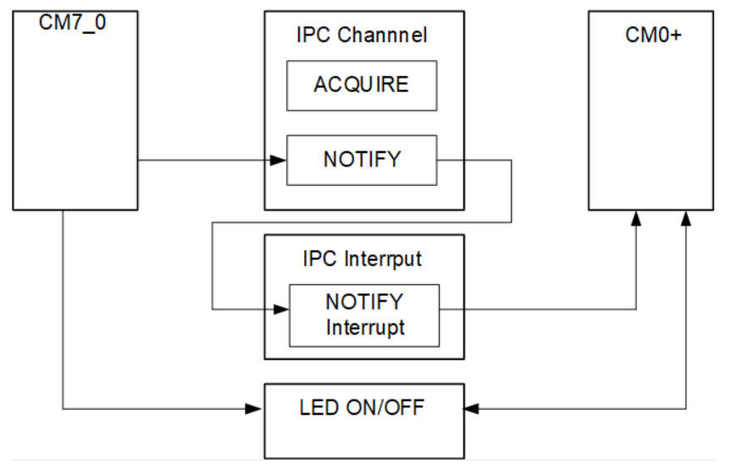
Figure 8. CPU Synchronization using IPC

In this code example, CM0+ CPU is the primary CPU, which is responsible for initializing the system.
- CM7_0 core initializes the peripheral cybsp_init().
- After CM7_0 completes the peripheral initialization, force releases the lock state through Cy_IPC_Drv_LockRelease function, and then waits for the CM0+ IPC server to start.
- CM7_0 generates a notify interrupt which occurs in the CM0+.
- CM0+ initiates the LED ON/OFF operation, returning from the interrupt routine.

The table below shows FAQs which will provide you useful information.

Table 3. FAQs
No. | Question | Answer
1 | How many IPC channels and structures are available? | TRAVEO™ T2G provides up to 8 IPC channels and 8 corresponding interrupt structures. Each IPC structure contains control, status, and data registers for inter-core communication.
2 | How do I configure an IPC channel/interrupt? | Configure the corresponding CPUSS_CMx_SYSTEM_INT_CTL register and enable the related NVIC interrupt. Implement an interrupt handler to process IPC notifications.
3 | How is data synchronized between cores? | IPC uses hardware semaphores to ensure exclusive channel access. Shared memory transfers can be protected and synchronized using SMPU and IPC signaling.
4 | What about performance overhead? | IPC communication has minimal latency and CPU overhead. Most execution time is spent in the interrupt handler rather than the IPC transfer itself.
5 | How are errors or conflicts handled? | Hardware semaphores prevent simultaneous access to the same IPC channel. Software must handle retry, timeout, and interrupt configuration errors.
6 | Can IPC be used during low-power modes or reset? | IPC is available only when the CPU subsystem is active. After reset, CM0+ initializes IPC resources before enabling CM7 cores.

Reference

Table 4. Reference list
No. | Item/Resource | Description
1 | 002-37237 Rev. *B  2024-06-14 | KIT_T2G-B-H_LITE TRAVEO™ T2G Body High Lite Kit user guide.
2 | 002-24401 Rev. *H  2024-09-03 | TRAVEO™ T2G Automotive MCU body controller high architecture technical reference manual.

Revision history

Table 5. Document revision history
Date | Revision | Changes
31-May-2026 | 1 | Initial release.

