ĐẠI HỌC BÁCH KHOA HÀ NỘI  
 TRƯỜNG CÔNG NGHỆ THÔNG TIN VÀ TRUYỀN THÔNG

BÁO CÁO THỰC HÀNH  
 **IT1130-744362-2024.1**

BÀI THỰC HÀNH 05

Họ và tên sv: Nguyễn Đức Bình  
 Lớp: **Việt Nhật 03**

GVHD: Lê Thị Hoa

TA: **Bùi Trọng Dũng**

Hà Nội 9/2024

BÁO CÁO THỰC HÀNH LAB 5 LẬP TRÌNH HƯỚNG ĐỐI TƯỢNG

Contents

1. Swing components 4
   1. AWTAccumulator 4
   2. SwingAccumulator 5
2. Organizing Swing components with Layout Managers 6
   1. Code 6
   2. Demo 8
3. Create a graphical user interface for AIMS with Swing 9
   1. Create class StoreScreen 9
   2. Create class MediaStore 13
   3. Demo 14
4. JavaFX API 16
   1. Create class Painter 16
   2. Create Painter.fxml 16
   3. Create class PainterController 17
5. View Cart Screen 19
   1. Create cart.fxml 19
   2. Create class CartScreen 20
   3. Create class CartScreenController 21
   4. Demo 22
6. Updating buttons based on selected item in TableView – ChangeListener 22
   1. Edit class CartScreenController 22
   2. Demo 23
7. Deleting a media 24
   1. Code 24
   2. Demo 25
8. Complete the Aims GUI application 26
9. Use case Diagram 30
10. Class Diagram 31

### Figure 1.1: Source code of AWTAccumulator 4

### Figure 1.2: Demo of AWTAccumulator 5

### Figure 1.3: Source code of SwingAccumulator 5

### Figure 1.4: Demo of SwingAccumulator 6

### Figure 2.1: Source code of NumberGrid 1 6

### Figure 2.2: Source code of NumberGrid 2 7

### Figure 2.3: Demo buttons 0-9 8

### Figure 2.4: Demo DEL button 8

### Figure 2.5: Demo C button 8

### Figure 3.1: Class StoreScreen 1 9

### Figure 3.2: Class StoreScreen 2 10

### Figure 3.3: Class StoreScreen 3 10

### Figure 3.4: Class StoreScreen 4 11

### Figure 3.5: Class StoreScreen 5 11

### Figure 3.6: Class StoreScreen 6 12

### Figure 3.7: Class MediaStore 1 13

### Figure 3.8: Class MediaStore 2 13

### Figure 3.9: Class MediaStore 3 14

### Figure 3.10: StoreScreen 14

### Figure 3.11 Demo Add to cart button 15

### Figure 3.12 Demo Play button 15

### Figure 3.13 Demo View cart button 15

### Figure 4.1: Class Painter 16

### Figure 4.2: Painter.fxml 1 16

### Figure 4.3: Painter.fxml 2 17

### Figure 4.4: PainterController 17

### Figure 4.5: Use Pen 18

### Figure 4.6: Use Eraser 18

### Figure 4.7: Clear button 18

### Figure 5.1: Cart.fxml 1 19

### Figure 5.2: Cart.fxml 2 19

### Figure 5.3: Cart.fxml 3 20

### Figure 5.4: CartScreen class 20

### Figure 5.5: CartScreenController 1 21

### Figure 5.6: CartScreenController 2 21

### Figure 5.7: Demo CartScreen 22

### Figure 6.1: CartScreenController 1 22

### Figure 6.2: CartScreenController 2 23

### Figure 6.3: Demo media playable 23

### Figure 6.4: Demo media unplayable 24

### Figure 7.1: btnRemovePressed Method 24

### Figure 7.2: button Remove 25

### Figure 7.3: button Remove 25

### Figure 8.1: Store before add book 26

### Figure 8.2: Add book 26

### Figure 8.3: Store after add book 27

### Figure 8.4: Add CD 27

### Figure 8.5: Store after add CD 28

### Figure 8.6 Add DVD 28

### Figure 8.7: Store after add DVD 29

### Figure 8.8: Cart 29

### Figure 8.9: Exception 30

# Swing components

## AWTAccumulator

## 

## 

Figure 1.1: Source code of AWTAccumulator

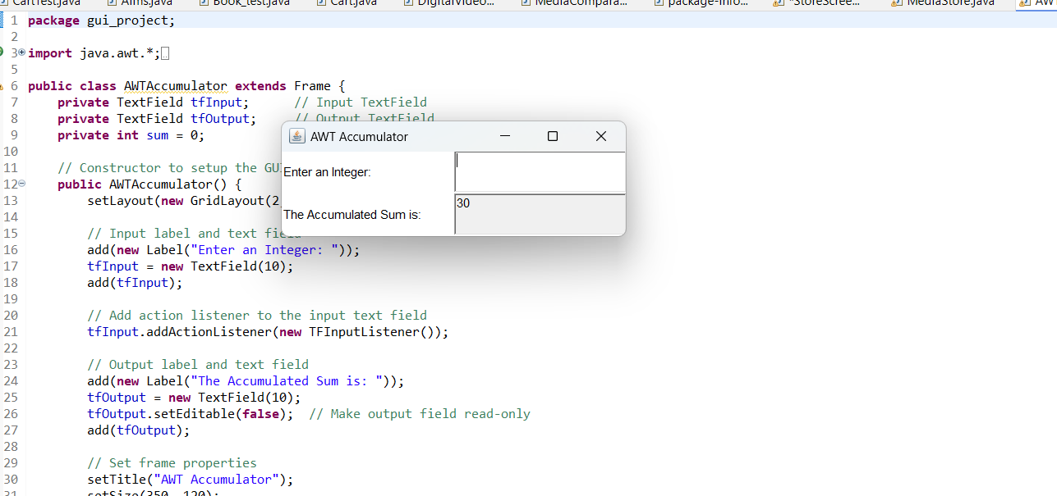

## SwingAccumulator

Figure 1.2: Demo of AWTAccumulator

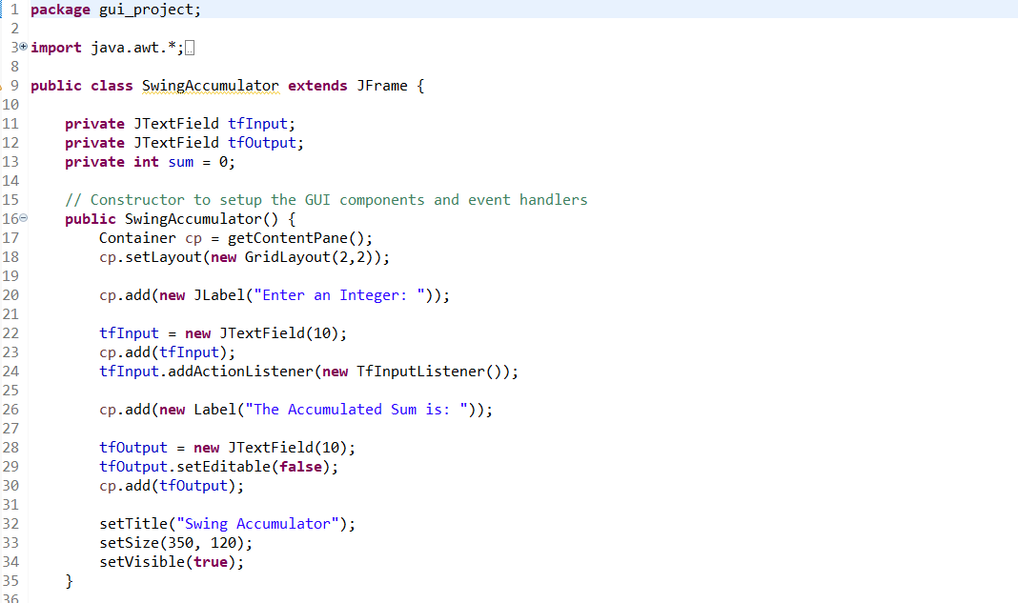

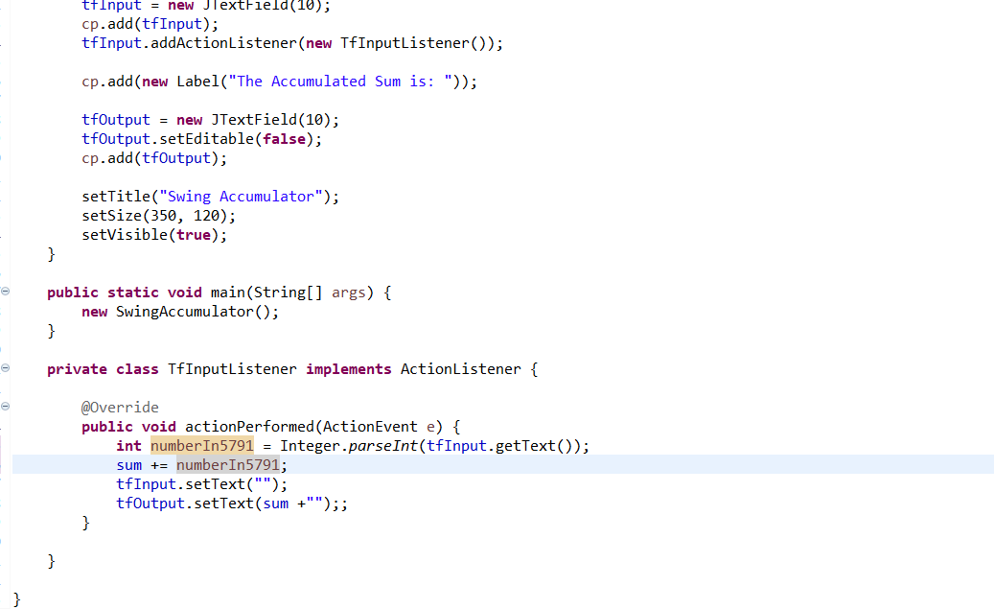

Figure 1.3: Source code of SwingAccumulator

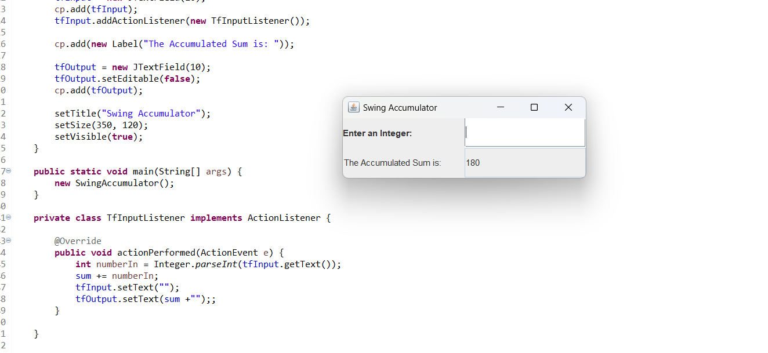

Figure 1.4: Demo of SwingAccumulator

# Organizing Swing components with Layout Managers

## Code

## 

Figure 2.1: Source code of NumberGrid 1

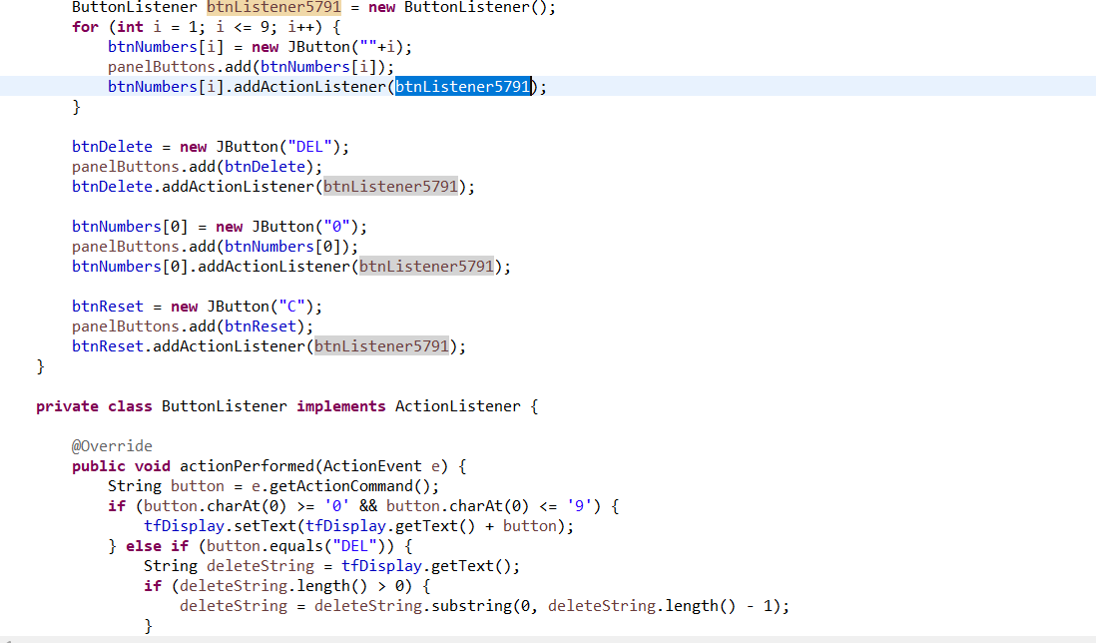

Figure 2.2: Source code of NumberGrid 2

## Demo

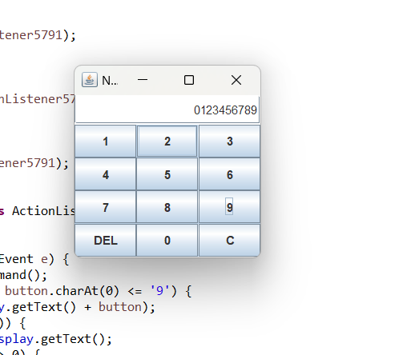

Figure 2.3: Demo buttons 0-9

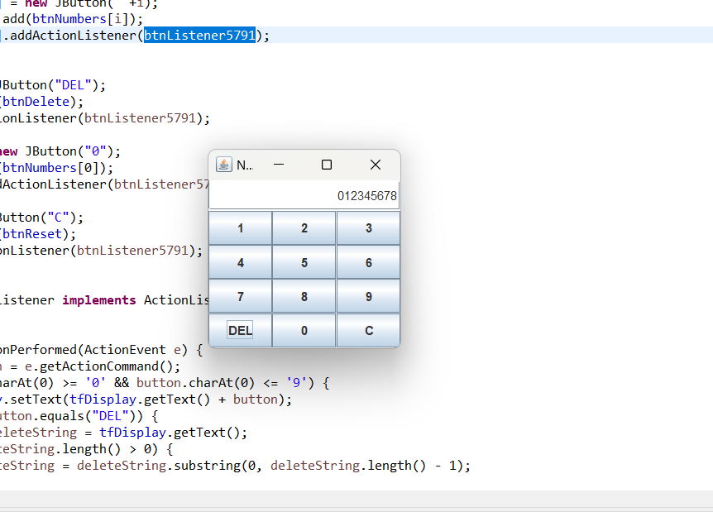

Figure 2.4: Demo DEL button

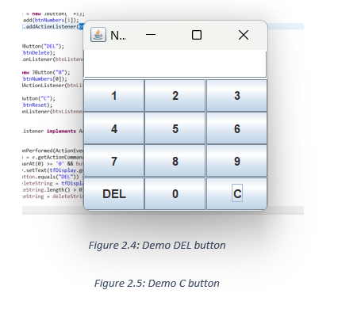

Figure 2.5: Demo C button

# Create a graphical user interface for AIMS with Swing

## Create class StoreScreen

## 

Figure 3.1: Class StoreScreen 1

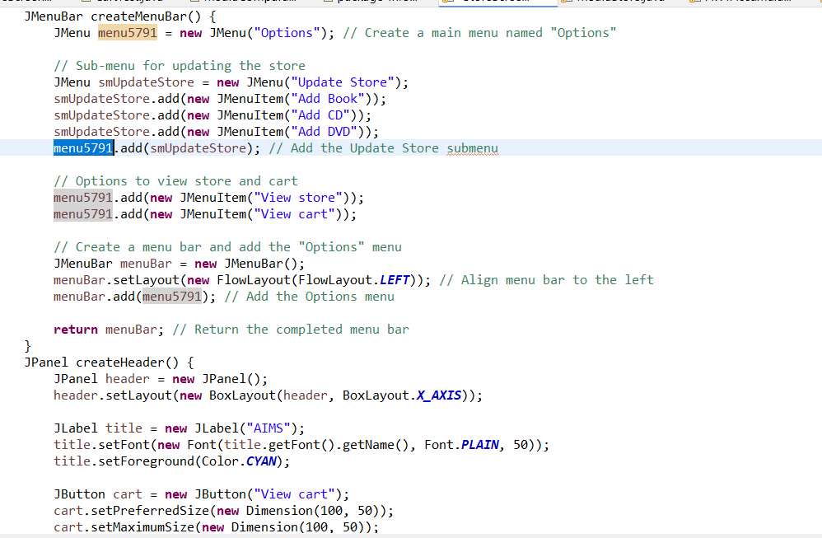

Figure 3.2: Class StoreScreen 2

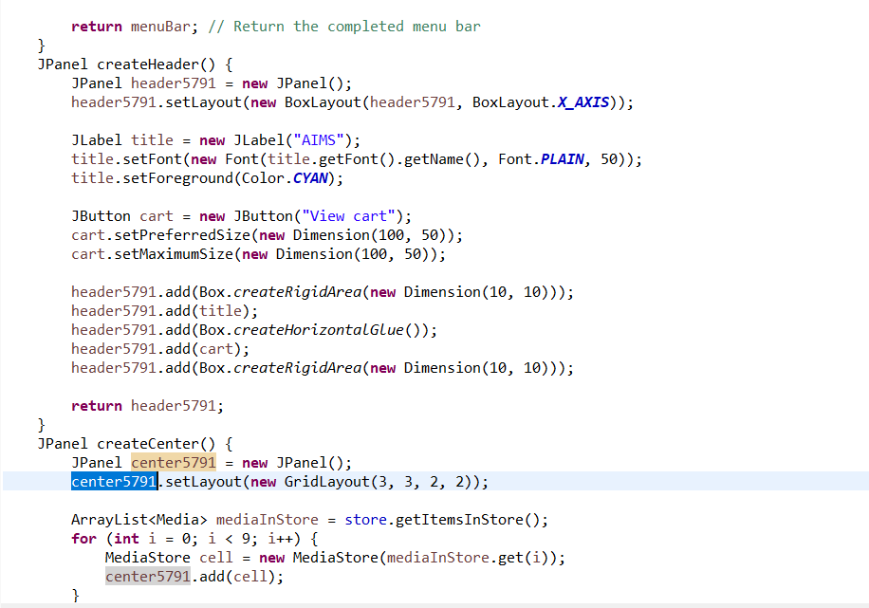

Figure 3.3: Class StoreScreen 3

## Create class MediaStore

## 

Figure 3.7: Class MediaStore 1

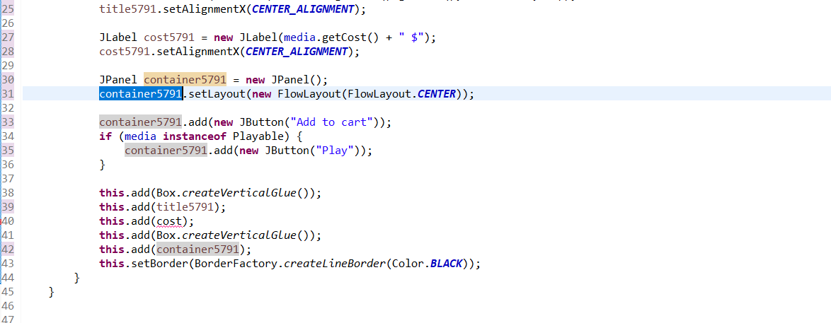

Figure 3.8: Class MediaStore 2

## Demo

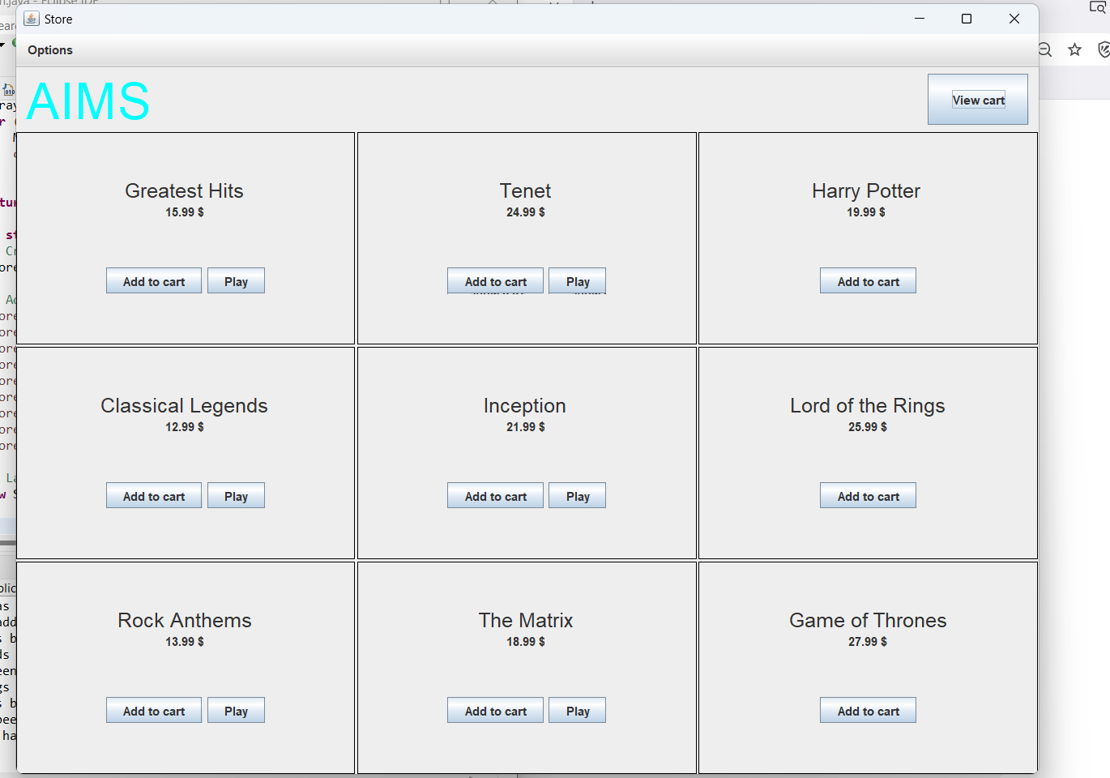

Figure 3.10: StoreScreen

# JavaFX API

## Create class Painter

## 

## Create Painter.fxml

## 

Figure 4.1: Class Painter

Figure 4.2: Painter.fxml 1

## Create class PainterController

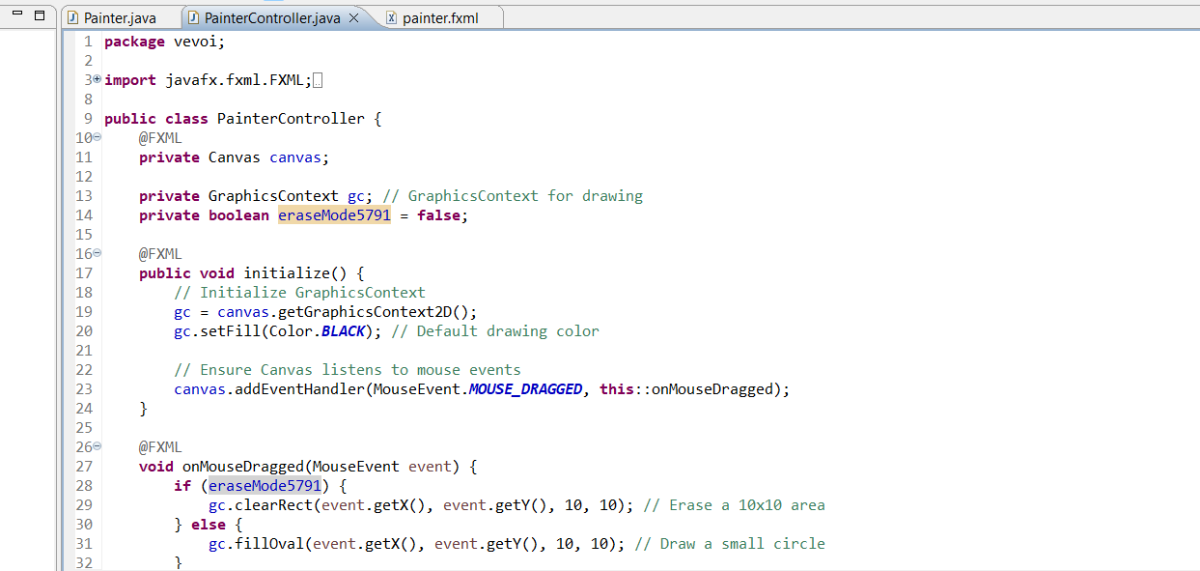Figure 4.3: Painter.fxml 2

Figure 4.4: PainterController

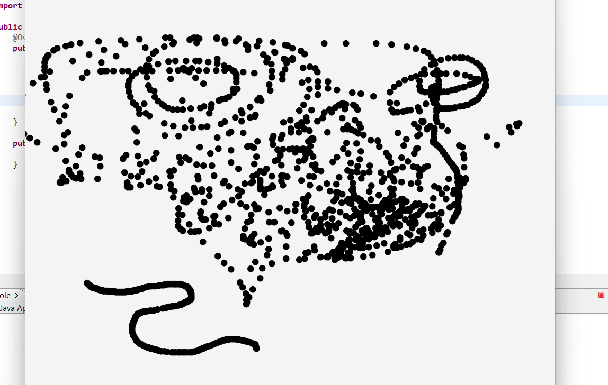

Figure 4.5: Use Pen

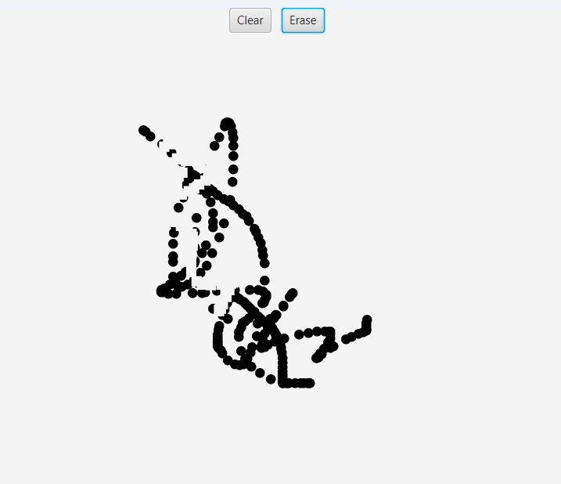

Figure 4.6: Use Eraser

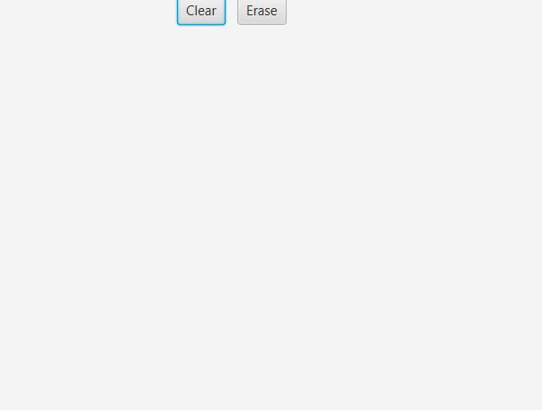

Figure 4.7: Clear button

# View Cart Screen

## Create class CartScreen

Figure 5.4: CartScreen class

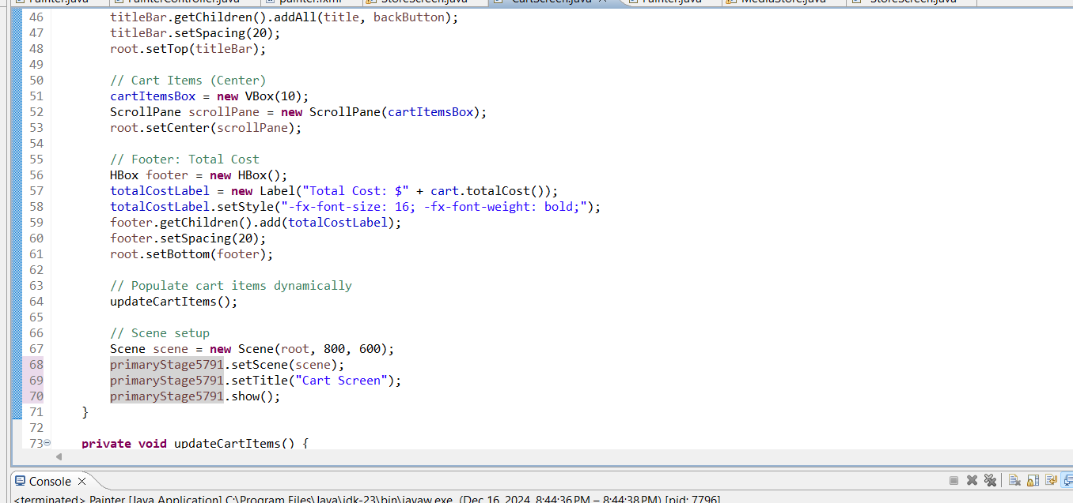

## 

## Demo

## 

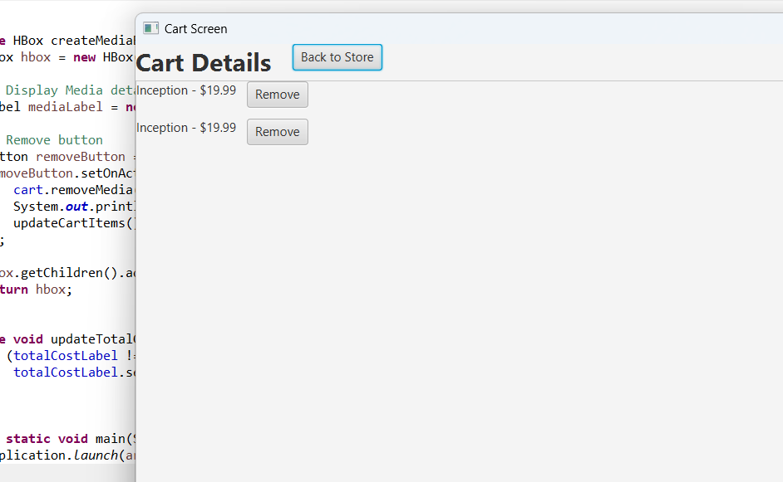

Figure 5.7: Demo CartScreen

1. Updating buttons based on selected item in TableView –

ChangeListener

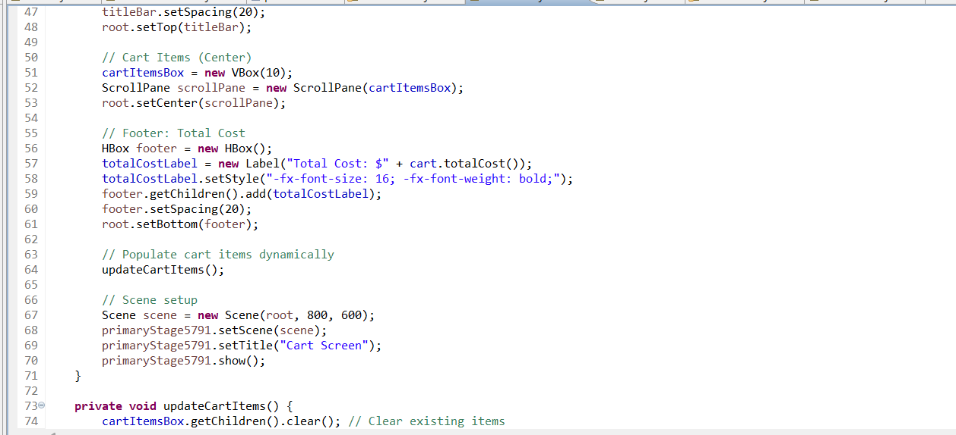

## Demo

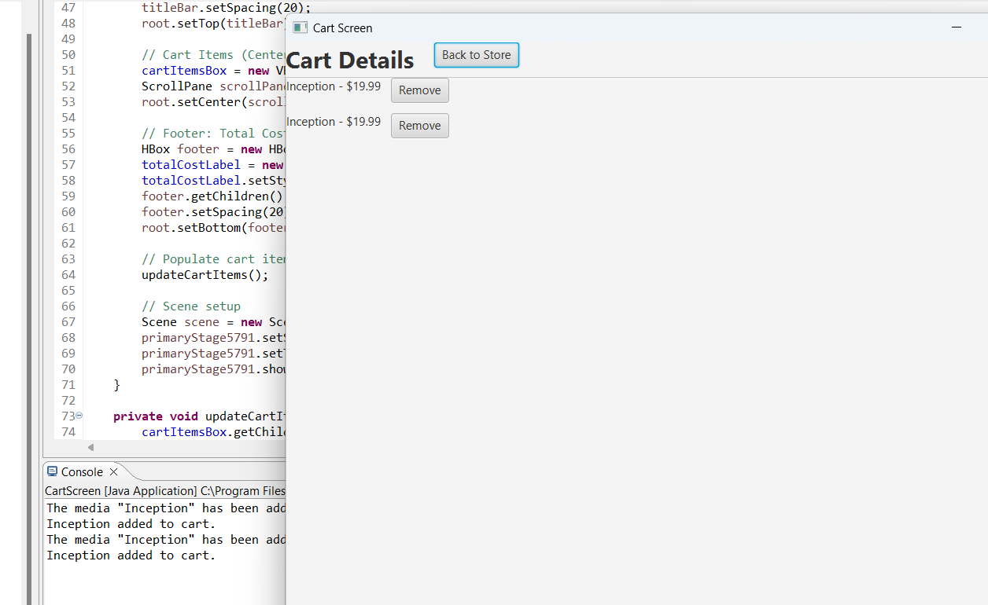

Figure 6.3: Demo media playable

Figure 6.4: Demo media unplayable

# Deleting a media

## Code

Figure 7.1: btnRemovePressed Method

## Demo’

# 

# Use case Diagram

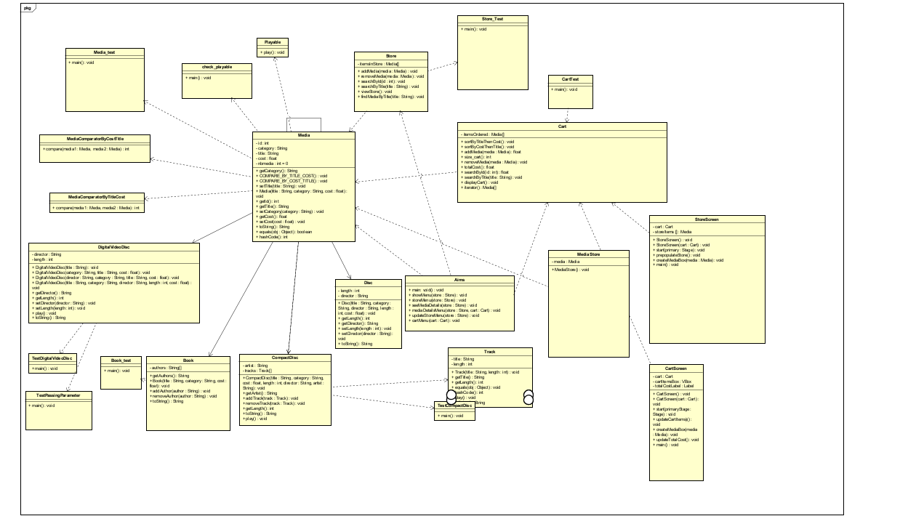

# Class Diagram

# =