**EX11**

1. 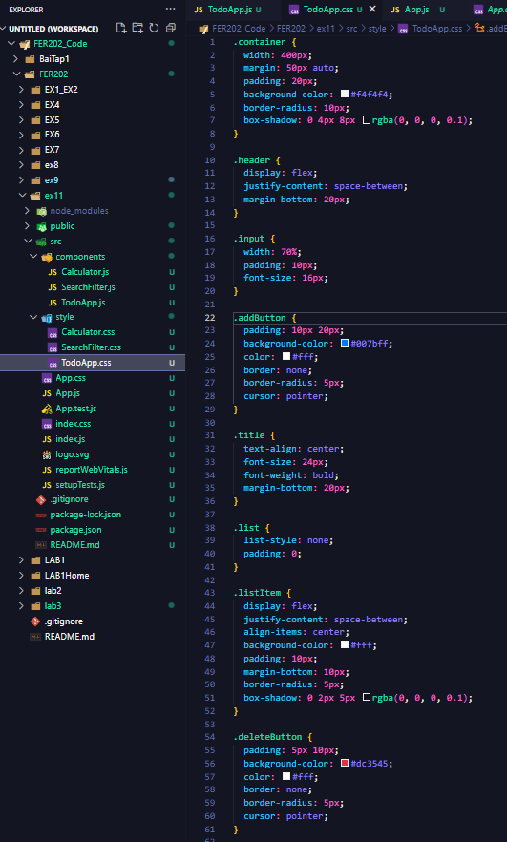**A screenshot of a computer screen

   Description automatically generatedTo do app**

1. A screenshot of a computer screen

   Description automatically generated**Calculator**

1. A screenshot of a computer

   Description automatically generatedA screenshot of a computer program

   Description automatically generatedA computer screen shot of a program

   Description automatically generated**Search filter**

