Kinh nghiệm cá nhân trong sử dụng query trong thực tế testing

1. Qurey trong mongodb

Note for query Mongo Database

CRUD Operations

1. Create

- inserOne(data, options)

- insertMany(data, options)

2. Update

- updateOne(filter, data, options)

- updateMany(filter, data, options)

EX:

Function update sẽ update nếu cột đó có sẵn, nếu ko, sẽ tạo thêm cột và update giá trị

updateOne({key:value}, {$set:{marker:"delete"}})

Function updateMany sẽ update cho tất cả các record trong bảng nếu filter is {}

updateMany({}, {$set:{marker:"delete"}})

3. Read

- find(filter, options)

- findOne(filter, options)

4. Delete

hàm deleteOne sẽ xóa record đầu tiên nó gặp khi filter

- deleteOne(filter, options)

- deleteMany(filter, options)

EX:

deleteOne({key:value})

Function deleteMany sẽ xóa hết các record có cột marker is delete

deleteMany({marker:"delete"})

db.getCollection("tickets").find({

$and: [

{"attachments": {$elemMatch:{url: { "$exists": true}}}},

{"owner.accountId" : "6335e5d0-afa4-45ae-b342-77290a01011a"}

]

})

db.getCollection("tickets").find(

{

$and: [

{

"silentTicket": false

},

{

"ticketType": "panelmanagement_de"

},

{

"_id": ObjectId("65bd166e0531cd56cd37bd16")

},

{

"owner.accountId": "633fc523-d9d4-41ba-a4d1-23aa0a01011a"

},

{

"owner.subAccountIds": []

}

,

{

"additionalProperties": {$elemMatch:{"value": "lab@spectos.com"}}

},

{

"createdAt": {$lte:ISODate("2024-02-02T23:59:59.999Z")},

"createdAt": {$gte:ISODate("2024-02-02T16:21:02.166Z")}

},

{

"comments": {$elemMatch:{attachTicket : false}}

},

{

// mongodb query array contains multiple values

"tags": {$in: ["6358ac472d5c3e403d11ed98"]}

}

]

},

{

"owner": 1, "_id": 0

}

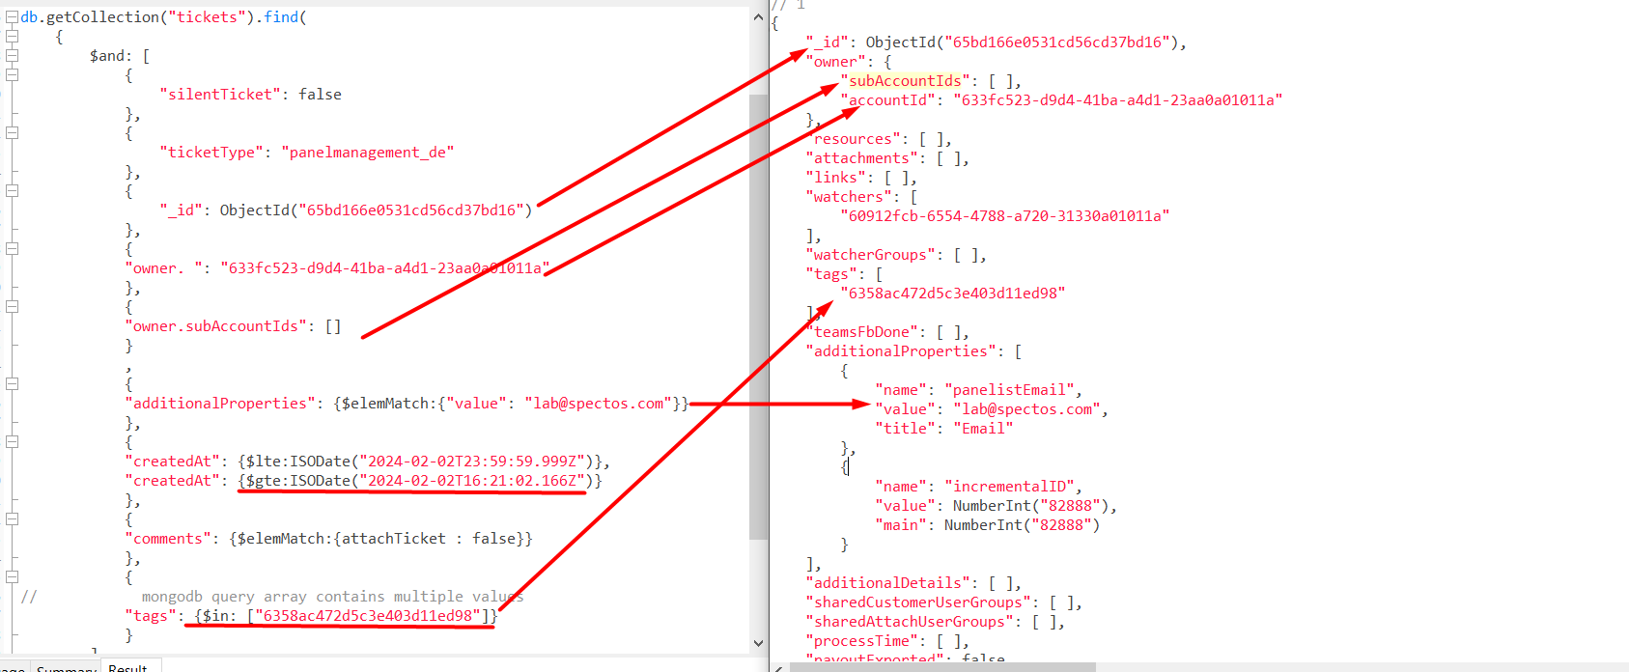

1. Qurey trong SQL

SELECT * FROM (SELECT morning.fbIdM FROM (SELECT f.panel_member_id AS panelMeneberM, f.id AS fbIdM ,a.`value` AS valueM, EXTRACT(DAY FROM f.created) AS createdM FROM `feedbacks` f

LEFT JOIN answers a

ON f.id = a.feedback_id

LEFT JOIN panel_members pm

ON pm.id=f.panel_member_id

WHERE f.survey_id IN ("5c6e65f4-9838-488a-896e-3e730a01011a")

-- AND pm.`value` LIKE '%"Luxemburger Wort"%'

AND f.visible = 1

AND f.deleted IS NULL

AND f.created >= "2024-01-01 00:00:00"

AND f.created <= "2024-01-31 23:59:59"

AND a.question_id = "5c6e65f4-8cb0-4df5-b2b7-3e730a01011a"

AND a.`value` = 0) AS morning -- no recieve morning;

UNION

SELECT afternoon.fbIdA FROM

(SELECT f.panel_member_id AS panelMeneberA, f.id AS fbIdA ,a.`value` AS valueA, EXTRACT(DAY FROM f.created) AS createdA FROM `feedbacks` f

LEFT JOIN answers a

ON f.id = a.feedback_id

LEFT JOIN panel_members pm

ON pm.id=f.panel_member_id

WHERE f.survey_id IN ("5c6e6b92-7c3c-4840-8c8b-6dbb0a01011a")

-- AND pm.`value` LIKE '%"Luxemburger Wort"%'

AND f.visible = 1

AND f.deleted IS NULL

AND f.created >= "2024-01-01 00:00:00"

AND f.created <= "2024-01-31 23:59:59"

AND a.question_id = "5c6e6b92-ec88-4bf9-9985-6dbb0a01011a"

AND a.`value` = 0) AS afternoon -- no recieve afternoon;

) AS a

-- WHERE a.fbIdM NOT IN ("65a4c51e-4534-4b6c-9f66-383e0a01011a", "65aa0920-9aa8-421b-aac3-443a0a01011a")

WHERE a.fbIdM NOT IN

(SELECT fbIdM FROM (SELECT f.panel_member_id AS panelMeneberM, f.id AS fbIdM ,a.`value` AS valueM, EXTRACT(DAY FROM f.created) AS createdM FROM `feedbacks` f

LEFT JOIN answers a

ON f.id = a.feedback_id

LEFT JOIN panel_members pm

ON pm.id=f.panel_member_id

WHERE f.survey_id IN ("5c6e65f4-9838-488a-896e-3e730a01011a")

-- AND pm.`value` LIKE '%"Luxemburger Wort"%'

AND f.visible = 1

AND f.deleted IS NULL

AND f.created >= "2024-01-01 00:00:00"

AND f.created <= "2024-01-31 23:59:59"

AND a.question_id = "5c6e65f4-8cb0-4df5-b2b7-3e730a01011a"

AND a.`value` = 0) AS morning -- no recieve morning;

INNER JOIN

-- SELECT * FROM `feedbacks` f

(SELECT f.panel_member_id AS panelMeneberA, f.id AS fbIdA ,a.`value` AS valueA, EXTRACT(DAY FROM f.created) AS createdA FROM `feedbacks` f

LEFT JOIN answers a

ON f.id = a.feedback_id

LEFT JOIN panel_members pm

ON pm.id=f.panel_member_id

WHERE f.survey_id IN ("5c6e6b92-7c3c-4840-8c8b-6dbb0a01011a")

-- AND pm.`value` LIKE '%"Luxemburger Wort"%'

AND f.visible = 1

AND f.deleted IS NULL

AND f.created >= "2024-01-01 00:00:00"

AND f.created <= "2024-01-31 23:59:59"

AND a.question_id = "5c6e6b92-ec88-4bf9-9985-6dbb0a01011a"

AND a.`value` IN (0,1)) AS afternoon-- no recieve afternoon;

ON morning.panelMeneberM = afternoon.panelMeneberA

AND morning.createdM = afternoon.createdA)

tính toán : Not recieve cho lux: Công thức tính: Tổng not reciept morning + afternoon - (cùng ngày , cùng panelmenberID: not reciept buổi sáng + not recieve buổi chiều) - (cùng ngày, cùng panelmemberID: not recipt buổi sáng + recive buổi chiều)

* Dùng function JSON_EXTRACT để query

SELECT *, JSON_EXTRACT(st.`value`, '$.mapping_ticket_default.channel.value') AS value1 FROM `survey_tickets` AS st

WHERE id = "643f5e41-029c-4240-a905-4c9fc8a8cd0d"

AND JSON_EXTRACT(st.`value`, '$.ticket_type') = "samsung"

AND JSON_EXTRACT(st.`value`, '$.mapping_ticket_default.channel.value') = "trustpilot"

* Dùng LIKE

SELECT *, JSON_EXTRACT(pm.`value`, '$.email') AS email FROM `panel_members` AS pm

WHERE pm.`value` LIKE '%"5c2d8aaa2647f420728b4567"%' -- pm.value containt 5c2d8aaa2647f420728b4567

* Query 1 json array value dung index

FROM `users`

WHERE users.id = "561220d7-dfd8-43b9-be0f-17a50a00011a"

AND JSON_EXTRACT(users.properties, '$.postcon_extra_filters[0]') = "l2w"

Một số thông tin cần lưu lại

Tạo job kết nối với jenkins job maven: https://www.youtube.com/watch?v=o2gAw929--g

cd D:\selenium\RtpmAutoTestFramework

mvn -f "D:\selenium\RtpmAutoTestFramework\pom.xml" clean test

Cấu hình html report hiển thị trên jenkins: <https://wiki.jenkins.io/JENKINS/HTML-Publisher-Plugin.html>

Jenkisn dùng allure report: hiển thị OK nhất: Link hướng dẫn: <https://qaautomation.expert/2022/12/02/integration-of-allure-report-with-jenkins/>

--enable-future-java

java -jar jenkins.war --httpPort=8080 --enable-future-java

…or create a new repository on the command line

echo "# automation_test" >> README.md

git init

git add README.md

git commit -m "first commit"

git branch -M main

git remote add origin https://github.com/BuiBinhTester/automation_test.git

git push -u origin main

…or push an existing repository from the command line

git remote add origin https://github.com/BuiBinhTester/automation_test.git

git branch -M main

git push -u origin main

=IF(COUNTIF($D$2:$D$5,A2)>0, "Match", "No Match")