|  |  |  |
| --- | --- | --- |
|  |  | Education App  How to setup – by Binh Le |

This document is to be used only for students in class ISYS2048

# Introduction

This sample education app is a full stack solution which utilize most of knowledge delivered in subject ISYS2048 – Developing Mobility Solution. Without understanding of HTML, CSS, Javascript, AngularJS, you may not be able to make any further change to the product.

To start, go to Github [**https://github.com/mameluke/ISYS2048**](https://github.com/mameluke/ISYS2048)**,** and download the whole directory  
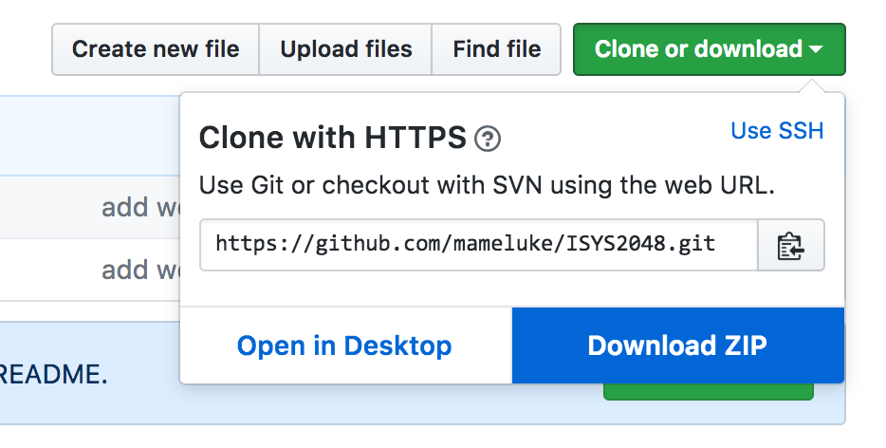

However, you will only need to use the directory “education_app”

# Back-end

## Setting up XAMPP

1. go to <https://www.apachefriends.org/index.html>
2. Choose the correct version of your operating system  
   
3. Once downloaded, following the installer instruction and install the software.
4. Once installed, you can open XAMPP control panel then start Apache Server and MySQL Server  
   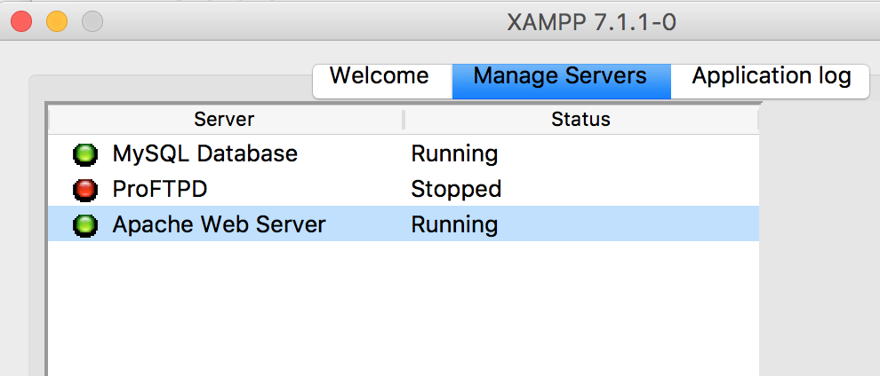
5. To confirm the server is up and running, open browser and type in [**http://localhost**](http://localhost). And you will see following page. It means Apache server is running.  
   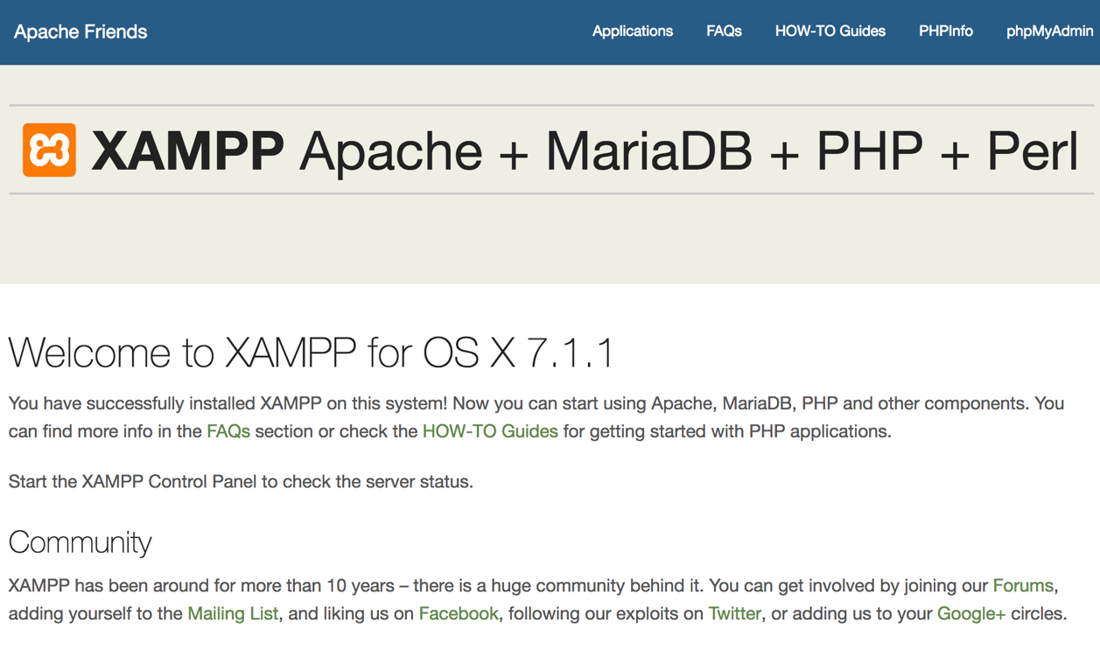
6. To confirm MySQL server is running, click on phpMyAdmin in the menu bar. You will see the following:  
   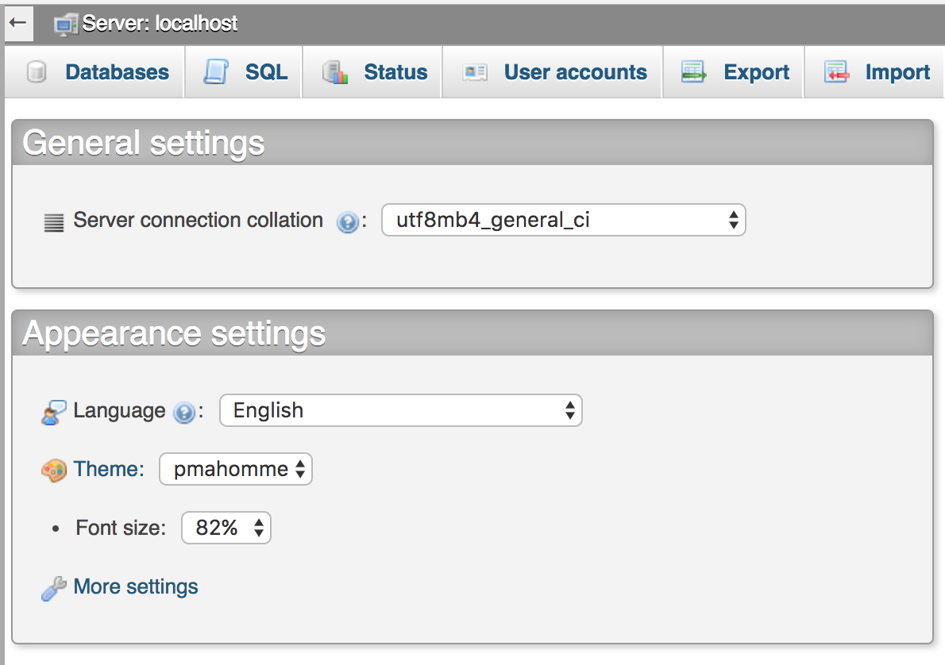

## Import database

1. In PHPMyAdmin, click on import and choose the education.sql (downloaded from github). Then scroll down and click import  
   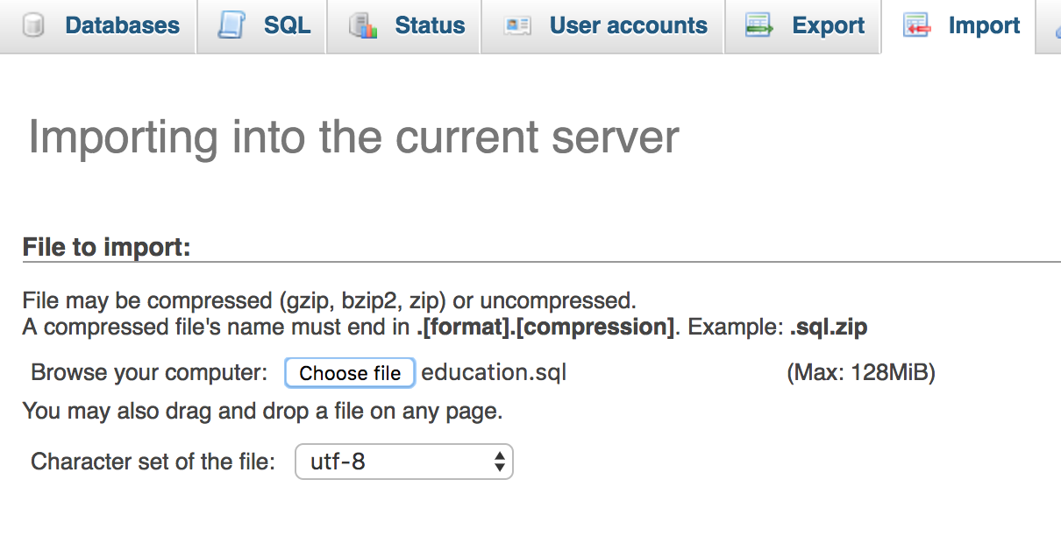
2. Once import, you can see the database “education” in the database list on the right:  
   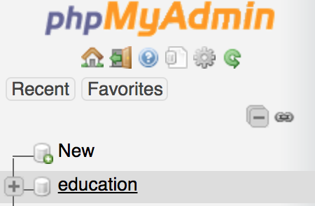  
   Click on that you will see the dabase contain 1 table: “university”

## Seting up files

In the downloaded files from Github, copy both directory **education_api** and **education_app** to **htdocs** directory located inside XAMPP

To verify back-end run successfully, in browser go to <http://localhost/education_api/university.php>

You will set the list of all records in University table printed out in JSON formated  
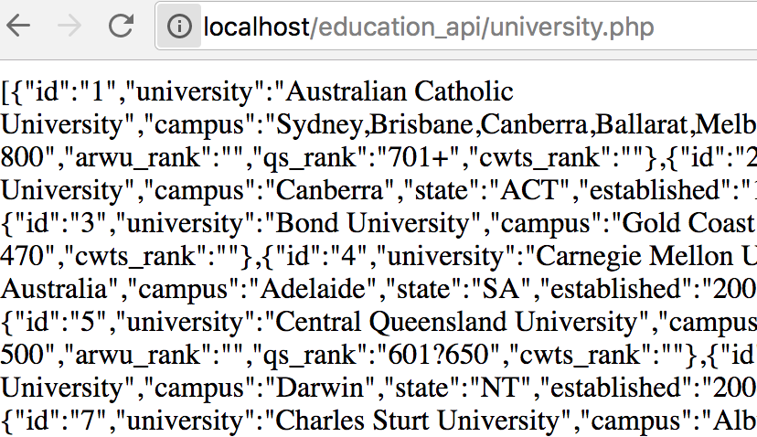

To have better view, you can install following chrome plugin and reload the page

<https://chrome.google.com/webstore/detail/json-viewer/gbmdgpbipfallnflgajpaliibnhdgobh/related>

# FRONT-END

## PhoneGap

To be able to test on mobile devide, you required to download PhoneGap on both desktop/laptopn and on your mobile.

On desktop/laptop, go to <https://phonegap.com/getstarted/>, follow the instruction and intall the software.

1. Once installed, open the software, click on the + icon and choose “Open existing PhoneGap project”  
   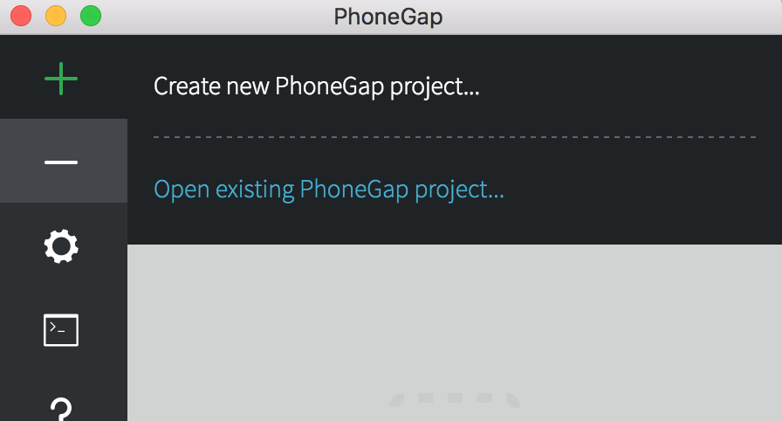
2. Choose the copied directory **education_app** in htdocs, the you will see the following  
   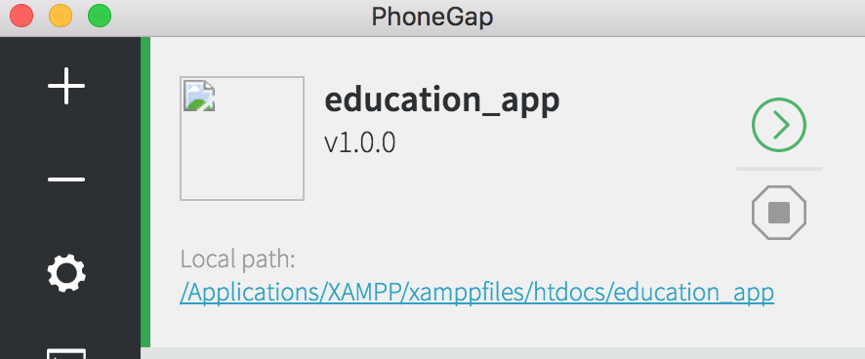
3. Make sure the icon  is green and the server running  
   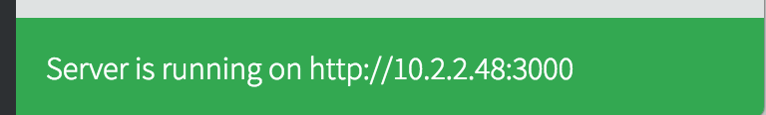
4. Make sure your desktop/laptop and your mobile app is connected to the same LAN network

On mobile, install PhoneGap Developer App

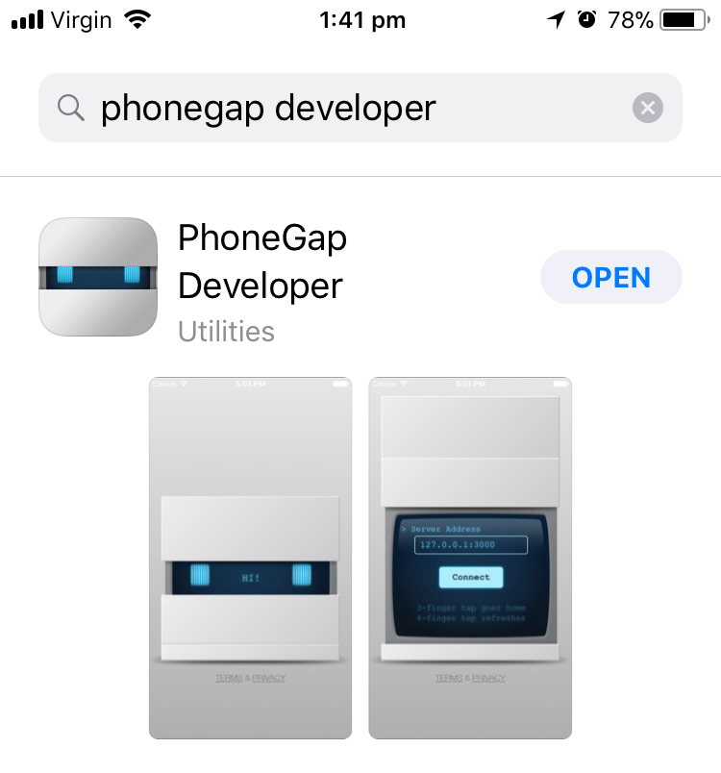

1. Once installed, open the app and make sure the IP Address is the same as you see on desktop/laptop, then click connect. You will see the app is now ready for you.
2. To make change to the app, simple change the code in **education_app/www**
3. To debug, HTML, CSS, Javascript, open browser and go to <http://localhost/education_app/www>