Change request log – ps1

# Team

Binh Doan - developer

# Change Request

The Split by size module of PDFsam allows to split a PDF file in files of a given size (see Figure 1). Ideally, the

created files should be smaller than the given size, but this does not always happen (see Figure 2). You are

requested to fix this functionality, so that the created files never exceed the specified size, unless the created file

contains a single page that by itself exceeds the limit size.

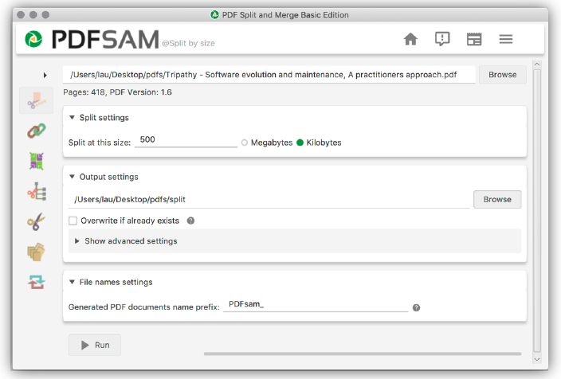

Figure . Split by size module of PDFsam

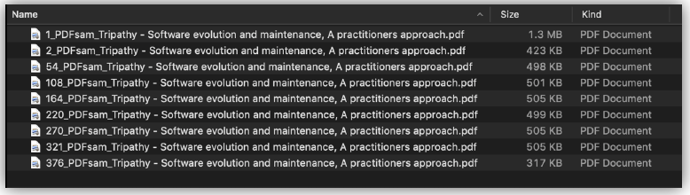

Figure 2. Files created by PDFsam after splitting at 500 Kilobytes

# Concept Location

The table below describes each step I perform the concept location for this change request.

|  |  |  |
| --- | --- | --- |
| Step # | Description | Rationale |
| 1 | I started the pdfSam v4.0.5 and follow the steps provided in the change request. |  |
| 2 | I could not reproduce the bug. | All created files are either within the limit size or contain one single page that by itself exceeds the limit size. |
| 3 | The pdfSam source code is categorized nicely following its feature. Therefore, I can navigate to the Split-by-size source code very quickly. I temporarily marked this package as “located” with the concept “size”. |  |

**Time spent (in minutes):** 30

# Impact Analysis

**Time spent (in minutes):** 0

# Prefactoring (optional)

Not implemented.

**Time spent (in minutes):** 0

# Actualization

The table below describes each step I followed when changing the code.

|  |  |  |
| --- | --- | --- |
| Step # | Description | Rationale |
| 1 | I focused on the “size” variables within these classes. I debugged and see that the size and the converted to bytes size are as expected. |  |
| 2 | Since I cannot locate the concept and cannot reproduce the bug. This bug will be marked as “won’t fix”. |  |

**Time spent (in minutes):** 30

# Postfactoring (optional)

Not implemented.

**Time spent (in minutes):** 0

# Validation

**Time spent (in minutes):** 0

# Timing

Summarize the time spent on each phase.

|  |  |
| --- | --- |
| Phase Name | Time (in minutes) |
| Concept location | 30 |
| Impact Analysis | 0 |
| Prefactoring | 0 |
| Actualization | 30 |
| Postfactoring | 0 |
| Validation | 0 |
| Total | 60 |

# Reverse engineering

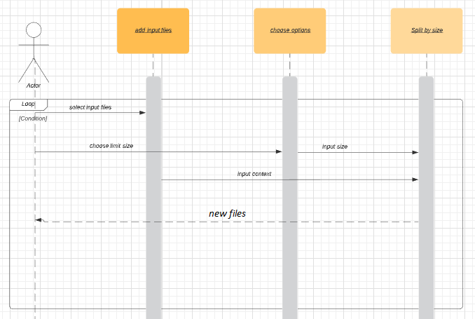

Figure 3. UML sequence diagram

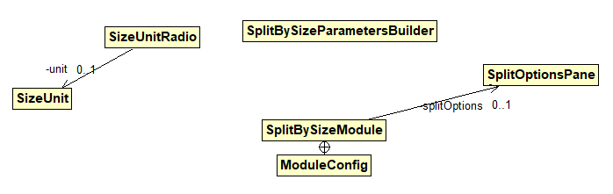

Figure 3. UML class diagram shows the visited classes connecting to the HyperSearchResults class

# Conclusions

Bug cannot be reproduced. An email has been sent to the bug reported to request for more details. Unless further information is provided, bug will not be fixed.