论文阅读笔记

Deep Knowledge Tracing

引言
popular educational platforms such as Khan Academy, Coursera, and EdX.
knowledge tracing model:
a. first order Markov models with restricted functional forms
b. Deep Knowledge Tracing (DKT)：
1. A novel application of recurrent neural networks to tracing student knowledge.
2. A 25% gain in AUC over the best previous result on a knowledge tracing benchmark.
3. Demonstration that our knowledge tracing model does not need expert annotations.
4. Discovery of exercise influence and generation of improved exercise curricula.

知识追踪定义：given observations of interactions x0 …xt taken by a student on a particular learning task, predict aspects of their next interaction xt+1. xt = {qt, at} that combines a tag for the exercise being answered qt with whether or not the exercise was answered correctly at.

模型发展历史
- Bayesian Knowledge Tracing (BKT)
BKT models a learner’s latent knowledge state as a set of binary variables, each of which represents understanding or non-understanding of a single concept. A Hidden Markov Model (HMM) is used to update the probabilities across each of these binary variables.
Recent extensions to this model include contextualization of guessing and slipping estimates, estimating prior knowledge for individual learners, and estimating problem difficulty.
Knowledge Tracing suffers from several difficulties. First, the binary representation of student understanding may be unrealistic. Second, the meaning of the hidden variables and their mappings onto exercises can be ambiguous, rarely meeting the model’s expectation of a single concept per exercise.
- Partially Observable Markov Decision Processes (POMDPs)
- Performance Factors Analysis (PFA)
- Learning Factors Analysis (LFA)
- combining Item Response Theory (IRT) models with switched nonlinear Kalman filters.
模型的局限性：with the same limitations, including a requirement for accurate concept labeling.

DKT模型结构
DKT model structure: apply two different types of RNNs – a vanilla RNN model with sigmoid units and a Long Short Term Memory (LSTM) model.
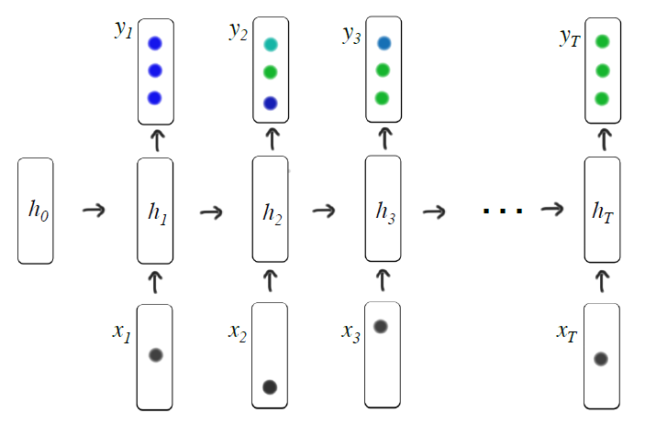

数据集
three datasets: simulated data, Khan Academy Data, and the Assistments benchmark dataset
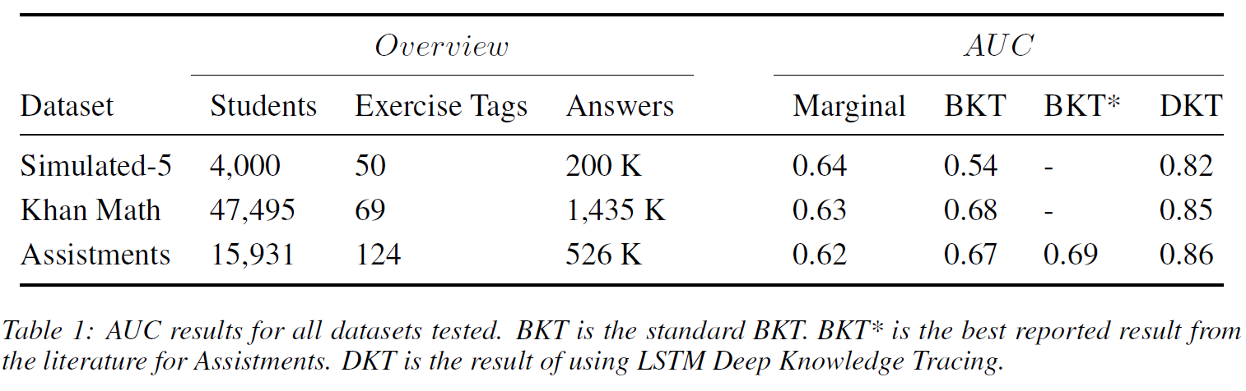

结果分析：Discovering Exercise Relationships
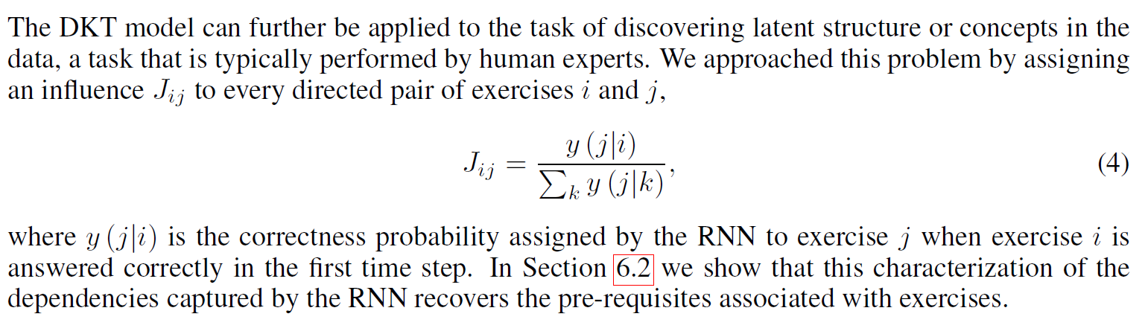

Exploiting Cognitive Structure for Adaptive Learning
we propose a Cognitive Structure Enhanced framework for Adaptive Learning, named CSEAL. By viewing path recommendation as a Markov Decision Process and applying an actor-critic algorithm, CSEAL can sequentially identify the right learning items to different learners.

we first utilize a recurrent neural network to trace the evolving knowledge levels of learners at each learning step. Then, we design a navigation algorithm on the knowledge structure to ensure the logicality of learning paths, which reduces the search space in the decision process. Finally, the actor-critic algorithm is used to determine what to learn next and whose parameters are dynamically updated along the learning path.

The cognitive structure describes the qualitative development of knowledge and contains two parts: knowledge level of learners and knowledge structure (e.g., the prerequisite relations) of learning items.

Introduction
methods based on knowledge level without the knowledge structure may fail to resolve learning items dependency, e.g., prerequisite.
The methods based on knowledge structure which ignore learners’ knowledge level can not reflect the learning abilities of different learners, so that they can not precisely determine
the customized learning tempo定制化学习节奏。

exploit cognitive structure including both knowledge level and knowledge structure for adaptive learning is still a challenging problem.
First, the knowledge level of learner cannot be observed directly and keeps evolving. Thus, it is necessary to model the implicit evolving knowledge level.
Second, the knowledge structure of learning items should be incorporated to determine logical learning paths.
Third, a good learning path recommendation should maximize the overall gain along the whole
learning path instead of only focusing on the gain in one step.

related work

Learning Path Recommendation
协同过滤方法collaborative filtering methods (e.g., KNN, MPR) and deep learning methods (e.g. GRU4Rec).

Cognitive Structure
Cognitive structure contains two parts: knowledge level of learners and knowledge structure of items.
Knowledge tracing models learners’ knowledge level over time so that how learners will perform on future interactions can be accurately predicted.
Knowledge Graph, with entities (e.g. learning items) as nodes, elations (e.g. prerequisite) as edges, stores a large amount of information containing domain knowledge by graph structure

Reinforcement Learning
due to three key challenges, the traditional reinforcement learning is difficult to be applied in learning path recommendation:
(1) how to represent state;
(2) how to avoid the recommendation violating the sequence logicality during exploring;
(3) how to reduce the large searching space of learning item paths.

PRELIMINARIES

Terminologies
Learning is a long procedure composed of many learning sessions, and each learning session has individual learning targets which can be set by tutors or learners. each learning session includes two main components: learning path and examinations. Some typical learning sessions
are homework, chapters and semesters.
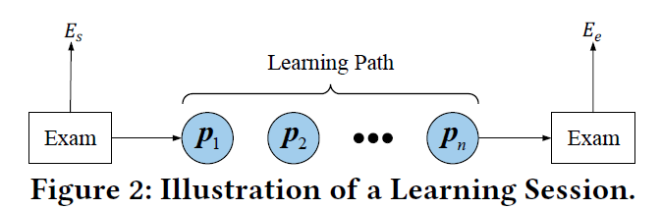
the effectiveness of a learning session
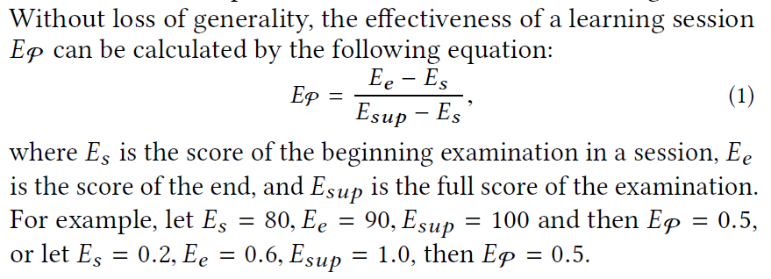

Prerequisite Graph
A prerequisite graph is a subgraph of knowledge graph, which indicates the hierarchical structure existing among learning items.
the nodes of the graph represent learning items while the arrows from one to another mean that the former is a prerequisite for the latter, e.g., two digit addition is a prerequisite for multiplication.

CSEAL
Generally, our CSEAL model contains three submodules, i.e., Knowledge Tracing (KT), Cognitive Navigation (CN), Actor-Critic Recommender (ACR).
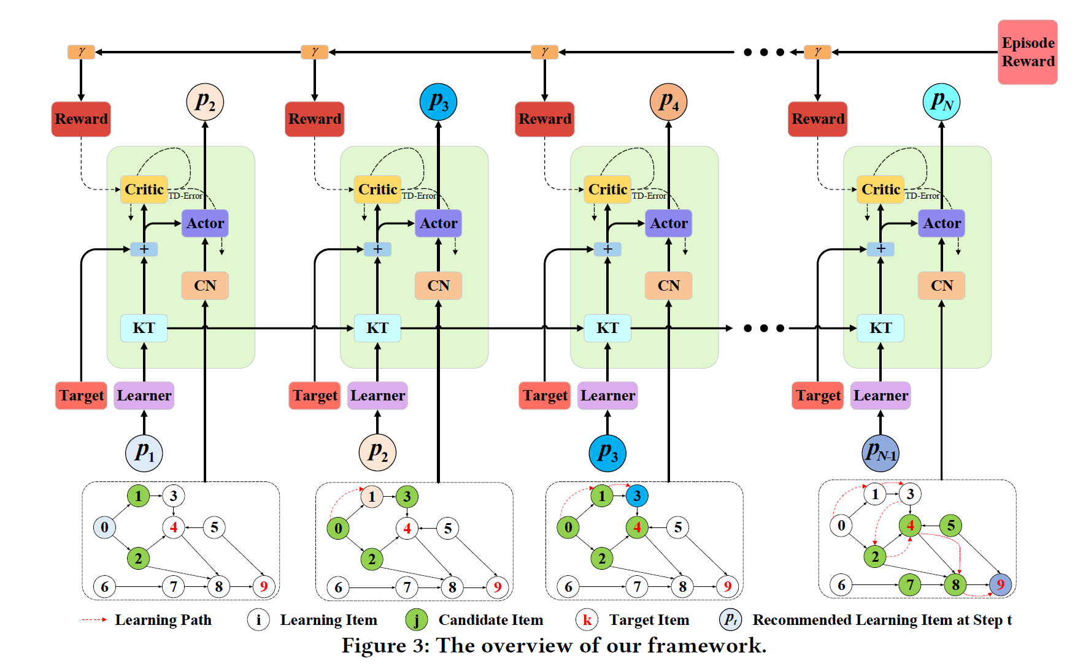

System Simulators

Knowledge Structure based Simulator(KSS)
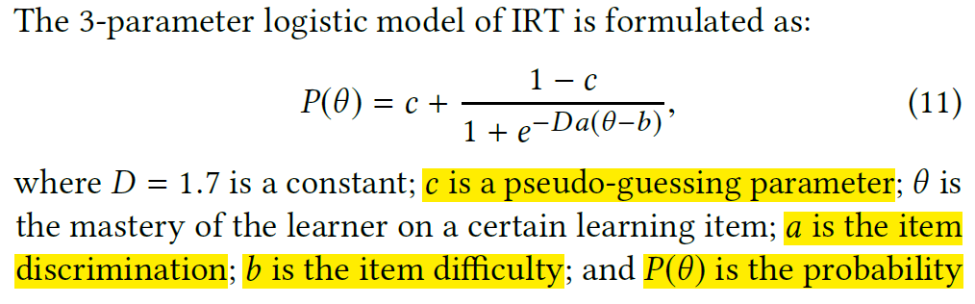

Knowledge Evolution based Simulator(KES).
We train a DKT model based on the existing data. The input of DKT is a record data, and the output, Si , is the current knowledge level of the learner. Then whether the next exercise can be answered correctly is determined by this knowledge level.

Experimental Setup

KSS
we employ KSS to generate the off-line dataset, i.e., dataOff, which is then used to train baseline methods or Knowledge Tracing model in the agents. The dataset dataOff has 4,000 records with a max-length of 50.
we randomly divide the dataset dataOff into training, validation, and testing sets by the proportion of 80/10/10.
The prerequisite graph in KSS contains 10 nodes and 12 links.

KES
we introduce the learning records mentioned in Section 5.1 as dataSim. Furthermore, we randomly divide dataSim into two parts: dataOff and dataRec by the proportion 50/50.

(1) dataSim is utilized to train the DKT model in the environment;
(2) dataOff is used to train baseline methods and Knowledge Tracing model in the agents, which is the same as in KSS;
(3) dataRec is to retrieve the initialization records and learning targets. For each session record in dataRec, the first 60% of the data is applied to initialize the original learner’s knowledge level in DKT. The middle 20% is masked and the lasting 20% is reserved as the learning target of this session.

Framework Setting
10 in KSS (a small number learning items scenario) and 835 in KES (a large number learning items scenario).
KSS: The embedding dimension used in DKT is 15, hidden dimension of LSTM is 20 while the dimension of output layer is the same as the number of learning items, i.e., 10. The dimensions of two layers in value-policy network are 128 and 32 respectively.
KES: The embedding dimension used in DKT is 600, hidden dimension of LSTM is 900 and the dimension of output layer is the same as the number of learning items, i.e., 835. The dimensions of two layers in value-policy network are 1,024 and 512 respectively. The DKT embedded in environment and agent shares the same value of dimension parameters but diverse training data.

Baseline Approaches
• KNN: KNN [9] finds a predefined number of learners nearest to the new learner by comparing the cosine distance of their learning paths, and decides what to learn next for the new learner.
• GRU4Rec: GRU4Rec is a classical session-based recommendation model. The input of the model is the sequence of the session while the output is the probability distribution of learning
items which appear in the next step.
• MCS: Monte Carlo Search (MCS) combined with KT is a searching method where KT predicts the promotion of each search path as the index for ranking.
• DQN: Some works have proposed to leverage reinforcement learning for this problem, but these works require abundant human domain knowledge to design the transition matrix in MDP and an exact initial state, which is not practical. Thus, KT model and Deep Q Leaning replace the states in MDP and simple q-learning separately.
• CN-Random: The recommended item is randomly picked from the candidate items selected by CN(cognitive navigation), and this baseline is treated as a simple knowledge structure-based approach.
• Cog: The recommended item is weighted-randomly picked from the candidate items selected by CN (Cognitive Navigation), where the weight of the item is inversely proportional to the mastery measured by KT model.
• CSEAL-NCN: It is similar with our proposed model but without the Cognitive Navigation system.

Evaluation Metrics
Learning path recommendation focuses on the learning effectiveness rather than the selection of the learner (i.e., being practiced by the learner) or the correction of one exercise, which is essentially different from the general recommendation problem (e.g., merchandise recommendation, movie recommendation). Because of this issue, classical metrics like precision, recall and NDCG cannot be applied.
NDCG?

We validate the performance of models particularly based on the promotion EP given by simulators and the logicality evaluated by human experts.

Promotion Comparison
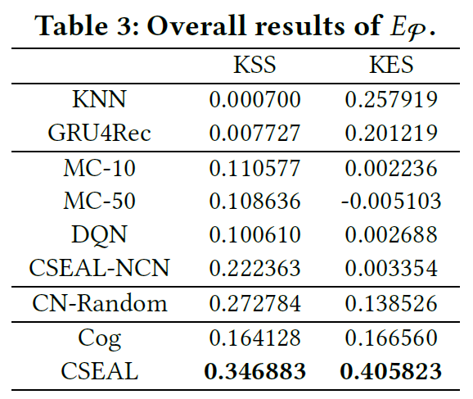

Experts Comparison
we invite six experts in education area who are familiar with learning path scheduling to evaluate the results of various methods based on their own logicality.
Experts rate every learning path with a score from 1 to 5 and a higher score represents the higher logicality. Experts are asked to rate the 100 selected cases. Every case contains the historical learning record, the learning target and the recommended learning path.
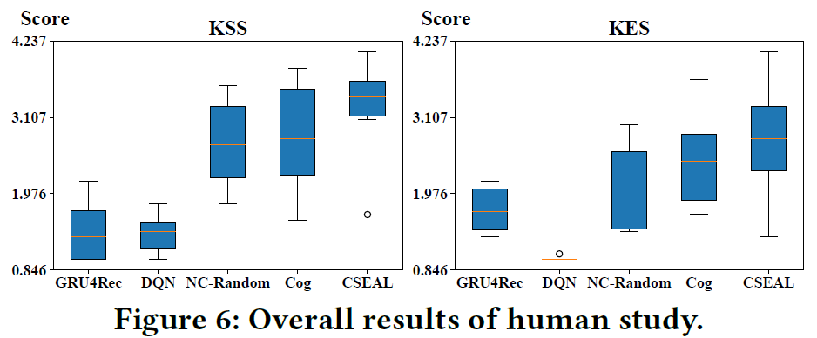

Impact of Knowledge Structure

CONCLUSIONS
based on the historical learning records, learning target and prerequisite graph, we firstly used a Knowledge Tracing model to retrieve the knowledge level of each learner. Then, we applied a Cognitive Navigation system to maintain the knowledge structure of learning items. Finally, we designed the Actor-Critic Recommender to dynamically provide learning items during a learning cycle.

Knowledge Tracing with Sequential Key-Value Memory Networks
Although these deep learning models have shown promising results, they have limitations: either lack the ability to go deeper to trace how specific concepts in a knowledge state are mastered by a student, or fail to capture long-term dependencies in an exercise sequence.

we address these limitations by proposing a novel deep learning model for knowledge tracing, namely Sequential Key-Value Memory Networks (SKVMN). This model unifies the strengths of recurrent modelling capacity and memory capacity of the existing deep learning KT models for modelling student learning. We have extensively evaluated our proposed model on five benchmark datasets.
The experimental results show that (1) SKVMN outperforms the state-of-the-art KT models on all datasets, (2) SKVMN can better discover the correlation between latent concepts and questions, and (3) SKVMN can trace the knowledge state of student dynamics, and a leverage sequential dependencies in an exercise sequence for improved predication accuracy.

This model provides three advantages over the existing deep learning KT models:
First, SKVMN unifies the strengths of both recurrent modelling capacity of DKT and memory capacity of DKVMN for modelling student learning.

SEQUENTIAL KEY-VALUE MEMORY NETWORKS

