|  |  |
| --- | --- |
|  |  |



**Example Project**

|  |  |  |  |
| --- | --- | --- | --- |
| **MCU** | | | |
| **Manufacturer** | **Family** | **Part Name** |  |
| Microchip | dcPIC33E | dsPIC33EP256GP506 |  |
| Microchip | dcPIC33F | dsPIC33FJ256GP710 |  |
| Microchip | PIC24E | PIC24EP512GU810 |  |
| Microchip | PIC24F | PIC24FJ128GA010 |  |

## ****PROJECT INSTRUCTIONS****

**PRODUCTS AND VERSION REFERENCE**

|  |  |  |
| --- | --- | --- |
| **TOOLCHAIN IDEs** | | |
| **IDE Name** | | **Version** |
| MPLABX | | V2.10 |
| XC16 Compiler | | V1.22 |
| ICD3  Explorer16 Board | |  |
| **MICRIUM** | | |
| **Micrium Product** | **Version** | |
| uC/CPU | 1.30.01.01 | |
| uC/LIB | 1.38.01 | |
| uC/OS-II | 2.92.11 | |
| uC/Probe | 3.2 | |

**LOADING & RUNNING THE PROJECT ON THE BOARD**

Icon

**[WARNING]:** Make sure to open the project using the mentioned IDE(s) version or later.

**MPLABX IDE**

1. Click on **File→Open Project**
2. Navigate to the directory where the workspace is located:  
   $\Micrium\Software\EvalBoards\Microchip\Explorer16\XC16\OS-Probe
3. Click **Open**.
4. For Safety, clean the project by clicking on **Run->Clean and Build the main project(It can also be done by left clicking on project then select Clean and Build)**
5. Connect the debugger (e.g. ICD3) to the Explorer 16 board via RJ45 connector; connect the debugger to the PC.
6. Power up the board.(Use 9 Volts power adapter)
7. If the user wants to run the demo, click on Run->Run the main project**.**
8. If the user wants to debug the project , click on Debug->Debug the main project

MPLABX Screen Shots:

1. Open project

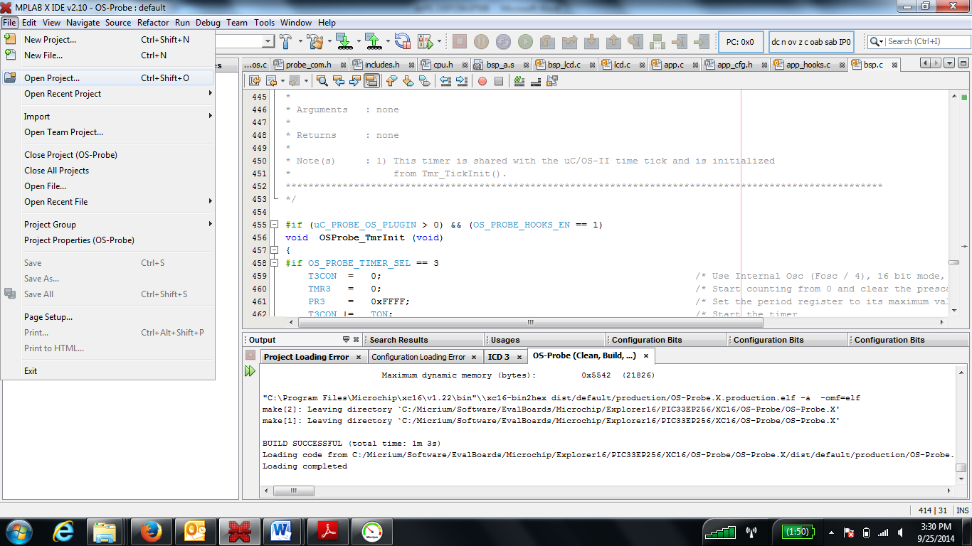

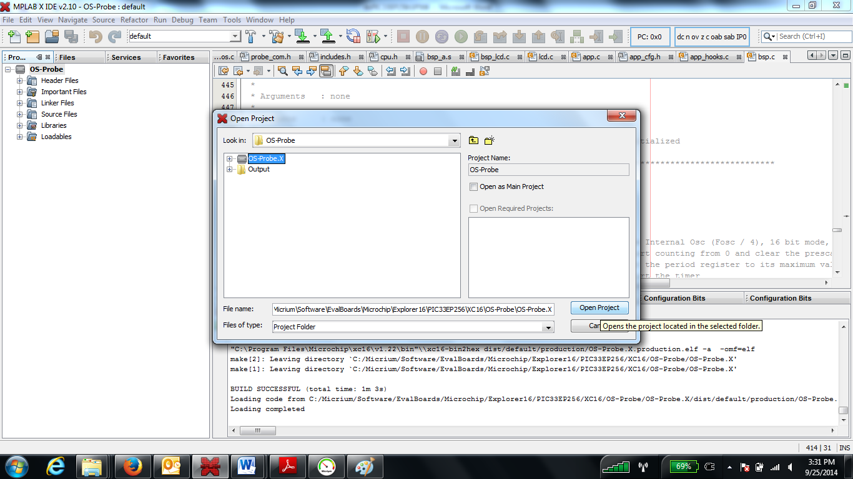

1. Select the required configuration(device family) as shown in the figure below

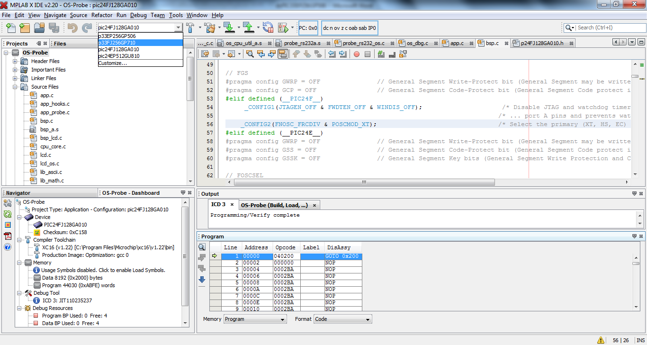

1. Build Project:

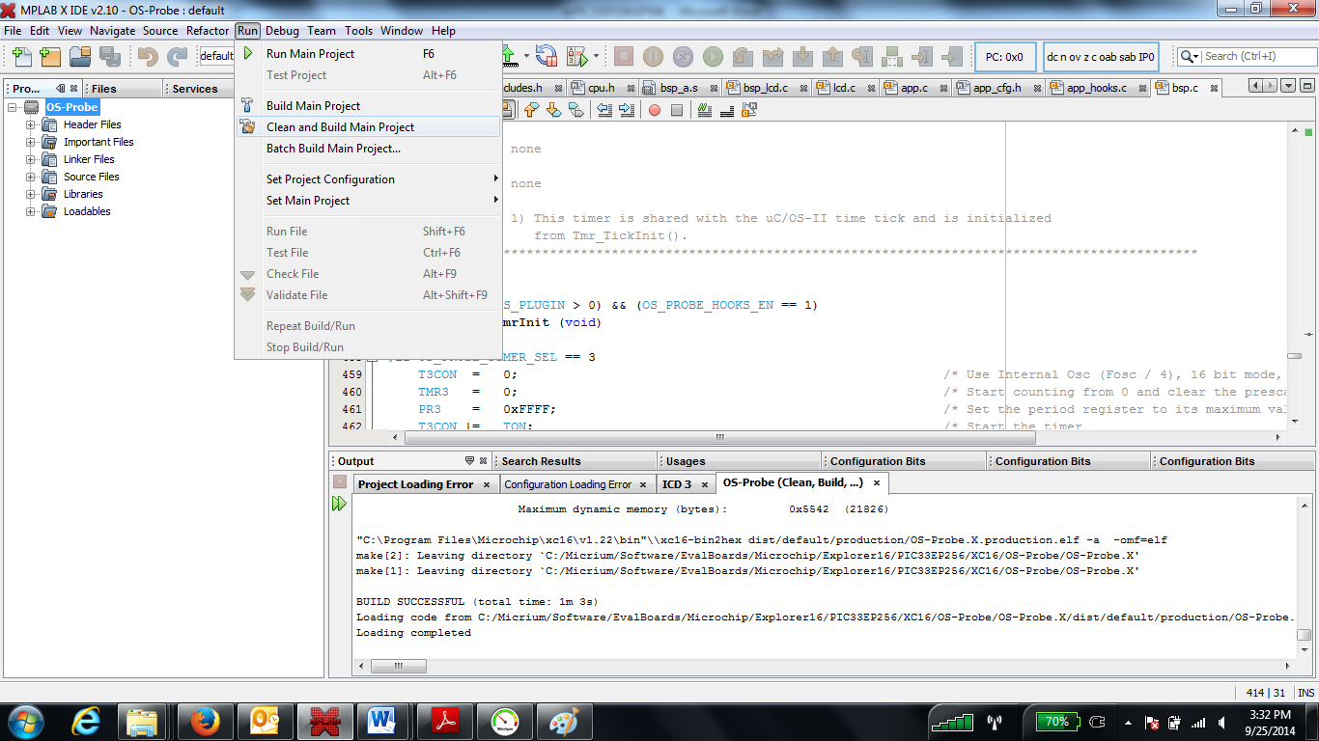

1. Run Project

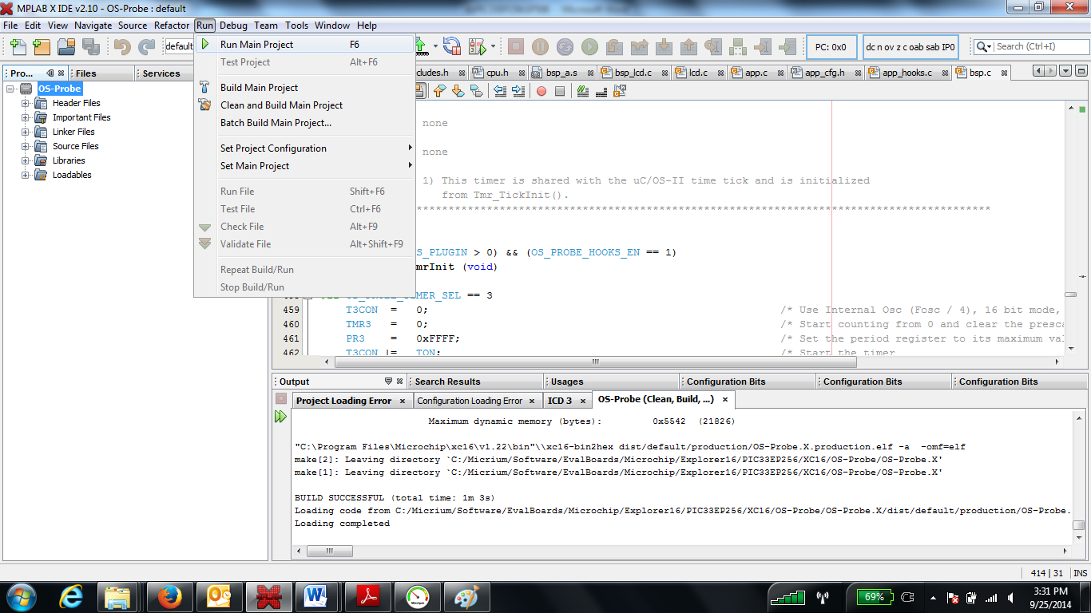

1. Debug

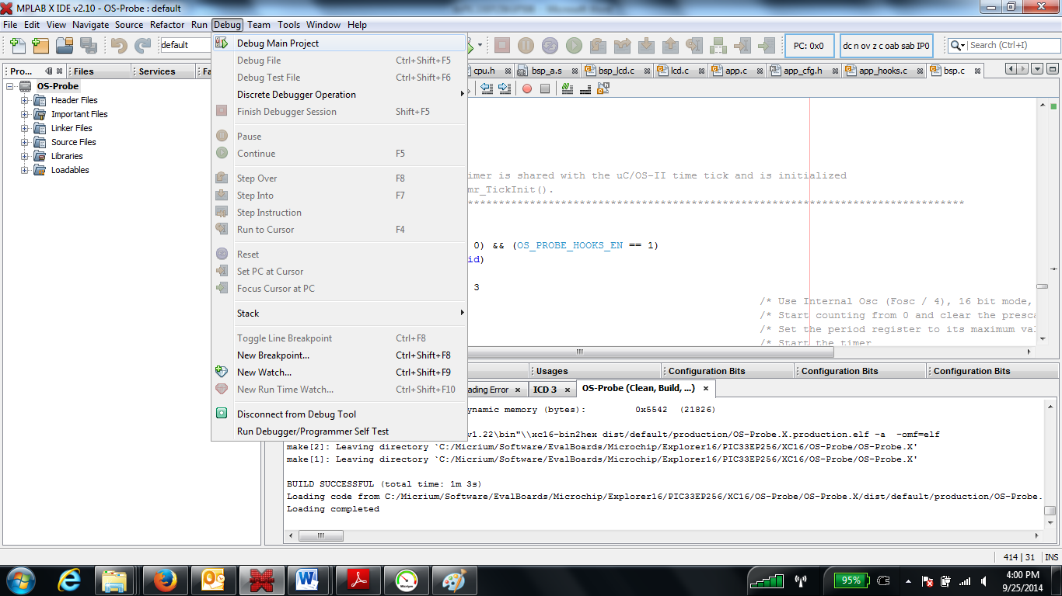

**Hardware:**

