Hanoi University of Science and Technology
School of Information and Communication Technology
──────── * ───────


Network Programming Project
Application Design

Kahoot

Group Number: 4
Group members:
- Nguyễn Tuấn Anh - 20176680
- Nguyễn Bình Long - 20176807
- Lê Hồng Minh - 20176820

Hanoi, April 2020
Application Design Report

- Introduction
  - The project is a multi-player game based on Kahoot:
Host can create rooms and questions. Other players can join rooms to answer them and earn points. Player who has a highest point can get a reward.

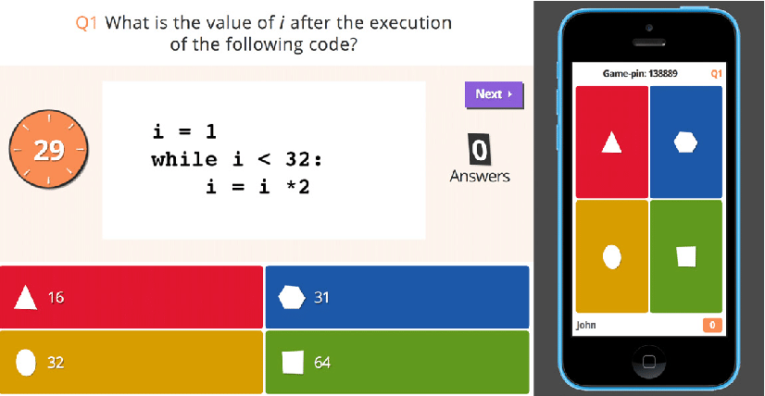

  - Technology used:
  - Programming language: Java
  - Socket API on Java
  - GUI: Java swing

- Architecture:
Client / Server architecture
TCP/IP model
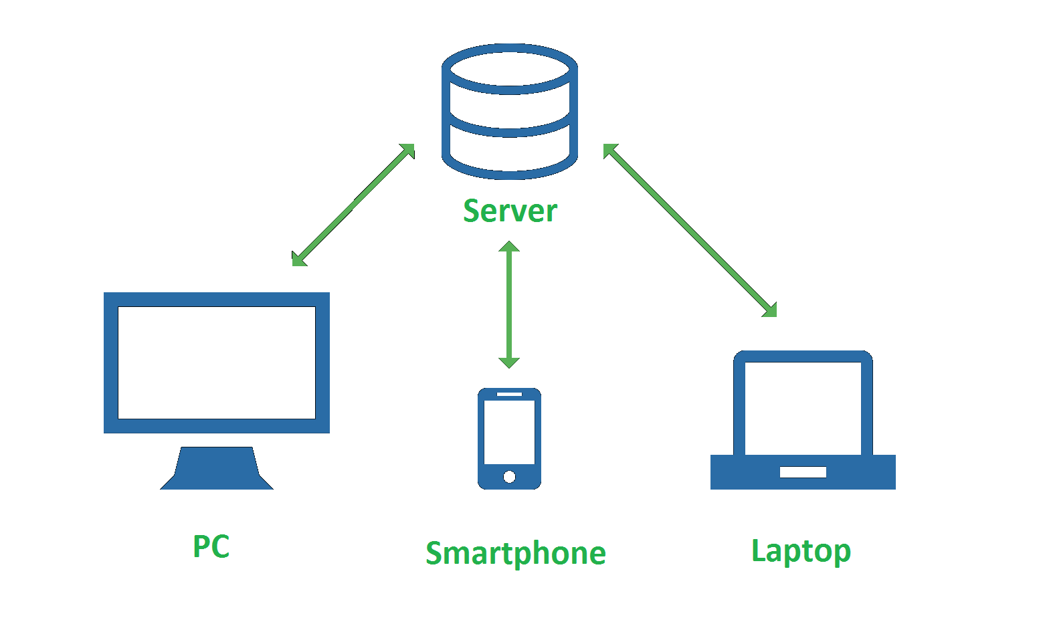

- Functionalities
- Client can choose to create room or join a room by entering room ID.
- Create name: Client is asked to create a name.
- Create room: Client enters some questions and answers into the form generated by the server. Those questions and answers will be sent to the server and stored into a database. This client can choose the time to start the game.
- Enter room: Client enters the room ID to join a room. When the host start the game, choices are given for the client to choose the answer
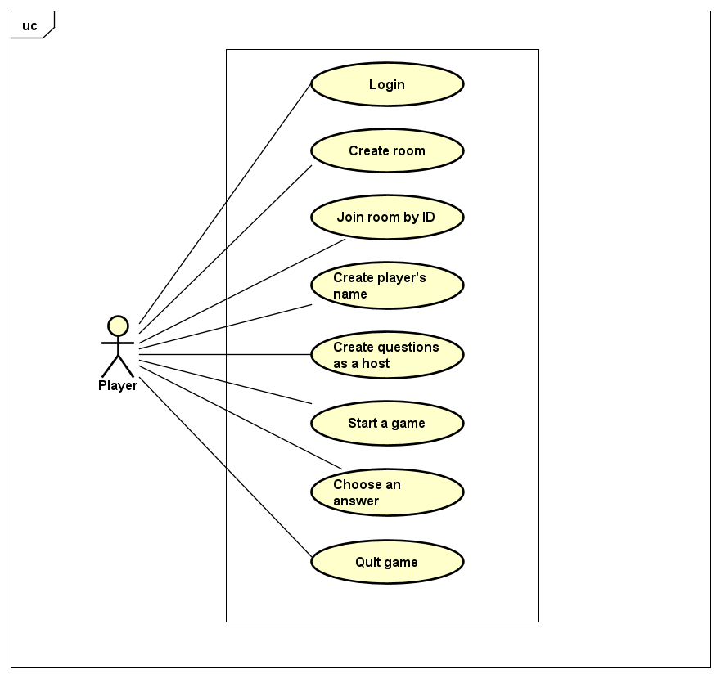

- Server stores the database, update the database whenever a client hosting a new room. When the game is started, questions and answers are re-sent to the host to be displayed.

- Application protocol design:
- Client:
- LI: login
- CR: create room
- CN : create name
- JR: join room
- RL: get list of room
- ER: exit room
- CQ: create question + 4 options
- GQ: get question
- CA: create answer
- CO: choose option
- SG: start game
- GS: get score
- CSc: create score
- US: update score
- CT: create topic
- TL: get list of topic
- CS: close socket
- WH: wait host

- Server:
- OK: accept
- NO: refuse

- Message & Message Processing

From Client to Server | From Server to Client
LI <Username> <Password>  - Request to login  CN <Name> <password>  - Request to create name | OK  - Response login successfully  NO  - Reponse login unseccessfull  OK <Name>  Response name created
CR  - Request to create a room. | OK <Room_ID>  - Response a room ID.
JR <Room_ID>  - Request to join a room with ID.  JR <Room_ID> <Password>  - Request to join a room with ID and password. | OK  - Response to host of the room and the one who joins the room.  NO Pass_Require  - Response to the client who wants to join the room to enter room’s password.  NO Room_full  - Response to the client who wants to join the room if the room with that ID is already full.
RL  - Get room list | OK  - Response list of available room
SG  - Request to start the game. | OK  - Response to all clients in the room to start the game.
ER  - Request to exit the room. | OK  - Response to the client who exits  EX <Client_ID>  - Response to the other clients that <Client_ID> has left the room.
CQ <Question> -- <Choice1> -- <Choice2> -- <Choice3> -- <Choice4> -- <Answer  - Request to create a question with 4 options  CA <Choice>  - Request to create correct answer | OK  - Response question created successfully  NO  - Response question created unsuccessfully  OK  - Response answer created successfully
GQ <Room_ID>  - Get question from given room | OK <Question> - <Choice1> - <Choice2> - <Choice3> - <Choice4>  - Response question from database
GS <Room_ID>  - Get score of players playing given room | OK  - Response score of each player
US <Username> - <Room_ID> - <Score>  - Update score of player | OK  - Response score of player is updated successfully
CSc <Username> - <Room_ID> - <0>  - Initial score of player | OK  - Response score of player is initial successfully
CT <Username> - <Topic>  - Create new topic | OK  - Response topic created successfully
TL <Username>  - Get list of topics | OK  - Response list of available topics
CS  - Close socket | OK
WH  - Wait host | OK

Database design

