Touchstone 4 Template
Interactivity and Client-Side Data
Name:
Course: | Introduction to Web Development
Date:
Selected Client: | Client A: North Star Bakery

Important: Continue using the same client and website from Touchstone Task 2 and Touchstone 3. Submit this completed template as your single Touchstone file. Your linked project must contain the updated HTML, CSS, and JavaScript files.

Section 1: Project Link
Paste the URL to your public GitHub repository for this project. The repository should include all updated HTML, CSS, and JavaScript files required for this Touchstone.
Working Project Link:
Repository Link (if different):

Section 2: Implementation Explanation
Respond to every prompt below. Each response should be 2–4 sentences, refer to a specific element or behavior from your project, and explain how the implementation works. Reference your screenshots where requested.
Feature Purpose
Explain what your interactive feature helps users do and how it supports your client’s goals or audience. Identify the page where the feature appears and describe the user need it addresses.
Reference Screenshot 1 in your response.
Response:
The interactive feature is a pre-order list on products.html, where visitors add or remove bakery items with a button on each product card. North Star Bakery wants to encourage pre-orders from local customers, commuters, families, and event planners, and this feature lets a busy visitor collect everything they want while browsing instead of trying to remember it. As shown in Screenshot 1, the "My Pre-Order List" panel updates immediately and includes a "Request these items" link to the contact form. This supports the client's goal of turning browsing into pre-order requests.

User Interaction
Describe how a user interacts with the feature step by step. Explain what JavaScript changes on the page after the user clicks, selects, or enters information.
Include the key action and the visible result.
Response:
A visitor clicks "Add to pre-order list" on a product card such as Country Sourdough. JavaScript adds that item's id to the savedIds array, changes the button to "Added to list (remove)" with aria-pressed set to true, and rebuilds the My Pre-Order List panel with the item name and a Remove button. Clicking the card button again, clicking Remove in the panel, or clicking Clear list removes items, and the status message updates to show how many items are saved. When the visitor opens the contact page, the saved items are written into the item details field and the pre-order request type is selected automatically.

Form Validation
Identify at least two JavaScript validation checks you added to your form. Explain how invalid submission is prevented and how feedback appears near the relevant fields so users can correct their entries.
Reference Screenshot 2 and quote or summarize at least one error message.
Response:
I added JavaScript validation to the contact form for required fields (name, email, request type, and item details), email format (using a regular expression), phone format (###-###-####), message length (10 to 500 characters), and a pickup date rule that requires at least two days of notice and rejects Mondays because the bakery is closed. The form has the novalidate attribute and a submit handler that calls event.preventDefault(), runs validateForm(), and stops the submission if any field has an error. As Screenshot 2 shows, each message appears directly under its field, such as "Error: We are closed on Mondays. Please choose another day.", and invalid fields get a thicker dashed border. The entries stay in the form, focus moves to the first invalid field, and each error disappears as soon as the user starts correcting that field.

Data Storage
State whether you used localStorage or sessionStorage. Explain what data is stored, when it is saved, and when it is loaded again. Describe how this improves the user experience.
Reference Screenshot 3 and identify the restored or remembered data.
Response:
I used localStorage with the key northStarPreorderList to store the visitor's saved pre-order items as a JSON array of item ids. The list is saved every time an item is added, removed, or cleared, and it is loaded when products.html opens and again when contact.html opens to pre-fill the form. Screenshot 3 was taken after refreshing the products page, and it shows the same three items still in the list with the Country Sourdough button still marked "Added to list (remove)". This improves the experience because a customer can browse, leave, and come back later without rebuilding their list, and the list is cleared after a request is successfully submitted.

Technical Design
Explain how functions organize your JavaScript and how arrays or objects manage data. Name at least one function and one array or object, then describe what each does in your implementation.
For Advanced performance, the rubric expects at least two arrays or at least two objects.
Response:
The JavaScript is divided into small functions that each do one job, such as toggleItem() to add or remove an item, renderList() to rebuild the list panel, loadSavedIds() and storeSavedIds() to read and write localStorage, and validateEmail() and validatePickupDate() to check individual fields. The catalog array holds one object for each product (with an id, name, and category), and the savedIds array tracks which items the visitor chose. The messages object keeps every validation message in one place, and the settings object stores the storage key, the minimum days of notice, and the closed day. A validateForm() function returns an object that maps each field to its error message, so the submit handler can show the errors and find the first invalid field.

Challenges Encountered
Describe one specific problem you encountered while building or testing the feature, validation, or storage. Explain what was not working, how you identified the cause, and what change fixed it.
Focus on a real implementation decision rather than a general statement.
Response:
While testing, a valid contact form submission showed no confirmation message, and the browser console reported "Cannot set properties of null (setting 'innerHTML')". I traced it to handleSubmit(), which calls clearList() to empty the saved list after a request; clearList() calls updateProductsPage(), which tries to update a list element that exists only on products.html, so it threw an error on the contact page before the success message could appear. I fixed it by adding a check at the top of updateProductsPage() that returns early when the saved-list element is not on the page. After that change, the success message appeared and the console stayed clear.

Section 3: Technical and Submission Checklist
Check each item after testing your project.
☒ One meaningful JavaScript feature responds to a click, selection, or user input.
☒ The feature updates the page dynamically and clearly supports the client’s goals.
☒ JavaScript is organized into multiple functions rather than one large block.
☒ At least one array or object is used to manage data.
☒ For Advanced performance, at least two arrays or at least two objects are used.
☒ At least two JavaScript validation checks are implemented.
☒ Invalid form submission is prevented.
☒ Clear validation feedback appears near the relevant fields.
☒ Users can correct errors without losing the information they already entered.
☒ localStorage or sessionStorage saves at least one meaningful piece of data.
☒ Stored data is loaded when the relevant page opens or reloads.
☒ All previous HTML, CSS, navigation, media, and form functionality still works.
☐ The working project link is included and opens without requiring sign-in.
☒ All six explanation sections are complete and use project-specific examples.
☒ At least three screenshots and captions are included below.

Section 4: Screenshots
Insert at least three clear screenshots. Crop each image so the relevant feature is easy to see, and add a short caption that explains what the screenshot proves.
Screenshot 1: Interactive Feature in Use
Show the feature after a user action and the resulting dynamic update on the page.
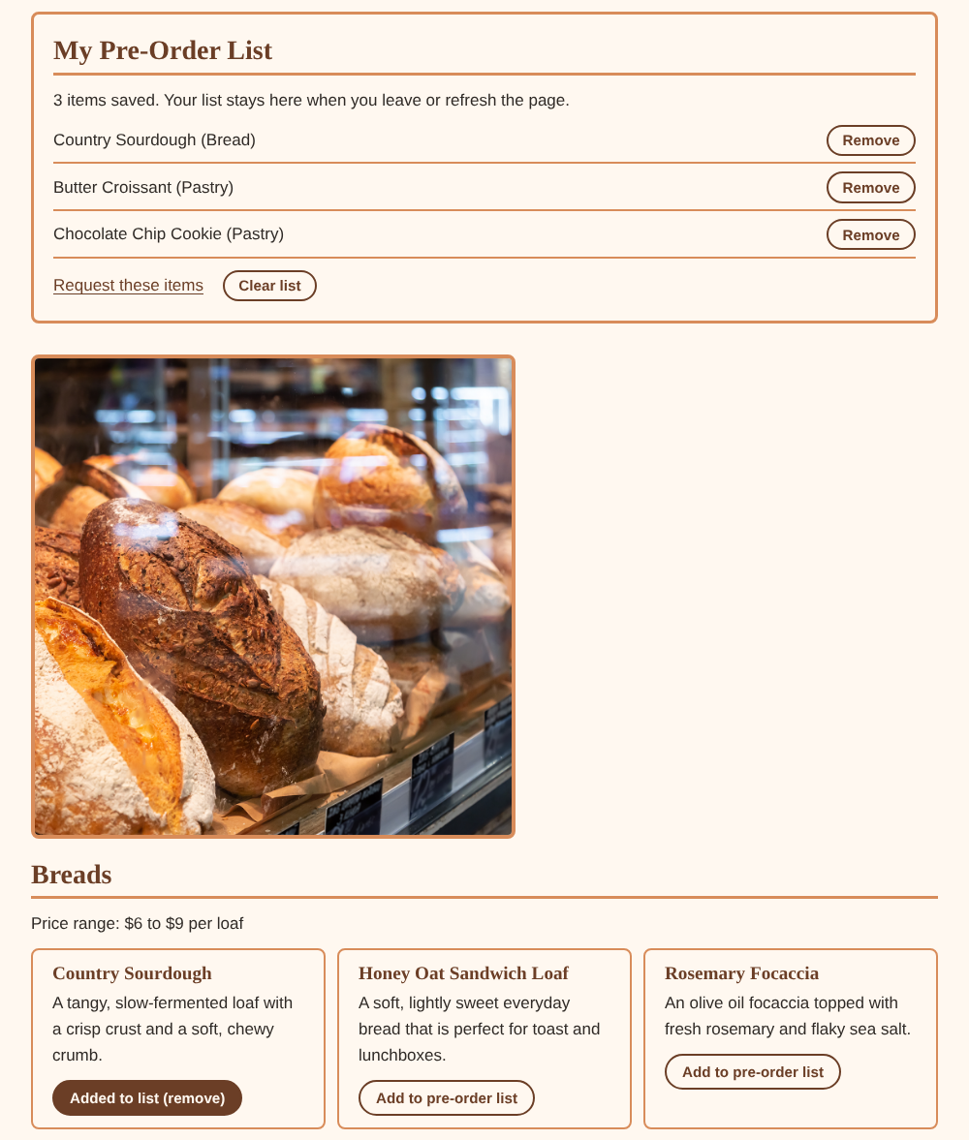
Caption: After clicking "Add to pre-order list" on three items, the My Pre-Order List panel on products.html updates and the Country Sourdough button changes to "Added to list (remove)".
Screenshot 2: Form Validation Feedback
Show at least two validation messages displayed near the relevant fields while submission is prevented.
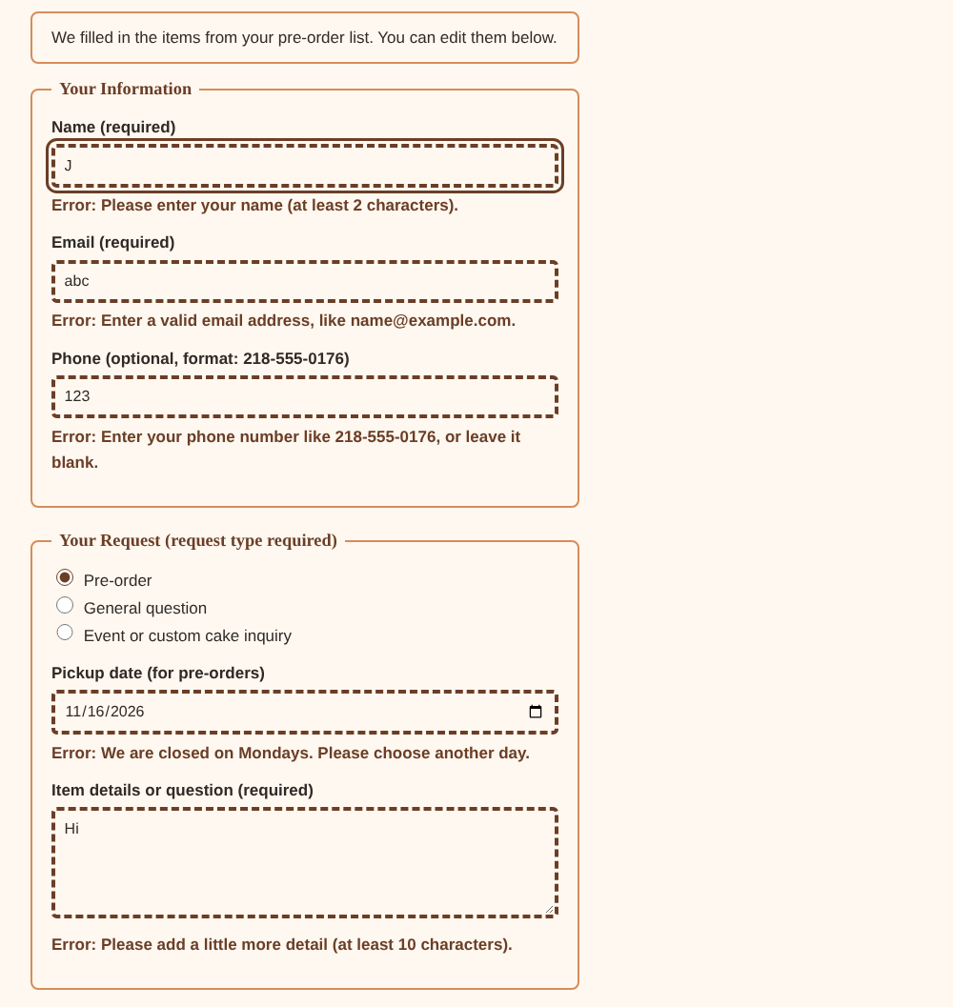
Caption: Submitting the contact form with invalid entries is blocked, and error messages appear beneath the name, email, phone, pickup date, and message fields while the entries stay in place.
Screenshot 3: Browser Storage Working
Show data restored after a refresh or return visit, such as a remembered selection, saved favorite, or pre-filled field.
Caption: After refreshing products.html, the saved items are loaded from localStorage and the Country Sourdough button still shows as added.

Section 5: Final Review
☐ The interactive feature works as expected after repeated testing.
☐ The page updates dynamically when the user takes the intended action.
☐ Validation prevents invalid submission and messages appear near fields.
☐ Valid form entries can proceed without unnecessary errors.
☐ Stored data saves and reloads correctly after refreshing or reopening the page.
☐ No JavaScript errors appear in the browser console during normal use.
☐ Navigation and relative file paths work across all pages.
☐ The project remains readable and usable at mobile and desktop widths.
☐ The submitted link and all screenshots match the final version of the project.

Section 1: GitHub Repository
Paste the URL to your public GitHub repository for this project. The repository should include all updated HTML, CSS, and JavaScript files required for this Touchstone.
Repository URL:
______________________________________

Updated Final Review Items
- ☐ Public GitHub repository link included
- ☐ Repository opens without requiring login
- ☐ Repository contains all updated HTML, CSS, and JavaScript files
- ☐ Interactive feature works as expected
- ☐ Form validation prevents invalid submission
- ☐ Feedback appears near the relevant fields
- ☐ Stored data persists correctly
- ☐ Previous HTML and CSS functionality remains intact

