using System;
using System.Data;
using System.Data.SqlClient;
using System.Windows.Forms;

namespace _1150080005_Lab7
{
public partial class Form1 : Form
{
string strCon = @"Data Source=LAPTOP-J64LDBSP\SQL2022;
Initial Catalog=QuanLyBanSach;
Integrated Security=True";

SqlConnection sqlCon = null;

public Form1()
{
InitializeComponent();
}
private void MoKetNoi()
{
if (sqlCon == null)
sqlCon = new SqlConnection(strCon);

if (sqlCon.State == ConnectionState.Closed)
sqlCon.Open();
}
private void DongKetNoi()
{
if (sqlCon != null && sqlCon.State == ConnectionState.Open)
sqlCon.Close();
}
private void btnHienThi_Click(object sender, EventArgs e)
{
try
{
MoKetNoi();
string sql = "SELECT * FROM NhaXuatBan";
SqlDataAdapter adapter = new SqlDataAdapter(sql, sqlCon);
DataSet ds = new DataSet();
adapter.Fill(ds, "NhaXuatBan");
dgvDanhSach.DataSource = ds.Tables["NhaXuatBan"];
}
catch (Exception ex)
{
MessageBox.Show("Lỗi khi hiển thị dữ liệu: " + ex.Message);
}
finally
{
DongKetNoi();
}
}
}
}

Form1.designer.cs
namespace _1150080005_Lab7
{
partial class Form1
{
private System.ComponentModel.IContainer components = null;

/// <summary>
/// Dọn tài nguyên
/// </summary>
/// <param name="disposing"></param>
protected override void Dispose(bool disposing)
{
if (disposing && (components != null))
{
components.Dispose();
}
base.Dispose(disposing);
}

#region Windows Form Designer generated code

private void InitializeComponent()
{
this.btnHienThi = new System.Windows.Forms.Button();
this.dgvDanhSach = new System.Windows.Forms.DataGridView();
((System.ComponentModel.ISupportInitialize)(this.dgvDanhSach)).BeginInit();
this.SuspendLayout();
this.btnHienThi.Font = new System.Drawing.Font("Microsoft Sans Serif", 10F, System.Drawing.FontStyle.Bold);
this.btnHienThi.Location = new System.Drawing.Point(120, 30);
this.btnHienThi.Name = "btnHienThi";
this.btnHienThi.Size = new System.Drawing.Size(550, 50);
this.btnHienThi.TabIndex = 0;
this.btnHienThi.Text = "Hiển thị danh sách";
this.btnHienThi.UseVisualStyleBackColor = true;
this.btnHienThi.Click += new System.EventHandler(this.btnHienThi_Click);
this.dgvDanhSach.ColumnHeadersHeightSizeMode = System.Windows.Forms.DataGridViewColumnHeadersHeightSizeMode.AutoSize;
this.dgvDanhSach.Location = new System.Drawing.Point(50, 100);
this.dgvDanhSach.Name = "dgvDanhSach";
this.dgvDanhSach.RowHeadersWidth = 51;
this.dgvDanhSach.RowTemplate.Height = 24;
this.dgvDanhSach.Size = new System.Drawing.Size(700, 300);
this.dgvDanhSach.TabIndex = 1;
this.AutoScaleDimensions = new System.Drawing.SizeF(8F, 16F);
this.AutoScaleMode = System.Windows.Forms.AutoScaleMode.Font;
this.ClientSize = new System.Drawing.Size(800, 450);
this.Controls.Add(this.dgvDanhSach);
this.Controls.Add(this.btnHienThi);
this.Name = "Form1";
this.StartPosition = System.Windows.Forms.FormStartPosition.CenterScreen;
this.Text = "Quản lý Nhà Xuất Bản";
((System.ComponentModel.ISupportInitialize)(this.dgvDanhSach)).EndInit();
this.ResumeLayout(false);
}

#endregion

private System.Windows.Forms.Button btnHienThi;
private System.Windows.Forms.DataGridView dgvDanhSach;
}
}

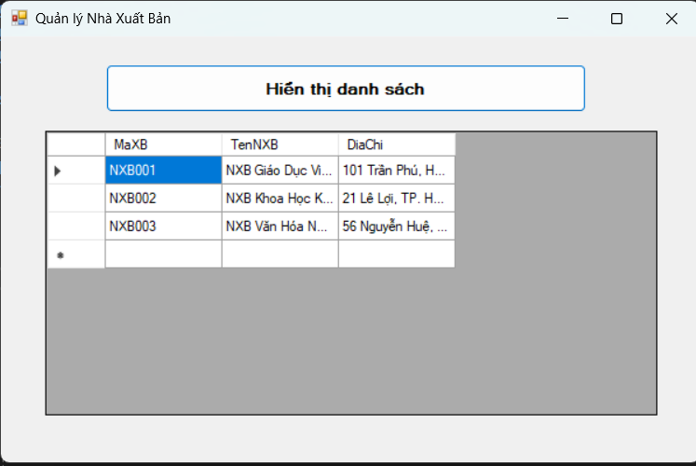

using System;
using System.Data;
using System.Data.SqlClient;
using System.Windows.Forms;

namespace _1150080005_Lab7
{
public partial class Form2 : Form
{
string strCon = @"Data Source=LAPTOP-J64LDBSP\SQL2022;
Initial Catalog=QuanLyBanSach;
Integrated Security=True";

SqlConnection sqlCon = null;

public Form2()
{
InitializeComponent();
}
private void MoKetNoi()
{
if (sqlCon == null)
sqlCon = new SqlConnection(strCon);
if (sqlCon.State == ConnectionState.Closed)
sqlCon.Open();
}

private void DongKetNoi()
{
if (sqlCon != null && sqlCon.State == ConnectionState.Open)
sqlCon.Close();
}
private void HienThiDuLieu()
{
try
{
MoKetNoi();
string sql = "SELECT * FROM NhaXuatBan";
SqlCommand cmd = new SqlCommand(sql, sqlCon);
SqlDataReader reader = cmd.ExecuteReader();

lsvNXB.Items.Clear();
while (reader.Read())
{
ListViewItem lvi = new ListViewItem(reader["MaXB"].ToString());
lvi.SubItems.Add(reader["TenNXB"].ToString());
lvi.SubItems.Add(reader["DiaChi"].ToString());
lsvNXB.Items.Add(lvi);
}

reader.Close();
}
catch (Exception ex)
{
MessageBox.Show("❌ Lỗi hiển thị dữ liệu: " + ex.Message);
}
finally
{
DongKetNoi();
}
}
private void Form2_Load(object sender, EventArgs e)
{
// Cấu hình ListView
lsvNXB.View = View.Details;
lsvNXB.FullRowSelect = true;
lsvNXB.GridLines = true;

lsvNXB.Columns.Add("Mã NXB", 100);
lsvNXB.Columns.Add("Tên NXB", 200);
lsvNXB.Columns.Add("Địa chỉ", 250);

// Hiển thị dữ liệu ban đầu
HienThiDuLieu();
}
private void btnThem_Click(object sender, EventArgs e)
{
if (txtMaNXB.Text == "" || txtTenNXB.Text == "" || txtDiaChi.Text == "")
{
MessageBox.Show("⚠️ Vui lòng nhập đầy đủ thông tin!");
return;
}

try
{
MoKetNoi();
string sql = "INSERT INTO NhaXuatBan (MaXB, TenNXB, DiaChi) VALUES (@ma, @ten, @diachi)";
SqlCommand cmd = new SqlCommand(sql, sqlCon);
cmd.Parameters.AddWithValue("@ma", txtMaNXB.Text.Trim());
cmd.Parameters.AddWithValue("@ten", txtTenNXB.Text.Trim());
cmd.Parameters.AddWithValue("@diachi", txtDiaChi.Text.Trim());

int rows = cmd.ExecuteNonQuery();
if (rows > 0)
{
MessageBox.Show("✅ Thêm dữ liệu thành công!");
txtMaNXB.Clear();
txtTenNXB.Clear();
txtDiaChi.Clear();
HienThiDuLieu();
}
else
{
MessageBox.Show("❌ Thêm dữ liệu thất bại!");
}
}
catch (Exception ex)
{
MessageBox.Show("❌ Lỗi khi thêm dữ liệu: " + ex.Message);
}
finally
{
DongKetNoi();
}
}
}
}

Form2.designer.cs
namespace _1150080005_Lab7
{
partial class Form2
{
private System.ComponentModel.IContainer components = null;

/// <summary>
/// Giải phóng tài nguyên
/// </summary>
protected override void Dispose(bool disposing)
{
if (disposing && (components != null))
{
components.Dispose();
}
base.Dispose(disposing);
}

#region Windows Form Designer generated code

private void InitializeComponent()
{
this.lblTieuDe = new System.Windows.Forms.Label();
this.lblDanhSach = new System.Windows.Forms.Label();
this.lsvNXB = new System.Windows.Forms.ListView();
this.lblMaNXB = new System.Windows.Forms.Label();
this.lblTenNXB = new System.Windows.Forms.Label();
this.lblDiaChi = new System.Windows.Forms.Label();
this.txtMaNXB = new System.Windows.Forms.TextBox();
this.txtTenNXB = new System.Windows.Forms.TextBox();
this.txtDiaChi = new System.Windows.Forms.TextBox();
this.btnThem = new System.Windows.Forms.Button();
this.lblNhapThongTin = new System.Windows.Forms.Label();
this.SuspendLayout();
this.lblTieuDe.AutoSize = true;
this.lblTieuDe.Font = new System.Drawing.Font("Microsoft Sans Serif", 12F, System.Drawing.FontStyle.Bold);
this.lblTieuDe.Location = new System.Drawing.Point(270, 15);
this.lblTieuDe.Name = "lblTieuDe";
this.lblTieuDe.Size = new System.Drawing.Size(265, 25);
this.lblTieuDe.TabIndex = 0;
this.lblTieuDe.Text = "Thêm dữ liệu vào database";
this.lblDanhSach.AutoSize = true;
this.lblDanhSach.Location = new System.Drawing.Point(20, 60);
this.lblDanhSach.Name = "lblDanhSach";
this.lblDanhSach.Size = new System.Drawing.Size(128, 16);
this.lblDanhSach.TabIndex = 1;
this.lblDanhSach.Text = "Danh sách nhà xuất bản:";
this.lsvNXB.Location = new System.Drawing.Point(20, 80);
this.lsvNXB.Name = "lsvNXB";
this.lsvNXB.Size = new System.Drawing.Size(360, 330);
this.lsvNXB.TabIndex = 2;
this.lsvNXB.UseCompatibleStateImageBehavior = false;
this.lblNhapThongTin.AutoSize = true;
this.lblNhapThongTin.Location = new System.Drawing.Point(420, 60);
this.lblNhapThongTin.Name = "lblNhapThongTin";
this.lblNhapThongTin.Size = new System.Drawing.Size(90, 16);
this.lblNhapThongTin.TabIndex = 3;
this.lblNhapThongTin.Text = "Nhập thông tin:";
this.lblMaNXB.AutoSize = true;
this.lblMaNXB.Location = new System.Drawing.Point(420, 100);
this.lblMaNXB.Name = "lblMaNXB";
this.lblMaNXB.Size = new System.Drawing.Size(58, 16);
this.lblMaNXB.TabIndex = 4;
this.lblMaNXB.Text = "Mã NXB:";
this.txtMaNXB.Location = new System.Drawing.Point(500, 95);
this.txtMaNXB.Name = "txtMaNXB";
this.txtMaNXB.Size = new System.Drawing.Size(250, 22);
this.txtMaNXB.TabIndex = 5;
this.lblTenNXB.AutoSize = true;
this.lblTenNXB.Location = new System.Drawing.Point(420, 145);
this.lblTenNXB.Name = "lblTenNXB";
this.lblTenNXB.Size = new System.Drawing.Size(63, 16);
this.lblTenNXB.TabIndex = 6;
this.lblTenNXB.Text = "Tên NXB:";

this.txtTenNXB.Location = new System.Drawing.Point(500, 140);
this.txtTenNXB.Name = "txtTenNXB";
this.txtTenNXB.Size = new System.Drawing.Size(250, 22);
this.txtTenNXB.TabIndex = 7;

this.lblDiaChi.AutoSize = true;
this.lblDiaChi.Location = new System.Drawing.Point(420, 190);
this.lblDiaChi.Name = "lblDiaChi";
this.lblDiaChi.Size = new System.Drawing.Size(49, 16);
this.lblDiaChi.TabIndex = 8;
this.lblDiaChi.Text = "Địa chỉ:";

this.txtDiaChi.Location = new System.Drawing.Point(500, 185);
this.txtDiaChi.Name = "txtDiaChi";
this.txtDiaChi.Size = new System.Drawing.Size(250, 22);
this.txtDiaChi.TabIndex = 9;
this.btnThem.Location = new System.Drawing.Point(500, 230);
this.btnThem.Name = "btnThem";
this.btnThem.Size = new System.Drawing.Size(250, 35);
this.btnThem.TabIndex = 10;
this.btnThem.Text = "Thêm dữ liệu";
this.btnThem.UseVisualStyleBackColor = true;
this.btnThem.Click += new System.EventHandler(this.btnThem_Click);

this.AutoScaleDimensions = new System.Drawing.SizeF(8F, 16F);
this.AutoScaleMode = System.Windows.Forms.AutoScaleMode.Font;
this.ClientSize = new System.Drawing.Size(800, 450);
this.Controls.Add(this.btnThem);
this.Controls.Add(this.txtDiaChi);
this.Controls.Add(this.lblDiaChi);
this.Controls.Add(this.txtTenNXB);
this.Controls.Add(this.lblTenNXB);
this.Controls.Add(this.txtMaNXB);
this.Controls.Add(this.lblMaNXB);
this.Controls.Add(this.lblNhapThongTin);
this.Controls.Add(this.lsvNXB);
this.Controls.Add(this.lblDanhSach);
this.Controls.Add(this.lblTieuDe);
this.Name = "Form2";
this.StartPosition = System.Windows.Forms.FormStartPosition.CenterScreen;
this.Text = "Thêm dữ liệu";
this.Load += new System.EventHandler(this.Form2_Load);
this.ResumeLayout(false);
this.PerformLayout();
}

#endregion

private System.Windows.Forms.Label lblTieuDe;
private System.Windows.Forms.Label lblDanhSach;
private System.Windows.Forms.ListView lsvNXB;
private System.Windows.Forms.Label lblMaNXB;
private System.Windows.Forms.Label lblTenNXB;
private System.Windows.Forms.Label lblDiaChi;
private System.Windows.Forms.TextBox txtMaNXB;
private System.Windows.Forms.TextBox txtTenNXB;
private System.Windows.Forms.TextBox txtDiaChi;
private System.Windows.Forms.Button btnThem;
private System.Windows.Forms.Label lblNhapThongTin;
}
}

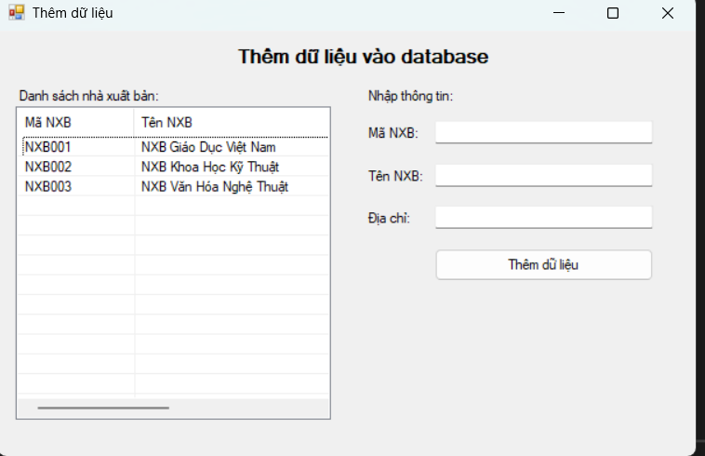

using System;
using System.Data;
using System.Data.SqlClient;
using System.Windows.Forms;

namespace _1150080005_Lab7
{
public partial class Form3 : Form
{

string strCon = @"Data Source=LAPTOP-J64LDBSP\SQL2022;
Initial Catalog=QuanLyBanSach;
Integrated Security=True";

SqlConnection sqlCon = null;

public Form3()
{
InitializeComponent();
}
private void MoKetNoi()
{
if (sqlCon == null)
sqlCon = new SqlConnection(strCon);
if (sqlCon.State == ConnectionState.Closed)
sqlCon.Open();
}

private void DongKetNoi()
{
if (sqlCon != null && sqlCon.State == ConnectionState.Open)
sqlCon.Close();
}

private void HienThiDuLieu()
{
try
{
MoKetNoi();
string sql = "SELECT * FROM NhaXuatBan";
SqlCommand cmd = new SqlCommand(sql, sqlCon);
SqlDataReader reader = cmd.ExecuteReader();

lsvNXB.Items.Clear();
while (reader.Read())
{
ListViewItem lvi = new ListViewItem(reader["MaXB"].ToString());
lvi.SubItems.Add(reader["TenNXB"].ToString());
lvi.SubItems.Add(reader["DiaChi"].ToString());
lsvNXB.Items.Add(lvi);
}

reader.Close();
}
catch (Exception ex)
{
MessageBox.Show("❌ Lỗi hiển thị dữ liệu: " + ex.Message);
}
finally
{
DongKetNoi();
}
}

private void Form3_Load(object sender, EventArgs e)
{
lsvNXB.View = View.Details;
lsvNXB.FullRowSelect = true;
lsvNXB.GridLines = true;
lsvNXB.Columns.Add("Mã NXB", 100);
lsvNXB.Columns.Add("Tên NXB", 200);
lsvNXB.Columns.Add("Địa chỉ", 250);

HienThiDuLieu();
}

private void lsvNXB_SelectedIndexChanged(object sender, EventArgs e)
{
if (lsvNXB.SelectedItems.Count > 0)
{
ListViewItem lvi = lsvNXB.SelectedItems[0];
txtMaNXB.Text = lvi.SubItems[0].Text;
txtTenNXB.Text = lvi.SubItems[1].Text;
txtDiaChi.Text = lvi.SubItems[2].Text;
}
}

private void btnSua_Click(object sender, EventArgs e)
{
if (txtMaNXB.Text == "")
{
MessageBox.Show("⚠️ Vui lòng chọn nhà xuất bản để sửa!");
return;
}

try
{
MoKetNoi();
string sql = "UPDATE NhaXuatBan SET TenNXB=@ten, DiaChi=@diachi WHERE MaXB=@ma";
SqlCommand cmd = new SqlCommand(sql, sqlCon);
cmd.Parameters.AddWithValue("@ma", txtMaNXB.Text.Trim());
cmd.Parameters.AddWithValue("@ten", txtTenNXB.Text.Trim());
cmd.Parameters.AddWithValue("@diachi", txtDiaChi.Text.Trim());

int rows = cmd.ExecuteNonQuery();
if (rows > 0)
{
MessageBox.Show("✅ Cập nhật thành công!");
HienThiDuLieu();
}
else
{
MessageBox.Show("❌ Không tìm thấy Mã NXB để sửa!");
}
}
catch (Exception ex)
{
MessageBox.Show("❌ Lỗi khi sửa dữ liệu: " + ex.Message);
}
finally
{
DongKetNoi();
}
}
}
}

Form3.designer.cs
namespace _1150080005_Lab7
{
partial class Form3
{
private System.ComponentModel.IContainer components = null;

/// <summary>
/// Giải phóng tài nguyên
/// </summary>
protected override void Dispose(bool disposing)
{
if (disposing && (components != null))
{
components.Dispose();
}
base.Dispose(disposing);
}

#region Windows Form Designer generated code

private void InitializeComponent()
{
this.lblTieuDe = new System.Windows.Forms.Label();
this.lblDanhSach = new System.Windows.Forms.Label();
this.lsvNXB = new System.Windows.Forms.ListView();
this.lblNhapThongTin = new System.Windows.Forms.Label();
this.lblMaNXB = new System.Windows.Forms.Label();
this.lblTenNXB = new System.Windows.Forms.Label();
this.lblDiaChi = new System.Windows.Forms.Label();
this.txtMaNXB = new System.Windows.Forms.TextBox();
this.txtTenNXB = new System.Windows.Forms.TextBox();
this.txtDiaChi = new System.Windows.Forms.TextBox();
this.btnSua = new System.Windows.Forms.Button();
this.SuspendLayout();

this.lblTieuDe.AutoSize = true;
this.lblTieuDe.Font = new System.Drawing.Font("Microsoft Sans Serif", 12F, System.Drawing.FontStyle.Bold);
this.lblTieuDe.Location = new System.Drawing.Point(260, 15);
this.lblTieuDe.Name = "lblTieuDe";
this.lblTieuDe.Size = new System.Drawing.Size(269, 25);
this.lblTieuDe.TabIndex = 0;
this.lblTieuDe.Text = "Chỉnh sửa thông tin dữ liệu";

this.lblDanhSach.AutoSize = true;
this.lblDanhSach.Location = new System.Drawing.Point(20, 60);
this.lblDanhSach.Name = "lblDanhSach";
this.lblDanhSach.Size = new System.Drawing.Size(134, 16);
this.lblDanhSach.TabIndex = 1;
this.lblDanhSach.Text = "Danh sách nhà xuất bản:";

this.lsvNXB.Location = new System.Drawing.Point(20, 80);
this.lsvNXB.Name = "lsvNXB";
this.lsvNXB.Size = new System.Drawing.Size(360, 330);
this.lsvNXB.TabIndex = 2;
this.lsvNXB.UseCompatibleStateImageBehavior = false;
this.lsvNXB.SelectedIndexChanged += new System.EventHandler(this.lsvNXB_SelectedIndexChanged);

this.lblNhapThongTin.AutoSize = true;
this.lblNhapThongTin.Location = new System.Drawing.Point(420, 60);
this.lblNhapThongTin.Name = "lblNhapThongTin";
this.lblNhapThongTin.Size = new System.Drawing.Size(106, 16);
this.lblNhapThongTin.TabIndex = 3;
this.lblNhapThongTin.Text = "Chỉnh sửa thông tin:";

this.lblMaNXB.AutoSize = true;
this.lblMaNXB.Location = new System.Drawing.Point(420, 100);
this.lblMaNXB.Name = "lblMaNXB";
this.lblMaNXB.Size = new System.Drawing.Size(58, 16);
this.lblMaNXB.TabIndex = 4;
this.lblMaNXB.Text = "Mã NXB:";

this.txtMaNXB.Location = new System.Drawing.Point(500, 95);
this.txtMaNXB.Name = "txtMaNXB";
this.txtMaNXB.Size = new System.Drawing.Size(250, 22);
this.txtMaNXB.TabIndex = 5;

this.lblTenNXB.AutoSize = true;
this.lblTenNXB.Location = new System.Drawing.Point(420, 145);
this.lblTenNXB.Name = "lblTenNXB";
this.lblTenNXB.Size = new System.Drawing.Size(63, 16);
this.lblTenNXB.TabIndex = 6;
this.lblTenNXB.Text = "Tên NXB:";

this.txtTenNXB.Location = new System.Drawing.Point(500, 140);
this.txtTenNXB.Name = "txtTenNXB";
this.txtTenNXB.Size = new System.Drawing.Size(250, 22);
this.txtTenNXB.TabIndex = 7;
this.lblDiaChi.AutoSize = true;
this.lblDiaChi.Location = new System.Drawing.Point(420, 190);
this.lblDiaChi.Name = "lblDiaChi";
this.lblDiaChi.Size = new System.Drawing.Size(49, 16);
this.lblDiaChi.TabIndex = 8;
this.lblDiaChi.Text = "Địa chỉ:";

this.txtDiaChi.Location = new System.Drawing.Point(500, 185);
this.txtDiaChi.Name = "txtDiaChi";
this.txtDiaChi.Size = new System.Drawing.Size(250, 22);
this.txtDiaChi.TabIndex = 9;

this.btnSua.Location = new System.Drawing.Point(500, 230);
this.btnSua.Name = "btnSua";
this.btnSua.Size = new System.Drawing.Size(250, 35);
this.btnSua.TabIndex = 10;
this.btnSua.Text = "Chỉnh sửa thông tin";
this.btnSua.UseVisualStyleBackColor = true;
this.btnSua.Click += new System.EventHandler(this.btnSua_Click);

this.AutoScaleDimensions = new System.Drawing.SizeF(8F, 16F);
this.AutoScaleMode = System.Windows.Forms.AutoScaleMode.Font;
this.ClientSize = new System.Drawing.Size(800, 450);
this.Controls.Add(this.btnSua);
this.Controls.Add(this.txtDiaChi);
this.Controls.Add(this.lblDiaChi);
this.Controls.Add(this.txtTenNXB);
this.Controls.Add(this.lblTenNXB);
this.Controls.Add(this.txtMaNXB);
this.Controls.Add(this.lblMaNXB);
this.Controls.Add(this.lblNhapThongTin);
this.Controls.Add(this.lsvNXB);
this.Controls.Add(this.lblDanhSach);
this.Controls.Add(this.lblTieuDe);
this.Name = "Form3";
this.StartPosition = System.Windows.Forms.FormStartPosition.CenterScreen;
this.Text = "Chỉnh sửa dữ liệu";
this.Load += new System.EventHandler(this.Form3_Load);
this.ResumeLayout(false);
this.PerformLayout();
}

#endregion

private System.Windows.Forms.Label lblTieuDe;
private System.Windows.Forms.Label lblDanhSach;
private System.Windows.Forms.ListView lsvNXB;
private System.Windows.Forms.Label lblNhapThongTin;
private System.Windows.Forms.Label lblMaNXB;
private System.Windows.Forms.Label lblTenNXB;
private System.Windows.Forms.Label lblDiaChi;
private System.Windows.Forms.TextBox txtMaNXB;
private System.Windows.Forms.TextBox txtTenNXB;
private System.Windows.Forms.TextBox txtDiaChi;
private System.Windows.Forms.Button btnSua;
}
}

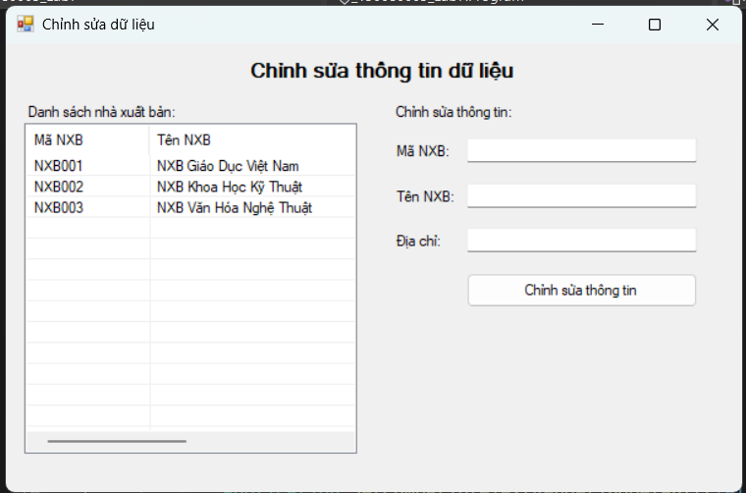

using System;
using System.Data;
using System.Data.SqlClient;
using System.Windows.Forms;

namespace _1150080005_Lab7
{
public partial class Form4 : Form
{
// 🔹 Chuỗi kết nối SQL Server của bạn
string strCon = @"Data Source=LAPTOP-J64LDBSP\SQL2022;
Initial Catalog=QuanLyBanSach;
Integrated Security=True";

SqlConnection sqlCon = null;

public Form4()
{
InitializeComponent();
}

private void MoKetNoi()
{
if (sqlCon == null)
sqlCon = new SqlConnection(strCon);
if (sqlCon.State == ConnectionState.Closed)
sqlCon.Open();
}

private void DongKetNoi()
{
if (sqlCon != null && sqlCon.State == ConnectionState.Open)
sqlCon.Close();
}

private void HienThiDuLieu()
{
try
{
MoKetNoi();
string sql = "SELECT * FROM NhaXuatBan";
SqlCommand cmd = new SqlCommand(sql, sqlCon);
SqlDataReader reader = cmd.ExecuteReader();

lsvNXB.Items.Clear();
while (reader.Read())
{
ListViewItem lvi = new ListViewItem(reader["MaXB"].ToString());
lvi.SubItems.Add(reader["TenNXB"].ToString());
lvi.SubItems.Add(reader["DiaChi"].ToString());
lsvNXB.Items.Add(lvi);
}

reader.Close();
}
catch (Exception ex)
{
MessageBox.Show("❌ Lỗi hiển thị dữ liệu: " + ex.Message);
}
finally
{
DongKetNoi();
}
}

private void Form4_Load(object sender, EventArgs e)
{
lsvNXB.View = View.Details;
lsvNXB.FullRowSelect = true;
lsvNXB.GridLines = true;
lsvNXB.Columns.Add("Mã NXB", 100);
lsvNXB.Columns.Add("Tên NXB", 200);
lsvNXB.Columns.Add("Địa chỉ", 250);

HienThiDuLieu();
}

private void btnXoa_Click(object sender, EventArgs e)
{
if (lsvNXB.SelectedItems.Count == 0)
{
MessageBox.Show("⚠️ Vui lòng chọn một nhà xuất bản để xóa!");
return;
}

string ma = lsvNXB.SelectedItems[0].SubItems[0].Text;

DialogResult result = MessageBox.Show(
"Bạn có chắc muốn xóa NXB có mã '" + ma + "'?",
"Xác nhận xóa",
MessageBoxButtons.YesNo,
MessageBoxIcon.Warning
);

if (result == DialogResult.Yes)
{
try
{
MoKetNoi();
string sql = "DELETE FROM NhaXuatBan WHERE MaXB = @ma";
SqlCommand cmd = new SqlCommand(sql, sqlCon);
cmd.Parameters.AddWithValue("@ma", ma);

int rows = cmd.ExecuteNonQuery();
if (rows > 0)
{
MessageBox.Show("✅ Xóa dữ liệu thành công!");
HienThiDuLieu();
}
else
{
MessageBox.Show("❌ Không tìm thấy mã NXB cần xóa!");
}
}
catch (Exception ex)
{
MessageBox.Show("❌ Lỗi khi xóa: " + ex.Message);
}
finally
{
DongKetNoi();
}
}
}
}
}

Form4.designer.cs
namespace _1150080005_Lab7
{
partial class Form4
{
private System.ComponentModel.IContainer components = null;

protected override void Dispose(bool disposing)
{
if (disposing && (components != null))
{
components.Dispose();
}
base.Dispose(disposing);
}

#region Windows Form Designer generated code

private void InitializeComponent()
{
this.lblTieuDe = new System.Windows.Forms.Label();
this.lblDanhSach = new System.Windows.Forms.Label();
this.lsvNXB = new System.Windows.Forms.ListView();
this.btnXoa = new System.Windows.Forms.Button();
this.SuspendLayout();

this.lblTieuDe.AutoSize = true;
this.lblTieuDe.Font = new System.Drawing.Font("Microsoft Sans Serif", 12F, System.Drawing.FontStyle.Bold);
this.lblTieuDe.Location = new System.Drawing.Point(250, 15);
this.lblTieuDe.Name = "lblTieuDe";
this.lblTieuDe.Size = new System.Drawing.Size(270, 25);
this.lblTieuDe.TabIndex = 0;
this.lblTieuDe.Text = "Xóa dữ liệu trong database";
this.lblDanhSach.AutoSize = true;
this.lblDanhSach.Location = new System.Drawing.Point(20, 60);
this.lblDanhSach.Name = "lblDanhSach";
this.lblDanhSach.Size = new System.Drawing.Size(134, 16);
this.lblDanhSach.TabIndex = 1;
this.lblDanhSach.Text = "Danh sách nhà xuất bản:";
this.lsvNXB.Location = new System.Drawing.Point(20, 80);
this.lsvNXB.Name = "lsvNXB";
this.lsvNXB.Size = new System.Drawing.Size(760, 300);
this.lsvNXB.TabIndex = 2;
this.lsvNXB.UseCompatibleStateImageBehavior = false;

this.btnXoa.Location = new System.Drawing.Point(320, 395);
this.btnXoa.Name = "btnXoa";
this.btnXoa.Size = new System.Drawing.Size(150, 35);
this.btnXoa.TabIndex = 3;
this.btnXoa.Text = "Xóa dữ liệu";
this.btnXoa.UseVisualStyleBackColor = true;
this.btnXoa.Click += new System.EventHandler(this.btnXoa_Click);

this.AutoScaleDimensions = new System.Drawing.SizeF(8F, 16F);
this.AutoScaleMode = System.Windows.Forms.AutoScaleMode.Font;
this.ClientSize = new System.Drawing.Size(800, 450);
this.Controls.Add(this.btnXoa);
this.Controls.Add(this.lsvNXB);
this.Controls.Add(this.lblDanhSach);
this.Controls.Add(this.lblTieuDe);
this.Name = "Form4";
this.StartPosition = System.Windows.Forms.FormStartPosition.CenterScreen;
this.Text = "Xóa dữ liệu";
this.Load += new System.EventHandler(this.Form4_Load);
this.ResumeLayout(false);
this.PerformLayout();
}

#endregion

private System.Windows.Forms.Label lblTieuDe;
private System.Windows.Forms.Label lblDanhSach;
private System.Windows.Forms.ListView lsvNXB;
private System.Windows.Forms.Button btnXoa;
}
}

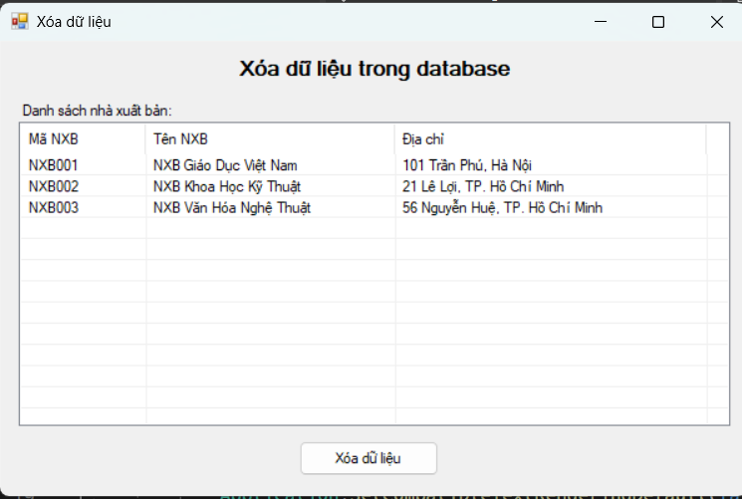

Phần 4
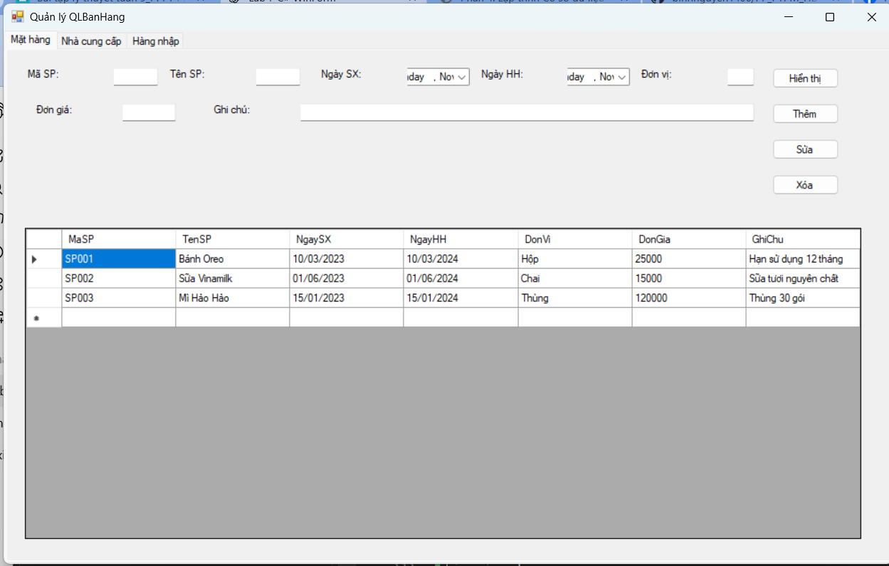

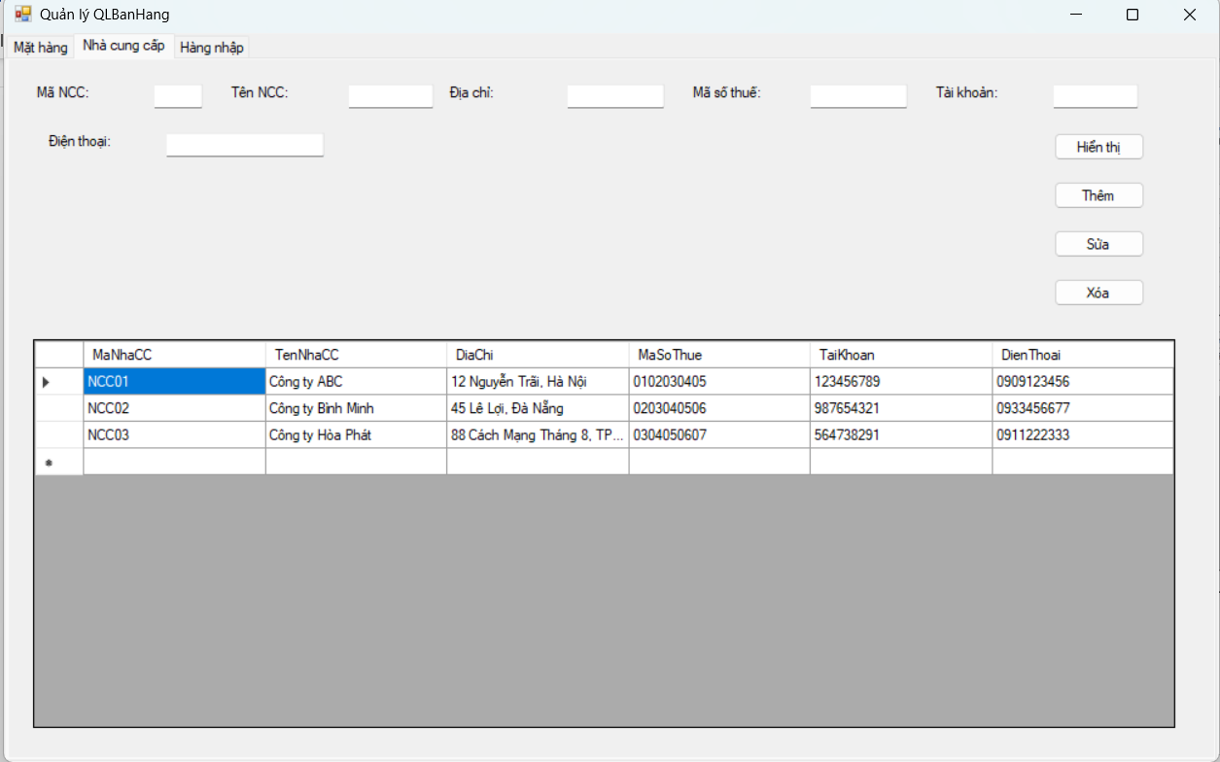

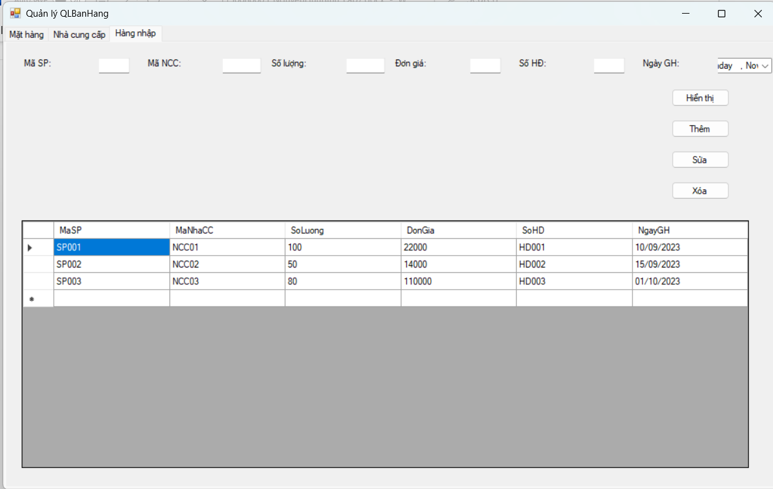

using System;
using System.Data;
using System.Data.SqlClient;
using System.Windows.Forms;

namespace _1150080005_Lab7
{
public partial class Form5 : Form
{
// 🔹 Chuỗi kết nối CSDL
string strCon = @"Data Source=LAPTOP-J64LDBSP\SQL2022;
Initial Catalog=QLBanHang;
Integrated Security=True";

SqlConnection sqlCon = null;

public Form5()
{
InitializeComponent();
this.Load += new System.EventHandler(this.Form5_Load); // GẮN SỰ KIỆN LOAD
}
private void MoKetNoi()
{
if (sqlCon == null)
sqlCon = new SqlConnection(strCon);
if (sqlCon.State == ConnectionState.Closed)
sqlCon.Open();
}

private void DongKetNoi()
{
if (sqlCon != null && sqlCon.State == ConnectionState.Open)
sqlCon.Close();
}
private void HienThiMatHang()
{
try
{
MoKetNoi();
string sql = "SELECT * FROM tblMatHang";
SqlDataAdapter da = new SqlDataAdapter(sql, sqlCon);
DataTable dt = new DataTable();
da.Fill(dt);
dgvMatHang.DataSource = dt;
}
catch (Exception ex)
{
MessageBox.Show("Lỗi hiển thị Mặt hàng: " + ex.Message);
}
finally { DongKetNoi(); }
}

private void HienThiNhaCungCap()
{
try
{
MoKetNoi();
string sql = "SELECT * FROM tblNhaCC";
SqlDataAdapter da = new SqlDataAdapter(sql, sqlCon);
DataTable dt = new DataTable();
da.Fill(dt);
dgvNCC.DataSource = dt;
}
catch (Exception ex)
{
MessageBox.Show("Lỗi hiển thị Nhà cung cấp: " + ex.Message);
}
finally { DongKetNoi(); }
}

private void HienThiHangNhap()
{
try
{
MoKetNoi();
string sql = "SELECT * FROM tblHangNhap";
SqlDataAdapter da = new SqlDataAdapter(sql, sqlCon);
DataTable dt = new DataTable();
da.Fill(dt);
dgvHN.DataSource = dt;
}
catch (Exception ex)
{
MessageBox.Show("Lỗi hiển thị Hàng nhập: " + ex.Message);
}
finally { DongKetNoi(); }
}
private void btnShowSP_Click(object sender, EventArgs e) => HienThiMatHang();

private void btnAddSP_Click(object sender, EventArgs e)
{
try
{
MoKetNoi();
string sql = @"INSERT INTO tblMatHang
VALUES (@MaSP, @TenSP, @NgaySX, @NgayHH, @DonVi, @DonGia, @GhiChu)";
SqlCommand cmd = new SqlCommand(sql, sqlCon);
cmd.Parameters.AddWithValue("@MaSP", txtMaSP.Text.Trim());
cmd.Parameters.AddWithValue("@TenSP", txtTenSP.Text.Trim());
cmd.Parameters.AddWithValue("@NgaySX", dtpNSX.Value);
cmd.Parameters.AddWithValue("@NgayHH", dtpNHH.Value);
cmd.Parameters.AddWithValue("@DonVi", txtDonVi.Text.Trim());
cmd.Parameters.AddWithValue("@DonGia", txtDonGia.Text.Trim());
cmd.Parameters.AddWithValue("@GhiChu", txtGhiChu.Text.Trim());
cmd.ExecuteNonQuery();
MessageBox.Show("✅ Thêm sản phẩm thành công!");
HienThiMatHang();
}
catch (Exception ex)
{
MessageBox.Show("Lỗi thêm sản phẩm: " + ex.Message);
}
finally { DongKetNoi(); }
}

private void btnEditSP_Click(object sender, EventArgs e)
{
try
{
MoKetNoi();
string sql = @"UPDATE tblMatHang
SET TenSP=@TenSP, NgaySX=@NgaySX, NgayHH=@NgayHH, DonVi=@DonVi, DonGia=@DonGia, GhiChu=@GhiChu
WHERE MaSP=@MaSP";
SqlCommand cmd = new SqlCommand(sql, sqlCon);
cmd.Parameters.AddWithValue("@MaSP", txtMaSP.Text.Trim());
cmd.Parameters.AddWithValue("@TenSP", txtTenSP.Text.Trim());
cmd.Parameters.AddWithValue("@NgaySX", dtpNSX.Value);
cmd.Parameters.AddWithValue("@NgayHH", dtpNHH.Value);
cmd.Parameters.AddWithValue("@DonVi", txtDonVi.Text.Trim());
cmd.Parameters.AddWithValue("@DonGia", txtDonGia.Text.Trim());
cmd.Parameters.AddWithValue("@GhiChu", txtGhiChu.Text.Trim());
cmd.ExecuteNonQuery();
MessageBox.Show("✏️ Sửa sản phẩm thành công!");
HienThiMatHang();
}
catch (Exception ex)
{
MessageBox.Show("Lỗi sửa sản phẩm: " + ex.Message);
}
finally { DongKetNoi(); }
}

private void btnDeleteSP_Click(object sender, EventArgs e)
{
try
{
MoKetNoi();
string sql = "DELETE FROM tblMatHang WHERE MaSP=@MaSP";
SqlCommand cmd = new SqlCommand(sql, sqlCon);
cmd.Parameters.AddWithValue("@MaSP", txtMaSP.Text.Trim());
cmd.ExecuteNonQuery();
MessageBox.Show("🗑️ Xóa sản phẩm thành công!");
HienThiMatHang();
}
catch (Exception ex)
{
MessageBox.Show("Lỗi xóa sản phẩm: " + ex.Message);
}
finally { DongKetNoi(); }
}
private void btnShowNCC_Click(object sender, EventArgs e) => HienThiNhaCungCap();

private void btnAddNCC_Click(object sender, EventArgs e)
{
try
{
MoKetNoi();
string sql = @"INSERT INTO tblNhaCC
VALUES (@MaNCC, @TenNCC, @DiaChi, @MaSoThue, @TaiKhoan, @DienThoai)";
SqlCommand cmd = new SqlCommand(sql, sqlCon);
cmd.Parameters.AddWithValue("@MaNCC", txtMaNCC.Text.Trim());
cmd.Parameters.AddWithValue("@TenNCC", txtTenNCC.Text.Trim());
cmd.Parameters.AddWithValue("@DiaChi", txtDiaChi.Text.Trim());
cmd.Parameters.AddWithValue("@MaSoThue", txtMST.Text.Trim());
cmd.Parameters.AddWithValue("@TaiKhoan", txtTK.Text.Trim());
cmd.Parameters.AddWithValue("@DienThoai", txtDT.Text.Trim());
cmd.ExecuteNonQuery();
MessageBox.Show("✅ Thêm nhà cung cấp thành công!");
HienThiNhaCungCap();
}
catch (Exception ex)
{
MessageBox.Show("Lỗi thêm NCC: " + ex.Message);
}
finally { DongKetNoi(); }
}

private void btnEditNCC_Click(object sender, EventArgs e)
{
try
{
MoKetNoi();
string sql = @"UPDATE tblNhaCC
SET TenNhaCC=@TenNCC, DiaChi=@DiaChi, MaSoThue=@MaSoThue, TaiKhoan=@TaiKhoan, DienThoai=@DienThoai
WHERE MaNhaCC=@MaNCC";
SqlCommand cmd = new SqlCommand(sql, sqlCon);
cmd.Parameters.AddWithValue("@MaNCC", txtMaNCC.Text.Trim());
cmd.Parameters.AddWithValue("@TenNCC", txtTenNCC.Text.Trim());
cmd.Parameters.AddWithValue("@DiaChi", txtDiaChi.Text.Trim());
cmd.Parameters.AddWithValue("@MaSoThue", txtMST.Text.Trim());
cmd.Parameters.AddWithValue("@TaiKhoan", txtTK.Text.Trim());
cmd.Parameters.AddWithValue("@DienThoai", txtDT.Text.Trim());
cmd.ExecuteNonQuery();
MessageBox.Show("✏️ Sửa nhà cung cấp thành công!");
HienThiNhaCungCap();
}
catch (Exception ex)
{
MessageBox.Show("Lỗi sửa NCC: " + ex.Message);
}
finally { DongKetNoi(); }
}

private void btnDeleteNCC_Click(object sender, EventArgs e)
{
try
{
MoKetNoi();
string sql = "DELETE FROM tblNhaCC WHERE MaNhaCC=@MaNCC";
SqlCommand cmd = new SqlCommand(sql, sqlCon);
cmd.Parameters.AddWithValue("@MaNCC", txtMaNCC.Text.Trim());
cmd.ExecuteNonQuery();
MessageBox.Show("🗑️ Xóa NCC thành công!");
HienThiNhaCungCap();
}
catch (Exception ex)
{
MessageBox.Show("Lỗi xóa NCC: " + ex.Message);
}
finally { DongKetNoi(); }
}
private void btnShowHN_Click(object sender, EventArgs e) => HienThiHangNhap();

private void btnAddHN_Click(object sender, EventArgs e)
{
try
{
MoKetNoi();
string sql = @"INSERT INTO tblHangNhap VALUES
(@MaSP, @MaNCC, @SoLuong, @DonGia, @SoHD, @NgayGH)";
SqlCommand cmd = new SqlCommand(sql, sqlCon);
cmd.Parameters.AddWithValue("@MaSP", txtMaSPHN.Text.Trim());
cmd.Parameters.AddWithValue("@MaNCC", txtMaNCCHN.Text.Trim());
cmd.Parameters.AddWithValue("@SoLuong", txtSL.Text.Trim());
cmd.Parameters.AddWithValue("@DonGia", txtDGNH.Text.Trim());
cmd.Parameters.AddWithValue("@SoHD", txtSoHD.Text.Trim());
cmd.Parameters.AddWithValue("@NgayGH", dtpNgayGH.Value);
cmd.ExecuteNonQuery();
MessageBox.Show("✅ Thêm hàng nhập thành công!");
HienThiHangNhap();
}
catch (Exception ex)
{
MessageBox.Show("Lỗi thêm hàng nhập: " + ex.Message);
}
finally { DongKetNoi(); }
}

private void btnEditHN_Click(object sender, EventArgs e)
{
try
{
MoKetNoi();
string sql = @"UPDATE tblHangNhap SET SoLuong=@SoLuong, DonGia=@DonGia, NgayGH=@NgayGH
WHERE MaSP=@MaSP AND MaNhaCC=@MaNCC AND SoHD=@SoHD";
SqlCommand cmd = new SqlCommand(sql, sqlCon);
cmd.Parameters.AddWithValue("@MaSP", txtMaSPHN.Text.Trim());
cmd.Parameters.AddWithValue("@MaNCC", txtMaNCCHN.Text.Trim());
cmd.Parameters.AddWithValue("@SoHD", txtSoHD.Text.Trim());
cmd.Parameters.AddWithValue("@SoLuong", txtSL.Text.Trim());
cmd.Parameters.AddWithValue("@DonGia", txtDGNH.Text.Trim());
cmd.Parameters.AddWithValue("@NgayGH", dtpNgayGH.Value);
cmd.ExecuteNonQuery();
MessageBox.Show("✏️ Sửa hàng nhập thành công!");
HienThiHangNhap();
}
catch (Exception ex)
{
MessageBox.Show("Lỗi sửa hàng nhập: " + ex.Message);
}
finally { DongKetNoi(); }
}

private void btnDeleteHN_Click(object sender, EventArgs e)
{
try
{
MoKetNoi();
string sql = "DELETE FROM tblHangNhap WHERE MaSP=@MaSP AND MaNhaCC=@MaNCC AND SoHD=@SoHD";
SqlCommand cmd = new SqlCommand(sql, sqlCon);
cmd.Parameters.AddWithValue("@MaSP", txtMaSPHN.Text.Trim());
cmd.Parameters.AddWithValue("@MaNCC", txtMaNCCHN.Text.Trim());
cmd.Parameters.AddWithValue("@SoHD", txtSoHD.Text.Trim());
cmd.ExecuteNonQuery();
MessageBox.Show("🗑️ Xóa hàng nhập thành công!");
HienThiHangNhap();
}
catch (Exception ex)
{
MessageBox.Show("Lỗi xóa hàng nhập: " + ex.Message);
}
finally { DongKetNoi(); }
}

private void Form5_Load(object sender, EventArgs e)
{
HienThiMatHang();
HienThiNhaCungCap();
HienThiHangNhap();
}
}
}

Form5.designer.cs

using System.Windows.Forms;

namespace _1150080005_Lab7
{
partial class Form5
{
private System.ComponentModel.IContainer components = null;
private System.Windows.Forms.TabControl tabControl1;
private System.Windows.Forms.TabPage tabMatHang;
private System.Windows.Forms.TabPage tabNhaCC;
private System.Windows.Forms.TabPage tabHangNhap;

private System.Windows.Forms.DataGridView dgvMatHang;
private System.Windows.Forms.TextBox txtMaSP, txtTenSP, txtDonVi, txtDonGia, txtGhiChu;
private System.Windows.Forms.DateTimePicker dtpNSX, dtpNHH;
private System.Windows.Forms.Button btnShowSP, btnAddSP, btnEditSP, btnDeleteSP;
private System.Windows.Forms.DataGridView dgvNCC;
private System.Windows.Forms.TextBox txtMaNCC, txtTenNCC, txtDiaChi, txtMST, txtTK, txtDT;
private System.Windows.Forms.Button btnShowNCC, btnAddNCC, btnEditNCC, btnDeleteNCC;

// Hàng nhập
private System.Windows.Forms.DataGridView dgvHN;
private System.Windows.Forms.TextBox txtMaSPHN, txtMaNCCHN, txtSL, txtDGNH, txtSoHD;
private System.Windows.Forms.DateTimePicker dtpNgayGH;
private System.Windows.Forms.Button btnShowHN, btnAddHN, btnEditHN, btnDeleteHN;

protected override void Dispose(bool disposing)
{
if (disposing && (components != null))
components.Dispose();
base.Dispose(disposing);
}

private void InitializeComponent()
{
this.components = new System.ComponentModel.Container();
this.tabControl1 = new System.Windows.Forms.TabControl();
this.tabMatHang = new System.Windows.Forms.TabPage();
this.tabNhaCC = new System.Windows.Forms.TabPage();
this.tabHangNhap = new System.Windows.Forms.TabPage();
this.SuspendLayout();
this.Text = "Quản lý QLBanHang";
this.ClientSize = new System.Drawing.Size(1000, 600);
this.tabControl1.Dock = System.Windows.Forms.DockStyle.Fill;
this.tabControl1.Controls.Add(this.tabMatHang);
this.tabControl1.Controls.Add(this.tabNhaCC);
this.tabControl1.Controls.Add(this.tabHangNhap);
this.Controls.Add(this.tabControl1);
this.tabMatHang.Text = "Mặt hàng";
Label lblMaSP = new Label() { Text = "Mã SP:", Location = new System.Drawing.Point(20, 20) };
Label lblTenSP = new Label() { Text = "Tên SP:", Location = new System.Drawing.Point(180, 20) };
Label lblNgaySX = new Label() { Text = "Ngày SX:", Location = new System.Drawing.Point(350, 20) };
Label lblNgayHH = new Label() { Text = "Ngày HH:", Location = new System.Drawing.Point(530, 20) };
Label lblDonVi = new Label() { Text = "Đơn vị:", Location = new System.Drawing.Point(710, 20) };
Label lblDonGia = new Label() { Text = "Đơn giá:", Location = new System.Drawing.Point(30, 60) };
Label lblGhiChu = new Label() { Text = "Ghi chú:", Location = new System.Drawing.Point(230, 60) };

txtMaSP = new TextBox() { Location = new System.Drawing.Point(70, 20), Width = 100 };
txtTenSP = new TextBox() { Location = new System.Drawing.Point(230, 20), Width = 100 };
dtpNSX = new DateTimePicker() { Location = new System.Drawing.Point(420, 20), Width = 100 };
dtpNHH = new DateTimePicker() { Location = new System.Drawing.Point(600, 20), Width = 100 };
txtDonVi = new TextBox() { Location = new System.Drawing.Point(760, 20), Width = 80 };
txtDonGia = new TextBox() { Location = new System.Drawing.Point(90, 60), Width = 100 };
txtGhiChu = new TextBox() { Location = new System.Drawing.Point(290, 60), Width = 550 };

btnShowSP = new Button() { Text = "Hiển thị", Location = new System.Drawing.Point(860, 20) };
btnAddSP = new Button() { Text = "Thêm", Location = new System.Drawing.Point(860, 60) };
btnEditSP = new Button() { Text = "Sửa", Location = new System.Drawing.Point(860, 100) };
btnDeleteSP = new Button() { Text = "Xóa", Location = new System.Drawing.Point(860, 140) };

dgvMatHang = new DataGridView()
{
Location = new System.Drawing.Point(20, 200),
Size = new System.Drawing.Size(940, 350),
AutoSizeColumnsMode = DataGridViewAutoSizeColumnsMode.Fill
};

tabMatHang.Controls.AddRange(new Control[]
{
lblMaSP, lblTenSP, lblNgaySX, lblNgayHH, lblDonVi, lblDonGia, lblGhiChu,
txtMaSP, txtTenSP, dtpNSX, dtpNHH, txtDonVi, txtDonGia, txtGhiChu,
btnShowSP, btnAddSP, btnEditSP, btnDeleteSP, dgvMatHang
});
this.tabNhaCC.Text = "Nhà cung cấp";
Label lblMaNCC = new Label() { Text = "Mã NCC:", Location = new System.Drawing.Point(20, 20) };
Label lblTenNCC = new Label() { Text = "Tên NCC:", Location = new System.Drawing.Point(180, 20) };
Label lblDiaChi = new Label() { Text = "Địa chỉ:", Location = new System.Drawing.Point(360, 20) };
Label lblMST = new Label() { Text = "Mã số thuế:", Location = new System.Drawing.Point(560, 20) };
Label lblTK = new Label() { Text = "Tài khoản:", Location = new System.Drawing.Point(760, 20) };
Label lblDT = new Label() { Text = "Điện thoại:", Location = new System.Drawing.Point(30, 60) };

txtMaNCC = new TextBox() { Location = new System.Drawing.Point(80, 20), Width = 80 };
txtTenNCC = new TextBox() { Location = new System.Drawing.Point(250, 20), Width = 100 };
txtDiaChi = new TextBox() { Location = new System.Drawing.Point(420, 20), Width = 120 };
txtMST = new TextBox() { Location = new System.Drawing.Point(640, 20), Width = 100 };
txtTK = new TextBox() { Location = new System.Drawing.Point(830, 20), Width = 100 };
txtDT = new TextBox() { Location = new System.Drawing.Point(110, 60), Width = 150 };

btnShowNCC = new Button() { Text = "Hiển thị", Location = new System.Drawing.Point(860, 60) };
btnAddNCC = new Button() { Text = "Thêm", Location = new System.Drawing.Point(860, 100) };
btnEditNCC = new Button() { Text = "Sửa", Location = new System.Drawing.Point(860, 140) };
btnDeleteNCC = new Button() { Text = "Xóa", Location = new System.Drawing.Point(860, 180) };

dgvNCC = new DataGridView()
{
Location = new System.Drawing.Point(20, 230),
Size = new System.Drawing.Size(940, 320),
AutoSizeColumnsMode = DataGridViewAutoSizeColumnsMode.Fill
};

tabNhaCC.Controls.AddRange(new Control[]
{
lblMaNCC, lblTenNCC, lblDiaChi, lblMST, lblTK, lblDT,
txtMaNCC, txtTenNCC, txtDiaChi, txtMST, txtTK, txtDT,
btnShowNCC, btnAddNCC, btnEditNCC, btnDeleteNCC, dgvNCC
});
this.tabHangNhap.Text = "Hàng nhập";
Label lblMaSPHN = new Label() { Text = "Mã SP:", Location = new System.Drawing.Point(20, 20) };
Label lblMaNCCHN = new Label() { Text = "Mã NCC:", Location = new System.Drawing.Point(180, 20) };
Label lblSoLuong = new Label() { Text = "Số lượng:", Location = new System.Drawing.Point(340, 20) };
Label lblDonGiaHN = new Label() { Text = "Đơn giá:", Location = new System.Drawing.Point(500, 20) };
Label lblSoHD = new Label() { Text = "Số HĐ:", Location = new System.Drawing.Point(660, 20) };
Label lblNgayGH = new Label() { Text = "Ngày GH:", Location = new System.Drawing.Point(820, 20) };

txtMaSPHN = new TextBox() { Location = new System.Drawing.Point(70, 20), Width = 90 };
txtMaNCCHN = new TextBox() { Location = new System.Drawing.Point(240, 20), Width = 90 };
txtSL = new TextBox() { Location = new System.Drawing.Point(410, 20), Width = 80 };
txtDGNH = new TextBox() { Location = new System.Drawing.Point(560, 20), Width = 80 };
txtSoHD = new TextBox() { Location = new System.Drawing.Point(720, 20), Width = 80 };
dtpNgayGH = new DateTimePicker() { Location = new System.Drawing.Point(890, 20), Width = 100 };

btnShowHN = new Button() { Text = "Hiển thị", Location = new System.Drawing.Point(860, 60) };
btnAddHN = new Button() { Text = "Thêm", Location = new System.Drawing.Point(860, 100) };
btnEditHN = new Button() { Text = "Sửa", Location = new System.Drawing.Point(860, 140) };
btnDeleteHN = new Button() { Text = "Xóa", Location = new System.Drawing.Point(860, 180) };

dgvHN = new DataGridView()
{
Location = new System.Drawing.Point(20, 230),
Size = new System.Drawing.Size(940, 320),
AutoSizeColumnsMode = DataGridViewAutoSizeColumnsMode.Fill
};

tabHangNhap.Controls.AddRange(new Control[]
{
lblMaSPHN, lblMaNCCHN, lblSoLuong, lblDonGiaHN, lblSoHD, lblNgayGH,
txtMaSPHN, txtMaNCCHN, txtSL, txtDGNH, txtSoHD, dtpNgayGH,
btnShowHN, btnAddHN, btnEditHN, btnDeleteHN, dgvHN
});

this.ResumeLayout(false);
}
}
}

