Họ tên: Nguyễn Hữu Bình
Lớp: 11_ĐH_CNPM1
MSSV: 1150080005
Thực hành 1
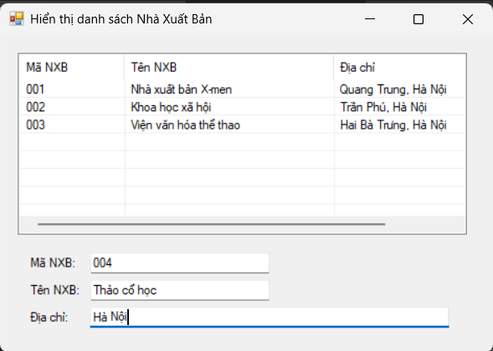
Form1.cs
using System;
using System.Data;
using System.Data.SqlClient;
using System.Windows.Forms;

namespace Btap8
{
public partial class Form1 : Form
{
// Chuỗi kết nối (sửa đường dẫn theo file .mdf của bạn)
string strCon = @"Data Source=(LocalDB)\MSSQLLocalDB;
AttachDbFilename=|DataDirectory|\QuanLySach.mdf;
Integrated Security=True";

SqlConnection sqlCon = null;

public Form1()
{
InitializeComponent();
}

// Hàm mở kết nối
private void MoKetNoi()
{
if (sqlCon == null)
sqlCon = new SqlConnection(strCon);
if (sqlCon.State == ConnectionState.Closed)
sqlCon.Open();
}

// Hàm đóng kết nối
private void DongKetNoi()
{
if (sqlCon != null && sqlCon.State == ConnectionState.Open)
sqlCon.Close();
}

// Hàm hiển thị danh sách nhà xuất bản
private void HienThiDanhSachNXB()
{
MoKetNoi();
SqlCommand sqlCmd = new SqlCommand();
sqlCmd.CommandType = CommandType.Text;
sqlCmd.CommandText = "SELECT * FROM NhaXuatBan";
sqlCmd.Connection = sqlCon;

SqlDataReader reader = sqlCmd.ExecuteReader();

lsvDanhSach.Items.Clear();

while (reader.Read())
{
string maNXB = reader.GetString(0);
string tenNXB = reader.GetString(1);
string diaChi = reader.GetString(2);

ListViewItem lvi = new ListViewItem(maNXB);
lvi.SubItems.Add(tenNXB);
lvi.SubItems.Add(diaChi);
lsvDanhSach.Items.Add(lvi);
}

reader.Close();
DongKetNoi();
}

// Khi form load
private void Form1_Load(object sender, EventArgs e)
{
HienThiDanhSachNXB();
}

// Khi chọn 1 dòng trong ListView
private void lsvDanhSach_SelectedIndexChanged(object sender, EventArgs e)
{
if (lsvDanhSach.SelectedItems.Count == 0) return;

ListViewItem lvi = lsvDanhSach.SelectedItems[0];
txtMaNXB.Text = lvi.SubItems[0].Text;
txtTenNXB.Text = lvi.SubItems[1].Text;
txtDiaChi.Text = lvi.SubItems[2].Text;
}
}
}

Form1.Designer.cs
namespace Btap8
{
partial class Form1
{
private System.ComponentModel.IContainer components = null;

protected override void Dispose(bool disposing)
{
if (disposing && (components != null))
{
components.Dispose();
}
base.Dispose(disposing);
}

#region Windows Form Designer generated code

private void InitializeComponent()
{
this.lsvDanhSach = new System.Windows.Forms.ListView();
this.colMa = ((System.Windows.Forms.ColumnHeader)(new System.Windows.Forms.ColumnHeader()));
this.colTen = ((System.Windows.Forms.ColumnHeader)(new System.Windows.Forms.ColumnHeader()));
this.colDiaChi = ((System.Windows.Forms.ColumnHeader)(new System.Windows.Forms.ColumnHeader()));
this.txtMaNXB = new System.Windows.Forms.TextBox();
this.txtTenNXB = new System.Windows.Forms.TextBox();
this.txtDiaChi = new System.Windows.Forms.TextBox();
this.lblMa = new System.Windows.Forms.Label();
this.lblTen = new System.Windows.Forms.Label();
this.lblDiaChi = new System.Windows.Forms.Label();
this.SuspendLayout();
this.lsvDanhSach.Columns.AddRange(new System.Windows.Forms.ColumnHeader[] {
this.colMa,
this.colTen,
this.colDiaChi});
this.lsvDanhSach.FullRowSelect = true;
this.lsvDanhSach.GridLines = true;
this.lsvDanhSach.HideSelection = false;
this.lsvDanhSach.Location = new System.Drawing.Point(20, 20);
this.lsvDanhSach.Name = "lsvDanhSach";
this.lsvDanhSach.Size = new System.Drawing.Size(500, 200);
this.lsvDanhSach.TabIndex = 0;
this.lsvDanhSach.UseCompatibleStateImageBehavior = false;
this.lsvDanhSach.View = System.Windows.Forms.View.Details;
this.lsvDanhSach.SelectedIndexChanged += new System.EventHandler(this.lsvDanhSach_SelectedIndexChanged);
this.colMa.Text = "Mã NXB";
this.colMa.Width = 100;
this.colTen.Text = "Tên NXB";
this.colTen.Width = 200;
this.colDiaChi.Text = "Địa chỉ";
this.colDiaChi.Width = 200;
this.txtMaNXB.Location = new System.Drawing.Point(100, 240);
this.txtMaNXB.Name = "txtMaNXB";
this.txtMaNXB.Size = new System.Drawing.Size(200, 23);
this.txtMaNXB.TabIndex = 1;
this.txtTenNXB.Location = new System.Drawing.Point(100, 270);
this.txtTenNXB.Name = "txtTenNXB";
this.txtTenNXB.Size = new System.Drawing.Size(200, 23);
this.txtTenNXB.TabIndex = 2;
this.txtDiaChi.Location = new System.Drawing.Point(100, 300);
this.txtDiaChi.Name = "txtDiaChi";
this.txtDiaChi.Size = new System.Drawing.Size(400, 23);
this.txtDiaChi.TabIndex = 3;
this.lblMa.AutoSize = true;
this.lblMa.Location = new System.Drawing.Point(30, 243);
this.lblMa.Name = "lblMa";
this.lblMa.Size = new System.Drawing.Size(50, 15);
this.lblMa.TabIndex = 4;
this.lblMa.Text = "Mã NXB:";
this.lblTen.AutoSize = true;
this.lblTen.Location = new System.Drawing.Point(30, 273);
this.lblTen.Name = "lblTen";
this.lblTen.Size = new System.Drawing.Size(54, 15);
this.lblTen.TabIndex = 5;
this.lblTen.Text = "Tên NXB:";
this.lblDiaChi.AutoSize = true;
this.lblDiaChi.Location = new System.Drawing.Point(30, 303);
this.lblDiaChi.Name = "lblDiaChi";
this.lblDiaChi.Size = new System.Drawing.Size(49, 15);
this.lblDiaChi.TabIndex = 6;
this.lblDiaChi.Text = "Địa chỉ:";
this.AutoScaleDimensions = new System.Drawing.SizeF(7F, 15F);
this.AutoScaleMode = System.Windows.Forms.AutoScaleMode.Font;
this.ClientSize = new System.Drawing.Size(550, 350);
this.Controls.Add(this.lblDiaChi);
this.Controls.Add(this.lblTen);
this.Controls.Add(this.lblMa);
this.Controls.Add(this.txtDiaChi);
this.Controls.Add(this.txtTenNXB);
this.Controls.Add(this.txtMaNXB);
this.Controls.Add(this.lsvDanhSach);
this.Name = "Form1";
this.Text = "Hiển thị danh sách Nhà Xuất Bản";
this.Load += new System.EventHandler(this.Form1_Load);
this.ResumeLayout(false);
this.PerformLayout();
}

#endregion

private System.Windows.Forms.ListView lsvDanhSach;
private System.Windows.Forms.ColumnHeader colMa;
private System.Windows.Forms.ColumnHeader colTen;
private System.Windows.Forms.ColumnHeader colDiaChi;
private System.Windows.Forms.TextBox txtMaNXB;
private System.Windows.Forms.TextBox txtTenNXB;
private System.Windows.Forms.TextBox txtDiaChi;
private System.Windows.Forms.Label lblMa;
private System.Windows.Forms.Label lblTen;
private System.Windows.Forms.Label lblDiaChi;
}
}
Thực hành 2
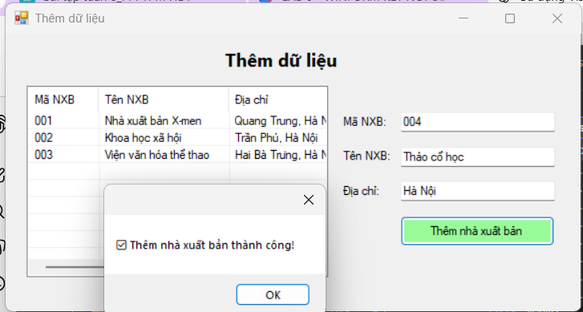
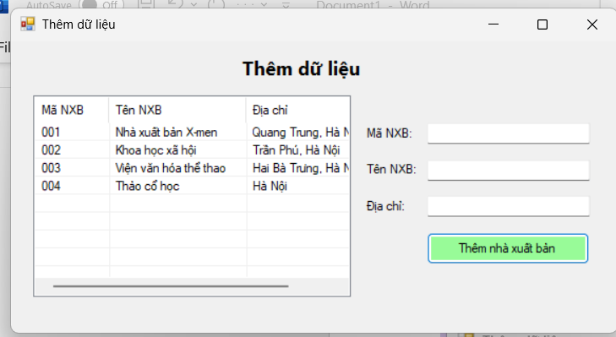

Form1.cs
using System;
using System.Data;
using System.Data.SqlClient;
using System.Windows.Forms;

namespace Btap8
{
public partial class Form1 : Form
{
string strCon = @"Data Source=(LocalDB)\MSSQLLocalDB;
AttachDbFilename=|DataDirectory|\QuanLySach.mdf;
Integrated Security=True";

SqlConnection sqlCon = null;

public Form1()
{
InitializeComponent();
}

// Mở kết nối
private void MoKetNoi()
{
if (sqlCon == null)
sqlCon = new SqlConnection(strCon);
if (sqlCon.State == ConnectionState.Closed)
sqlCon.Open();
}

// Đóng kết nối
private void DongKetNoi()
{
if (sqlCon != null && sqlCon.State == ConnectionState.Open)
sqlCon.Close();
}

// Hiển thị danh sách nhà xuất bản
private void HienThiDanhSach()
{
MoKetNoi();
string sql = "SELECT * FROM NhaXuatBan";
SqlCommand cmd = new SqlCommand(sql, sqlCon);
SqlDataReader reader = cmd.ExecuteReader();

lsvNXB.Items.Clear();

while (reader.Read())
{
string ma = reader["NXB"].ToString();
string ten = reader["TenNXB"].ToString();
string diachi = reader["DiaChi"].ToString();

ListViewItem lvi = new ListViewItem(ma);
lvi.SubItems.Add(ten);
lvi.SubItems.Add(diachi);
lsvNXB.Items.Add(lvi);
}

reader.Close();
DongKetNoi();
}

private void Form1_Load(object sender, EventArgs e)
{
HienThiDanhSach();
}

// Nút thêm nhà xuất bản
private void btnThem_Click(object sender, EventArgs e)
{
if (txtMaNXB.Text == "" || txtTenNXB.Text == "" || txtDiaChi.Text == "")
{
MessageBox.Show("Vui lòng nhập đầy đủ thông tin!", "Thông báo");
return;
}

MoKetNoi();
string sql = "INSERT INTO NhaXuatBan VALUES (@ma, @ten, @diachi)";
SqlCommand cmd = new SqlCommand(sql, sqlCon);
cmd.Parameters.AddWithValue("@ma", txtMaNXB.Text.Trim());
cmd.Parameters.AddWithValue("@ten", txtTenNXB.Text.Trim());
cmd.Parameters.AddWithValue("@diachi", txtDiaChi.Text.Trim());

try
{
int kq = cmd.ExecuteNonQuery();
if (kq > 0)
{
MessageBox.Show("✅ Thêm nhà xuất bản thành công!");
HienThiDanhSach();
txtMaNXB.Clear();
txtTenNXB.Clear();
txtDiaChi.Clear();
}
else
{
MessageBox.Show("❌ Không thêm được dữ liệu!");
}
}
catch (Exception ex)
{
MessageBox.Show("Lỗi: " + ex.Message);
}

DongKetNoi();
}
}
}

Form1.Designer.cs
namespace Btap8
{
partial class Form1
{
private System.ComponentModel.IContainer components = null;

protected override void Dispose(bool disposing)
{
if (disposing && (components != null))
{
components.Dispose();
}
base.Dispose(disposing);
}

#region Windows Form Designer generated code

private void InitializeComponent()
{
this.lsvNXB = new System.Windows.Forms.ListView();
this.colMa = ((System.Windows.Forms.ColumnHeader)(new System.Windows.Forms.ColumnHeader()));
this.colTen = ((System.Windows.Forms.ColumnHeader)(new System.Windows.Forms.ColumnHeader()));
this.colDiaChi = ((System.Windows.Forms.ColumnHeader)(new System.Windows.Forms.ColumnHeader()));
this.txtMaNXB = new System.Windows.Forms.TextBox();
this.txtTenNXB = new System.Windows.Forms.TextBox();
this.txtDiaChi = new System.Windows.Forms.TextBox();
this.btnThem = new System.Windows.Forms.Button();
this.lblMa = new System.Windows.Forms.Label();
this.lblTen = new System.Windows.Forms.Label();
this.lblDiaChi = new System.Windows.Forms.Label();
this.lblTitle = new System.Windows.Forms.Label();
this.SuspendLayout();
this.lsvNXB.Columns.AddRange(new System.Windows.Forms.ColumnHeader[] {
this.colMa,
this.colTen,
this.colDiaChi});
this.lsvNXB.FullRowSelect = true;
this.lsvNXB.GridLines = true;
this.lsvNXB.HideSelection = false;
this.lsvNXB.Location = new System.Drawing.Point(25, 60);
this.lsvNXB.Name = "lsvNXB";
this.lsvNXB.Size = new System.Drawing.Size(350, 220);
this.lsvNXB.TabIndex = 0;
this.lsvNXB.UseCompatibleStateImageBehavior = false;
this.lsvNXB.View = System.Windows.Forms.View.Details;
this.colMa.Text = "Mã NXB";
this.colMa.Width = 70;
this.colTen.Text = "Tên NXB";
this.colTen.Width = 130;
this.colDiaChi.Text = "Địa chỉ";
this.txtMaNXB.Location = new System.Drawing.Point(460, 90);
this.txtMaNXB.Name = "txtMaNXB";
this.txtMaNXB.Size = new System.Drawing.Size(180, 23);
this.txtMaNXB.TabIndex = 1;
this.txtTenNXB.Location = new System.Drawing.Point(460, 130);
this.txtTenNXB.Name = "txtTenNXB";
this.txtTenNXB.Size = new System.Drawing.Size(180, 23);
this.txtTenNXB.TabIndex = 2;
this.txtDiaChi.Location = new System.Drawing.Point(460, 170);
this.txtDiaChi.Name = "txtDiaChi";
this.txtDiaChi.Size = new System.Drawing.Size(180, 23);
this.txtDiaChi.TabIndex = 3;
this.btnThem.BackColor = System.Drawing.Color.PaleGreen;
this.btnThem.Location = new System.Drawing.Point(460, 210);
this.btnThem.Name = "btnThem";
this.btnThem.Size = new System.Drawing.Size(180, 35);
this.btnThem.TabIndex = 4;
this.btnThem.Text = "Thêm nhà xuất bản";
this.btnThem.UseVisualStyleBackColor = false;
this.btnThem.Click += new System.EventHandler(this.btnThem_Click);
this.lblMa.AutoSize = true;
this.lblMa.Location = new System.Drawing.Point(390, 93);
this.lblMa.Name = "lblMa";
this.lblMa.Size = new System.Drawing.Size(54, 15);
this.lblMa.TabIndex = 5;
this.lblMa.Text = "Mã NXB:";
this.lblTen.AutoSize = true;
this.lblTen.Location = new System.Drawing.Point(390, 133);
this.lblTen.Name = "lblTen";
this.lblTen.Size = new System.Drawing.Size(58, 15);
this.lblTen.TabIndex = 6;
this.lblTen.Text = "Tên NXB:";
this.lblDiaChi.AutoSize = true;
this.lblDiaChi.Location = new System.Drawing.Point(390, 173);
this.lblDiaChi.Name = "lblDiaChi";
this.lblDiaChi.Size = new System.Drawing.Size(49, 15);
this.lblDiaChi.TabIndex = 7;
this.lblDiaChi.Text = "Địa chỉ:";
this.lblTitle.AutoSize = true;
this.lblTitle.Font = new System.Drawing.Font("Segoe UI", 13F, System.Drawing.FontStyle.Bold);
this.lblTitle.Location = new System.Drawing.Point(250, 15);
this.lblTitle.Name = "lblTitle";
this.lblTitle.Size = new System.Drawing.Size(126, 25);
this.lblTitle.TabIndex = 8;
this.lblTitle.Text = "Thêm dữ liệu";
this.AutoScaleDimensions = new System.Drawing.SizeF(7F, 15F);
this.AutoScaleMode = System.Windows.Forms.AutoScaleMode.Font;
this.ClientSize = new System.Drawing.Size(670, 320);
this.Controls.Add(this.lblTitle);
this.Controls.Add(this.lblDiaChi);
this.Controls.Add(this.lblTen);
this.Controls.Add(this.lblMa);
this.Controls.Add(this.btnThem);
this.Controls.Add(this.txtDiaChi);
this.Controls.Add(this.txtTenNXB);
this.Controls.Add(this.txtMaNXB);
this.Controls.Add(this.lsvNXB);
this.Name = "Form1";
this.Text = "Thêm dữ liệu";
this.Load += new System.EventHandler(this.Form1_Load);
this.ResumeLayout(false);
this.PerformLayout();
}

#endregion

private System.Windows.Forms.ListView lsvNXB;
private System.Windows.Forms.ColumnHeader colMa;
private System.Windows.Forms.ColumnHeader colTen;
private System.Windows.Forms.ColumnHeader colDiaChi;
private System.Windows.Forms.TextBox txtMaNXB;
private System.Windows.Forms.TextBox txtTenNXB;
private System.Windows.Forms.TextBox txtDiaChi;
private System.Windows.Forms.Button btnThem;
private System.Windows.Forms.Label lblMa;
private System.Windows.Forms.Label lblTen;
private System.Windows.Forms.Label lblDiaChi;
private System.Windows.Forms.Label lblTitle;
}
}

Thực hành 3

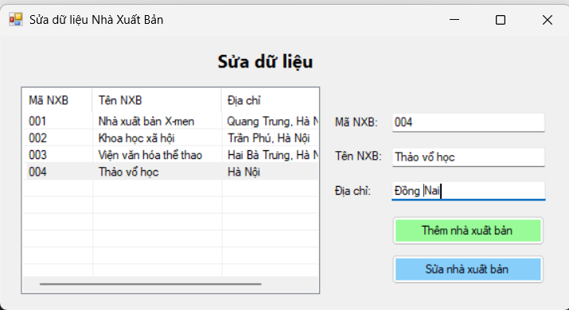
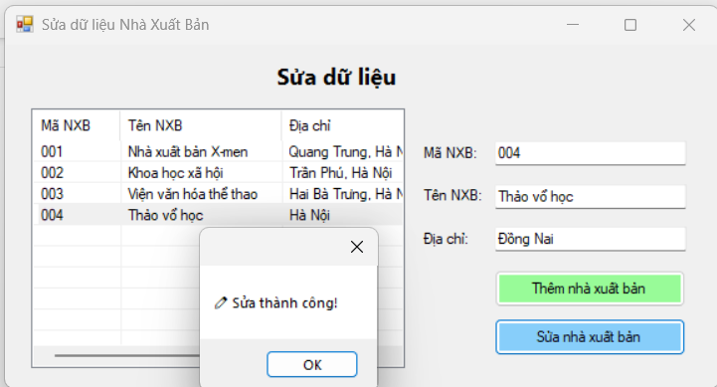
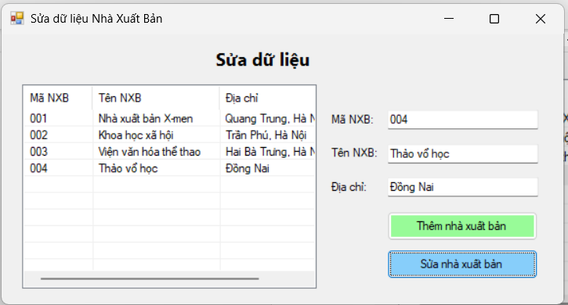

Form1.cs
using System;
using System.Data;
using System.Data.SqlClient;
using System.Windows.Forms;

namespace Btap8
{
public partial class Form1 : Form
{
// 🔹 Chuỗi kết nối — sửa lại đường dẫn nếu cần
string strCon = @"Data Source=(LocalDB)\MSSQLLocalDB;
AttachDbFilename=|DataDirectory|\QuanLySach.mdf;
Integrated Security=True";
SqlConnection sqlCon = null;

public Form1()
{
InitializeComponent();
}

// 🔹 Mở kết nối
private void MoKetNoi()
{
if (sqlCon == null)
sqlCon = new SqlConnection(strCon);
if (sqlCon.State == ConnectionState.Closed)
sqlCon.Open();
}

// 🔹 Đóng kết nối
private void DongKetNoi()
{
if (sqlCon != null && sqlCon.State == ConnectionState.Open)
sqlCon.Close();
}

// 🔹 Hiển thị danh sách NXB
private void HienThiDanhSach()
{
MoKetNoi();
string sql = "SELECT * FROM NhaXuatBan";
SqlCommand cmd = new SqlCommand(sql, sqlCon);
SqlDataReader reader = cmd.ExecuteReader();

lsvNXB.Items.Clear();
while (reader.Read())
{
string ma = reader["NXB"].ToString();
string ten = reader["TenNXB"].ToString();
string diachi = reader["DiaChi"].ToString();

ListViewItem lvi = new ListViewItem(ma);
lvi.SubItems.Add(ten);
lvi.SubItems.Add(diachi);
lsvNXB.Items.Add(lvi);
}

reader.Close();
DongKetNoi();
}

// 🔹 Khi form load
private void Form1_Load(object sender, EventArgs e)
{
HienThiDanhSach();
}

// 🔹 Khi chọn dòng trong ListView
private void lsvNXB_SelectedIndexChanged(object sender, EventArgs e)
{
if (lsvNXB.SelectedItems.Count == 0) return;

ListViewItem lvi = lsvNXB.SelectedItems[0];
txtMaNXB.Text = lvi.SubItems[0].Text;
txtTenNXB.Text = lvi.SubItems[1].Text;
txtDiaChi.Text = lvi.SubItems[2].Text;
}

// 🔹 Nút thêm
private void btnThem_Click(object sender, EventArgs e)
{
if (txtMaNXB.Text == "" || txtTenNXB.Text == "" || txtDiaChi.Text == "")
{
MessageBox.Show("Vui lòng nhập đầy đủ thông tin!", "Thông báo");
return;
}

MoKetNoi();
string sql = "INSERT INTO NhaXuatBan VALUES (@ma, @ten, @diachi)";
SqlCommand cmd = new SqlCommand(sql, sqlCon);
cmd.Parameters.AddWithValue("@ma", txtMaNXB.Text.Trim());
cmd.Parameters.AddWithValue("@ten", txtTenNXB.Text.Trim());
cmd.Parameters.AddWithValue("@diachi", txtDiaChi.Text.Trim());

try
{
cmd.ExecuteNonQuery();
MessageBox.Show("✅ Thêm thành công!");
HienThiDanhSach();
txtMaNXB.Clear();
txtTenNXB.Clear();
txtDiaChi.Clear();
}
catch (Exception ex)
{
MessageBox.Show("Lỗi khi thêm: " + ex.Message);
}
DongKetNoi();
}

// 🔹 Nút sửa
private void btnSua_Click(object sender, EventArgs e)
{
if (txtMaNXB.Text == "")
{
MessageBox.Show("Hãy chọn một nhà xuất bản để sửa!", "Thông báo");
return;
}

MoKetNoi();
string sql = "UPDATE NhaXuatBan SET TenNXB=@ten, DiaChi=@diachi WHERE NXB=@ma";
SqlCommand cmd = new SqlCommand(sql, sqlCon);
cmd.Parameters.AddWithValue("@ma", txtMaNXB.Text.Trim());
cmd.Parameters.AddWithValue("@ten", txtTenNXB.Text.Trim());
cmd.Parameters.AddWithValue("@diachi", txtDiaChi.Text.Trim());

try
{
int rows = cmd.ExecuteNonQuery();
if (rows > 0)
{
MessageBox.Show("✏️ Sửa thành công!");
HienThiDanhSach();
}
else
{
MessageBox.Show("❌ Không tìm thấy Mã NXB cần sửa!");
}
}
catch (Exception ex)
{
MessageBox.Show("Lỗi khi sửa: " + ex.Message);
}
DongKetNoi();
}
}
}

Form1.Deseigner.cs
namespace Btap8
{
partial class Form1
{
private System.ComponentModel.IContainer components = null;

protected override void Dispose(bool disposing)
{
if (disposing && (components != null))
{
components.Dispose();
}
base.Dispose(disposing);
}

#region Windows Form Designer generated code

private void InitializeComponent()
{
this.lsvNXB = new System.Windows.Forms.ListView();
this.colMa = ((System.Windows.Forms.ColumnHeader)(new System.Windows.Forms.ColumnHeader()));
this.colTen = ((System.Windows.Forms.ColumnHeader)(new System.Windows.Forms.ColumnHeader()));
this.colDiaChi = ((System.Windows.Forms.ColumnHeader)(new System.Windows.Forms.ColumnHeader()));
this.txtMaNXB = new System.Windows.Forms.TextBox();
this.txtTenNXB = new System.Windows.Forms.TextBox();
this.txtDiaChi = new System.Windows.Forms.TextBox();
this.btnThem = new System.Windows.Forms.Button();
this.btnSua = new System.Windows.Forms.Button();
this.lblMa = new System.Windows.Forms.Label();
this.lblTen = new System.Windows.Forms.Label();
this.lblDiaChi = new System.Windows.Forms.Label();
this.lblTitle = new System.Windows.Forms.Label();
this.SuspendLayout();
this.lsvNXB.Columns.AddRange(new System.Windows.Forms.ColumnHeader[] {
this.colMa,
this.colTen,
this.colDiaChi});
this.lsvNXB.FullRowSelect = true;
this.lsvNXB.GridLines = true;
this.lsvNXB.HideSelection = false;
this.lsvNXB.Location = new System.Drawing.Point(25, 60);
this.lsvNXB.Name = "lsvNXB";
this.lsvNXB.Size = new System.Drawing.Size(350, 240);
this.lsvNXB.TabIndex = 0;
this.lsvNXB.UseCompatibleStateImageBehavior = false;
this.lsvNXB.View = System.Windows.Forms.View.Details;
this.lsvNXB.SelectedIndexChanged += new System.EventHandler(this.lsvNXB_SelectedIndexChanged);
this.colMa.Text = "Mã NXB";
this.colMa.Width = 70;
this.colTen.Text = "Tên NXB";
this.colTen.Width = 130;
this.colDiaChi.Text = "Địa chỉ";
this.colDiaChi.Width = 150;
this.txtMaNXB.Location = new System.Drawing.Point(460, 90);
this.txtMaNXB.Name = "txtMaNXB";
this.txtMaNXB.Size = new System.Drawing.Size(180, 23);
this.txtMaNXB.TabIndex = 1;
this.txtTenNXB.Location = new System.Drawing.Point(460, 130);
this.txtTenNXB.Name = "txtTenNXB";
this.txtTenNXB.Size = new System.Drawing.Size(180, 23);
this.txtTenNXB.TabIndex = 2;
this.txtDiaChi.Location = new System.Drawing.Point(460, 170);
this.txtDiaChi.Name = "txtDiaChi";
this.txtDiaChi.Size = new System.Drawing.Size(180, 23);
this.txtDiaChi.TabIndex = 3;
this.btnThem.BackColor = System.Drawing.Color.PaleGreen;
this.btnThem.Location = new System.Drawing.Point(460, 210);
this.btnThem.Name = "btnThem";
this.btnThem.Size = new System.Drawing.Size(180, 35);
this.btnThem.TabIndex = 4;
this.btnThem.Text = "Thêm nhà xuất bản";
this.btnThem.UseVisualStyleBackColor = false;
this.btnThem.Click += new System.EventHandler(this.btnThem_Click);
this.btnSua.BackColor = System.Drawing.Color.LightSkyBlue;
this.btnSua.Location = new System.Drawing.Point(460, 255);
this.btnSua.Name = "btnSua";
this.btnSua.Size = new System.Drawing.Size(180, 35);
this.btnSua.TabIndex = 5;
this.btnSua.Text = "Sửa nhà xuất bản";
this.btnSua.UseVisualStyleBackColor = false;
this.btnSua.Click += new System.EventHandler(this.btnSua_Click);
this.lblMa.AutoSize = true;
this.lblMa.Location = new System.Drawing.Point(390, 93);
this.lblMa.Name = "lblMa";
this.lblMa.Size = new System.Drawing.Size(54, 15);
this.lblMa.TabIndex = 6;
this.lblMa.Text = "Mã NXB:";
this.lblTen.AutoSize = true;
this.lblTen.Location = new System.Drawing.Point(390, 133);
this.lblTen.Name = "lblTen";
this.lblTen.Size = new System.Drawing.Size(58, 15);
this.lblTen.TabIndex = 7;
this.lblTen.Text = "Tên NXB:";
this.lblDiaChi.AutoSize = true;
this.lblDiaChi.Location = new System.Drawing.Point(390, 173);
this.lblDiaChi.Name = "lblDiaChi";
this.lblDiaChi.Size = new System.Drawing.Size(49, 15);
this.lblDiaChi.TabIndex = 8;
this.lblDiaChi.Text = "Địa chỉ:";
this.lblTitle.AutoSize = true;
this.lblTitle.Font = new System.Drawing.Font("Segoe UI", 13F, System.Drawing.FontStyle.Bold);
this.lblTitle.Location = new System.Drawing.Point(250, 15);
this.lblTitle.Name = "lblTitle";
this.lblTitle.Size = new System.Drawing.Size(126, 25);
this.lblTitle.TabIndex = 9;
this.lblTitle.Text = "Sửa dữ liệu";
this.AutoScaleDimensions = new System.Drawing.SizeF(7F, 15F);
this.AutoScaleMode = System.Windows.Forms.AutoScaleMode.Font;
this.ClientSize = new System.Drawing.Size(670, 320);
this.Controls.Add(this.lblTitle);
this.Controls.Add(this.lblDiaChi);
this.Controls.Add(this.lblTen);
this.Controls.Add(this.lblMa);
this.Controls.Add(this.btnSua);
this.Controls.Add(this.btnThem);
this.Controls.Add(this.txtDiaChi);
this.Controls.Add(this.txtTenNXB);
this.Controls.Add(this.txtMaNXB);
this.Controls.Add(this.lsvNXB);
this.Name = "Form1";
this.Text = "Sửa dữ liệu Nhà Xuất Bản";
this.Load += new System.EventHandler(this.Form1_Load);
this.ResumeLayout(false);
this.PerformLayout();
}

#endregion

private System.Windows.Forms.ListView lsvNXB;
private System.Windows.Forms.ColumnHeader colMa;
private System.Windows.Forms.ColumnHeader colTen;
private System.Windows.Forms.ColumnHeader colDiaChi;
private System.Windows.Forms.TextBox txtMaNXB;
private System.Windows.Forms.TextBox txtTenNXB;
private System.Windows.Forms.TextBox txtDiaChi;
private System.Windows.Forms.Button btnThem;
private System.Windows.Forms.Button btnSua;
private System.Windows.Forms.Label lblMa;
private System.Windows.Forms.Label lblTen;
private System.Windows.Forms.Label lblDiaChi;
private System.Windows.Forms.Label lblTitle;
}
}
Thực hành 4

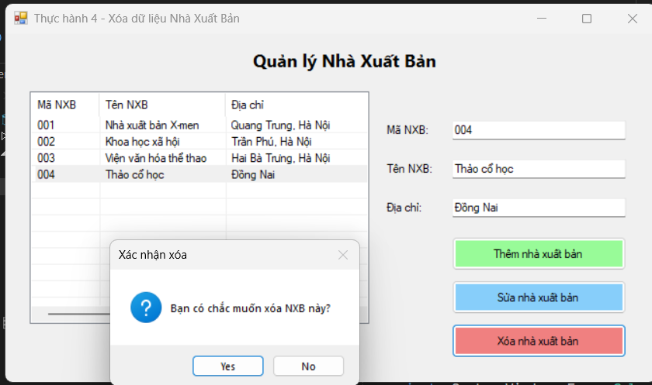
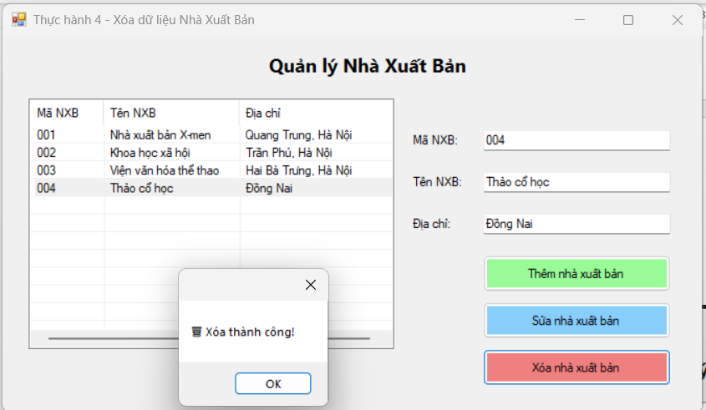

Form1.cs
using System;
using System.Data;
using System.Data.SqlClient;
using System.Windows.Forms;

namespace Btap8
{
public partial class Form1 : Form
{
string strCon = @"Data Source=(LocalDB)\MSSQLLocalDB;
AttachDbFilename=|DataDirectory|\QuanLySach.mdf;
Integrated Security=True";
SqlConnection sqlCon = null;

public Form1()
{
InitializeComponent();
}

private void MoKetNoi()
{
if (sqlCon == null)
sqlCon = new SqlConnection(strCon);
if (sqlCon.State == ConnectionState.Closed)
sqlCon.Open();
}

private void DongKetNoi()
{
if (sqlCon != null && sqlCon.State == ConnectionState.Open)
sqlCon.Close();
}

private void HienThiDanhSach()
{
MoKetNoi();
string sql = "SELECT * FROM NhaXuatBan";
SqlCommand cmd = new SqlCommand(sql, sqlCon);
SqlDataReader reader = cmd.ExecuteReader();

lsvNXB.Items.Clear();
while (reader.Read())
{
string ma = reader["NXB"].ToString();
string ten = reader["TenNXB"].ToString();
string diachi = reader["DiaChi"].ToString();

ListViewItem lvi = new ListViewItem(ma);
lvi.SubItems.Add(ten);
lvi.SubItems.Add(diachi);
lsvNXB.Items.Add(lvi);
}

reader.Close();
DongKetNoi();
}

private void Form1_Load(object sender, EventArgs e)
{
HienThiDanhSach();
}

private void lsvNXB_SelectedIndexChanged(object sender, EventArgs e)
{
if (lsvNXB.SelectedItems.Count == 0) return;

ListViewItem lvi = lsvNXB.SelectedItems[0];
txtMaNXB.Text = lvi.SubItems[0].Text;
txtTenNXB.Text = lvi.SubItems[1].Text;
txtDiaChi.Text = lvi.SubItems[2].Text;
}

private void btnThem_Click(object sender, EventArgs e)
{
if (txtMaNXB.Text == "" || txtTenNXB.Text == "" || txtDiaChi.Text == "")
{
MessageBox.Show("Vui lòng nhập đầy đủ thông tin!");
return;
}

MoKetNoi();
string sql = "INSERT INTO NhaXuatBan VALUES (@ma, @ten, @diachi)";
SqlCommand cmd = new SqlCommand(sql, sqlCon);
cmd.Parameters.AddWithValue("@ma", txtMaNXB.Text.Trim());
cmd.Parameters.AddWithValue("@ten", txtTenNXB.Text.Trim());
cmd.Parameters.AddWithValue("@diachi", txtDiaChi.Text.Trim());

try
{
cmd.ExecuteNonQuery();
MessageBox.Show("✅ Thêm thành công!");
HienThiDanhSach();
txtMaNXB.Clear();
txtTenNXB.Clear();
txtDiaChi.Clear();
}
catch (Exception ex)
{
MessageBox.Show("Lỗi khi thêm: " + ex.Message);
}
DongKetNoi();
}

private void btnSua_Click(object sender, EventArgs e)
{
if (txtMaNXB.Text == "")
{
MessageBox.Show("Hãy chọn một nhà xuất bản để sửa!");
return;
}

MoKetNoi();
string sql = "UPDATE NhaXuatBan SET TenNXB=@ten, DiaChi=@diachi WHERE NXB=@ma";
SqlCommand cmd = new SqlCommand(sql, sqlCon);
cmd.Parameters.AddWithValue("@ma", txtMaNXB.Text.Trim());
cmd.Parameters.AddWithValue("@ten", txtTenNXB.Text.Trim());
cmd.Parameters.AddWithValue("@diachi", txtDiaChi.Text.Trim());

try
{
int rows = cmd.ExecuteNonQuery();
if (rows > 0)
{
MessageBox.Show("✏️ Sửa thành công!");
HienThiDanhSach();
}
else
{
MessageBox.Show("❌ Không tìm thấy Mã NXB để sửa!");
}
}
catch (Exception ex)
{
MessageBox.Show("Lỗi khi sửa: " + ex.Message);
}
DongKetNoi();
}

// 🔹 Nút Xóa
private void btnXoa_Click(object sender, EventArgs e)
{
if (txtMaNXB.Text == "")
{
MessageBox.Show("Hãy chọn một nhà xuất bản để xóa!");
return;
}

if (MessageBox.Show("Bạn có chắc muốn xóa NXB này?", "Xác nhận xóa",
MessageBoxButtons.YesNo, MessageBoxIcon.Question) == DialogResult.Yes)
{
MoKetNoi();
string sql = "DELETE FROM NhaXuatBan WHERE NXB=@ma";
SqlCommand cmd = new SqlCommand(sql, sqlCon);
cmd.Parameters.AddWithValue("@ma", txtMaNXB.Text.Trim());

try
{
int rows = cmd.ExecuteNonQuery();
if (rows > 0)
{
MessageBox.Show("🗑️ Xóa thành công!");
HienThiDanhSach();
txtMaNXB.Clear();
txtTenNXB.Clear();
txtDiaChi.Clear();
}
else
{
MessageBox.Show("❌ Không tìm thấy Mã NXB để xóa!");
}
}
catch (Exception ex)
{
MessageBox.Show("Lỗi khi xóa: " + ex.Message);
}

DongKetNoi();
}
}
}
}

Form1.Deseigner.cs
namespace Btap8
{
partial class Form1
{
private System.ComponentModel.IContainer components = null;

protected override void Dispose(bool disposing)
{
if (disposing && (components != null))
{
components.Dispose();
}
base.Dispose(disposing);
}

#region Windows Form Designer generated code

private void InitializeComponent()
{
this.lsvNXB = new System.Windows.Forms.ListView();
this.colMa = ((System.Windows.Forms.ColumnHeader)(new System.Windows.Forms.ColumnHeader()));
this.colTen = ((System.Windows.Forms.ColumnHeader)(new System.Windows.Forms.ColumnHeader()));
this.colDiaChi = ((System.Windows.Forms.ColumnHeader)(new System.Windows.Forms.ColumnHeader()));
this.txtMaNXB = new System.Windows.Forms.TextBox();
this.txtTenNXB = new System.Windows.Forms.TextBox();
this.txtDiaChi = new System.Windows.Forms.TextBox();
this.btnThem = new System.Windows.Forms.Button();
this.btnSua = new System.Windows.Forms.Button();
this.btnXoa = new System.Windows.Forms.Button();
this.lblMa = new System.Windows.Forms.Label();
this.lblTen = new System.Windows.Forms.Label();
this.lblDiaChi = new System.Windows.Forms.Label();
this.lblTitle = new System.Windows.Forms.Label();
this.SuspendLayout();
this.lsvNXB.Columns.AddRange(new System.Windows.Forms.ColumnHeader[] {
this.colMa,
this.colTen,
this.colDiaChi});
this.lsvNXB.FullRowSelect = true;
this.lsvNXB.GridLines = true;
this.lsvNXB.HideSelection = false;
this.lsvNXB.Location = new System.Drawing.Point(25, 60);
this.lsvNXB.Name = "lsvNXB";
this.lsvNXB.Size = new System.Drawing.Size(350, 240);
this.lsvNXB.TabIndex = 0;
this.lsvNXB.UseCompatibleStateImageBehavior = false;
this.lsvNXB.View = System.Windows.Forms.View.Details;
this.lsvNXB.SelectedIndexChanged += new System.EventHandler(this.lsvNXB_SelectedIndexChanged);
this.colMa.Text = "Mã NXB";
this.colMa.Width = 70;
this.colTen.Text = "Tên NXB";
this.colTen.Width = 130;
this.colDiaChi.Text = "Địa chỉ";
this.colDiaChi.Width = 150;
this.txtMaNXB.Location = new System.Drawing.Point(460, 90);
this.txtMaNXB.Name = "txtMaNXB";
this.txtMaNXB.Size = new System.Drawing.Size(180, 23);
this.txtMaNXB.TabIndex = 1;
this.txtTenNXB.Location = new System.Drawing.Point(460, 130);
this.txtTenNXB.Name = "txtTenNXB";
this.txtTenNXB.Size = new System.Drawing.Size(180, 23);
this.txtTenNXB.TabIndex = 2;
this.txtDiaChi.Location = new System.Drawing.Point(460, 170);
this.txtDiaChi.Name = "txtDiaChi";
this.txtDiaChi.Size = new System.Drawing.Size(180, 23);
this.txtDiaChi.TabIndex = 3;
this.btnThem.BackColor = System.Drawing.Color.PaleGreen;
this.btnThem.Location = new System.Drawing.Point(460, 210);
this.btnThem.Name = "btnThem";
this.btnThem.Size = new System.Drawing.Size(180, 35);
this.btnThem.TabIndex = 4;
this.btnThem.Text = "Thêm nhà xuất bản";
this.btnThem.UseVisualStyleBackColor = false;
this.btnThem.Click += new System.EventHandler(this.btnThem_Click);
this.btnSua.BackColor = System.Drawing.Color.LightSkyBlue;
this.btnSua.Location = new System.Drawing.Point(460, 255);
this.btnSua.Name = "btnSua";
this.btnSua.Size = new System.Drawing.Size(180, 35);
this.btnSua.TabIndex = 5;
this.btnSua.Text = "Sửa nhà xuất bản";
this.btnSua.UseVisualStyleBackColor = false;
this.btnSua.Click += new System.EventHandler(this.btnSua_Click);
this.btnXoa.BackColor = System.Drawing.Color.LightCoral;
this.btnXoa.Location = new System.Drawing.Point(460, 300);
this.btnXoa.Name = "btnXoa";
this.btnXoa.Size = new System.Drawing.Size(180, 35);
this.btnXoa.TabIndex = 6;
this.btnXoa.Text = "Xóa nhà xuất bản";
this.btnXoa.UseVisualStyleBackColor = false;
this.btnXoa.Click += new System.EventHandler(this.btnXoa_Click);
this.lblMa.AutoSize = true;
this.lblMa.Location = new System.Drawing.Point(390, 93);
this.lblMa.Text = "Mã NXB:";
this.lblTen.AutoSize = true;
this.lblTen.Location = new System.Drawing.Point(390, 133);
this.lblTen.Text = "Tên NXB:";
this.lblDiaChi.AutoSize = true;
this.lblDiaChi.Location = new System.Drawing.Point(390, 173);
this.lblDiaChi.Text = "Địa chỉ:";
this.lblTitle.AutoSize = true;
this.lblTitle.Font = new System.Drawing.Font("Segoe UI", 13F, System.Drawing.FontStyle.Bold);
this.lblTitle.Location = new System.Drawing.Point(250, 15);
this.lblTitle.Text = "Quản lý Nhà Xuất Bản";
this.ClientSize = new System.Drawing.Size(670, 360);
this.Controls.Add(this.lblTitle);
this.Controls.Add(this.lblDiaChi);
this.Controls.Add(this.lblTen);
this.Controls.Add(this.lblMa);
this.Controls.Add(this.btnXoa);
this.Controls.Add(this.btnSua);
this.Controls.Add(this.btnThem);
this.Controls.Add(this.txtDiaChi);
this.Controls.Add(this.txtTenNXB);
this.Controls.Add(this.txtMaNXB);
this.Controls.Add(this.lsvNXB);
this.Name = "Form1";
this.Text = "Thực hành 4 - Xóa dữ liệu Nhà Xuất Bản";
this.Load += new System.EventHandler(this.Form1_Load);
this.ResumeLayout(false);
this.PerformLayout();
}

#endregion

private System.Windows.Forms.ListView lsvNXB;
private System.Windows.Forms.ColumnHeader colMa;
private System.Windows.Forms.ColumnHeader colTen;
private System.Windows.Forms.ColumnHeader colDiaChi;
private System.Windows.Forms.TextBox txtMaNXB;
private System.Windows.Forms.TextBox txtTenNXB;
private System.Windows.Forms.TextBox txtDiaChi;
private System.Windows.Forms.Button btnThem;
private System.Windows.Forms.Button btnSua;
private System.Windows.Forms.Button btnXoa;
private System.Windows.Forms.Label lblMa;
private System.Windows.Forms.Label lblTen;
private System.Windows.Forms.Label lblDiaChi;
private System.Windows.Forms.Label lblTitle;
}
}

