Bài 1
using Microsoft.VisualStudio.TestTools.UnitTesting;

namespace PowerUnitTest
{
[TestClass]
public class PowerTests
{
static double Power(double x, int n)
{
if (n == 0)
return 1.0;
else if (n > 0)
return x * Power(x, n - 1);
else
return Power(x, n + 1) / x;
}

[TestMethod]
public void TC01_N_Bang_0()
{
Assert.AreEqual(1.0, Power(10, 0));
}

[TestMethod]
public void TC02_N_Duong()
{
Assert.AreEqual(8.0, Power(2, 3));
Assert.AreEqual(25.0, Power(5, 2));
}

[TestMethod]
public void TC03_N_Am()
{
Assert.AreEqual(0.5, Power(2, -1), 1e-9);
Assert.AreEqual(0.25, Power(2, -2), 1e-9);
}

[TestMethod]
public void TC04_Co_So_Am()
{
Assert.AreEqual(-8.0, Power(-2, 3), 1e-9);
Assert.AreEqual(4.0, Power(-2, 2), 1e-9);
}

[TestMethod]
public void TC05_Co_So_Bang_1()
{
Assert.AreEqual(1.0, Power(1, 50), 1e-9);
Assert.AreEqual(1.0, Power(1, -50), 1e-9);
}
}
}

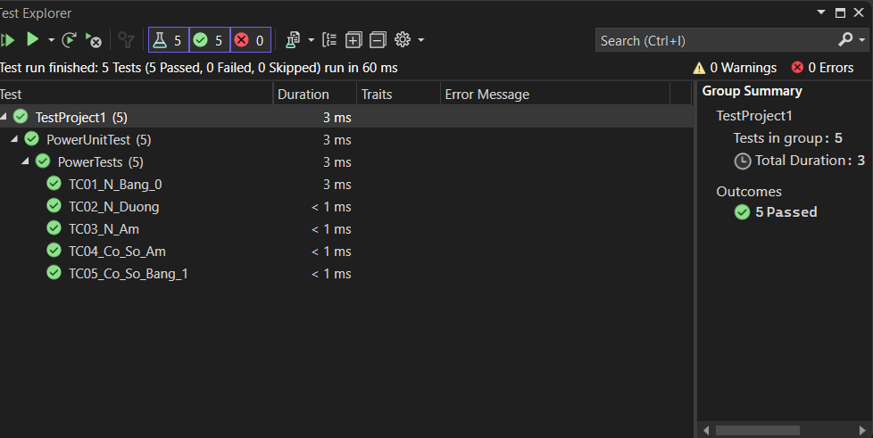

bài 2
using Microsoft.VisualStudio.TestTools.UnitTesting;
using System;
using System.Collections.Generic;

namespace PolynomialUnitTest
{
[TestClass]
public class PolynomialTests
{
class Polynomial
{
private int n;
private List<int> a;

public Polynomial(int n, List<int> a)
{
if (n < 0 || a.Count != n + 1)
throw new ArgumentException("Invalid Data");

this.n = n;
this.a = a;
}

public int Cal(double x)
{
int result = 0;
for (int i = 0; i <= this.n; i++)
{
result += (int)(a[i] * Math.Pow(x, i));
}
return result;
}
}

[TestMethod]
public void TC01_DaThuc_Bac_2()
{
var poly = new Polynomial(2, new List<int> { 1, 2, 3 });
int result = poly.Cal(2);
Assert.AreEqual(17, result); // 1 + 2*2 + 3*4
}

[TestMethod]
public void TC02_DaThuc_Bac_0()
{
var poly = new Polynomial(0, new List<int> { 5 });
int result = poly.Cal(10);
Assert.AreEqual(5, result);
}

[TestMethod]
public void TC03_Thieu_He_So()
{
Assert.ThrowsException<ArgumentException>(() =>
{
new Polynomial(2, new List<int> { 1, 2 });
});
}

[TestMethod]
public void TC04_Du_He_So()
{
Assert.ThrowsException<ArgumentException>(() =>
{
new Polynomial(1, new List<int> { 1, 2, 3 });
});
}

[TestMethod]
public void TC05_N_Am()
{
Assert.ThrowsException<ArgumentException>(() =>
{
new Polynomial(-1, new List<int> { 1 });
});
}
}
}
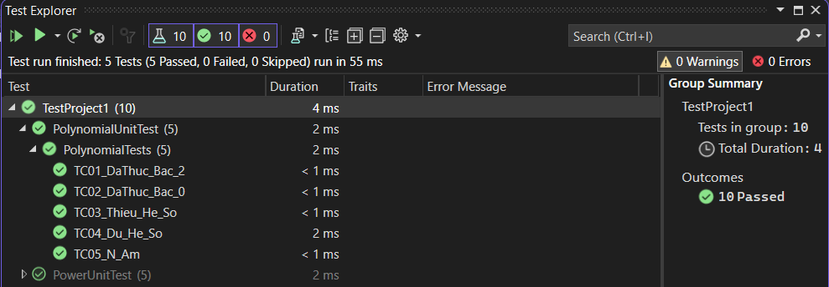

Bài 3
using Microsoft.VisualStudio.TestTools.UnitTesting;
using System;
using System.Collections.Generic;

namespace RadixUnitTest
{
[TestClass]
public class RadixTests
{

public class Radix
{
private int number;

public Radix(int number)
{
if (number < 0)
throw new ArgumentException("Incorrect Value");

this.number = number;
}

public string ConvertDecimalToAnother(int radix = 2)
{
int n = this.number;

if (radix < 2 || radix > 16)
throw new ArgumentException("Invalid Radix");

List<string> result = new List<string>();
while (n > 0)
{
int value = n % radix;
if (value < 10)
result.Add(value.ToString());
else
{
switch (value)
{
case 10: result.Add("A"); break;
case 11: result.Add("B"); break;
case 12: result.Add("C"); break;
case 13: result.Add("D"); break;
case 14: result.Add("E"); break;
case 15: result.Add("F"); break;
}
}
n /= radix;
}
result.Reverse();
return string.Join("", result.ToArray());
}
}

[TestMethod]
public void TC01_He_2()
{
var r = new Radix(10);
Assert.AreEqual("1010", r.ConvertDecimalToAnother(2));
}

[TestMethod]
public void TC02_He_16_Mot_Chu_So()
{
var r = new Radix(15);
Assert.AreEqual("F", r.ConvertDecimalToAnother(16));
}

[TestMethod]
public void TC03_He_16_Nhieu_Chu_So()
{
var r = new Radix(255);
Assert.AreEqual("FF", r.ConvertDecimalToAnother(16));
}

[TestMethod]
public void TC04_He_8()
{
var r = new Radix(8);
Assert.AreEqual("10", r.ConvertDecimalToAnother(8));
}

[TestMethod]
public void TC05_Number_Am()
{
Assert.ThrowsException<ArgumentException>(() =>
{
new Radix(-5);
});
}

[TestMethod]
public void TC06_Radix_Khong_Hop_Le()
{
var r = new Radix(10);
Assert.ThrowsException<ArgumentException>(() =>
{
r.ConvertDecimalToAnother(1);
});
}
}
}
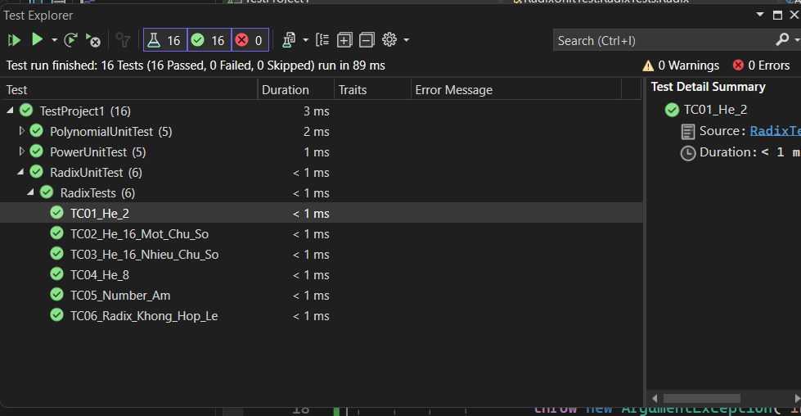

Bài 4
using Microsoft.VisualStudio.TestTools.UnitTesting;

namespace RectangleUnitTest
{
[TestClass]
public class HinhChuNhatTests
{

public class Diem
{
public int X { get; set; }
public int Y { get; set; }

public Diem(int x, int y)
{
X = x;
Y = y;
}
}

public class HinhChuNhat
{
private Diem topLeft;
private Diem bottomRight;

public HinhChuNhat(Diem topLeft, Diem bottomRight)
{
this.topLeft = topLeft;
this.bottomRight = bottomRight;
}

public int DienTich()
{
int width = bottomRight.X - topLeft.X;
int height = topLeft.Y - bottomRight.Y;
if (width < 0 || height < 0) return 0;
return width * height;
}

public bool GiaoNhau(HinhChuNhat other)
{
if (this.bottomRight.X <= other.topLeft.X ||
this.topLeft.X >= other.bottomRight.X ||
this.bottomRight.Y >= other.topLeft.Y ||
this.topLeft.Y <= other.bottomRight.Y)
return false;

return true;
}
}

[TestMethod]
public void TC01_Tinh_Dien_Tich()
{
var rect = new HinhChuNhat(
new Diem(0, 4),
new Diem(5, 0)
);
Assert.AreEqual(20, rect.DienTich());
}

[TestMethod]
public void TC02_Dien_Tich_Bang_0()
{
var rect = new HinhChuNhat(
new Diem(0, 0),
new Diem(0, 0)
);
Assert.AreEqual(0, rect.DienTich());
}

[TestMethod]
public void TC03_Hai_HCN_Giao_Nhau()
{
var r1 = new HinhChuNhat(
new Diem(0, 4),
new Diem(4, 0)
);
var r2 = new HinhChuNhat(
new Diem(2, 3),
new Diem(6, 1)
);
Assert.IsTrue(r1.GiaoNhau(r2));
}

[TestMethod]
public void TC04_Hai_HCN_Khong_Giao()
{
var r1 = new HinhChuNhat(
new Diem(0, 4),
new Diem(4, 0)
);
var r2 = new HinhChuNhat(
new Diem(5, 3),
new Diem(7, 1)
);
Assert.IsFalse(r1.GiaoNhau(r2));
}

[TestMethod]
public void TC05_Hai_HCN_Cham_Bien()
{
var r1 = new HinhChuNhat(
new Diem(0, 4),
new Diem(4, 0)
);
var r2 = new HinhChuNhat(
new Diem(4, 3),
new Diem(6, 1)
);
Assert.IsFalse(r1.GiaoNhau(r2));
}
}
}
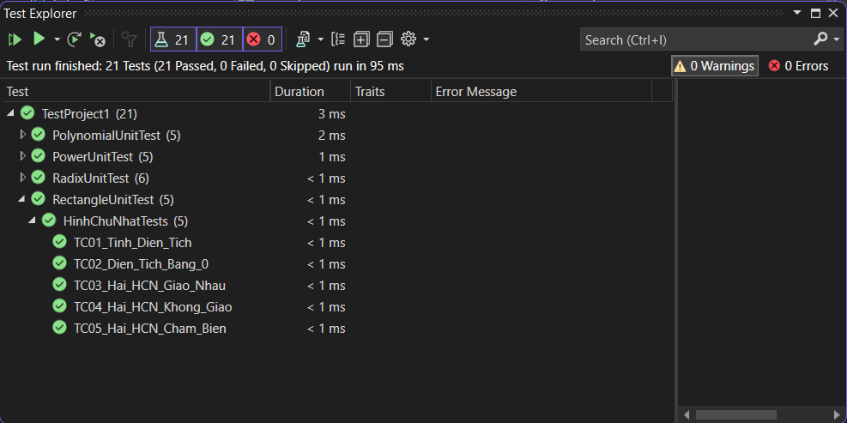

Bài 5
using Microsoft.VisualStudio.TestTools.UnitTesting;

namespace HocVienUnitTest
{
[TestClass]
public class HocVienTests
{
public class HocVien
{
public string MaHV { get; set; }
public string HoTen { get; set; }
public string QueQuan { get; set; }
public double Diem1 { get; set; }
public double Diem2 { get; set; }
public double Diem3 { get; set; }

public HocVien(string ma, string ten, string que, double d1, double d2, double d3)
{
MaHV = ma;
HoTen = ten;
QueQuan = que;
Diem1 = d1;
Diem2 = d2;
Diem3 = d3;
}

public double DiemTrungBinh()
{
return (Diem1 + Diem2 + Diem3) / 3;
}

public bool DuDieuKienHocBong()
{
return DiemTrungBinh() >= 8.0
&& Diem1 >= 5
&& Diem2 >= 5
&& Diem3 >= 5;
}
}

[TestMethod]
public void TC01_Du_Dieu_Kien_Hoc_Bong()
{
var hv = new HocVien("HV01", "An", "HN", 8.5, 8.0, 9.0);
Assert.IsTrue(hv.DuDieuKienHocBong());
}

[TestMethod]
public void TC02_Diem_TB_Nho_Hon_8()
{
var hv = new HocVien("HV02", "Binh", "HP", 7.0, 7.0, 9.0);
Assert.IsFalse(hv.DuDieuKienHocBong());
}

[TestMethod]
public void TC03_Co_Mon_Duoi_5()
{
var hv = new HocVien("HV03", "Cuong", "DN", 9.0, 4.5, 9.0);
Assert.IsFalse(hv.DuDieuKienHocBong());
}

[TestMethod]
public void TC04_Diem_TB_Bang_8()
{
var hv = new HocVien("HV04", "Dung", "HCM", 8.0, 8.0, 8.0);
Assert.IsTrue(hv.DuDieuKienHocBong());
}

[TestMethod]
public void TC05_Mon_Bang_5()
{
var hv = new HocVien("HV05", "Huy", "CT", 9.0, 5.0, 10.0);
Assert.IsTrue(hv.DuDieuKienHocBong());
}
}
}
