Bài 1.1
package dtm;

import io.github.bonigarcia.wdm.WebDriverManager;
import org.openqa.selenium.WebDriver;
import org.openqa.selenium.chrome.ChromeDriver;
import org.testng.Assert;
import org.testng.annotations.*;

public class TitleTest {

WebDriver driver;

@BeforeMethod
public void setup() {

WebDriverManager.chromedriver().setup();

driver = new ChromeDriver();

driver.manage().window().maximize();

driver.get("https://www.saucedemo.com");
}

@Test
public void testTitle() {

String expectedTitle = "Swag Labs";

String actualTitle = driver.getTitle();

Assert.assertEquals(actualTitle, expectedTitle);

}

@AfterMethod
public void close() {

driver.quit();
}
}

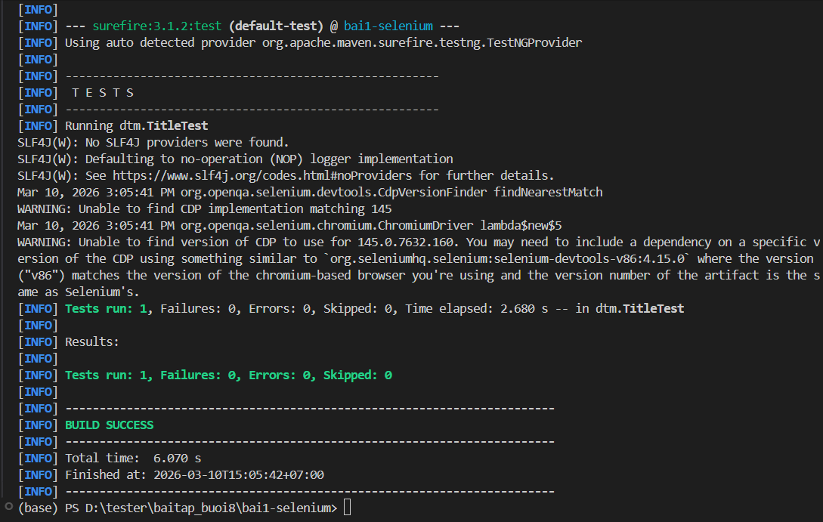
Bài 2.1
LoginTest.java
package dtm;
import io.github.bonigarcia.wdm.WebDriverManager;
import org.openqa.selenium.*;
import org.openqa.selenium.chrome.ChromeDriver;
import org.testng.Assert;
import org.testng.annotations.*;

public class LoginTest {

WebDriver driver;

@BeforeMethod
public void setup() {

WebDriverManager.chromedriver().setup();
driver = new ChromeDriver();

driver.manage().window().maximize();
driver.get("https://www.saucedemo.com");

}

@Test
public void testLoginSuccess(){

driver.findElement(By.id("user-name")).sendKeys("standard_user");
driver.findElement(By.id("password")).sendKeys("secret_sauce");
driver.findElement(By.id("login-button")).click();

Assert.assertTrue(driver.getCurrentUrl().contains("inventory"));

}

@Test
public void testLoginWrongPassword(){

driver.findElement(By.id("user-name")).sendKeys("standard_user");
driver.findElement(By.id("password")).sendKeys("wrong_pass");
driver.findElement(By.id("login-button")).click();

String error = driver.findElement(By.cssSelector("h3")).getText();

Assert.assertTrue(error.contains("Username and password do not match"));

}

@Test
public void testLoginEmptyUsername(){

driver.findElement(By.id("password")).sendKeys("secret_sauce");
driver.findElement(By.id("login-button")).click();

String error = driver.findElement(By.cssSelector("h3")).getText();

Assert.assertTrue(error.contains("Username is required"));

}

@Test
public void testLoginEmptyPassword(){

driver.findElement(By.id("user-name")).sendKeys("standard_user");
driver.findElement(By.id("login-button")).click();

String error = driver.findElement(By.cssSelector("h3")).getText();

Assert.assertTrue(error.contains("Password is required"));

}

@Test
public void testLoginLockedUser(){

driver.findElement(By.id("user-name")).sendKeys("locked_out_user");
driver.findElement(By.id("password")).sendKeys("secret_sauce");
driver.findElement(By.id("login-button")).click();

String error = driver.findElement(By.cssSelector("h3")).getText();

Assert.assertTrue(error.contains("Sorry, this user has been locked out"));

}

@AfterMethod
public void close(){

driver.quit();

}

}

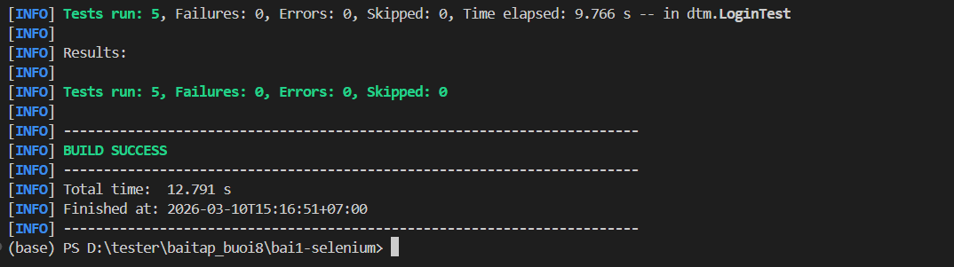

Bài tập 2
Bài 2.1
CartTest.java
package dtm;

import io.github.bonigarcia.wdm.WebDriverManager;
import org.openqa.selenium.*;
import org.openqa.selenium.chrome.ChromeDriver;
import org.testng.Assert;
import org.testng.annotations.*;

public class CartTest {

WebDriver driver;

@BeforeMethod
public void setup() {

WebDriverManager.chromedriver().setup();
driver = new ChromeDriver();

driver.manage().window().maximize();
driver.get("https://www.saucedemo.com");

// login trước
driver.findElement(By.id("user-name")).sendKeys("standard_user");
driver.findElement(By.id("password")).sendKeys("secret_sauce");
driver.findElement(By.id("login-button")).click();
}

@Test
public void testAddToCart() {

driver.findElement(By.id("add-to-cart-sauce-labs-backpack")).click();

String badge = driver.findElement(By.className("shopping_cart_badge")).getText();

Assert.assertEquals(badge, "1");
}

@Test
public void testRemoveFromCart() {

driver.findElement(By.id("add-to-cart-sauce-labs-backpack")).click();
driver.findElement(By.id("remove-sauce-labs-backpack")).click();

boolean badge = driver.findElements(By.className("shopping_cart_badge")).size() > 0;

Assert.assertFalse(badge);
}

@AfterMethod
public void close() {

driver.quit();
}
}

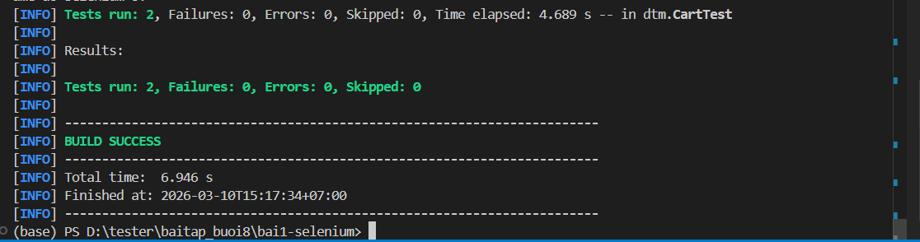

CheckoutTest.java
package dtm;

import io.github.bonigarcia.wdm.WebDriverManager;
import org.openqa.selenium.By;
import org.openqa.selenium.WebDriver;
import org.openqa.selenium.chrome.ChromeDriver;
import org.testng.Assert;
import org.testng.annotations.*;

public class CheckoutTest {

WebDriver driver;

@BeforeMethod
public void setup() {

WebDriverManager.chromedriver().setup();
driver = new ChromeDriver();

driver.manage().window().maximize();
driver.get("https://www.saucedemo.com");

// Login
driver.findElement(By.id("user-name")).sendKeys("standard_user");
driver.findElement(By.id("password")).sendKeys("secret_sauce");
driver.findElement(By.id("login-button")).click();
}

@Test(groups = {"smoke","regression"})
public void testCheckoutButton() {

// Add product
driver.findElement(By.id("add-to-cart-sauce-labs-backpack")).click();

// Click cart
driver.findElement(By.className("shopping_cart_link")).click();

// Click checkout
driver.findElement(By.id("checkout")).click();

String url = driver.getCurrentUrl();

Assert.assertTrue(url.contains("checkout-step-one"));
}

@Test(groups = {"regression"})
public void testCheckoutInformation() {

driver.findElement(By.id("add-to-cart-sauce-labs-backpack")).click();
driver.findElement(By.className("shopping_cart_link")).click();
driver.findElement(By.id("checkout")).click();

driver.findElement(By.id("first-name")).sendKeys("Test");
driver.findElement(By.id("last-name")).sendKeys("User");
driver.findElement(By.id("postal-code")).sendKeys("12345");

driver.findElement(By.id("continue")).click();

String url = driver.getCurrentUrl();

Assert.assertTrue(url.contains("checkout-step-two"));
}

@AfterMethod
public void close() {

driver.quit();

}
}
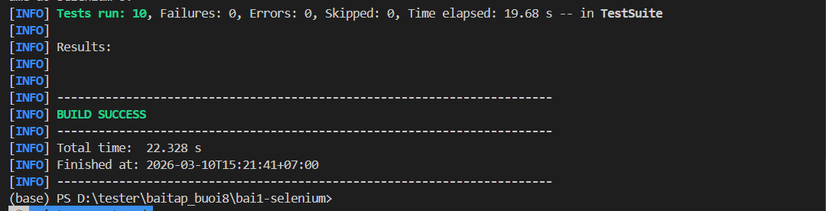

Bài 2.2
DriverFactory.java
package dtm;

import io.github.bonigarcia.wdm.WebDriverManager;
import org.openqa.selenium.WebDriver;
import org.openqa.selenium.chrome.ChromeDriver;

public class DriverFactory {

private static ThreadLocal<WebDriver> tlDriver = new ThreadLocal<>();

public static void initDriver() {

WebDriverManager.chromedriver().setup();

WebDriver driver = new ChromeDriver();
driver.manage().window().maximize();

tlDriver.set(driver);
}

public static WebDriver getDriver() {
return tlDriver.get();
}

public static void quitDriver() {

if (tlDriver.get() != null) {

tlDriver.get().quit();
tlDriver.remove();
}
}
}

testng.xml
<!DOCTYPE suite SYSTEM "https://testng.org/testng-1.0.dtd">

<suite name="SauceDemoSuite"
parallel="classes"
thread-count="2"
verbose="1">

<!-- Chỉ chạy nhóm smoke -->
<groups>
<run>
<include name="smoke"/>
</run>
</groups>

<test name="SauceDemoTests">

<classes>
<class name="dtm.LoginTest"/>
<class name="dtm.CartTest"/>
<class name="dtm.CheckoutTest"/>
</classes>

</test>

</suite>

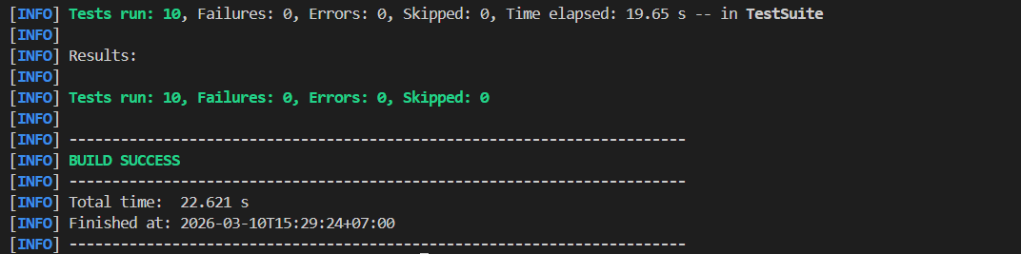

Bài 3.1
Entry
↓
Node1: diemTB < 0 OR diemTB > 10
├──[True] → Exit("Diem khong hop le")
└──[False] → Node2

Node2: diemTB >= 8.5
├──[True] → Exit("Gioi")
└──[False] → Node3

Node3: diemTB >= 7.0
├──[True] → Exit("Kha")
└──[False] → Node4

Node4: diemTB >= 5.5
├──[True] → Exit("Trung Binh")
└──[False] → Node5

Node5: coThiLai == true
├──[True] → Exit("Thi lai")
└──[False] → Exit("Yeu - Hoc lai")

Test Case

TC | diemTB | coThiLai | Đường đi CFG | Kết quả
TC1 | -1 | false | N1=True → Exit | Diem khong hop le
TC2 | 9 | false | N1=F → N2=True | Gioi
TC3 | 7.5 | false | N1=F → N2=F → N3=True | Kha
TC4 | 6 | false | N1=F → N2=F → N3=F → N4=True | Trung Binh
TC5 | 4 | true | N1=F → N2=F → N3=F → N4=F → N5=True | Thi lai
TC6 | 4 | false | N1=F → N2=F → N3=F → N4=F → N5=False | Yeu - Hoc lai
Statement Coverage = 6/6 nodes = 100%

Nhánh | Mô tả | TC phủ
N1-True | diemTB ngoài [0,10] | TC1
N1-False | diemTB hợp lệ | TC2,TC3,TC4,TC5,TC6
N2-True | diemTB ≥ 8.5 | TC2
N2-False | diemTB < 8.5 | TC3,TC4,TC5,TC6
N3-True | diemTB ≥ 7 | TC3
N3-False | diemTB < 7 | TC4,TC5,TC6
N4-True | diemTB ≥ 5.5 | TC4
N4-False | diemTB < 5.5 | TC5,TC6
N5-True | có thi lại | TC5
N5-False | không thi lại | TC6

TestNG
import org.testng.Assert;
import org.testng.annotations.Test;
public class XepLoaiBranchTest {
@Test
public void tc1_DiemKhongHopLe() {
Assert.assertEquals(xepLoai(-1,false),"Diem khong hop le");
}
@Test
public void tc2_Gioi() {
Assert.assertEquals(xepLoai(9,false),"Gioi");
}
@Test
public void tc3_Kha() {
Assert.assertEquals(xepLoai(7,false),"Kha");
}
@Test
public void tc4_TrungBinh() {
Assert.assertEquals(xepLoai(6,false),"Trung Binh");
}
@Test
public void tc5_ThiLai() {
Assert.assertEquals(xepLoai(4,true),"Thi lai");
}
@Test
public void tc6_YeuHocLai() {
Assert.assertEquals(xepLoai(4,false),"Yeu - Hoc lai");
}
}

Bài 3.2
Entry
↓
Node1: soM3 <= 0
├──[True] → Exit(0)
└──[False] → Node2

Node2: loaiKH == ho_ngheo
├──[True] → Exit(soM3 * 5000)
└──[False] → Node3

Node3: loaiKH == dan_cu
├──[True] → Node4
└──[False] → Exit(soM3 * 22000)

Node4: soM3 <= 10
├──[True] → Exit(soM3 * 7500)
└──[False] → Node5

Node5: soM3 <= 20
├──[True] → Exit(soM3 * 9900)
└──[False] → Exit(soM3 * 11400)

Test Cases
TC | soM3 | loaiKH | Nhánh phủ | Kết quả
TC1 | 0 | dan_cu | N1-True | 0
TC2 | 5 | ho_ngheo | N2-True | 25000
TC3 | 8 | dan_cu | N3=True, N4=True | 60000
TC4 | 15 | dan_cu | N4-F, N5=True | 148500
TC5 | 25 | dan_cu | N4-F, N5-False | 285000
TC6 | 10 | kinh_doanh | N3-False | 220000

TestNG
import org.testng.Assert;
import org.testng.annotations.Test;
public class TinhTienNuocTest {
@Test
public void tc1(){
Assert.assertEquals(tinhTienNuoc(0,"dan_cu"),0.0,0.01);
}
@Test
public void tc2(){
Assert.assertEquals(tinhTienNuoc(5,"ho_ngheo"),25000.0,0.01);
}
@Test
public void tc3(){
Assert.assertEquals(tinhTienNuoc(8,"dan_cu"),60000.0,0.01);
}
@Test
public void tc4(){
Assert.assertEquals(tinhTienNuoc(15,"dan_cu"),148500.0,0.01);
}
@Test
public void tc5(){
Assert.assertEquals(tinhTienNuoc(25,"dan_cu"),285000.0,0.01);
}
@Test
public void tc6(){
Assert.assertEquals(tinhTienNuoc(10,"kinh_doanh"),220000.0,0.01);
}
}

