

**Requirement & Design Specification**

**Hotel management**

**Version: 1.0**

– Hanoi, May 2025 –

Record of Change

| **Version** | **Date** | **A,M, D\*** | **In charge** | **Change Description** |
| --- | --- | --- | --- | --- |
| V1.0 | 21/05 | A | BinhNT | Actors Table |
| V1.0 | 21/05 | A | BinhNT | Requirements specification logout, Login business rule. |
| V1.0 | 21/05 | A | BinhNT | Design specifications common features Register account. |
| V1.0 | 21/05 | A | VietNH | Draw use case. |
| V1.0 | 25/05 | A | BinhNT | Database Access Login Feature. |
| V1.0 | 25/05 | A | HieuDN | Design specifications common features View room. |
|  |  |  |  |  |
|  |  |  |  |  |
|  |  |  |  |  |
|  |  |  |  |  |
|  |  |  |  |  |

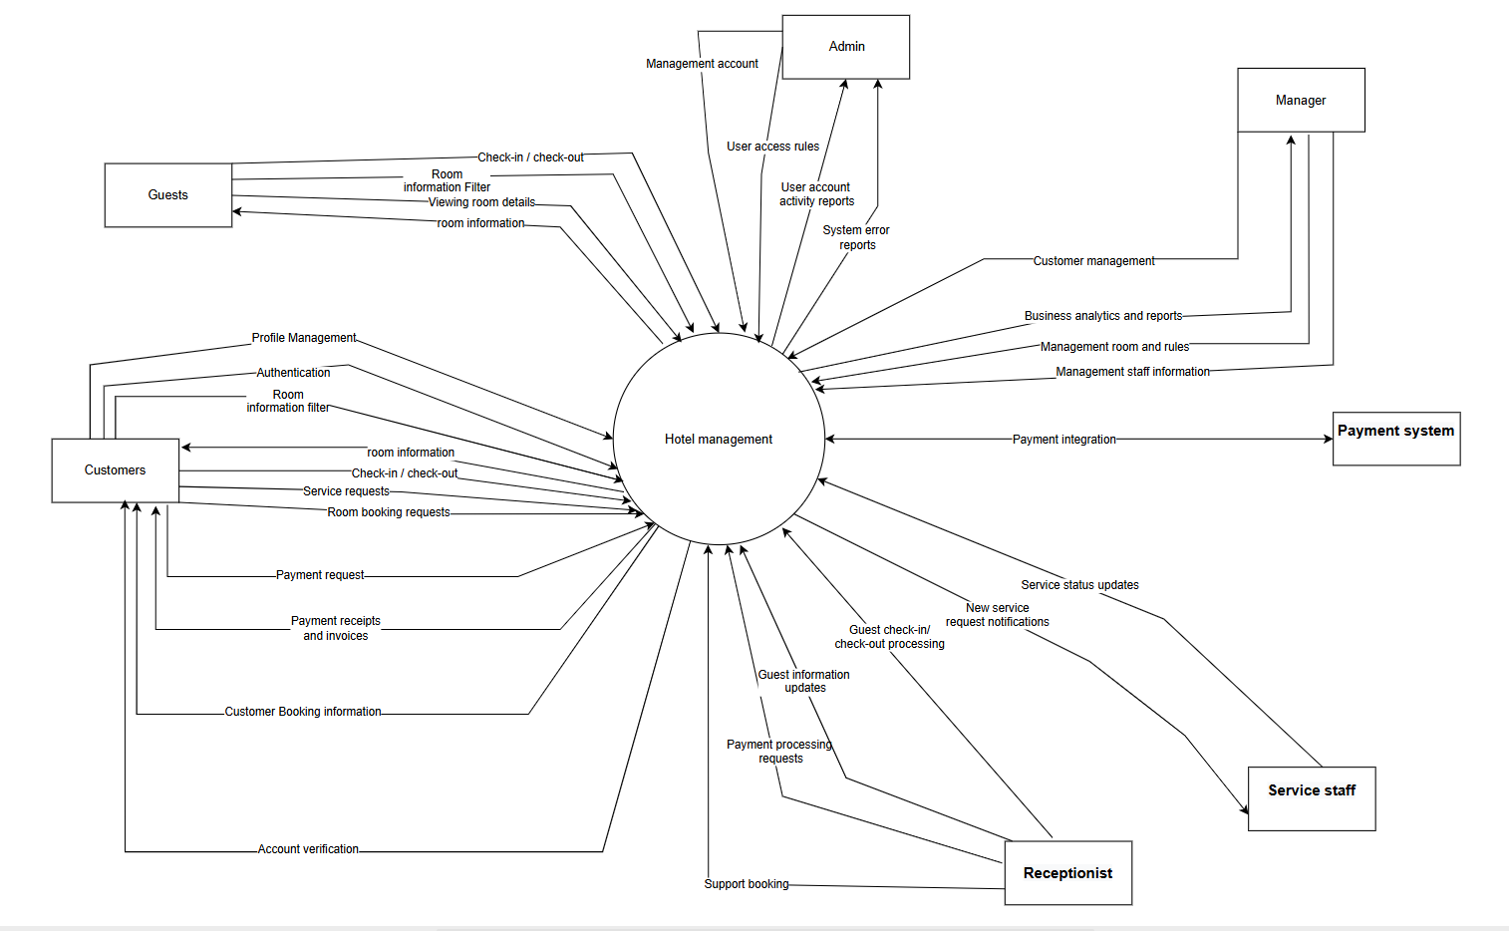

Contents

Record of Change 1

4

I. Overview 4

1. User Requirements 4

1.1. Actors 4

1.2. Use Cases 5

2. Overall Functionalities 8

2.1. Screenflow 8

2.2. Screen Descriptions 8

2.3. Screen Authorization 9

2.4. Non-UI Functions 9

3. System High Level Design 10

3.1. Database Design 10

II. Requirement Specifications 12

1. Public Features 12

1.1. UC-01_View Home page 12

1.2. UC-02_Register Account 14

1.3. UC-03 Search room 15

2.2. UC-05 View room 16

2.3. UC-06 Filter Room 17

2.5. UC-08_View Room Details 18

2. Common Features 19

2.1. UC-07 Login System 19

2.2. UC-08 Logout System 20

2.3. UC-09 Forgot Password System 21

2.2. UC-10 Change Password System 22

3. Guest Features 23

3.1. UC-04 Search room 23

4. Manager Features 23

4.1. UC-20 Search room 23

5. Admin Features 25

5.1. UC-04 Search room 25

6. Receptionist Features 25

6.1. UC-04 Search room 25

7. Cleaner Features 25

7.1. UC-04 Search room 25

III. Design Specifications 25

1. Public Feature 25

1.1. Home page 25

1.2. Room page 26

2. Common Features 27

2.1. User Login 27

3. Customer Features 28

3.1 28

a. UI Design 28

4. Manager Features 28

4.1 View Statistics 28

5. Admin Features 29

5.1 29

6. Receptionist Features 29

6.1 29

7. Cleaner Features 29

7.1 29

IV. Appendix 29

1. Assumptions & Dependencies 29

2. Limitations & Exclusions 30

3. Business Rules 30



I. Overview

1. User Requirements

1.1. Actors

|  |  |  |
| --- | --- | --- |
| **#** | **Actor** | **Description** |
| 1 | Admin | The admin, also known as the system administrator, has elevated privileges and oversees the entire system. They manage user accounts, permissions, and system settings. |
| 2 | Manager | The manager oversees the overall operations of the hotel. They manage room pricing, services and promotions, monitor customer booking history and details, handle revenue and booking rate reports, review and respond to customer feedback or complaints and send internal notifications to staff. |
| 3 | Customer | Customers are registered users who have created accounts on the website. They can access specific features, book rooms, and interact with the platform. |
| 4 | Guest | Guests are visitors who haven’t registered for an account. They can browse the website but typically have limited access to certain features. |
| 5 | Receptionist | The receptionist handles guest-facing operations at the front desk. They manage check–in/check-out processes, create manual bookings, retrieve booking and payment details, process payments (cash, card, VNpay), and record guest service requests. |
| 6 | Cleaner | The housekeeping staff receive cleaning requests from guests, update the service status(cleaned or not cleaned), and report incidents or special notes related to rooms. |

1.2. Use Cases

a. Diagram(s)

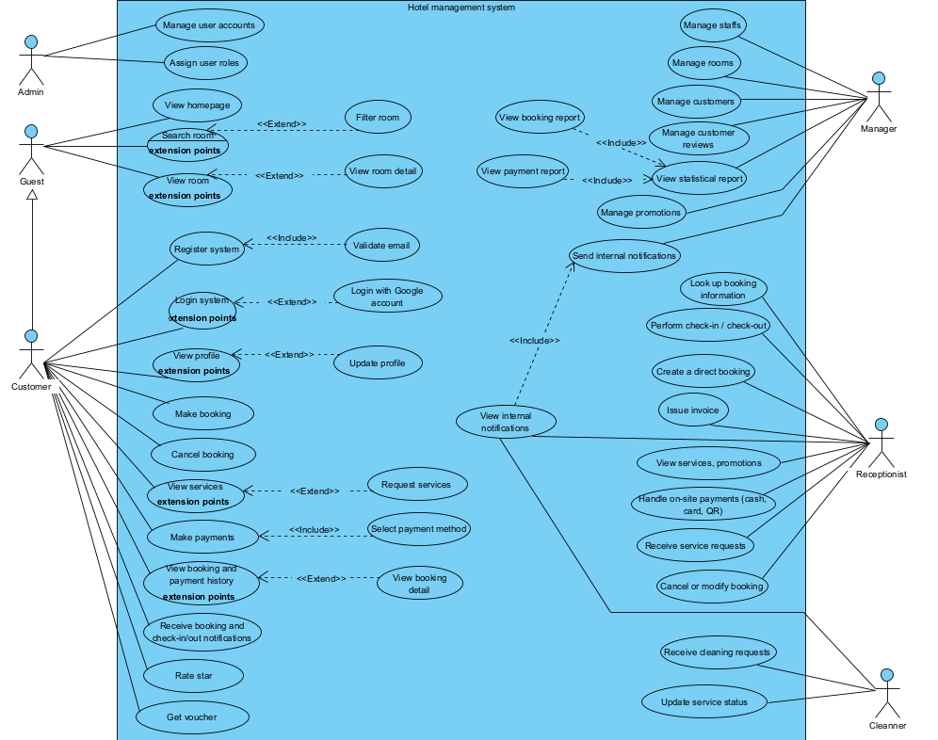

*Figure 1: Use case for The Hotel management System*

b. Descriptions

|  |  |  |  |
| --- | --- | --- | --- |
| **ID** | **Feature** | **Use case** | **Use case description** |
| 1 | Common | Login system | This use case allows users who have registered before to access personalized features. |
| 2 | Logout system | This use case allows users to log out the system. |
| 3 | Register account | This use case allows users to create a new user account on the website. |
| 4 | View homepage | Allows users to view the home page. |
| 5 | View room | This use case allows users to view the website’s room display page. |
| 6 | Search room | Allow user search rooms they need. |
| 7 | Filter room | This use case allows users to filter room type by price/type/time. |
| 8 | View room details | This use case allows users to view room details information. |
| 9 | Customer | View profile | Allows users to view personal information saved on their account. |
| 10 | Update profile | This use case allows users to manage their personal information, edit it and update their personal information |
| 11 | Make booking | Allow customers to book rooms by check-in/out date and desired room type. |
| 12 | Cancel booking | Allow customers to cancel reservations before the specified deadline. |
| 13 | View services | View a list of services the hotel offers.  (Phiên bản V1 mới chỉ có dọn dẹp) |
| 14 | Request services | Customers may request to use services during their stay. (Phiên bản V1 mới chỉ có dọn dẹp) |
| 15 | Make payment | Allow customers to pay for reservations or services used. |
| 16 | Select payment method | Customer chooses a payment method(cash, card, VNpay). |
| 17 | View booking history | View a list of past bookings. |
| 18 | View payment history | View payment transactions made for each booking. |
| 19 | View booking detail | Customers view details of a specific booking(room, price, additional services (mở rộng sẽ có thêm phần voucher)). |
| 20 | Receive booking notifications | Send notifications to customers when bookings are confirmed, modified or canceled. |
| 21 | Receive check-in/check-out notifications | Receive notification before check-in/check-out time. |
| 22 | Rate star | Allow customers to rate the room/services after their stay. |
| 23 | Get voucher | Display and apply vouchers/promotions that customers are eligible to receive. |
| 24 | Manager | Manage staffs | Manage employee information includes add, edit, delete, assigning permissions and quit. |
| 25 | Manage rooms | Manage hotel room categories(add new, update information) |
| 26 | Manage customers | View customer information, classify by booking history(to receive promotions). |
| 27 | Manage reviews | Monitor, approve reviews and send internal notifications to improve quality or hide inappropriate reviews. |
| 28 | Manage promotions | Manage can create, edit, delete promotions, discount vouchers, set up conditions apply. |
| 29 | View statistical report | View overview reports over time(revenue, bookings). |
| 30 | View booking report | View detailed statistics on bookings, room type. |
| 31 | View payment report | View revenue statistics reports by payment method, time, customer. |
| 32 | Send internal notifications | Send internal notifications from employees(service, attitude, evaluation, quality). |
| 33 | Admin | Manage user account | Manage system-wide user accounts(customers, employees, managers) include: view, create, lock/unlock. |
| 34 | Assign user role | Assign and change roles for user accounts such as Staff, Manager, ensuring correct system access rights according to business authorization. |
| 35 | Receptionist | Look up booking information | Look up booking information by customer name or phone number to verify upon arrival and departure or when needed. |
| 36 | Perform check-in/check-out | Perform check-in/check-out procedures, update booking status in real time. |
| 37 | Create direct booking | Make reservations directly at the counter for walk-in customers or by phone. |
| 38 | Cancel or modify booking | Cancel or edit reservations information as requested by the customer, in accordance with hotel policy. |
| 39 | Issue invoice | Create and print detailed payment invoices for customers including room information, number of rooms, service used, promotion (if any).(using iText, JasperReports library) |
| 40 | View services, promotions | View list of services and promotions to advise customers. |
| 41 | Handle on-site payment | Process payments at the counter using multiple methods(cash, card, QR). |
| 42 | Receive service request | Receive service quests from guests(room cleaning) and forward them to relevant departments. |
| 43 | View internal notification | View internal information from management. |
| 44 | Cleaner | Receive cleaning request | Receive room cleaning requests from the system(after check-out or from receptionist), with room, time and notes if any. |
| 45 | Update service status | Update housekeeping status(cleaned). |
| 46 | View internal notification | View internal information from management. |

2. Overall Functionalities

2.1. Screenflow

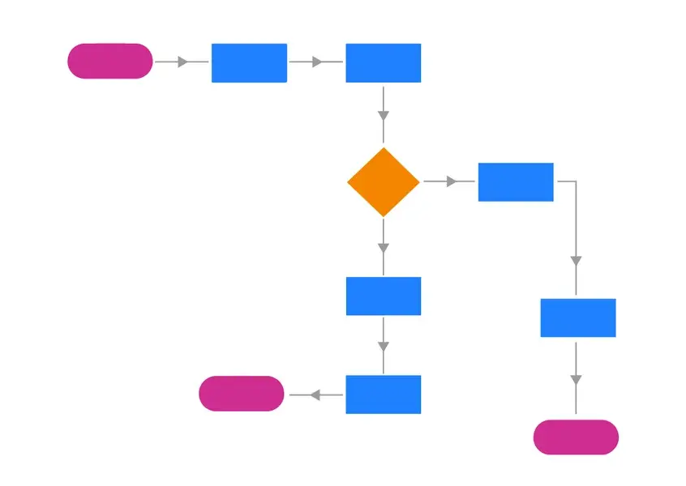

*Figure 2: Screen flow.*

2.2. Screen Descriptions

| **#** | **Feature** | **Screen** | **Description** |
| --- | --- | --- | --- |
| 1 | Guest |  |  |
|  | Customer |  |  |
|  | System Admin |  |  |
|  | Manager |  |  |
|  | Receptionist |  |  |
|  | Service staff |  |  |

2.3. Screen Authorization

|  |  |  |  |  |  |  |
| --- | --- | --- | --- | --- | --- | --- |
| **Screen** | **Guest** | **Customer** | **Admin** | **Manager** | **Receptionist** | **Service Staff** |
| Home | X | X | X | X | X | X |
| Login |  | X | X | X | X | X |
| Register account |  | X |  | X | X | X |
| Forgot Password |  | X | X | X | X | X |
| Change Password |  | X | X | X | X | X |
| Login With Google |  | X | X | X | X | X |
| View Profile |  | X | X | X | X | X |
| View room detail | X | X | X | X | X | X |
| Search Room | X | X | X | X | X | X |
| Filter Room | X | X | X | X | X | X |
| Booking Room |  | X |  | X | X | X |
| Manage booking |  |  |  | X |  |  |
| Manage Room |  |  |  | X |  |  |
| Payment |  | X |  |  | X |  |
| Payment history |  | X |  | X | X |  |
| Check-in |  | X |  |  | X |  |
| Check-out |  |  |  |  | X |  |
| View booking history |  | X |  | X | X |  |

2.4. Non-UI Functions

| # | **Feature** | **System Function** | **Description** |
| --- | --- | --- | --- |
| 1 | Payment Processing | Securely efficiently | It communicates with payment gateways, verifies transactions, and updates payment status by displaying any scenes to users. |
| 2 | Session Management | Session Token Management | Generating and validating session tokens to maintain a user's authenticated state. |
| 3 | Notification | Send notifications alerts | This function sends out notifications or alerts based on certain triggers or events. |

3. System High Level Design

3.1. Database Design

a. Database Schema

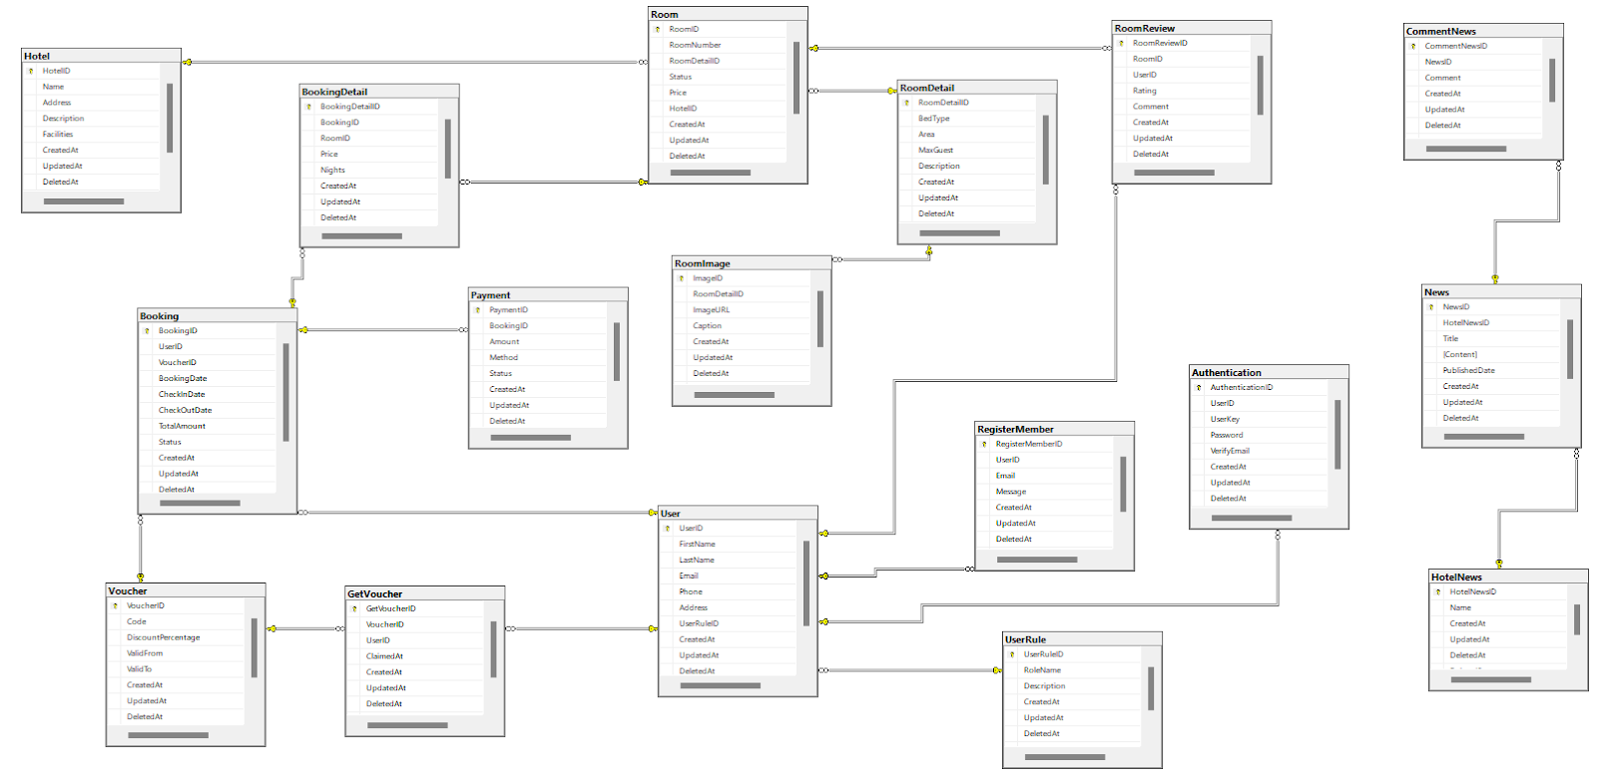

b. Table Descriptions

|  |  |  |
| --- | --- | --- |
| **No** | **Table** | **Description** |
| 01 | UserRole | - Primary keys:   * ID INT AUTO_INCREMENT   - Foreign keys: None |
| 02 | User | - Primary keys:   * ID INT AUTO_INCREMENT   - Foreign keys:   * RoleID FOREIGN KEY REFERENCE UserRole(UserRoleID) |
| 03 | Authentication | - Primary keys:   * ID INT  AUTO_INCREMENT   - Foreign keys:   * UserId FOREIGN KEY REFERENCE User(UserID) |
| 04 | Hotel | - Primary keys:   * ID INT  AUTO_INCREMENT   - Foreign keys: none |
| 05 | Room | - Primary keys:   * ID INT  AUTO_INCREMENT   - Foreign keys:   * HotelID FOREIGN KEY REFERENCE Hotel(HotelID) * RoomDetailID INT FOREIGN KEY REFERENCES RoomDetail(RoomDetailID) |
| 06 | Room Detail | - Primary keys:   * ID INT  AUTO_INCREMENT   - Foreign keys: none |
| 07 | Booking | - Primary keys:   * ID INT  AUTO_INCREMENT   - Foreign keys:   * UserId FOREIGN KEY REFERENCE User(UserID) * VoucherID INT FOREIGN KEY REFERENCES Voucher(VoucherID) |
| 08 | Booking detail | - Primary keys:   * ID INT  AUTO_INCREMENT   - Foreign keys:   * BookingID INT FOREIGN KEY REFERENCES Booking(BookingID) * RoomID INT FOREIGN KEY REFERENCES Room(RoomID) |
| 09 | Payment | - Primary keys:   * ID INT  AUTO_INCREMENT   - Foreign keys:   * BookingID INT FOREIGN KEY REFERENCES Booking(BookingID) |
| 10 | Get Voucher | - Primary keys:   * ID INT  AUTO_INCREMENT   - Foreign keys:   * VoucherID INT FOREIGN KEY REFERENCES Voucher(VoucherID) * UserId FOREIGN KEY REFERENCE User(UserID) |
| 11 | Room review | - Primary keys:   * ID INT  AUTO_INCREMENT   - Foreign keys:   * RoomID INT FOREIGN KEY REFERENCES Room(RoomID) * UserId FOREIGN KEY REFERENCE User(UserID) |
| 12 | News | - Primary keys:   * ID INT  AUTO_INCREMENT   - Foreign keys:   * Hotel NewsID INT FOREIGN KEY REFERENCES Hotel News(HotelNewsID) |

3.2. Code Packages

*Figure 4: Code package.*

***Package descriptions***

|  |  |  |
| --- | --- | --- |
| **No** | **Package** | **Description** |
| 1 |  |  |
|  |  |  |
|  |  |  |
|  |  |  |
|  |  |  |

II. Requirement Specifications

1. Public Features

1.1. UC-01_View Home page

a. Functional Description

|  |  |  |  |
| --- | --- | --- | --- |
| UC ID and Name: | **UC-01_View Home page** | | |
| Created By: | Nguyen Hai Viet | Date Created: | 25/05/2025 |
| Primary Actor: | User | Secondary Actors: |  |
| Trigger: | Users will navigate to the website's home page by directly entering the URL. | | |
| Description: | As a user, I want to access and view the system's home page so that I can learn about the hotel. | | |
| Preconditions: | PRE-1. Users can either go to the site as a customer or visit the home page as a guest. | | |
| Postconditions: | POST-1. The user sees the home page with all its elements correctly displayed.  POST-2. The user can navigate to other parts of the website from the home page. | | |
| Normal Flow | 1. The user (customer or guest) opens their web browser and navigates to the website URL or clicks on a link to the home page. 2. The system processes the request and loads the home page. 3. The home page displays information about the hotel on the system. | | |
| Alternative Flows: | N/A | | |
| Exceptions: | 1. If the home page fails to load due to server issues:  * An error message is displayed to the user. * The user may retry accessing the page or contact support.  1. If some elements of the home page fail to load (e.g., images, scripts):  * The system displays a partial home page with placeholders or error messages for missing elements. * The user can still navigate to other sections of the website. | | |
| Priority: | Medium | | |
| Frequency of use: | Very Frequent | | |
| Business Rules: | BR1.1, BR1.2 | | |
| Other Information: | N/A | | |
| Assumptions: | The website's hosting infrastructure is reliable and can handle the expected traffic load.  The user has a compatible web browser and a stable internet connection. | | |

b. Business Rules

|  |  |  |
| --- | --- | --- |
| **ID** | **Business Rule** | **Business Rule Description** |
| BR1.1 | Key Information Visibility | Key information such as navigation links, promotions, and announcements must be prominently displayed. |
| BR1.2 | Content Freshness | Promotional content and announcements on the home page must be up-to-date and relevant. |

1.2. UC-02_Register Account

a. Functional Description

|  |  |  |  |
| --- | --- | --- | --- |
| UC ID and Name: | **UC-02_Register** | | |
| Created By: | Ngo Thanh Binh | Date Created: | 25/05/2025 |
| Primary Actor: | Customer | Secondary Actors: | Admin |
| Trigger: | The user aims to set up a new account in the system. | | |
| Description: | A User visits the website and completes the new user registration process to establish an account, which grants them access to customized features. | | |
| Preconditions: | PRE-1.The user has access to the website.  The user is not already registered. | | |
| Postconditions: | POST-1.The customer has successfully finalized the registration and now possesses an account on the website. | | |
| Normal Flow: | 1. The user navigates to the website’s homepage. 2. The user clicks on the “Đăng ký” button. 3. The system presents a registration form. 4. The user enters username, email address and password. 5. The user enters Captcha and submits the form. 6. The system validates the input data. 7. If validation passes, the user receives an email with a 6-digit OTP. 8. The user enters the OTP received via email. 9. If the user does not receive the email, the user can click the “resend” button to resend OTP. 10. The system validates the input OTP. If validation passes, the system activates the account and then redirects to the login page. | | |
| Alternative Flows: | N/A | | |
| Exceptions: | 1. If the email address is already registered, display an error message. 2. If the password does not meet security requirements, prompt the user to choose a stronger password. 3. If the username is invalid or exists, display an error message. | | |
| Priority: | High | | |
| Frequency of Use: | Common | | |
| Business Rules: | BR2.1, BR2.2, BR2.3, BR2.4 | | |
| Other Information: | Captcha may be used to prevent automated registrations. | | |
| Assumption: | The user has a valid email address. | | |

b. Business Rules

|  |  |  |
| --- | --- | --- |
| **ID** | **Business Rule** | **Business Rule Description** |
| BR2.1 | Unique Email Address | Each user must have a unique email address when registering an account. The system should prevent multiple users from using the same email address for registration. |
| BR2.2 | Password Security Requirements | The system should enforce specific security requirements for user passwords during registration. These requirements may include:  - Minimum password length (at least 6 characters).  - At least one uppercase letter, one lowercase letter, and one numeric digit. |
| BR2.3 | Email Verification | After registration, the system should send a 6-digit OTP via email. The user must enter OTP to verify their account. |
| BR2.4 | Captcha | To prevent automated registrations by bots, the system may implement CAPTCHA during the registration process. |

1.3. UC-03 Search room

a. Functional Description

|  |  |  |  |
| --- | --- | --- | --- |
| UC ID and Name: | **UC-03 Search Room** | | |
| Created By: | Dang Nguyen Hieu | Date Created: | 26/05/2024 |
| Primary Actor: | Customer, Guest, Staff | Secondary Actors: | Manager |
| Trigger: | User accesses the system via link/URL. User clicks on the "Room" button. The system will take the user to the product page. User enters input into the search box and clicks on the "Search" button. | | |
| Description: | As a User, I want to search for rooms on the system so that I can view and book rooms. | | |
| Preconditions: | N/A | | |
| Postconditions: | POST-1. The system will display rooms according to the user's search request or display a message if there are no suitable rooms. | | |
| Normal Flow: | 1. The user navigates to the home page of the hotel site. 2. The user clicks the "rooms" button to go to the room page. 3. The user enters a keyword into the search bar. 4. The system processes the request. 5. The system returns a list of matching rooms. 6. The user views and browses the room list. | | |
| Alternative Flows: | N/A | | |
| Exceptions: | 1. There are no rooms matching your search term. 2. Error connecting to database. | | |
| Priority: | Medium | | |
| Frequency of Use: | Common | | |
| Business Rules: | BR4.1, BR4.2, BR4.3, BR4.4 | | |
| Other Information: | N/A | | |
| Assumption: | Users have a stable internet connection. | | |

b. Business Rules

|  |  |  |
| --- | --- | --- |
| **ID** | **Business Rule** | **Business Rule Description** |
| BR3.1 | Relevant Results | The system must return the most relevant rooms that match the user's search keywords. |
| BR3.2 | Search suggestions | The system must provide keyword suggestions when users type into the search bar. |
| BR3.3 | Search speed | The system must process the search and return results as quickly as possible. |
| BR3.4 | Filter Integration | The search must integrate with other filter criteria so that users can easily narrow down their search results. |

2.2. UC-05 View room

a. Functionalities

|  |  |  |  |
| --- | --- | --- | --- |
| UC ID and Name: | **UC-05 View Room** | | |
| Created By: | Dang Nguyen Hieu | Date Created: | 26/05/2024 |
| Primary Actor: | Guest, Customer, Staff | Secondary Actors: | Manager |
| Trigger: | Allows visitors to view a list of available rooms without needing to log in or create an account. | | |
| Description: | As a guest, I want to see the rooms, making it easy for me to learn about the rooms the website offers. | | |
| Preconditions: | The user is redirected to the system's room page. | | |
| Postconditions: | POST-1. Users can view all available rooms on the system.  POST-2. Users can click on each room to view detailed information about the room.  POST-3. Users can rate and give feedback on the room or the system.  POST-4. Customers can book rooms on the system. | | |
| Normal Flow: | 1. Customers access the system's home page. 2. Click on the "room" button to go to the room page. 3. On the room page, customers view the room list. 4. Click on the room to view product details. | | |
| Alternative     Flows: | N/A | | |
| Exceptions: | 1. If the website is unavailable, customers will not be able to see the room list. 2. If the room isn't on the system, customers will not find the room. | | |
| Priority: | High , Must Have | | |
| Frequency of Use: | Very Frequent | | |
| Business Rules: | BR5.1, BR5.2, BR5.3 | | |
| Other Information: | 1. The list of rooms should be updated regularly with new rooms. 2. The room list should support pagination or lazy loading to ensure fast page loading speed. 3. Rooms are sorted by default based on creation date. | | |
| Assumptions: | The user has a stable internet connection. | | |

b. Business Rules

|  |  |  |
| --- | --- | --- |
| **ID** | **Business Rule** | **Business Rule Description** |
| BR5.1 | Room Image | Each room must have at least one high-quality representative image. |
| BR5.2 | Room type | Rooms must be categorized by room type. |
| BR5.3 | Room Sorting | Newest rooms and best-booking rooms should be prioritized in the room display order. |

2.3. UC-06 Filter Room

a. Functional Description

|  |  |  |  |
| --- | --- | --- | --- |
| UC ID and Name: | **UC-06_Filter Product** | | |
| Created By: | Dang Nguyen Hieu | Date Created: | 26/05/2025 |
| Primary Actor: | Guest, Customer | Secondary Actors: | Manager, Staff |
| Trigger: | User selects filter options (such as room type, price range, time.) on the room listing page. | | |
| Description: | This feature allows users to narrow down the list of rooms displayed based on specific criteria they select. It helps users find rooms that match their preferences more efficiently. | | |
| Preconditions: | PRE-1. The user can apply filters from multiple pages, such as the home page, the room listing page, or the search results page—any interface that displays rooms and allows filtering. | | |
| Postconditions: | POST-1. The room list is updated to display only the rooms that meet the selected filter criteria. The total number of matching rooms is also updated. | | |
| Normal Flow | 1. User accesses the “home” screen(Can be filtered from the home page)  2. User click “room” button  3. System allows user go to the room page  4. User click filter  5. User choose filter by Value/ by room type or both of them | | |
| Alternative Flows: | N/A | | |
| Exceptions: | If no rooms match the selected filter criteria, a message indicating "No rooms found" is displayed. If there is a server error or the filter operation fails, an error message will be shown. | | |
| Priority: | High | | |
| Frequency of Use: | Very frequent | | |
| Business Rules: | BR6.1, BR6.2 | | |
| Other Information: | Filter state (selected options) will be preserved when the user moves between linked pages. | | |
| Assumptions: | The user has a stable internet connection. | | |

b. Business Rules

|  |  |  |
| --- | --- | --- |
| **ID** | **Business Rule** | **Business Rule Description** |
| BR6.1 | Recommend room | After user used filter, display room for user screen |
| BR6.2 | Diverse Filter Criteria | The system must provide many filtering criteria so users can search for rooms by different attributes, helping them quickly find rooms that suit their needs. |

2.5. UC-08_View Room Details

a. Functionalities

|  |  |  |  |
| --- | --- | --- | --- |
| UC ID and Name: | **UC-08_View Product Details** | | |
| Created By: | Dang Nguyen hieu | Date Created: | 27/05/2025 |
| Primary Actor: | Guest, Customer | Secondary Actors: | Manager |
| Trigger: | Allows visitors to view detailed room data without needing to log in or create an account. | | |
| Description: | Provide full room details so users can easily refer to them before booking. | | |
| Preconditions: | PRE-1. Users has selected a room to view details | | |
| Postconditions: | POST-1. Users can view room details and can book the room. | | |
| Normal Flow: | 1. Users go to home page 2. Click button “Room” 3. The website displays details of the room the customer wants to view | | |
| Alternative Flows: | N/A | | |
| Exceptions: | 1. The system has no posts. 2. Filter invalid data. | | |
| Priority: | Medium | | |
| Frequency of Use: | Frequency | | |
| Business Rules: | BR8.1, BR8.2. | | |
| Other Information: | The room details should include price, description,specification. | | |
| Assumptions: | The customer has a stable internet connection | | |

b. Business Rules

|  |  |  |
| --- | --- | --- |
| **ID** | **Business Rule** | **Business Rule Description** |
| BR8.1 | Accessibility | The room details page must be accessible and adhere to web accessibility standards. |
| BR8.2 | Room Details | The room details should include price, description, specifications, and other relevant information. |

2. Common Features

2.1. UC-07 Login System

a. Functional Description

|  |  |  |  |
| --- | --- | --- | --- |
| UC ID and Name: | **UC-07 Login System** | | |
| Created By: | Ngo Thanh Binh | Date Created: | 25/May/2025 |
| Primary Actor: | Customer, Admin, Staff, Manager | Secondary Actors: | N/A |
| Trigger: | The customer wants to access their account and utilize personalized features on the website.(Account/Google Account) | | |
| Description: | As a user, I want to be able to log into the system so that I can use the system’s authenticated features and access my personalized account. | | |
| Preconditions: | PRE-1.User account has been created & authorized | | |
| Postconditions: | POST-1.User logs in the system successfully | | |
| Normal Flow  (Luồng hd chính) | 1. User accesses the User Login screen  2. User types in the login details or choose Login with google  3. User clicks the Login button  4. System validates the login details  5. System allows user to access  6. System accesses the Home Page | | |
| Alternative Flows:  (Luồng thay thế) | 1. User chooses to login system using Google account  2. System redirects the user to the Google’s Login screen  3. User types in the Google account details and chooses to login  4. Google validates user’s login information successfully and redirect him/her back to the system  5. Return to step 5 of normal flow. | | |
| Exceptions: | 1. The Error Message screen is shown to the user  2. User cancels the logging in *=> View Home Page*  3. User clicks “Forgot Password?”  4. User clicks “Register” link => change to UC-3_Register | | |
| Priority:  (Ưu tiên) | Must Have | | |
| Frequency of Use:(tần suất) | Very Frequent | | |
| Business Rules: | BR7.1, BR7.2 | | |
| Other Information: | The login process includes security measures such as encryption and strong secure password to ensure the privacy and protection of customer information. | | |
| Assumptions: (giả định) | The customer has already registered an account to the website  The customer has a stable internet connection | | |

b. Business Rules

|  |  |  |
| --- | --- | --- |
| **ID** | **Business Rule** | **Business Rule Description** |
| BR7.1 | Password Encoding | Password requires 8 characters and must have 1 capital letter and 1 numeric character |
| BR7.2 | Invalid Logging In | User can’t be authenticated to login the system if below cases  - His/her logging-in details are incorrect  - His/her account has not been verified  - His/her account has been locked or blocked |

2.2. UC-08 Logout System

a. Functional Description

|  |  |  |  |
| --- | --- | --- | --- |
| UC ID and Name: | **UC-08 Logout System** | | |
| Created By: | Ngo Thanh Binh | Date Created: | 25/05/2025 |
| Primary Actor: | Customer, Admin, Staff, Manager | Secondary Actors: | N/A |
| Trigger: | The user’s action of clicking on the option “Log out” on the menu. | | |
| Description: | This basic use case allows logged in users to log out and terminate their authenticated session when they want to exit the system. | | |
| Preconditions: | PRE-1.The user has already logged in the system. | | |
| Postconditions: | POST-1.The user's session is successfully terminated, and they are no longer authenticated within the application.  POST-2.The system redirects to the home page. | | |
| Normal Flow | 1.Click on the “Logout” option on the side menu.  2.The system will remove the user from the session and redirect to the Home page. | | |
| Alternative Flows: | N/A | | |
| Exceptions: | Technical issues preventing the system from successfully terminating the user's session. | | |
| Priority: | High | | |
| Frequency of Use: | Very Frequent | | |
| Business Rules: | BR 8.1 | | |
| Other Information: | N/A | | |
| Assumptions: | The customer has a stable internet connection and is logged in. | | |

b. Business Rules

|  |  |  |
| --- | --- | --- |
| **ID** | **Business Rule** | **Business Rule Description** |
| BR 8.1 | Session Termination | The user's session must be properly terminated to ensure no unauthorized access to their account post-logout. |

2.3. UC-09 Forgot Password System

a. Functional Description

|  |  |  |  |
| --- | --- | --- | --- |
| UC ID and Name: | **UC-09 Forgot Password System** | | |
| Created By: | Ngo Thanh Binh | Date Created: | 28/05/2025 |
| Primary Actor: | Customer, Admin, Staff, Manager | Secondary Actors: | N/A |
| Trigger: | Users who are not logged in click forget their account password. | | |
| Description: | This feature allows users who already have an account to recover their password if they forget it and have not logged into their account. | | |
| Preconditions: | PRE-1.The user account is not locked or disabled.  PRE-2.Users know the email address they used to register for an account. | | |
| Postconditions: | POST-1. Password reset code is sent to customer email if an account exists.  POST-2. The user is redirected to the password reset page upon completion. | | |
| Normal Flow | 1. The user accesses the login page.  2. User clicks on “Forgot Password”.  3. The system requires entering the account email address.  4. User enters the email address.  5. The system sends a password reset code to the customer's email.  6. The system redirects to the password reset page. | | |
| Alternative Flows: | N/A | | |
| Exceptions: | 1. The system fails to send the code to the user’s email (network outage, server error.)  2. Select the resend code but the system does not send a new code.  3. Code validation but the system does not redirect the page.  4. The code has not expired yet. Reload the page and send a new code. | | |
| Priority: | High | | |
| Frequency of Use: | Medium | | |
| Business Rules: | BR 9.1, BR9.2 | | |
| Other Information: | 1. The code link has a limited lifetime (e.g. 60s).  2. Each account will only be sent the reset code once at the time of request. | | |
| Assumptions: | 1. Users use their own email address, which they still control.  2. Network connection is available. | | |

b. Business Rules

|  |  |  |
| --- | --- | --- |
| **ID** | **Business Rule** | **Business Rule Description** |
| BR 9.1 | Email Exist | Email must have been used to register an account. |
| BR9.2 | Password reset code validation | The password reset code is only sent to the account owner’s email address. Each account is only sent the password reset code once at the time of request. The password reset code has a limited time (eg 60s). |

2.2. UC-10 Change Password System

a. Functional Description

|  |  |  |  |
| --- | --- | --- | --- |
| UC ID and Name: | **UC-10 Change Password System** | | |
| Created By: | Ngo Thanh Binh | Date Created: | 28/05/2025 |
| Primary Actor: | Customer, Admin, Staff, Manager | Secondary Actors: | N/A |
| Trigger: | The user already logged in wants to change their account password. | | |
| Description: | Allows users already logged in to change their account password to ensure security or to troubleshoot if they suspect the account is not secure. | | |
| Preconditions: | PRE-1. The user is logged into their account.  PRE-2. The user knows the current password. | | |
| Postconditions: | POST-1. The password is replaced with a completely new password. | | |
| Normal Flow | 1. Users access the ”Change password” section from their account.  2.The system asks for the current password, new password and confirm password.  3. Users submit change requests.  4. System checks current password, validates new password (length, regex)  5. If the requirements are met, the system updates the password in the databases and displays a successful update message. | | |
| Alternative Flows: | 1. If the current password is not correct , the system will ask for re entry.  2. If the new password does not meet security requirements, the system will request a replacement. | | |
| Exceptions: | Network error or error writing data to database. | | |
| Priority: | High | | |
| Frequency of Use: | Medium | | |
| Business Rules: | BR 10.1 | | |
| Other Information: | 1. Passwords are encrypted before being stored in the database. | | |
| Assumptions: | 1. The user is logged into their account.  2. A network connection is available. | | |

b. Business Rules

|  |  |  |
| --- | --- | --- |
| **ID** | **Business Rule** | **Business Rule Description** |
| BR 10.1 | Session Termination | The new password cannot be the same as the current password. |
|  |  |  |

3. Guest Features

3.1. UC-04 Search room

a. Functional Description

b. Business Rules

4. Manager Features

4.1. UC-20 Search room

a. Functional Description

|  |  |  |  |
| --- | --- | --- | --- |
| UC ID and Name: | **UC-20 Manage Customer** | | |
| Created By: | Nguyễn Hải Việt | Date Created: | 16/June/2025 |
| Primary Actor: | Customer, Admin, Staff, Manager | Secondary Actors: | N/A |
| Trigger: | Admin or Manager wants to add, edit, delete, or view customer information in the system. | | |
| Description: | Allows Admin and Manager to manage customer information, including creating, updating, deleting, and viewing customer details to ensure data accuracy and completeness. | | |
| Preconditions: | PRE-1.User account has been created & authorized | | |
| Postconditions: | POST-1.User logs in the system successfully | | |
| Normal Flow  (Luồng hd chính) | 1. User accesses the User Login screen  2. User types in the login details or choose Login with google  3. User clicks the Login button  4. System validates the login details  5. System allows user to access  6. System accesses the Home Page | | |
| Alternative Flows:  (Luồng thay thế) | 1. User chooses to login system using Google account  2. System redirects the user to the Google’s Login screen  3. User types in the Google account details and chooses to login  4. Google validates user’s login information successfully and redirect him/her back to the system  5. Return to step 5 of normal flow. | | |
| Exceptions: | 1. The Error Message screen is shown to the user  2. User cancels the logging in *=> View Home Page*  3. User clicks “Forgot Password?”  4. User clicks “Register” link => change to UC-3_Register | | |
| Priority:  (Ưu tiên) | Must Have | | |
| Frequency of Use:(tần suất) | Very Frequent | | |
| Business Rules: | BR7.1, BR7.2 | | |
| Other Information: | The login process includes security measures such as encryption and strong secure password to ensure the privacy and protection of customer information. | | |
| Assumptions: (giả định) | The customer has already registered an account to the website  The customer has a stable internet connection | | |

b. Business Rules

|  |  |  |
| --- | --- | --- |
| **ID** | **Business Rule** | **Business Rule Description** |
| BR7.1 | Password Encoding | Password requires 8 characters and must have 1 capital letter and 1 numeric character |
| BR7.2 | Invalid Logging In | User can’t be authenticated to login the system if below cases  - His/her logging-in details are incorrect  - His/her account has not been verified  - His/her account has been locked or blocked |

5. Admin Features

5.1. UC-04 Search room

a. Functional Description

b. Business Rules

6. Receptionist Features

6.1. UC-04 Search room

a. Functional Description

b. Business Rules

7. Cleaner Features

7.1. UC-04 Search room

a. Functional Description

b. Business Rules

III. Design Specifications

1. Public Feature

1.1. Home page

a. UI Design

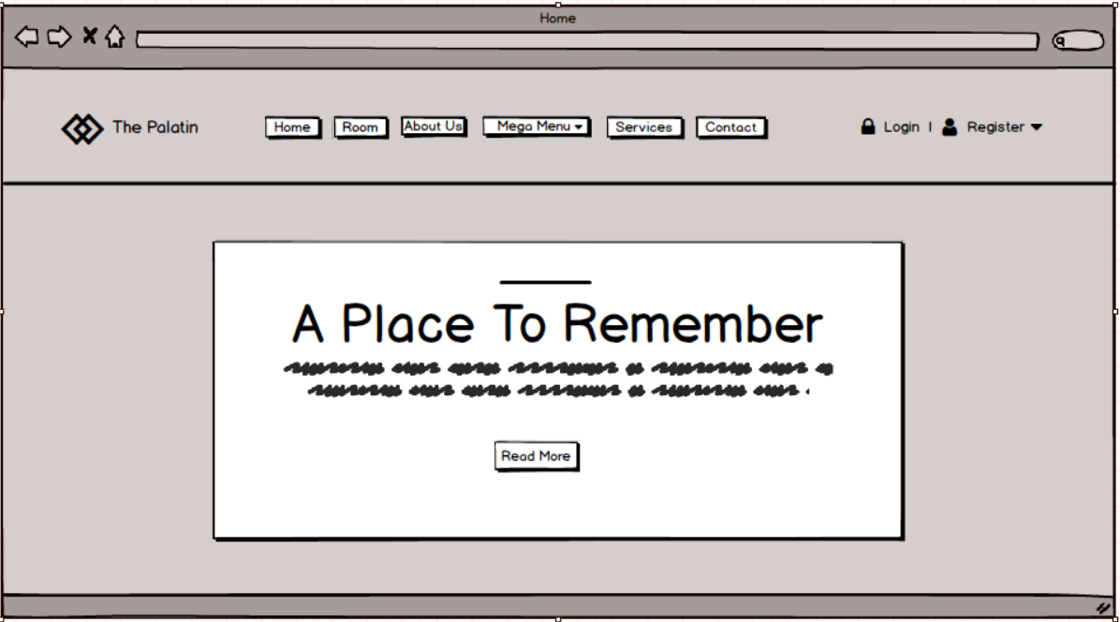

*Figure 5: Home page.*

|  |  |  |
| --- | --- | --- |
| **Field Name** | **Field Type** | **Description** |
| Home | Button | Allows users to go to the home page. |
|  |  |  |
|  |  |  |
|  |  |  |

b. Database access

|  |  |  |
| --- | --- | --- |
| **Table** | **CRUD** | **Description** |
|  |  |  |

***SQL Commands***

***1. Select table***

SELECT  FROM table

1.2. Room page

a. UI Design

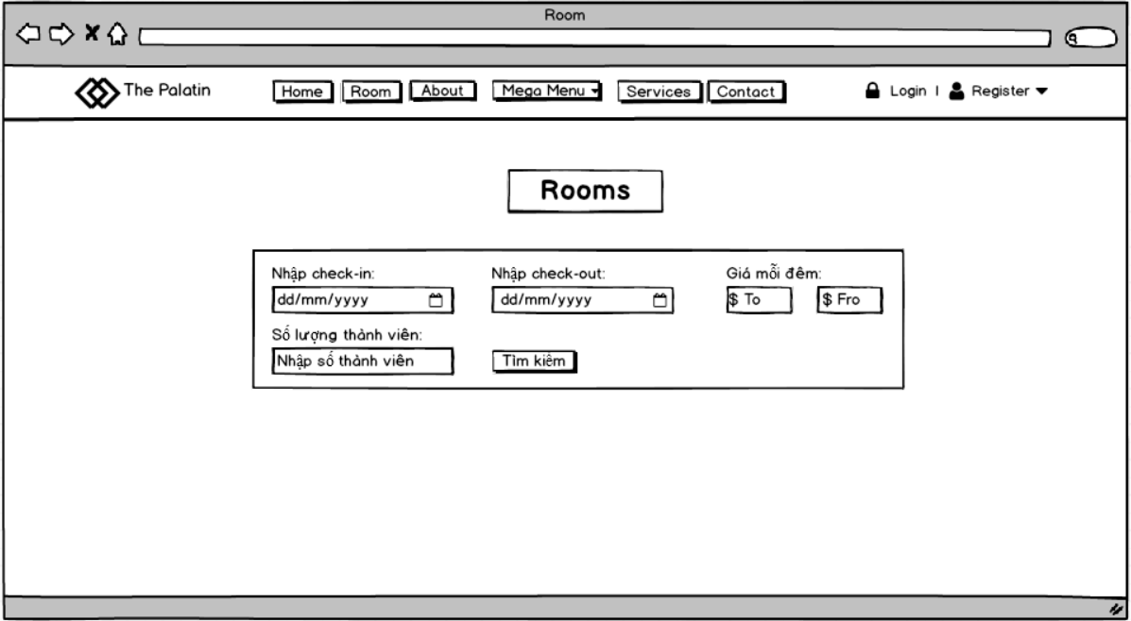

2. Common Features

2.1. User Login

a. UI Design

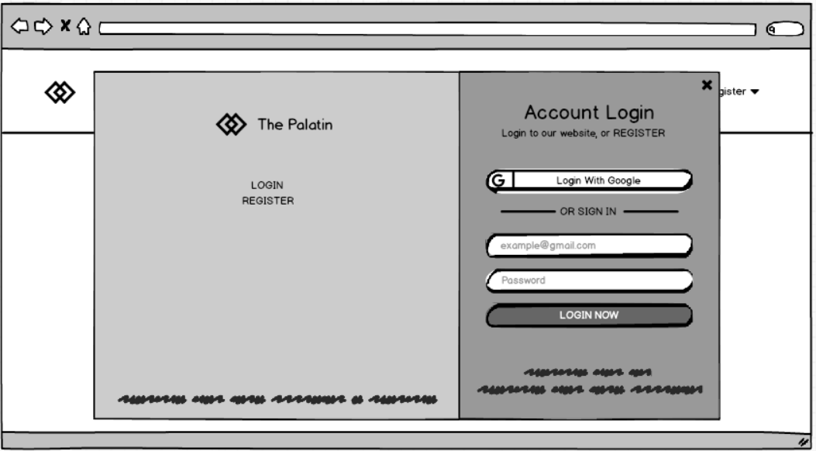

*Figure : Login page.*

|  |  |  |
| --- | --- | --- |
| **Field Name** | **Field Type** | **Description** |
| Tài khoản* | Text Box | The user enters a valid login account name |
| Password* | Password Box | User enters login password |
| Đăng nhập | Button | The user presses the button to log in to their account |
| Đăng ký |  |  |
| Quên mật khẩu |  |  |
| Đăng nhập Google |  |  |
| Captcha |  |  |
| Mã mới |  |  |
| Ghi nhớ đăng nhập |  |  |

b. Database access

|  |  |  |
| --- | --- | --- |
| **Table** | **CRUD** | **Description** |
| authentication | R | Verify Username & Password information |
| user | R | Query user information from the database |
| userrole | R | Query user role from the database |

***SQL Commands:***

**1. Query find account in database**

 SELECT  FROM

3. Customer Features

3.1

a. UI Design

4. Manager Features

4.1 View Statistics

a. UI Design

5. Admin Features

5.1

a. UI Design

6. Receptionist Features

6.1

a. UI Design

7. Cleaner Features

7.1

a. UI Design

IV. Appendix

1. Assumptions & Dependencies

2. Limitations & Exclusions

3. Business Rules