COMP30810: Intro to Text Analytics

LAB 01: Installation

Tasks:

PART 01: ANACONDA & ENVIRONMENT

1. Install Anaconda
2. Check version Python
3. Create working folder
4. Use command “cd” to go to the folder
5. Create python environment: comp30810py36 with python 3.6 and libraries: pandas, scikit-learn, nltk, matplotlib, numpy, scipy
6. Activate environment: comp30810py36 for further working
7. Done part01.

PART 02: FIRST TEST PYTHON WITH ‘.PY’

1. Check the working environment is: comp30810py36. If not, activate the comp30810py36 environment.
2. Open “Spyder” (using terminal command: spyder)
3. On Editor, write the code: print(“Hello COMP30810!”)
4. Save as… to the working folder with the name “test01.py”
5. Check the execution by:
   1. Using  on Spyder. The output will display at IPython console
   2. Using terminal: python test01.py
6. Are they the same result? 🡪 Close Spyder

PART 03: JUPYTER NOTEBOOK

1. Check the working environment is: comp30810py36. If not, activate the comp30810py36 environment.
2. Checking the working folder. If not there, use “cd” to get there.
3. Open Jupyter Notebook by terminal command: jupyter notebook
4. … The browser will be opened. If not, using the link: <http://localhost:8888/tree>
5. Create one notebook for today: at New 🡪 Python3

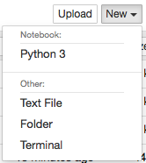

1. Change the name of notebook by: test02
2. In first cell, check the installed libraries as follows: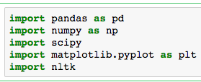 🡪 execute by CTRL + ENTER
3. If no error, use the second cell to download packages from nltk

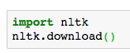

1. It will open the nltk downloader

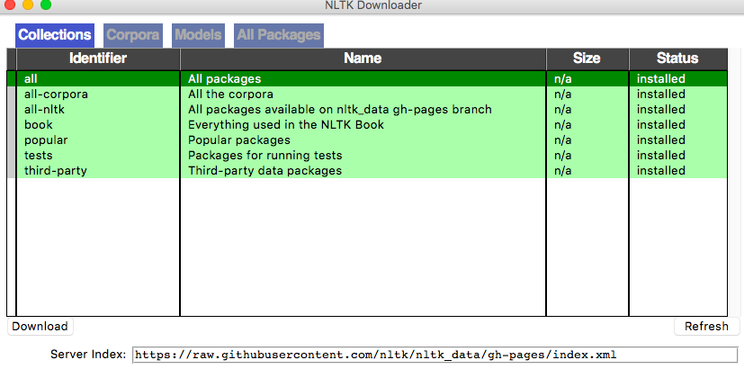

1. Click to Download “all”
2. After download, close the downloader window  
   Note: close downloader, not python.
3. Third cell: check the running of notebook by 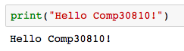
4. Done!