Machine Learning

### SSID - 2193396

***Link to Git Repository: https://github.com/binhudas/SSID-2193396-Report.doc.git***

# 

# Introduction, Background, Description of Problem:

Aims of project, Literary References

The healthcare data science landscape is rapidly evolving and one of the most drastic changes is the integration of machine learning techniques. These machine learning techniques find patterns in data which offer greater understanding.Through this they have become a transformative force, offering solutions to various challenges within the industry.

There is one such challenge in healthcare, which is especially pressing, revolving around optimising the management of patient admissions and discharges:

Research into disruption to NHS services shows “39% of the 1,084 people had their care postponed or cancelled on two or more occasions.”

*(Healthwatch.co.uk, 2024)*. This kind of disruption has a serious negative impact on the patient and the organisation. Patients who go through cancellations report issues such as “ongoing pain, worsening mental health, worsening symptoms” and the health organisation struggles to maintain trust with its patients.

Delays to treatment can arise from several factors however often it is due to a lack of resources. Frequently, patients who require a bed cannot acquire one since a previous patient's discharge has been postponed. Therefore we can see one way to ensure timely patient care is efficiently scheduling and coordinating patient discharges. This process is crucial for proper bed utilisation, reducing strain on resources and ultimately ensuring timely access to healthcare services. Accurately predicting the duration of stay for a patient is the business requirement of this project.

There are several difficulties to this process which can be because of the complexity of the data however several organisations are offering solutions. Amazon Web Services state they can use “machine learning (AI/ML) and natural language processing (NLP) on de-identified, longitudinal patient data to discover patterns in a patient’s medical history” to help with “data-driven care management” *(Amazon Web Services, Inc., 2024)*. This machine learning project aims to create a similar solution through pattern recognition.

The machine learning model will be supervised as the dataset is labelled. We will use the labels to learn the relationship between the input features (patient information, services provided) and the target variable. The nature of the target variable will be a continuous variable and the task of predicting a continuous outcome aligns with the principles of a regression model. Therefore, to summarise, the aim of this project is to use supervised machine learning to create a regression model that can predict duration of stay.

The workflow will match that of key machine learning frameworks such as the industry standard Cross-Industry Standard Process for Data Mining (CRISP-DM)

The project began with a clear understanding of the business problem: accurately predicting duration of stay of patients in healthcare facilities. This was identified with the requirements of possible stakeholders:improved resource allocation and enhanced patient outcomes.

# 

# Describe Dataset:

How it was obtained, Data Exploration, Ethical Considerations

Another aspect of the evolution of the data landscape in the healthcare industry is the mass influx of ‘big data driven by rapid advances in medical technology’. This ‘big data’ involves large amounts of information such that it defies traditional storage solutions. There are lots of possible data sources available in the healthcare industry including clinical trial data, data collected from wearable devices and Electronic Health Records (EHR),the last of which and the key focus of this project.

EHR data is obtained at a point of care such as a hospital. These records often contain information which offer granular insights into a patient's background as they can encompass a diverse range of information about a patient; from demographics and medical history to outcomes.

It is for the above description why EHRs will be the primary data source for this project. They contain information which can offer insight to the different factors behind the discharge dates of a patient. There is also administrative data available which offer similar information regarding the dates of patient care, however they lack the necessary background medical information. Which is why I have decided to source data from EHRs solely.

Ethical concerns arise from working with any medical data; however EHRs are especially sensitive due to their very personal nature. Due to this, they are under strict regulations such as the GDPR so handling EHRs requires careful consideration. Access to an actual database of EHRs would be difficult and the effort required would be unproductive. To avoid these issues, the use of a synthetic dataset was employed. However the same considerations for sensitive data were applied. These considerations took place in Exploratory Data Analysis (EDA) through the process of anonymization.

The EDA that took place gave some high level insights into the data.Some were quickly identified for the anonymisation process: Name, Doctor, Hospital, Insurance Provider.

Several other variables show promise to be valuable to the machine learning model due to possible relevance to the target variable: Age, Medical Condition, Medication and Test Results.   
The next part of the EDA involves taking a deeper dive into the types of data. This allows us to plan the preprocessing steps required.

Some more high level insights of the data take place which involve seeing the trends of different variables. For example most patients were admitted due to Asthma. The median stay is around 16 days with most being contained under 23 days. During this EDA, we created the ‘Hospital Stay Duration’ variable by subtracting the date of discharge from the date of admission. This variable will be our target variable.

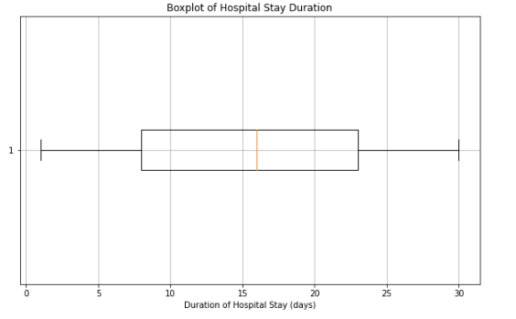

Now the data has been explored , we can now anonymise. The specific method used is hashing. Hashing ensures the anonymisation that takes place is irreversible ensuring complete protection and security of Personal Identifiable Information (PII). The hashing method is an pharmaceutical industry wide standard procedure due to the fact it is secure but does not compromise the data’s validity or reliability. The hashed values are truncated to a length of 5 for efficiency.

To summarise this part of the workflow in this project; relevant data sources were identified that included the necessary information, admission details and medical conditions. Exploratory data analysis (EDA) was used to better comprehend the dataset's structure, quality, and linkages. Greater understanding of the business problem was shown through the anonymisation process to upheld the confidentiality of patient data.

WIth the data anonymised and the added understanding for the EDA , preprocessing can take place.

# 

# Describe Workflow:

Preprocessing, What Algorithms and Fine Tuning Process, Evaluation, Which Programming; Include Snippets

.Various machine learning algorithms were considered for the predictive modelling task, including RandomForestRegressor.

The model was trained on the preprocessed data, with features such as patient demographics, medical conditions, and admission details used to predict discharge dates.

Hyperparameter tuning techniques, such as GridSearchCV, were employed to optimise the model's performance.

5. Evaluation:

Before any machine learning preprocessing takes place; the first step will be to implement a validation set. This is a portion of the overall data and its purpose is to evaluate the performance of the machine learning model by being a dataset to create predictions. We will explore its purpose later however we create the validation set through the following code.

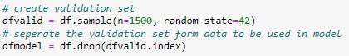

Now that the validation set has been created; Preprocessing can begin on the remaining data. One of the first parts of preprocessing involves separating the features and the target variable of the dataset. The target variable is defined by y while the features are defined by X.Some of the variables have been dropped as they have been determined to have little relevance. Having less variables makes the code more efficient and reduces runtime. The drop() function was used alongside the definition of the features variable.



The data can now be split into training and testing sets. The training set is 70% of the actual dataset and the other 15% is used to test the model. As we don’t have access to real world data this step is essential; it allows us to ensure we can validate our model on the unseen data. Despite the fact the data is split randomly we can use the random_state parameter to ensure reproducibility of the code. By setting it to 42 the data split will now remain consistent.

We can also begin to categorise our features, this is simply done by using the data types previously discovered in the EDA

Through our EDA we also previously established there are no missing values so there is no need for any imputations. We can now use the Pipeline function to create the numeric_transformer and categorical_tranformers to prepare the numerical and categorical variables respectively. The numerical variables which in this case is just age can be scaled to have a mean of 0 and a standard deviation of 1. This standardised the data to be on a similar scale which improves the performance of the algorithm. For the categorical variables, OneHotEncoder was used. This converts them into binary vectors where each category becomes a binary feature; a format that, again, can be used more effectively by machine learning algorithms. Both of these transformers are designed to increase the efficiency of the code.

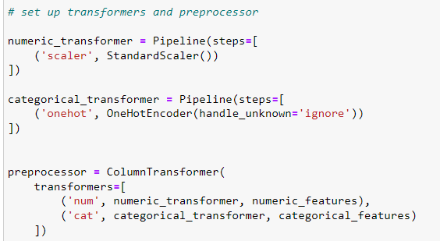

Data preprocessing techniques were implemented to clean and transform the raw data into a format appropriate for machine learning. With the data processed, the design of the model can begin.

As previously mentioned, the prediction model will implement regression to fulfil the aim of the project. It is based on a Random Forest Regressor model with 100 estimators. Random Forest is a common choice of supervised machine learning algorithms for regression tasks such as predicting continuous variables because it can handle complex relationships while avoiding overfitting. The specific Random Forest model used for this will have 100 decision trees. We again use the random state to ensure we are using the same random split previously used in our code.

Now the model has been set we run the model on the preprocessed training data (X_train and y_train) to then create predictions (y_pred).  
  
As this is taking place; we can also begin to create some form of measurement of the model’s prediction accuracy. For this we calculate the Mean Squared Error (MSE). The MSE is a metric which quantifies the difference between the predicted duration of stay and the actual duration of stay.

The MSE provides some quick insights into the model’s performance and from ou first run of the model the MSE is calculated to be:

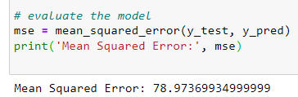

A good model will have an MSE close to 0 so we can see this model requires improvement.

Another way to analyse the model’s performance in a more visual way is through a scatter plot. To complete this we will utilise the validation set from prior. We input the variables in the validation set into the defined model in a similar way to previously done. We then plot the predicted duration against the actual duration to create the below scatter plot.

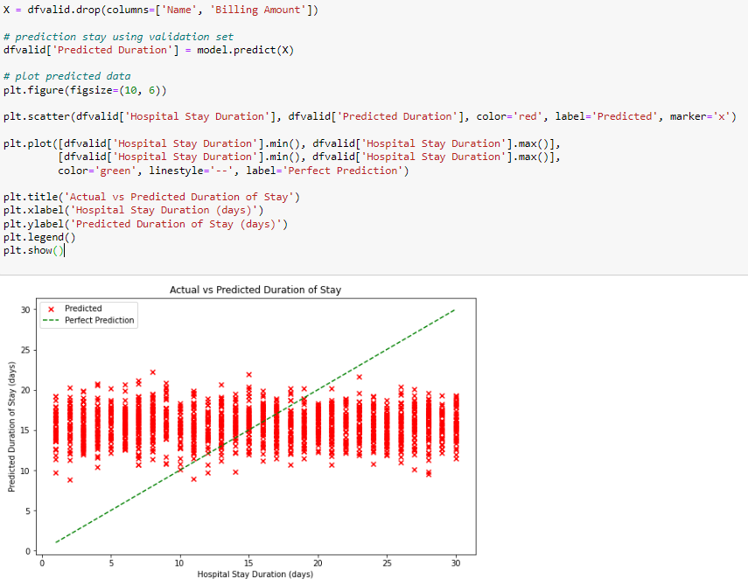

This scatter plot provides a qualitative assessment of the model’s performance.

With the first run of the model completed and some basic evaluation completed,, we now need to see how we can adjust the code to improve the performance of the model.

We will utilise the GridSearchCV method from scikit-learn to perform hyperparameter tuning. The principle behind this is to search through a grid of specified parameters and perform cross validation. The method begins by defining the grid of parameters (param_grid) which contains different values for the parameters of the regression model we created.

These parameters relate to the decision trees in the random forest tree algorithm; the number of decision trees in the random forest (n_estimators), the maximum depth of these decision trees (max_depth), and the minimum number of samples needed to separate an internal node in a decision tree (min_samples_split).

Each of these parameters are crucial for controlling the complexity of the model and finetuning them can optimise its performance on unseen data such as the validation set. Increasing the parameters to have a greater number of decision trees with greater depth can improve the performance. While reducing the min_samples_split will produce more splits resulting in more complex trees. However, these parameters can also have a negative impact on the model. A higher n_estimator increases computational cost and both max_depth and min_sample_split can lead to overfitting.

These factors have been considered and are reflected in the code below.

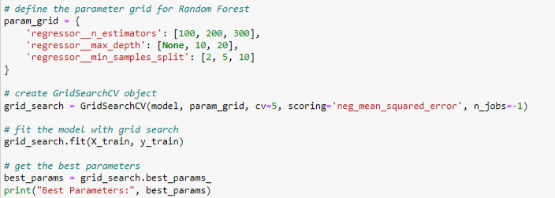

A GridSearchCV object has been created named grid_search by passing in our model, the param grid we created, the number of partitions into which the dataset is split (5) and the scoring metric we use to evaluate the performance during hyperparameter tuning (negative mean squared error). We also potentially increase efficiency in the computation process by utilising available CPU cores with the n_jobs=1 statement.

The training data is then passed through the grid_search object so cross validation is performed on this training data to calculate the best combination of hyperparameters.



With this information on the best parameters, we can code to refit our model according to them.

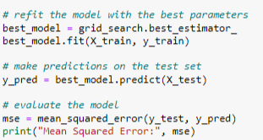

The code above refits the model pipeline to a new model called best_model with the parameters found during the grid search. This best_model is then tested with the test dataset and its performance is evaluated again with the calculation of the MSE.



The MSE is smaller which suggests an increase in performance confirming an iterative approach in the workflow. However, it is important to properly interpret these readings to critically evaluate the performance and its real world impact. The final part of this project will focus on this and extensively analyse the model and our workflow.

# 

# Present Results and Interpretations :

Critically analyse, Discuss Improvements, Ethical Considerations

The MSE, although a powerful metric, is only a single numerical value and so does not provide detailed insights into the nature of the prediction error or overall performance of the model; lacking interpretability. It also is insensitive to distributional differences as it treats all prediction errors equally. These factors make it difficult to understand the real world impact.

Visualisations such as the scatter plots offer the opportunity for model diagnostics by highlighting areas of strength and weakness for the model. That is why another scatter plot has been created; to gain a better understanding of the impact of the hyperparameter tuning and to critically analyse the model in summary.

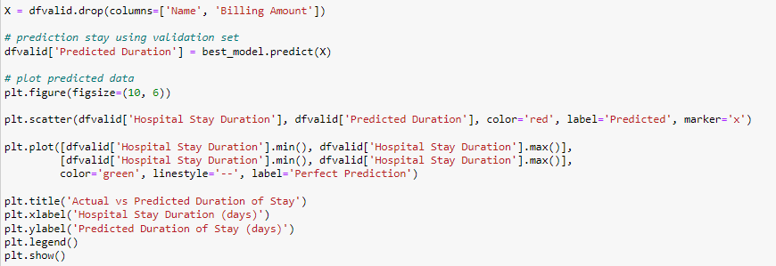

The code used is very similar to the code previously written as we are using the same validation dataset which in context is unseen data for both models. The scatter plot output produced is below:

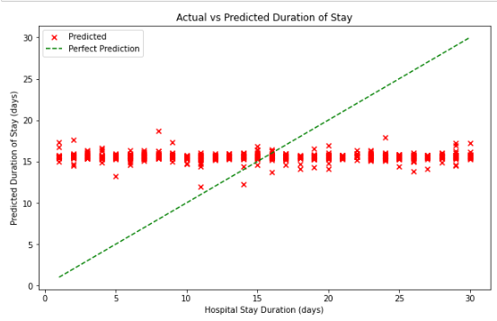

We can see instantly that the predictions of the model have been impacted by the hyperparameter tuning. The predictions are less varied and are more streamlined.

However we can see that towards the ends of the data, away from the median, the predictions stray further away from the perfect prediction line. This is an important discovery and gives us valuable insight into the model.

This shows in the model there is bias towards the central tendency of the target variable as it is optimised to predict values around the median of the target variable but struggles to accurately predict in other regions of the data.What this suggests is that the model may lack generalisation capabilities and will struggle with data that has a varied distribution.

This bias can result from a variety of reasons but specific to this project it is likely it arose from hyperparameter tuning; as the large number of parameters led to a prioritisation of fitting the data while sacrificing accuracy in fewer represented regions. In terms of addressing this issue an approach would likely take the form of simplifying the model by techniques such as increasing the min_samples_split.

The evaluation process of the workflow took several forms. Through appropriate evaluation metrics, such as the MSE and the interpretation of scatter plots.

In the context of real world implementations; this model would be useful for use on a general population that is likely to follow the majority or be close to the median. However several significant improvements would need to be implemented. This project lacked stakeholder feedback however in a real world scenario. This would be an integral part to the evaluation and would help for more iteration through feedback loops, leading to a better model that is aligned to the business problem. Experimenting with different machine learning algorithms may provide a better and more effective model; even some tuning with the current parameters could prove effective. Greater CPU capabilities would be required and unfortunately that is out of the scope of this project.

If greater resources were available, additional features could be included such as socioeconomic status and patient lifestyle factors to provide a more holistic view. Greater resources would also allow better evaluation through techniques such as feature importance graphs. Were the model to be implemented, model monitoring, maintenance and updating would need to be addressed to ensure continued effectiveness.

Privacy concerns regarding patient data anonymization and protection, which were mentioned earlier, were carefully considered throughout the project. Moreover, bias mitigation strategies should be implemented to prevent discriminatory outcomes, particularly concerning sensitive attributes such as race, gender, and socioeconomic status.

By adhering to the CRISP-DM workflow, this project effectively guided the development and deployment of a machine learning solution for predicting discharge dates in healthcare facilities, ultimately addressing the identified business problem and setting the foundations for a suitable solution.

# 

# References:

*Amazon Web Services, Inc. (2024). Patient Outcome Prediction | AWS Solutions for Healthcare, Life Sciences, and Genomics | AWS Solutions Library. [online] Available at: https://aws.amazon.com/solutions/health/patient-outcome-prediction/ [Accessed 29 Mar. 2024].*

*Healthwatch.co.uk. (2024). Delays to NHS care: Understanding the impact. [online] Available at: https://www.healthwatch.co.uk/report/2023-07-27/delays-nhs-care-understanding-impact [Accessed 29 Mar. 2024].*

*Senil, K. (n.d.). Pharmaceutical Data Protection in Supply Chain Using Hashing. [online] Available at: https://www.ijcse.net/docs/IJCSE19-08-02-027.pdf [Accessed 31 Mar. 2024].*

*The King’s Fund. (2023). The Hidden Problems Behind Delayed Discharges | The King’s Fund. [online] Available at: https://www.kingsfund.org.uk/insight-and-analysis/blogs/hidden-problems-delayed-discharges [Accessed 29 Mar. 2024].*