Jenkins Installation:
https://www.jenkins.io/doc/book/installing/linux/#red-hat-centos

- Install java

sudo yum list | grep java
sudo yum install fontconfig <add proper package here>

- Install jenkins

sudo wget -O /etc/yum.repos.d/jenkins.repo \
https://pkg.jenkins.io/rpm-stable/jenkins.repo
sudo yum upgrade
# Add required dependencies for the jenkins package
sudo yum install jenkins
sudo systemctl daemon-reload

- Start Jenkins

sudo systemctl enable Jenkins
sudo systemctl start Jenkins
sudo systemctl status Jenkins
- Open in browser: http://<public IP>:8080
- Copy content from below command and paste

sudo cat /var/lib/jenkins/secrets/initialAdminPassword

- After unlocking Jenkins, the Customize Jenkins page appears. Here you can install any number of useful plugins as part of your initial setup.
Git Plugin
Maven Integration Plugin
SSH agent Plugin
Pipeline Plugin
Docker Pipeline Plugin
Kubernete Plugin
Kubernetes CLI Plugin
GitHub Plugin

- Create First Admin User

- When the Jenkins is ready page appears, click Start using Jenkins.

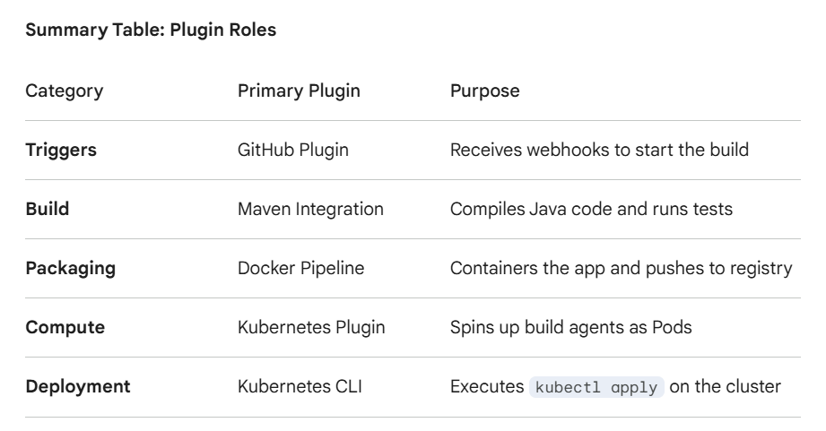

- Sudo visudo

Add jenkins ALL=(ALL) NOPASSWD:ALL

- Login to k8 masternode . switch to root user : set password for ec2-user

- passwd ec2-user
- sudo nano /etc/ssh/sshd_config
passwordauthentication yes
- sudo visudo
ec2-user ALL=(ALL) NOPASSWD:ALL

- Switch to root user from ec2-user and run below commands:

- sudo su –
- ssh-keygen
- sudo cat <path of private key> (add the content of this file in Jenkins credentials under ssh username/password category
- ssh-copy-id ec2-user@<private IP of k8Masternode>
- ssh ec2-user@<private IP of k8Masternode>
- exit

- switch to ec2-user and Install git, maven, docker

- sudo su – ec2-user
- sudo yum install git -y
- sudo yum install maven -y
- sudo yum install docker -y
- sudo usermod -aG docker jenkins
- sudo systemctl start docker
- sudo systemctl enable docker

