Setting up a Kubernetes cluster with kubeadm is a standard way to create a production-ready environment. Since you are using AWS EC2 instances (Amazon Linux), there are specific networking and configuration steps to ensure the nodes can communicate effectively.

1. Infrastructure Prerequisites
Ensure your EC2 instances meet the following minimum requirements:
- Master Node: At least 2 vCPUs and 4 GB RAM (t3.medium or larger).
- Worker Nodes: At least 1 vCPU and 2 GB RAM (t3.small or larger).
- OS: Amazon Linux 2023 or Amazon Linux 2.
- Security Groups: Open the following ports:
  - Master: 6443 (API Server), 2379-2380 (etcd), 10250 (Kubelet), 10259, 10257.
  - Worker: 10250 (Kubelet), 30000-32767 (NodePort Services).
  - All Nodes: Allow all traffic between nodes in the cluster (Internal).

2. Initial System Configuration (All Nodes)
Run these commands on both Master and Worker nodes to prepare the environment.
Disable Swap
Kubernetes requires swap to be disabled to function correctly.
Bash
sudo swapoff -a
sudo sed -i '/ swap / s/^\(.*\)$/#\1/g' /etc/fstab
Enable IPv4 Forwarding
Configure the kernel to allow bridged traffic for networking plugins.
Bash
cat <<EOF | sudo tee /etc/modules-load.d/k8s.conf
overlay
br_netfilter
EOF

sudo modprobe overlay
sudo modprobe br_netfilter

cat <<EOF | sudo tee /etc/sysctl.d/k8s.conf
net.bridge.bridge-nf-call-iptables = 1
net.bridge.bridge-nf-call-ip6tables = 1
net.ipv4.ip_forward = 1
EOF

sudo sysctl –system

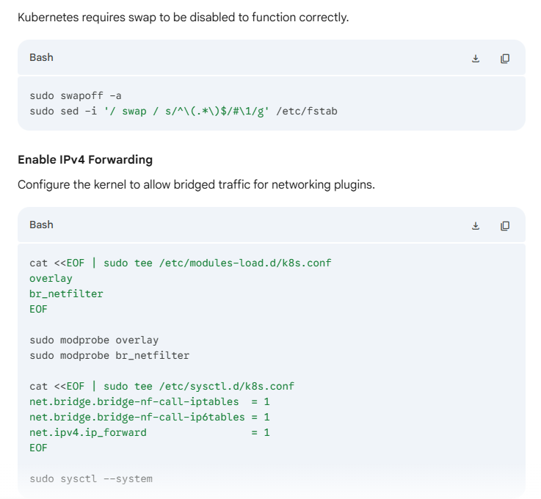

3. Install Container Runtime (All Nodes)
Kubernetes uses containerd as the standard runtime.
Bash
sudo dnf install -y containerd
sudo mkdir -p /etc/containerd
containerd config default | sudo tee /etc/containerd/config.toml
# Set SystemdCgroup to true for better stability
sudo sed -i 's/SystemdCgroup = false/SystemdCgroup = true/g' /etc/containerd/config.toml
sudo systemctl restart containerd
sudo systemctl enable containerd

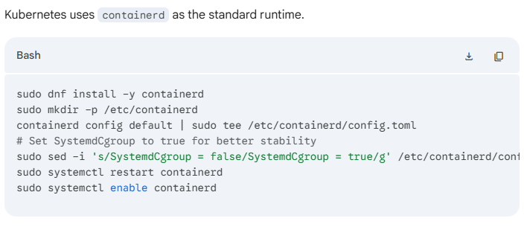

4. Install Kubernetes Tools (All Nodes)
Add the Kubernetes repository and install kubelet, kubeadm, and kubectl.
Bash
cat <<EOF | sudo tee /etc/yum.repos.d/kubernetes.repo
[kubernetes]
name=Kubernetes
baseurl=https://pkgs.k8s.io/core:/stable:/v1.30/rpm/
enabled=1
gpgcheck=1
gpgkey=https://pkgs.k8s.io/core:/stable:/v1.30/rpm/repodata/repomd.xml.key
EOF

sudo dnf install -y kubelet kubeadm kubectl --disableexcludes=kubernetes
sudo systemctl enable --now kubelet

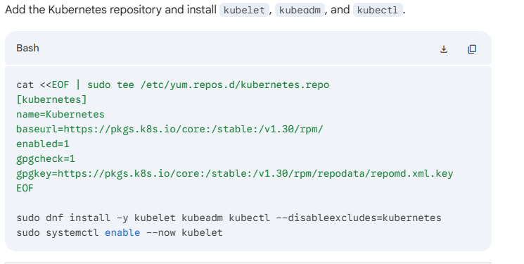

5. Initialize the Master Node (Master Only)
Initialize the cluster on the Master instance. Replace <Master-Private-IP> with your instance's internal IP.
Bash
sudo kubeadm init --pod-network-cidr=192.168.0.0/16
Once complete, set up the local kubectl configuration:
Bash
mkdir -p $HOME/.kube
sudo cp -i /etc/kubernetes/admin.conf $HOME/.kube/config
sudo chown $(id -u):$(id -g) $HOME/.kube/config
Note: Copy the kubeadm join command printed at the end of the output. You will need this for the worker nodes.

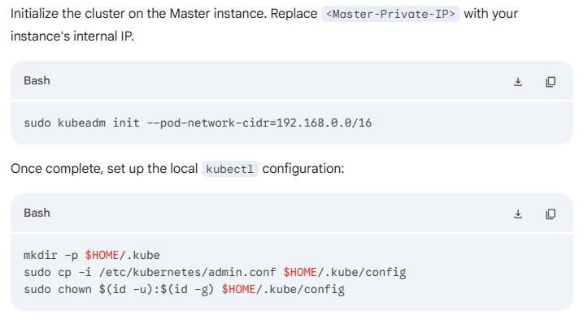

6. Install Pod Networking (Master Only)
Install Calico (or any CNI) to allow communication between pods.
Bash
kubectl create -f https://raw.githubusercontent.com/projectcalico/calico/v3.27.3/manifests/tigera-operator.yaml
kubectl create -f https://raw.githubusercontent.com/projectcalico/calico/v3.27.3/manifests/custom-resources.yaml
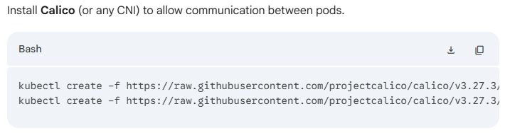

7. Join Worker Nodes (Worker Only)
On your Worker instances, paste the join command generated in Step 5. It should look like this:
Bash
sudo kubeadm join <Master-IP>:6443 --token <token> --discovery-token-ca-cert-hash sha256:<hash>
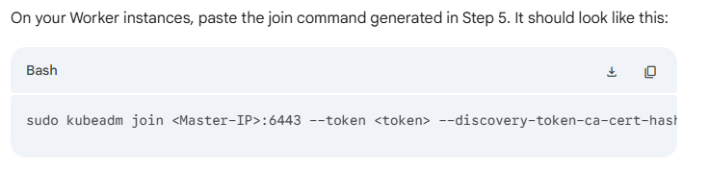

8. Verification
Go back to the Master Node and check the status of your cluster:
Bash
kubectl get nodes
All nodes should eventually transition to the Ready status.
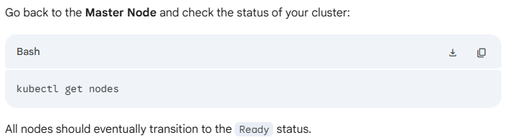
Summary Table: Node Roles
Component | Function | Status Check
Control Plane | Manages cluster state | kubectl get pods -n kube-system
Kubelet | Runs on all nodes; manages containers | systemctl status kubelet
CNI (Calico) | Provides pod-to-pod networking | kubectl get nodes

