Description

Intended User

Features

User Interface Mocks

Screen 1

Screen 2

Key Considerations

How will your app handle data persistence?

Describe any corner cases in the UX.

Describe any libraries you’ll be using and share your reasoning for including them.

Describe how you will implement Google Play Services.

Next Steps: Required Tasks

Task 1: Project Setup

Task 2: Implement UI for Each Activity and Fragment

Task 3: Your Next Task

Task 4: Your Next Task

Task 5: Your Next Task

**GitHub Username**: binit92

WaxTree

# Description

WaxTree is a crowdsourcing platform. It maintains directory of the projects that require contribution in some sense. The intent is to allow users to find projects that they can be involved in some way.   
  
Browse the portfolio and details of projects. Get Involved!

# Intended User

Students

Open-source contributors

# Features

* Shows list of projects
* Shows details of projects
* Bookmark projects
* Register / Unregister

# User Interface Mocks

## Screen 1

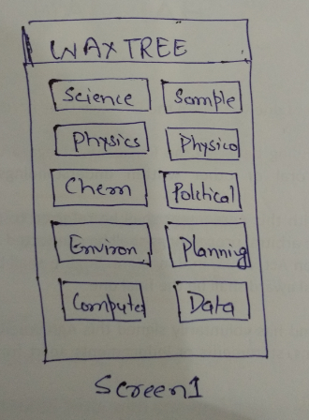

This is the main activity of the app that lets you choose select the area of interest. It is dynamically created by getting response from server in form of .json file. Selecting a value will show the details in next activity.

## Screen 2

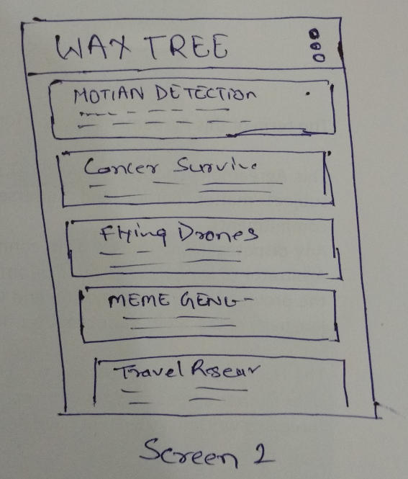

This activity shows users list of projects under the area that user had selected in first activity. Selecting any element here will show the details of the projects .

## Screen 3

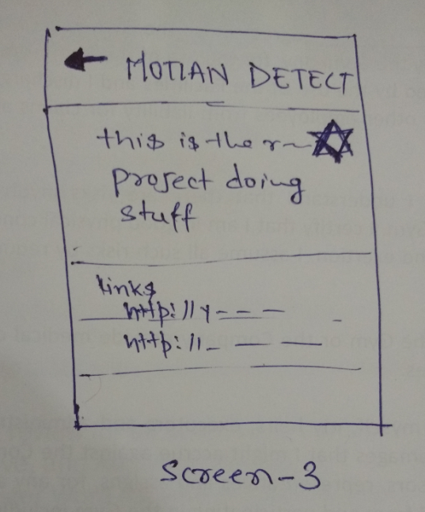

This is details activity that can be accessed from screen -2. It shows the details of the project that includes title, description, reference links etc. User can select favorite button to save it into local database.

## Screen 4

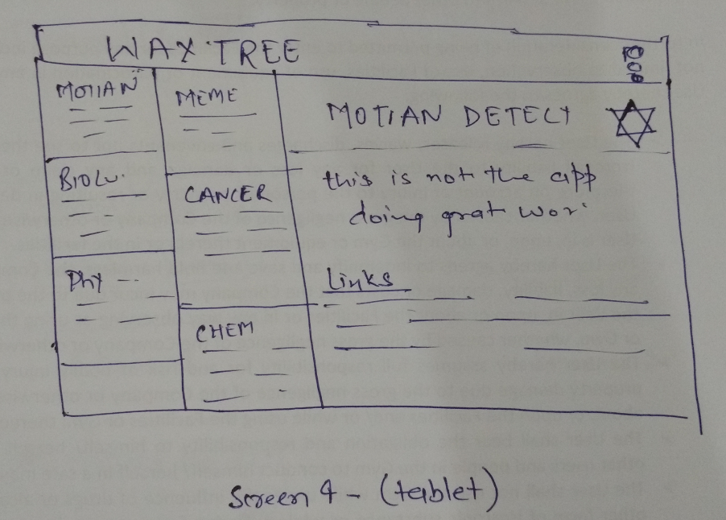

This activity shows the tablet UI. User can see list and detail in same screen.

# Key Considerations

### How will your app handle data persistence?

Initially App will load all the data from. json file from server. When a user favorites an app, it will save the details in local database using Content Provider. This way all the favorites projects can be viewed in offline mode too.

### Describe any edge or corner cases in the UX.

User can choose to view only favorite project using dropdown menu from the App Bar.

### Describe any libraries you’ll be using and share your reasoning for including them.

Picasso – to load any image

ButterKnife- to bind Android views   
Volley – for networking

Schematic – to generate content providers

### Describe how you will implement Google Play Services or other external services.

Not Applicable

# Next Steps: Required Tasks

This is the section where you can take the main features of your app (declared above) and break them down into tangible technical tasks that you can complete one at a time until you have a finished app.

## Task 1: Project Setup

List the subtasks.

* Create a new Android Studio Project
* Add discussed libraries, configure sdk version etc.
* Create a sample .json file
* Submit the initial code into Github

## Task 2: Implement UI for Each Activity and Fragment

List the subtasks.

* Build UI for MainActivity
* Build UI for List using Recycler View
* Build UI for Details of Projects
* Build UI for tablets
* Write Tests

## Task 3: Networking, Caching and Adapter code

List the subtasks.

* Volley networking request and JSON parsing
* Saving data and passing it into activity as a parcelable object
* Adapter to show list
* Update Tests

## Task 4: Content Providers

List the subtasks.

* Creating Content Provider and saving favorite projects
* Loading list with values inside local database
* Writing test for Content Providers

## Task 5: Sanity Test and Publishing App

List the subtasks.

* Sanity test across different devices.
* Publishing App to Google Play Store.