进度条使用说明

进度条机制：
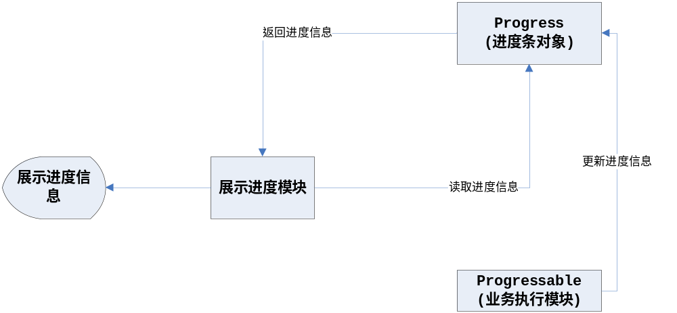
进度条模块测试代码：
public class ProgressTest {

public static void main(String[] args){
ProgressManager manager = new ProgressManager(new Progressable(){
public void execute(Map params, Progress progress) {
for(int i = 1; i <= 100; i++){
try {// 休眠
Thread.sleep(3000);
} catch (InterruptedException e) {
}
System.out.println(i);
progress.add(1);
}
}
}, 100, new HashMap());

ProgressTest test = new ProgressTest();
test.code = manager.execute();

//test.test1();
test.test2();
}

String code;
long delay = 3; //每次取进度信息间隔时间 单位 s

public void test1(){
//以下为同一个线程不停的请求进度信息
new Thread() {
public void run() {
while (true) {
long delay = getProgress(code);
try {
Thread.sleep(delay * 1000);
} catch (InterruptedException e) {
}
// test.doConceal(code);
}
}
}.start();
}

public void test2(){
//以下为不同的线程轮番请求进度信息
int i = 0;
while (true) {
new Thread() {
public void run() {
delay = getProgress(code);
}
}.start();

try {
Thread.sleep(delay * 1000);
} catch (InterruptedException e) {
}
if(i++ == 12)
doConceal(code);
}
}

public long getProgress(String code){
Progress progress = (Progress)ProgressPool.getSchedule(code);
if(!progress.isNormal()){
ProgressPool.removeSchedule(code);
Throwable t = progress.getException();
throw new BusinessException(t.getMessage());
}
if(progress.isConceal()){
System.out.println("取消进度成功");
System.exit(0);
}

Object[] info = progress.getProgressInfo();
System.out.println("已经完成" + info[0] + "%, " + info[1] + "s, 剩余时间" + info[2] + "s");

if(progress.isCompleted()){
ProgressPool.removeSchedule(code); //执行结束则将将进度对象从池中移除
System.exit(0);
}
return ((Long)info[1]).longValue();
}

public void doConceal(String code){
Progress progress = (Progress)ProgressPool.getSchedule(code);
progress.setIsConceal(true); //设置中止标志
getProgress(code);
}
}

