Module 4 – Nonclinical Study Reports

4.2.3 Toxicology
This document contains simulated nonclinical toxicology data generated solely for software testing, extraction validation, and demonstration purposes. All data herein are fictitious.

4.2.3.1 Single-Dose Toxicity Study
A single-dose toxicity study was conducted in Sprague-Dawley rats to evaluate the acute toxic effects of Compound X following oral administration.
Study Design:
- - Species: Rat (Sprague-Dawley)
- - Sex: Male and Female
- - Route of Administration: Oral gavage
- - Dose Levels: 0, 50, 150, 500 mg/kg
- - Observation Period: 14 days
Results Summary:
No mortality was observed at doses up to 150 mg/kg. At 500 mg/kg, transient clinical signs including reduced activity and piloerection were noted within the first 24 hours post-dose, resolving by Day 3.

4.2.3.2 Repeat-Dose Toxicity Study (28-Day)
A 28-day repeat-dose oral toxicity study was conducted in Sprague-Dawley rats to evaluate systemic toxicity and establish a NOAEL.
Study Design:
- - Species: Rat (Sprague-Dawley)
- - Group Size: 10 animals/sex/group
- - Route: Oral gavage
- - Dose Levels: 0, 10, 30, 100 mg/kg/day
Key Findings:
At 100 mg/kg/day, minimal hepatocellular hypertrophy was observed, accompanied by mild increases in liver weight. No treatment-related microscopic findings were observed at 30 mg/kg/day or below.
NOAEL:
Based on the absence of adverse findings, the NOAEL was determined to be 30 mg/kg/day in rats under the conditions of this study.
Table 4.2.3-1. Clinical Chemistry Parameters (Day 28)
Dose (mg/kg/day) | ALT (U/L) | AST (U/L) | BUN (mg/dL)
0 | 45 | 38 | 18
10 | 47 | 40 | 19
30 | 50 | 42 | 20
100 | 68 | 60 | 28
Mild, dose-dependent increases in ALT and AST were observed at 100 mg/kg/day.
Figure 4.2.3-1. Mean ALT Levels in Rats (Day 28)
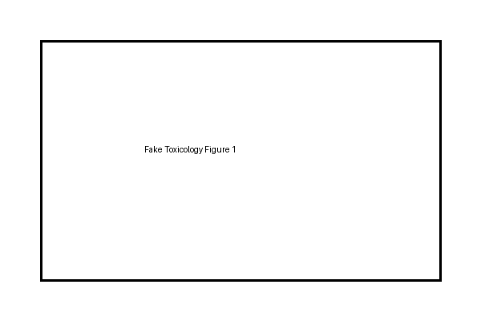
Table 4.2.3-2. Relative Liver Weights (% Body Weight)
Dose (mg/kg/day) | Male | Female
0 | 3.2 | 3.1
10 | 3.3 | 3.2
30 | 3.4 | 3.3
100 | 4.1 | 4.0
Increased relative liver weights were observed at 100 mg/kg/day.
Figure 4.2.3-2. Representative Liver Histopathology (H&E Stain)
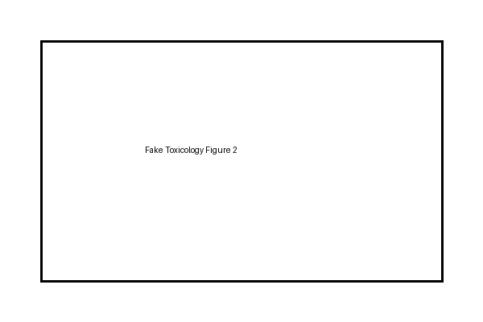

NOAEL Determination
Based on clinical chemistry and organ weight changes observed at 100 mg/kg/day, the NOAEL was determined to be 30 mg/kg/day.

4.2.3.3 Genotoxicity (Ames Test)
Compound X was evaluated for mutagenic potential using a bacterial reverse mutation assay (Ames test). No increase in revertant colonies was observed with or without metabolic activation.

4.2.3.4 Conclusion
The simulated toxicology studies indicate that Compound X was generally well tolerated in rats, with dose-limiting effects observed only at high doses. These data support further nonclinical development.

