Table of Contents
1.0 Gantt Chart 4
2.0 Project Budget 5
2.1 Total Cost (RM) 5
2.2 Network Hardware and Components 7
2.2.1 PC 7
2.2.2 Laptop 9
2.2.3 Router 10
2.2.4 Switch 11
2.2.5 Access Point 12
2.2.6 Server 13
2.3 Network Software and Configurations 14
2.3.1 Network Software 14
2.4 Cabling and Sockets Component 16
2.4.1 Cables 16
2.5 Main Hour Requirements 19
3.0 Network Topology 20
3.1 Logical Design 20
3.2 Physical Design 21
4.0 IPv6 Addressing Table 22
4.1 Lab1 22
4.2 Lab2 23
4.3 System Adminstrator office 23
4.4 Administrator Office 24
4.5 Wireless device 24
4.6 Server 24
4.7 Router 25
4.8 Classrooms 25
5.0 Router Configuration 26
5,1 IPv6 Address Configuration 26
5.2 DHCPv6 Configuration 29
5.3 OSPF configuration 31
6.0 Frame Relay Configuration 34
7.0 Access Control List Configuration 36
8.0 Server Configuration 37
8.1 Web Server Configuration 37
8.2 DNS Server Configuration 39
8.3 File Server Configuration 42
8.4 ISP Server Configuration 45
8.5 Cloud 46
9.0 Verify Connectivity 48
9.1 Ping(ICMP) 48
9.2 Web Browser 53
9.3 File Server 55
9.4 Access control 59
10 .0 Reference 61

1.0 Gantt Chart
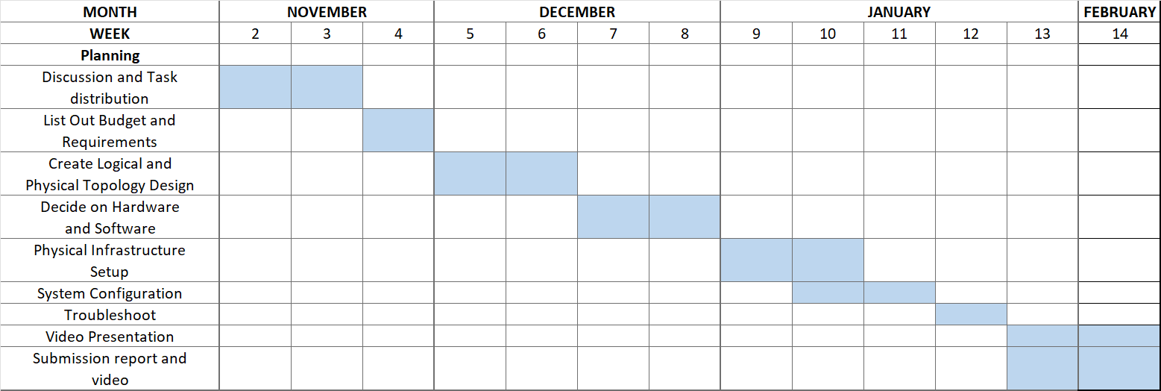

2.0 Project Budget

2.1 Total Cost (RM)
Network Hardware and Components | Quantity | Cost Per Price (RM) | Total Price (RM)
Dell OptiPlex 7010 MT  (PC) | 64 | 1600 | 102400
Dell Latitude E6430 (Laptop) | 1 | 1400 | 1400
Cisco Catalyst 2960-24TT-L (Switch) | 7 | 1000 | 7000
Cisco ISR 4331  (Router) | 4 | 8000 | 3200
Cisco Aironet 1832i (Access Point) | 1 | 1000 | 1000
Dell PowerEdge R710 (Server) | 4 | 3200 | 12800
Network Software
Cisco Packet Tracer | - | Free | -
Windows Server 2025 Standard Edition | 1 | 3000 | 3000
PRTG Network Monitor (commercial) | 1 | 6000 | 6000
Cabling and Socketing Components
Cat6 RJ-45 Ethernet Cable (3m) | 75 | 10 | 750
Cisco Smart Serial DCE/DTE Cable (3m) | 4 | 48 | 184
NIM-2T | 5 | 1600 | 8000
Total Cost (RM) |  |  | 145734

2.2 Network Hardware and Components

2.2.1 PC
Dell OptiPlex 7010 MT
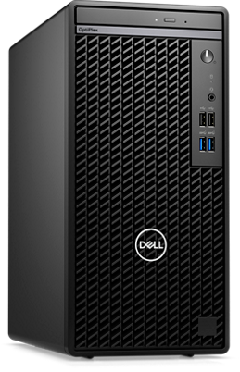
The Dell OptiPlex 7010 Mini Tower is a durable and budget-friendly desktop PC designed for everyday use in educational labs and office environments. It provides sufficient computing power for routine tasks such as browsing, file management, and accessing network services.

Features | Benefit
Intel Core i3 (3rd Generation) processor | Executes daily routine tasks efficiently with low power consumptions
Expandable memory (up to 16 GB DDR3) | Allows system upgrades to support future software requirement
500GB HDD (SSD upgrade supported) | Provides large storage and faster performance when upgraded to SSD
Intel HD Graphis 2500 | Supports multimedia presentations without extra hardware cost.
Gigabit Ethernet interface | Ensures and high-speed network connectivity
Windows OS support | Compatible with a wide range of educational and office applications

2.2.2 Laptop
Dell Latitude E6430
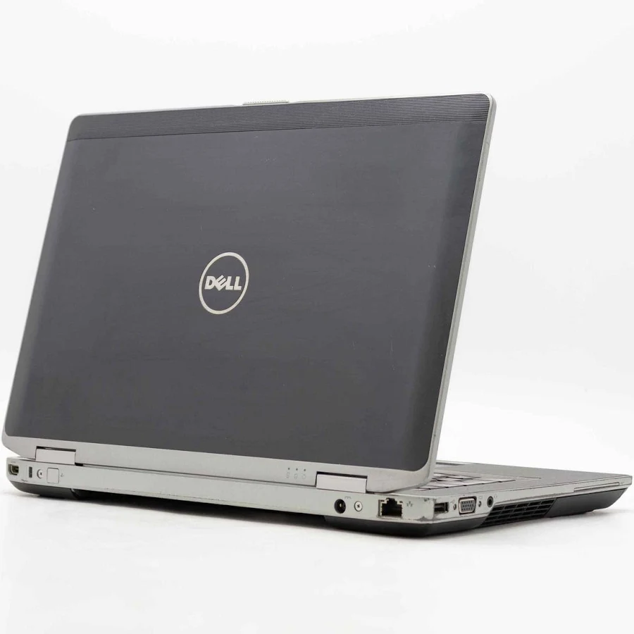
The Dell Latitude E6430 laptop represents mobile users who access the network through the wireless access point. It demonstrates how portable devices can participate in enterprise networks without physical cabling limitations. Its built-in wireless adapter allows dynamic association with the access point, supporting mobility within the coverage area. The dual capability of wired and wireless networking provides flexibility for testing different access methods and evaluating wireless network performance, authentication, and security behaviour.
Feature | Benefit
Built-in Wi-Fi adapter | Enables wireless access through the access point
Portable design | Allows flexible usage in different physical locations
Battery powered | Can operate without continuous power connection
Ethernet port support | Allow both wired and wireless networking.
Business-grade construction | Provides durability for long-term use

2.2.3 Router
Cisco ISR 4331
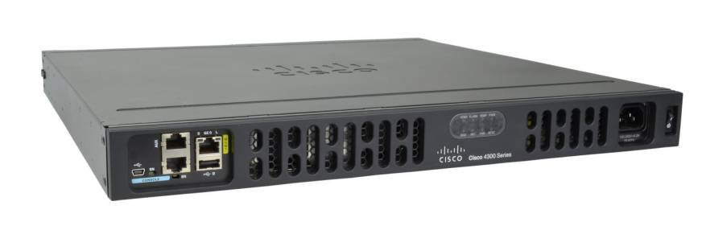
Features | Benefits
IPv6 support and OSPFv3 routing | Enables modern network communication and automatic route learning, reducing manual configuration errors.
Multiple Gigabit Ethernet ports | Allows high-speed connections between LAN segments, switches, and servers.
Modular interface slots (supports NIM-2T) | Provides flexibility to add serial ports for WAN and Frame Relay simulation.
Access Control List (ACL) capability | Enhances network security by controlling which traffic is allowed or denied.
High processing performance | Ensures stable data forwarding even when many devices are connected simultaneously.
The Cisco ISR 4331 is an enterprise-grade integrated services router designed for medium-sized networks such as campuses, laboratories, and branch offices. It provides reliable IPv6 routing, dynamic routing protocol support, WAN connectivity, and network security functions. In this project, the router acts as the core device that interconnects different departments, servers, and external networks.

2.2.4 Switch
Cisco Catalyst 2960-24TT-L
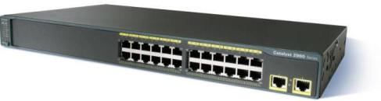
The Cisco Catalyst 2960-24TT-L is a Layer-2 access switch commonly deployed in enterprise networks to connect computers, servers, and network devices within the same local area network. It is used in this topology to provide wired connectivity for labs, offices, and server rooms.

Features | Benefits
24 Fast Ethernet ports | Supports large numbers of PCs in a single department or lab environment.
2 Gigabit uplink ports | Provides faster connections to routers or core switches, reducing network bottlenecks.
VLAN support | Enables logical network segmentation for security and traffic management.
Auto-negotiation (speed/duplex) | Ensures compatibility with different devices and minimizes configuration errors.
Reliable Layer-2 switching | Provides fast packet forwarding with low latency for stable LAN performance.

2.2.5 Access Point
Cisco Aironet 1832i
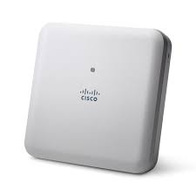
The Cisco Aironet 1832i is a business-class wireless access point designed to provide secure and reliable Wi-Fi connectivity. It allows wireless devices such as laptops to access the wired network without using physical cables.
Features | Benefits
Dual-band Wi-Fi (2.4 GHz and 5 GHz) | Reduces congestion and improves wireless performance.
IEEE 802.11ac support | Enables high-speed wireless data transfer for modern applications.
Ethernet uplink port | Allows seamless integration into the wired network infrastructure.
Supports multiple simultaneous clients | Suitable for classroom and office environments with many users.
WPA/WPA2 security support | Protects wireless communications from unauthorized access.

2.2.6 Server
Dell PowerEdge R710
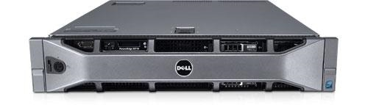
The Dell PowerEdge R710 is an enterprise rack-mount server designed to operate continuously while hosting critical network services such as DNS, web hosting, file sharing, and DHCPv6.
Features | Benefits
Dual Intel Xeon processors | Provides high computing performance for multiple services running simultaneously.
Large RAM capacity | Supports heavy workloads and multiple concurrent client connections.
RAID storage support | Protects data against disk failure and improves reliability.
Multiple Gigabit Ethernet interfaces | Enables redundancy and high network throughput.
Designed for 24/7 operation | Ensures high availability of network services.

2.3 Network Software and Configurations

2.3.1 Network Software
Cisco Packet Tracer
Cisco Packet Tracer is a comprehensive network simulation software developed by Cisco for learning, teaching, and designing computer networks. It allows users to create, configure, and test network topologies in a virtual environment that closely resembles real-world networking scenarios. Through its graphical interface and built-in simulation capabilities, users can observe network behavior, troubleshoot connectivity issues, and validate configurations before real deployment. The software is widely used in academic institutions and professional training, especially for Cisco certification preparation.
Features and Benefits
Features | Benefits
Graphical network simulation | Provides a visual platform for designing and understanding complex network topologies more easily.
Real-time and simulation modes | Allows testing of live network behavior or step-by-step packet flow analysis for troubleshooting and learning purposes.
Extensive device and protocol support | Supports routers, switches, servers, PCs, IoT devices, and protocols such as IPv6, OSPF, VLAN, DHCP, and DNS, enabling realistic enterprise network simulation.
IoT and programmability support | Enables advanced learning using IoT devices and scripting with Python and JavaScript for automation and smart network scenarios.
Alignment with Cisco certifications | Offers structured, scenario-based laboratories that support CCNA, CCNP, and other Cisco certification training.

Windows Server 2025 Standard Edition
Windows Server 2025 Standard Edition is a server operating system developed by Microsoft for managing enterprise networks, applications, user authentication, and data storage. It provides a secure and scalable platform for hosting essential services such as DNS, DHCP, web servers, file servers, and directory services. In this project, Windows Server is suitable for simulating centralized network services and enterprise-level server management.

Features and Benefits
Features | Benefits
Hybrid cloud integration | Supports seamless integration with cloud and on-premises environments, enabling organizations to extend services using Azure and Azure Arc.
Advanced security features | Provides hardware-based and software-based protection against cyberattacks, including enhanced Active Directory security and improved authentication mechanisms.
Modern and future-ready platform | Offers improved application compatibility, simplified updates, and easier system scalability for long-term use.
High performance networking and storage | Enhances data transfer speed, storage efficiency, and reduces downtime through features such as hot patching and optimized resource management.

Paessler PRTG Network Monitor
Paessler PRTG is a professional network monitoring tool developed by Paessler GmbH in Germany. It is designed to continuously monitor network infrastructure, detect faults, and provide real-time performance statistics. PRTG is commonly used by network administrators to ensure high availability, reliability, and optimal utilization of network resources.
Features and Benefits
Features | Benefits
Historical data storage and reporting | Enables long-term analysis of network performance trends, supporting capacity planning and optimization.
Multi-platform monitoring support | Allows administrators to access monitoring data from Windows, Linux, and macOS systems, increasing flexibility.
Comprehensive device monitoring | Monitors routers, switches, servers, bandwidth usage, and services in real time, ensuring early detection of network issues.
Web-based dashboards and alerts | Provides an intuitive interface with customizable dashboards and automated alerts, simplifying network management and decision-making.

2.4 Cabling and Sockets Component

2.4.1 Cables
Cat6 UTP RJ45
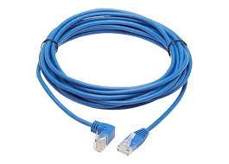
The Category 6 (Cat6) unshielded twisted pair (UTP) straight-through cable is the standard Ethernet cable used to connect end devices such as PCs, servers, switches, routers, and wireless access points. It supports high-speed data transmission and is widely used in modern LAN infrastructures.
Feature | Benefit
Category 6 (Cat6) standard (ANSI/TIA-568-C.2) | Supports data rates up to 1 Gbps (1000 Mbps) and bandwidth up to 250 MHz, ensuring fast and reliable LAN communication.
RJ-45 connectors (8P8C) | Universally compatible with Ethernet ports on PCs, switches, routers, servers, and access points.
Straight-through wiring (T568B–T568B) | Ideal for connecting different device types (PC→Switch, Switch→Router, Switch→Server), preventing wiring mismatches.
Unshielded Twisted Pair (UTP) design | Reduces electromagnetic interference and crosstalk, improving signal quality.
Copper conductors (24 AWG) | Provides stable electrical transmission and low signal loss over distances up to 100 meters.
Durable PVC outer jacket | Protects internal wires from physical damage and bending, increasing cable lifespan.

Cisco CAB-SS-2626X
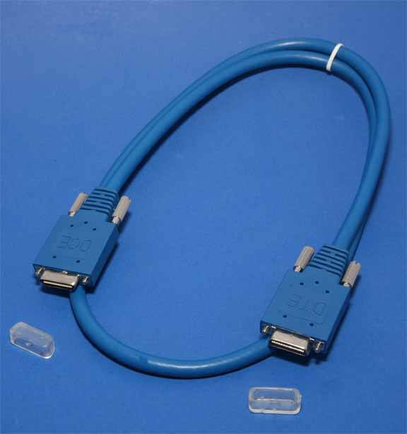
The Cisco Smart Serial DCE/DTE cable is a specialized WAN cable used to connect routers through serial interfaces. It is commonly used in enterprise networks to simulate leased lines and Frame Relay connections.
Feature | Benefit
Smart Serial connector (Cisco proprietary) | Designed specifically for Cisco routers, ensuring secure and stable physical connection.
Supports DCE and DTE modes | Allows one router to provide clocking (DCE) while the other receives it (DTE), ensuring synchronized data transmission.
Supports Frame Relay and PPP/HDLC | Enables realistic simulation of WAN technologies used by ISPs and enterprises.
Low-latency serial communication | Suitable for long-distance routing and backbone links.
Lightweight and flexible cable design | Easy to install and manage in network racks and labs.

NIM-2T (Router Module)
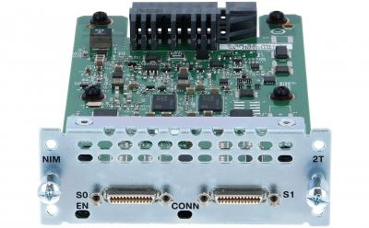
The Cisco Network Interface Module 2T (NIM-2T) is an expansion installed into the routers to provide additional serial communication ports. These ports are essential for simulating wide area network technologies such as point-to-point leased lines and Frame Relay connections.
Features | Benefits
Two high-speed serial interfaces | Enables a single router to connect to multiple WAN links, supporting complex topologies and redundancy testing.
DCE and DTE mode support | Provides clock synchronization between routers, ensuring accurate and stable serial data transmission.
Frame Relay compatibility | Allows realistic simulation of enterprise WAN services using virtual circuits, improving understanding of service provider networking.
Modular plug-in design | Allows easy installation and removal without replacing the router, reducing hardware cost and improving scalability.
Full integration with Cisco IOS | Supports IPv6 addressing, OSPFv3 routing, and WAN encapsulation protocols for real-world configuration practice.
Compact hardware form factor | Saves internal router space while still delivering essential WAN connectivity features.

2.5 Main Hour Requirements
Main Hour Budget
Number of hours work a day | 8 hours
Total number of workers | 4
Specific period:  10 November 2025 – 1 February | Public Holidays =3 days  Weekends=24 days
Main Hour | 84 days -24days = 60days  60 days -3 days =57 working days  Total man-hour calculation:  57 working hours x 8 hours/day x 4 workers  = 1824 man-hours

3.0 Network Topology

3.1 Logical Design
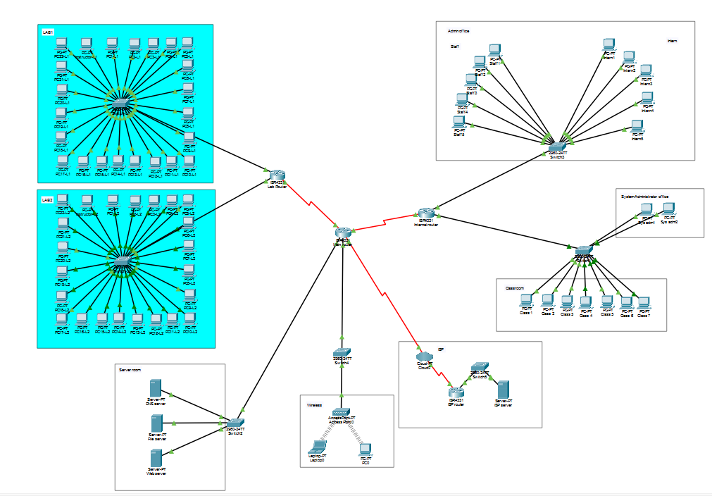

3.2 Physical Design
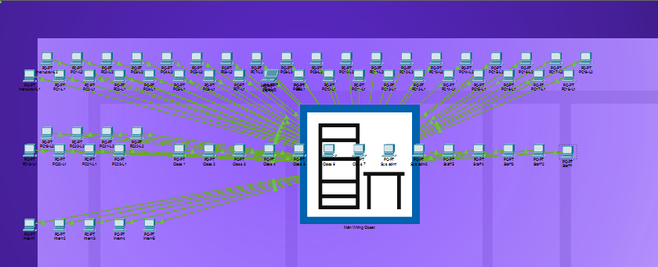

4.0 IPv6 Addressing Table

4.1 Lab1
Device | Interface | IPv6 Address | Default Gateway
Instructor(L1) | FastEthernet0 | 2026:A3F9:C21E:1:DHCPv6 assigned | FE80:1::1
PC1_Lab1 | FastEthernet0 | 2026:A3F9:C21E:1:DHCPv6 assigned | FE80:1::1
PC2_Lab1 | FastEthernet0 | 2026:A3F9:C21E:1:DHCPv6 assigned | FE80:1::1
PC3_Lab1 | FastEthernet0 | 2026:A3F9:C21E:1:DHCPv6 assigned | FE80:1::1
PC4_Lab1 | FastEthernet0 | 2026:A3F9:C21E:1:DHCPv6 assigned | FE80:1::1
PC5_Lab1 | FastEthernet0 | 2026:A3F9:C21E:1:DHCPv6 assigned | FE80:1::1
PC6_Lab1 | FastEthernet0 | 2026:A3F9:C21E:1:DHCPv6 assigned | FE80:1::1
PC7_Lab1 | FastEthernet0 | 2026:A3F9:C21E:1:DHCPv6 assigned | FE80:1::1
PC8_Lab1 | FastEthernet0 | 2026:A3F9:C21E:1:DHCPv6 assigned | FE80:1::1
PC9_Lab1 | FastEthernet0 | 2026:A3F9:C21E:1:DHCPv6 assigned | FE80:1::1
PC10_Lab1 | FastEthernet0 | 2026:A3F9:C21E:1:DHCPv6 assigned | FE80:1::1
PC11_Lab1 | FastEthernet0 | 2026:A3F9:C21E:1:DHCPv6 assigned | FE80:1::1
PC12_Lab1 | FastEthernet0 | 2026:A3F9:C21E:1:DHCPv6 assigned | FE80:1::1
PC13_Lab1 | FastEthernet0 | 2026:A3F9:C21E:1:DHCPv6 assigned | FE80:1::1
PC14_Lab1 | FastEthernet0 | 2026:A3F9:C21E:1:DHCPv6 assigned | FE80:1::1
PC15_Lab1 | FastEthernet0 | 2026:A3F9:C21E:1:DHCPv6 assigned | FE80:1::1
PC16_Lab1 | FastEthernet0 | 2026:A3F9:C21E:1:DHCPv6 assigned | FE80:1::1
PC17_Lab1 | FastEthernet0 | 2026:A3F9:C21E:1:DHCPv6 assigned | FE80:1::1
PC18_Lab1 | FastEthernet0 | 2026:A3F9:C21E:1:DHCPv6 assigned | FE80:1::1
PC19_Lab1 | FastEthernet0 | 2026:A3F9:C21E:1:DHCPv6 assigned | FE80:1::1
PC20_Lab1 | FastEthernet0 | 2026:A3F9:C21E:1:DHCPv6 assigned | FE80:1::1
PC21_Lab1 | FastEthernet0 | 2026:A3F9:C21E:1:DHCPv6 assigned | FE80:1::1
PC22_Lab1 | FastEthernet0 | 2026:A3F9:C21E:1:DHCPv6 assigned | FE80:1::1

Device | Interface | IPv6 Address | Default Gateway
Instructor(L2) | FastEthernet0 | 2026:A3F9:C21E:2:DHCPv6 assigned | FE80:2::1
PC1_Lab2 | FastEthernet0 | 2026:A3F9:C21E:2:DHCPv6 assigned | FE80:2::1
PC2_Lab2 | FastEthernet0 | 2026:A3F9:C21E:2:DHCPv6 assigned | FE80:2::1
PC3_Lab2 | FastEthernet0 | 2026:A3F9:C21E:2:DHCPv6 assigned | FE80:2::1
PC4_Lab2 | FastEthernet0 | 2026:A3F9:C21E:2:DHCPv6 assigned | FE80:2::1
PC5_Lab2 | FastEthernet0 | 2026:A3F9:C21E:2:DHCPv6 assigned | FE80:2::1
PC6_Lab2 | FastEthernet0 | 2026:A3F9:C21E:2:DHCPv6 assigned | FE80:2::1
PC7_Lab2 | FastEthernet0 | 2026:A3F9:C21E:2:DHCPv6 assigned | FE80:2::1
PC8_Lab2 | FastEthernet0 | 2026:A3F9:C21E:2:DHCPv6 assigned | FE80:2::1
PC9_Lab2 | FastEthernet0 | 2026:A3F9:C21E:2:DHCPv6 assigned | FE80:2::1
PC10_Lab2 | FastEthernet0 | 2026:A3F9:C21E:2:DHCPv6 assigned | FE80:2::1
PC11_Lab2 | FastEthernet0 | 2026:A3F9:C21E:2:DHCPv6 assigned | FE80:2::1
PC12_Lab2 | FastEthernet0 | 2026:A3F9:C21E:2:DHCPv6 assigned | FE80:2::1
PC13_Lab2 | FastEthernet0 | 2026:A3F9:C21E:2:DHCPv6 assigned | FE80:2::1
PC14_Lab2 | FastEthernet0 | 2026:A3F9:C21E:2:DHCPv6 assigned | FE80:2::1
PC15_Lab2 | FastEthernet0 | 2026:A3F9:C21E:2:DHCPv6 assigned | FE80:2::1
PC16_Lab2 | FastEthernet0 | 2026:A3F9:C21E:2:DHCPv6 assigned | FE80:2::1
PC17_Lab2 | FastEthernet0 | 2026:A3F9:C21E:2:DHCPv6 assigned | FE80:2::1
PC18_Lab2 | FastEthernet0 | 2026:A3F9:C21E:2:DHCPv6 assigned | FE80:2::1
PC19_Lab2 | FastEthernet0 | 2026:A3F9:C21E:2:DHCPv6 assigned | FE80:2::1
PC20_Lab2 | FastEthernet0 | 2026:A3F9:C21E:2:DHCPv6 assigned | FE80:2::1
PC21_Lab2 | FastEthernet0 | 2026:A3F9:C21E:2:DHCPv6 assigned | FE80:2::1
PC22_Lab2 | FastEthernet0 | 2026:A3F9:C21E:2:DHCPv6 assigned | FE80:2::1

4.2 Lab2

Device | Interface | IPv6 Address | Default Gateway
Sys.Adm1 | FastEthernet0 | 2026:A3F9:C21E:5:DHCPv6 assigned | FE80:5::1
Sys.Adm2 | FastEthernet0 | 2026:A3F9:C21E:5:DHCPv6 assigned | FE80:5::1

4.3 System Adminstrator office

4.4 Administrator Office
Device | Interface | IPv6 Address | Default Gateway
PC_Intern1 | FastEthernet0 | 2026:A3F9:C21E:4:DHCPv6 assigned | FE80:4::1
PC_Intern2 | FastEthernet0 | 2026:A3F9:C21E:4:DHCPv6 assigned | FE80:4::1
PC_Intern3 | FastEthernet0 | 2026:A3F9:C21E:4:DHCPv6 assigned | FE80:4::1
PC_Intern4 | FastEthernet0 | 2026:A3F9:C21E:4:DHCPv6 assigned | FE80:4::1
PC_Intern5 | FastEthernet0 | 2026:A3F9:C21E:4:DHCPv6 assigned | FE80:4::1
Device | Interface | IPv6 Address | Default Gateway
PC_Staff1 | FastEthernet0 | 2026:A3F9:C21E:4:DHCPv6 assigned | FE80:4::1
PC_Staff2 | FastEthernet0 | 2026:A3F9:C21E:4:DHCPv6 assigned | FE80:4::1
PC_Staff3 | FastEthernet0 | 2026:A3F9:C21E:4:DHCPv6 assigned | FE80:4::1
PC_Staff4 | FastEthernet0 | 2026:A3F9:C21E:4:DHCPv6 assigned | FE80:4::1
PC_Staff5 | FastEthernet0 | 2026:A3F9:C21E:4:DHCPv6 assigned | FE80:4::1

4.5 Wireless device
Device | Interface | IPv6 Address | Default Gateway
Laptop1 | FastEthernet0 | 2026:A3F9:C21E:8:DHCPv6 assigned | FE80:8::1
PC1 | FastEthernet0 | 2026:A3F9:C21E:8:DHCPv6 assigned | FE80:8::1

Device | Interface | IPv6 Address | Default Gateway
DNS Server | FastEthernet0 | 2026:A3F9:C21E:7::100/64 | FE80:7::1
Internet Web Server | FastEthernet0 | 2026:A3F9:C21E:7::200/64 | FE80:7::1
File Server | FastEthernet0 | 2026:A3F9:C21E:7::300/64 | FE80:7::1
ISP Server | FastEthernet0 | 2026:A3F9:C21E:12::100/64 | FE80:12::1

4.6 Server

Device | Interface | IPv6 Address | Default Gateway
Lab Router | GigabitEthernet0/0/0 | 2026:A3F9:C21E:1::1/64 | FE80:1::1
 | GigabitEthernet0/0/1 | 2026:A3F9:C21E:2::1/64 | FE80:2::1
 | Serial0/1/0 | 2026:A3F9:C21E:3::1/64 | FE80:3::1
Internal Router | GigabitEthernet0/0/0 | 2026:A3F9:C21E:4::1/64 | FE80:4::1
 | GigabitEthernet0/0/1 | 2026:A3F9:C21E:5::1/64 | FE80:5::1
 | Serial0/1/0 | 2026:A3F9:C21E:6::1/64 | FE80:6::1
Main Router | GigabitEthernet0/0/0 | 2026:A3F9:C21E:7::1/64 | FE80:7::1
 | GigabitEthernet0/0/1 | 2026:A3F9:C21E:8::1/64 | FE80:8::1
 | Serial0/1/0 | 2026:A3F9:C21E:9::1/64 | FE80:9::1
 | Serial0/1/1 | 2026:A3F9:C21E:10::1/64 | FE80:10::1
 | Serial0/2/0 | 2026:A3F9:C21E:11::1/64 | FE80:11::1
ISP Router | GigabitEthernet0/0/0 | 2026:A3F9:C21E:12::1/64 | FE80:12::1
 | Serial0/1/0 | 2026:A3F9:C21E:11::2/64 | FE80:11::2

4.7 Router

Device | Interface | IPv6 Address | Default Gateway
PC_Class1 | FastEthernet0 | 2026:A3F9:C21E:5:DHCPv6 assigned | FE80:5::1
PC_Class2 | FastEthernet0 | 2026:A3F9:C21E:5:DHCPv6 assigned | FE80:5::1
PC_Class3 | FastEthernet0 | 2026:A3F9:C21E:5:DHCPv6 assigned | FE80:5::1
PC_Class4 | FastEthernet0 | 2026:A3F9:C21E:5:DHCPv6 assigned | FE80:5::1
PC_Class5 | FastEthernet0 | 2026:A3F9:C21E:5:DHCPv6 assigned | FE80:5::1
PC_Class6 | FastEthernet0 | 2026:A3F9:C21E:5:DHCPv6 assigned | FE80:5::1
PC_Class7 | FastEthernet0 | 2026:A3F9:C21E:5:DHCPv6 assigned | FE80:5::1

4.8 Classrooms

5.0 Router Configuration

5,1 IPv6 Address Configuration
Lab Router
Router>enable
Router#config terminal
Router (config)#hostname Lab_Router
Lab_Router(config)#ipv6 unicast-routing

Lab_Router(config)#interface g0/0/0
Lab_Router(config-if)# ipv6 address 2026:A3F9:C21E:1::1/64
Lab_Router(config-if)# ipv6 address FE80:1::1 link-local
Lab_Router(config-if)# :no shut
Lab_Router(config-if)# exit

Lab_Router(config)#interface g0/0/1
Lab_Router(config-if)# ipv6 address 2026:A3F9:C21E:2::1/64
Lab_Router(config-if)# ipv6 address FE80:2::1 link-local
Lab_Router(config-if)# :no shut
Lab_Router(config-if)# exit

Lab_Router(config)# interface s0/1/0
Lab_Router(config-if)# ipv6 address 2026:A3F9:C21E:3::1/64
Lab_Router(config-if)# ipv6 address FE80:3::1 link-local
Lab_Router(config-if)# no shut
Lab_Router(config-if)#exit
Lab_Router(config)#exit
Lab_Router#copy run start

Internal Router
Router>enable
Router#config terminal
Router (config)#hostname Internal_Router
Internal_Router(config)#ipv6 unicast-routing

Internal_Router(config)#interface g0/0/0
Internal_Router(config-if)# ipv6 address 2026:A3F9:C21E:4::1/64
Internal_Router(config-if)# ipv6 address FE80:4::1 link-local
Internal_Router(config-if)# :no shut
Internal_Router(config-if)# exit

Internal_Router(config)#interface g0/0/1
Internal_Router(config-if)# ipv6 address 2026:A3F9:C21E:5::1/64
Internal_Router(config-if)# ipv6 address FE80:5::1 link-local
Internal_Router(config-if)# :no shut
Internal_Router(config-if)# exit

Internal_Router(config)# interface s0/1/0
Internal_Router(config-if)# ipv6 address 2026:A3F9:C21E:6::1/64
Internal_Router(config-if)# ipv6 address FE80:6::1 link-local
Internal_Router(config-if)# no shut
Internal_Router(config-if)#exit
Internal_Router(config)#exit
Internal_Router#copy run start

Main Router
Router>enable
Router#config terminal
Router (config)#hostname Main_Router
Main_Router(config)#ipv6 unicast-routing

Main_Router(config)#interface g0/0/0
Main_Router(config-if)# ipv6 address 2026:A3F9:C21E:7::1/64
Main_Router(config-if)# ipv6 address FE80:7::1 link-local
Main_Router(config-if)# :no shut
Main_Router(config-if)# exit

Main_Router(config)#interface g0/0/1
Main_Router(config-if)# ipv6 address 2026:A3F9:C21E:8::1/64
Main_Router(config-if)# ipv6 address FE80:8::1 link-local
Main_Router(config-if)# :no shut
Main_Router(config-if)# exit

Main_Router(config)# interface s0/1/0
Main_Router(config-if)# ipv6 address 2026:A3F9:C21E:9::1/64
Main_Router(config-if)# ipv6 address FE80:9::1 link-local
Main_Router(config-if)# no shut
Main_Router(config-if)#exit

Main_Router(config)# interface s0/1/1
Main_Router(config-if)# ipv6 address 2026:A3F9:C21E:10::1/64
Main_Router(config-if)# ipv6 address FE80:10::1 link-local
Main_Router(config-if)# no shut
Main_Router(config-if)#exit

Main_Router(config)# interface s0/2/0
Main_Router(config-if)# ipv6 address 2026:A3F9:C21E:11::1/64
Main_Router(config-if)# ipv6 address FE80:11::1 link-local
Main_Router(config-if)# no shut
Main_Router(config-if)#exit
Main_Router(config)#exit
Main_Router#copy run start

ISP Router
Router>enable
Router#config terminal
Router (config)#hostname ISP_Router
ISP_Router(config)#ipv6 unicast-routing

ISP_Router(config)#interface g0/0/0
ISP_Router(config-if)# ipv6 address 2026:A3F9:C21E:12::1/64
ISP_Router(config-if)# ipv6 address FE80:12::1 link-local
ISP_Router(config-if)# :no shut
ISP_Router(config-if)# exit

ISP_Router(config)# interface s0/1/0
ISP_Router(config-if)# ipv6 address 2026:A3F9:C21E:11::2/64
ISP_Router(config-if)# ipv6 address FE80:11::2 link-local
ISP_Router(config-if)# no shut
ISP_Router(config-if)#exit
ISP_Router(config)#exit
ISP_Router#copy run start

5.2 DHCPv6 Configuration
DHCPv6 stateful Pool
DNS server=2026:A3F9:C21E:7::100/64
Lab Router
Lab_Router>en
Lab_Router# conf t
Lab_Router(config)#ipv6 dhcp pool STATEFUL_1
Lab_Router(config-dhcpv6)#address prefix 2026:A3F9:C21E:1::1/64
Lab_Router(config-dhcpv6)#dns-server 2026:A3F9:C21E:7::100
Lab_Router(config-dhcpv6)#domain-name FIST_Lab.com
Lab_Router(config-dhcpv6)#exit

Lab_Router(config)#ipv6 dhcp pool STATEFUL_2
Lab_Router(config-dhcpv6)#address prefix 2026:A3F9:C21E:2::1/64
Lab_Router(config-dhcpv6)#dns-server 2026:A3F9:C21E:7::100
Lab_Router(config-dhcpv6)#domain-name FIST_Lab.com
Lab_Router(config-dhcpv6)#exit

Lab_Router(config)#int g0/0/0
Lab_Router(config-if)#ipv6 nd managed-config-flag
Lab_Router(config-if)#ipv6 dhcp server STATEFUL_1
Lab_Router(config-if)#exit

Lab_Router(config)#int g0/0/1
Lab_Router(config-if)#ipv6 nd managed-config-flag
Lab_Router(config-if)#ipv6 dhcp server STATEFUL_2
Lab_Router(config-if)#exit
Lab_Router(config)#exit
Lab_Router#copy run start

Internal_Router
Internal_Router>en
Internal_Router# conf t
Internal_Router(config)#ipv6 dhcp pool STATEFUL_4
Internal_Router(config-dhcpv6)#address prefix 2026:A3F9:C21E:4::1/64
Internal_Router(config-dhcpv6)#dns-server 2026:A3F9:C21E:7::100
Internal_Router(config-dhcpv6)#domain-name FIST_Internet.com
Internal_Router(config-dhcpv6)#exit

Internal_Router(config)#ipv6 dhcp pool STATEFUL_5
Internal_Router(config-dhcpv6)#address prefix 2026:A3F9:C21E:5::1/64
Internal_Router(config-dhcpv6)#dns-server 2026:A3F9:C21E:7::100
Internal_Router(config-dhcpv6)#domain-name FIST_Internet.com
Internal_Router(config-dhcpv6)#exit

Internal_Router(config)#int g0/0/0
Internal_Router(config-if)#ipv6 nd managed-config-flag
Internal_Router(config-if)#ipv6 dhcp server STATEFUL_4
Internal_Router(config-if)#exit

Internal_Router(config)#int g0/0/1
Internal_Router(config-if)#ipv6 nd managed-config-flag
Internal_Router(config-if)#ipv6 dhcp server STATEFUL_5
Internal_Router(config-if)#exit
Internal_Router(config)#exit
Internal_Router#copy run start

Main_Router
Main_Router>en
Main_Router# conf t
Main_Router(config)#ipv6 dhcp pool STATEFUL_7
Main_Router(config-dhcpv6)#address prefix 2026:A3F9:C21E:7::1/64
Main_Router(config-dhcpv6)#dns-server 2026:A3F9:C21E:7::100
Main_Router(config-dhcpv6)#domain-name FIST_Main.com
Main_Router(config-dhcpv6)#exit

Main_Router(config)#ipv6 dhcp pool STATEFUL_8
Main_Router(config-dhcpv6)#address prefix 2026:A3F9:C21E:8::1/64
Main_Router(config-dhcpv6)#dns-server 2026:A3F9:C21E:7::100
Main_Router(config-dhcpv6)#domain-name FIST_Main.com
Main_Router(config-dhcpv6)#exit

Main_Router(config)#int g0/0/0
Main_Router(config-if)#ipv6 nd managed-config-flag
Main_Router(config-if)#ipv6 dhcp server STATEFUL_7
Main_Router(config-if)#exit

Main_Router(config)#int g0/0/1
Main_Router(config-if)#ipv6 nd managed-config-flag
Main_Router(config-if)#ipv6 dhcp server STATEFUL_8
Main_Router(config-if)#exit
Main_Router(config)#exit
Main_Router#copy run start

5.3 OSPF configuration
Lab Router
Lab_Router>en
Lab_Router# conf t
Lab_Router(config)#ipv6 router ospf 10
Lab_Router(config-rtr)#router-id 1.1.1.1
Lab_Router(config-rtr)#exit

Lab_Router(config)#int g0/0/0
Lab_Router(config-if)#ipv6 ospf 10 area 0
Lab_Router(config-if)#no shut
Lab_Router(config-if)#exit

Lab_Router(config)#int g0/0/1
Lab_Router(config-if)#ipv6 ospf 10 area 0
Lab_Router(config-if)#no shut
Lab_Router(config-if)#exit

Lab_Router(config)#int s0/1/0
Lab_Router(config-if)#ipv6 ospf 10 area 0
Lab_Router(config-if)#no shut
Lab_Router(config-if)#exit
Lab_Router(config)#exit
Lab_Router#copy run start

Internal_Router
Internal_Router>en
Internal_Router# conf t
Internal_Router(config)#ipv6 router ospf 10
Internal_Router(config-rtr)#router-id 2.2.2.2
Internal_Router(config-rtr)#exit

Internal_Router(config)#int g0/0/0
Internal_Router(config-if)#ipv6 ospf 10 area 0
Internal_Router(config-if)#no shut
Internal_Router(config-if)#exit

Internal_Router(config)#int g0/0/1
Internal_Router(config-if)#ipv6 ospf 10 area 0
Internal_Router(config-if)#no shut
Internal_Router(config-if)#exit

Internal_Router(config)#int s0/1/0
Internal_Router(config-if)#ipv6 ospf 10 area 0
Internal_Router(config-if)#no shut
Internal_Router(config-if)#exit
Internal_Router(config)#exit
Internal_Router#copy run start

Main_Router
Main_Router>en
Main_Router# conf t
Main_Router(config)#ipv6 router ospf 10
Main_Router(config-rtr)#router-id 3.3.3.3
Main_Router(config-rtr)#exit

Main_Router(config)#int g0/0/0
Main_Router(config-if)#ipv6 ospf 10 area 0
Main_Router(config-if)#no shut
Main_Router(config-if)#exit

Main_Router(config)#int g0/0/1
Main_Router(config-if)#ipv6 ospf 10 area 0
Main_Router(config-if)#no shut
Main_Router(config-if)#exit

Main_Router(config)#int s0/1/0
Main_Router(config-if)#ipv6 ospf 10 area 0
Main_Router(config-if)#no shut
Main_Router(config-if)#exit

Main_Router(config)#int s0/1/1
Main_Router(config-if)#ipv6 ospf 10 area 0
Main_Router(config-if)#no shut
Main_Router(config-if)#exit

Main_Router(config)#int s0/2/0
Main_Router(config-if)#ipv6 ospf 10 area 0
Main_Router(config-if)#no shut
Main_Router(config-if)#exit
Main_Router(config)#exit
Main_Router#copy run start

ISP_Router
ISP_Router>en
ISP_Router# conf t
ISP_Router(config)#ipv6 router ospf 10
ISP_Router(config-rtr)#router-id 4.4.4.4
ISP_Router(config-rtr)#exit

ISP_Router(config)#int g0/0/0
ISP_Router(config-if)#ipv6 ospf 10 area 0
ISP_Router(config-if)#no shut
ISP_Router(config-if)#exit

ISP_Router(config)#int s0/1/0
ISP_Router(config-if)#ipv6 ospf 10 area 0
ISP_Router(config-if)#no shut
ISP_Router(config-if)#exit
ISP_Router(config)#exit
ISP_Router#copy run start

6.0 Frame Relay Configuration
Frame Relay
From | Sublink | To Port | Sublink
Serial 0 | Main Router | Serial 1 | ISP Router

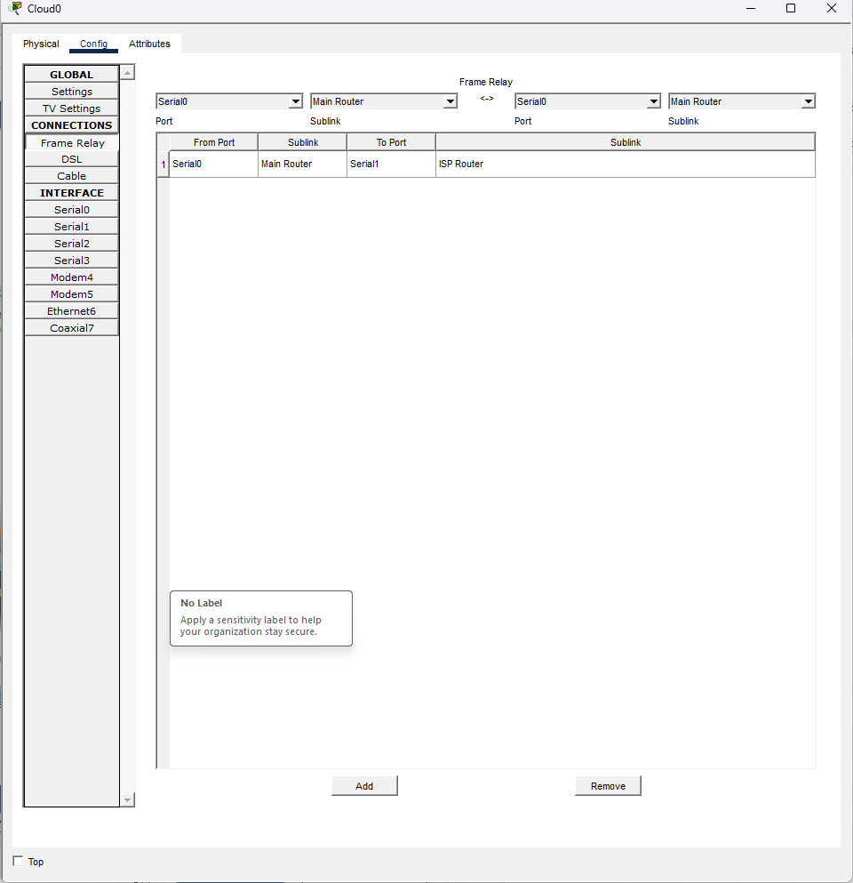

Main_Router
Main_Router>en
Main_Router# conf t
Main_Router(config)#int s0/2/0
Main_Router(config-if)#encapsulation frame-relay
Main_Router(config-if)#frame-relay map ipv6 2026:A3F9:C21E:11::2 100
Main_Router(config-if)#frame-relay map ipv6 FE80:11::2 100 broadcast
Main_Router(config)#end
Main_Router#copy run start

ISP_Router
ISP_Router>en
ISP_Router# conf t
ISP_Router(config)#int s0/1/0
ISP_Router(config-if)#encapsulation frame-relay
ISP_Router(config-if)#frame-relay map ipv6 2026:A3F9:C21E:11::1 101
ISP_Router(config-if)#frame-relay map ipv6 FE80:11::1 101 broadcast
ISP_Router(config)#end
ISP_Router#copy run start

7.0 Access Control List Configuration
Main_Router
Main_Router(config)#ipv6 access-list BLOCK_HTTP
Main_Router(config-ipv6-acl)#deny tcp any host 2026:A3F9:C21E:12::100 eq www
Main_Router(config-ipv6-acl)#deny tcp any host 2026:A3F9:C21E:12::100 eq 443
Main_Router(config-ipv6-acl)#permit ipv6 any any
Main_Router(config-ipv6-acl)#exit
Main_Router(config)#int g0/0/1
Main_Router(config-if)#ipv6 traffic-filter BLOCK_HTTP in
Main_Router(config-if)#exit
Main_Router(config)#
Main_Router#copy run start

Internal_Router
Internal_Router(config)#ipv6 access-list BLOCK_HTTP
Internal_Router(config-ipv6-acl)#deny tcp any host 2026:A3F9:C21E:12::100 eq www
Internal_Router(config-ipv6-acl)#deny tcp any host 2026:A3F9:C21E:12::100 eq 443
Internal_Router(config-ipv6-acl)#permit ipv6 any any
Internal_Router(config-ipv6-acl)#exit
Internal_Router(config)#int g0/0/1
Internal_Router(config-if)#ipv6 traffic-filter BLOCK_HTTP in
Internal_Router(config-if)#exit
Internal_Router(config)#exit
Internal_Router#copy run start

Main_Router
Main_Router(config)#ipv6 access-list BLOCK_HTTP
Main_Router(config-ipv6-acl)#deny tcp any host 2026:A3F9:C21E:12::100 eq www
Main_Router(config-ipv6-acl)#deny tcp any host 2026:A3F9:C21E:12::100 eq 443
Main_Router(config-ipv6-acl)#permit ipv6 any any
Main_Router(config-ipv6-acl)#exit
Main_Router(config)#int g0/0/1
Main_Router(config-if)#ipv6 traffic-filter BLOCK_HTTP in
Main_Router(config-if)#exit
Main_Router(config)#exit
Main_Router#copy run start

8.0 Server Configuration

8.1 Web Server Configuration
Ipv6 address:2026:A3F9:C21E:7::200/64
Default gateway:FE80:7::1
DNS Server:2026:A3F9:C21E:7::100
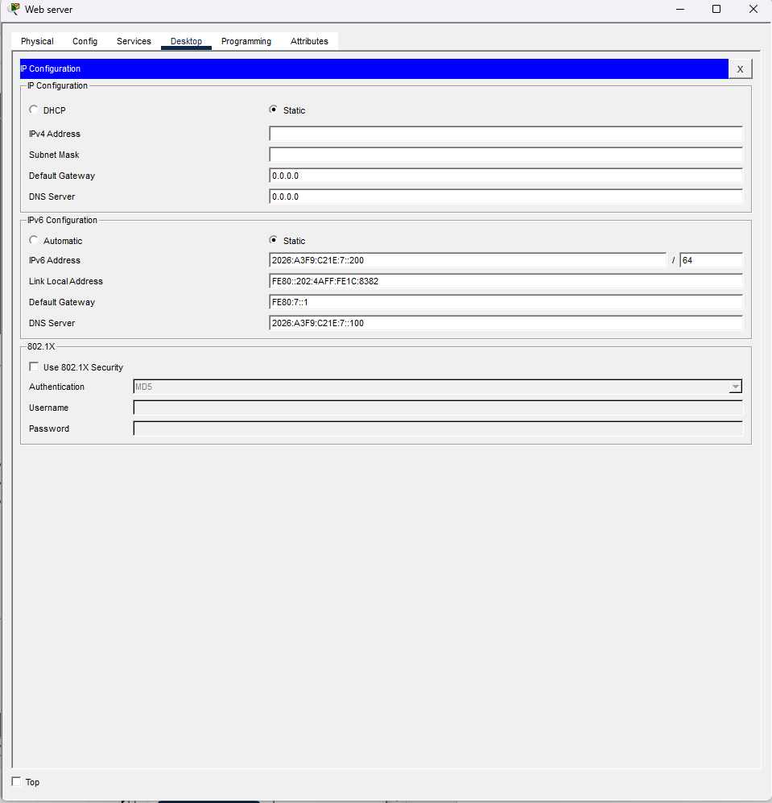

Edit index.html
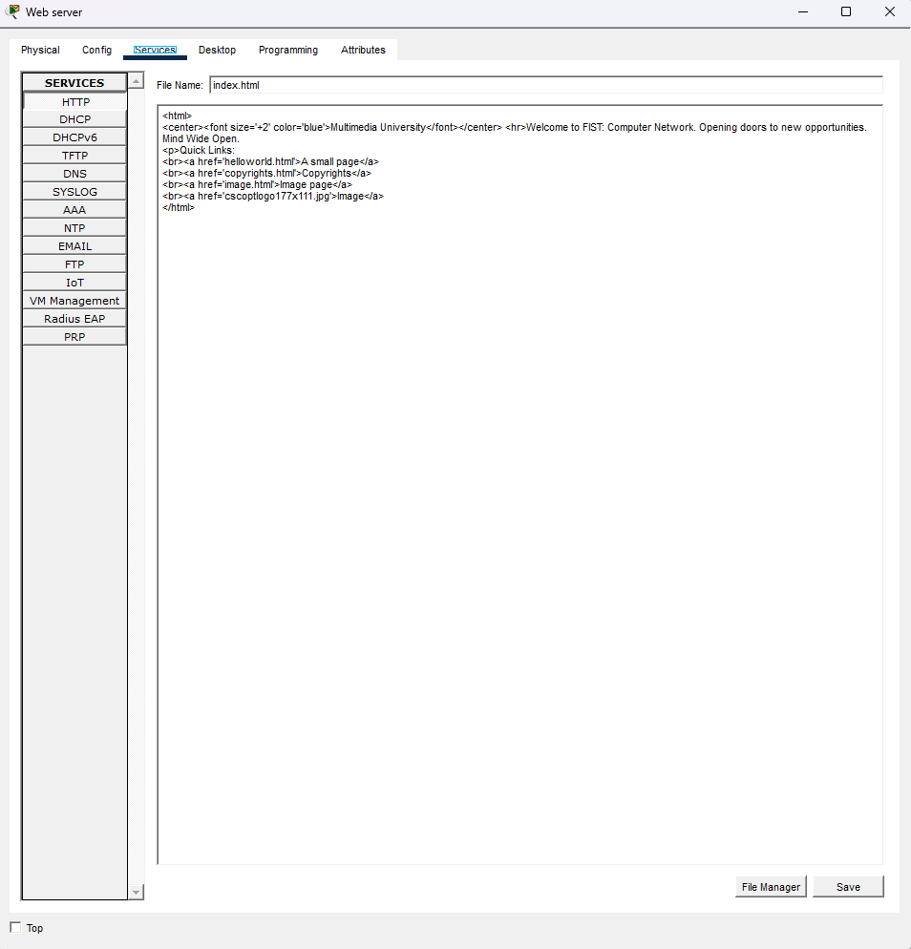

8.2 DNS Server Configuration
Ipv6 address:2026:A3F9:C21E:7::100/64
Default gateway:FE80:7::1
DNS server:2026:A3F9:C21E:7::100
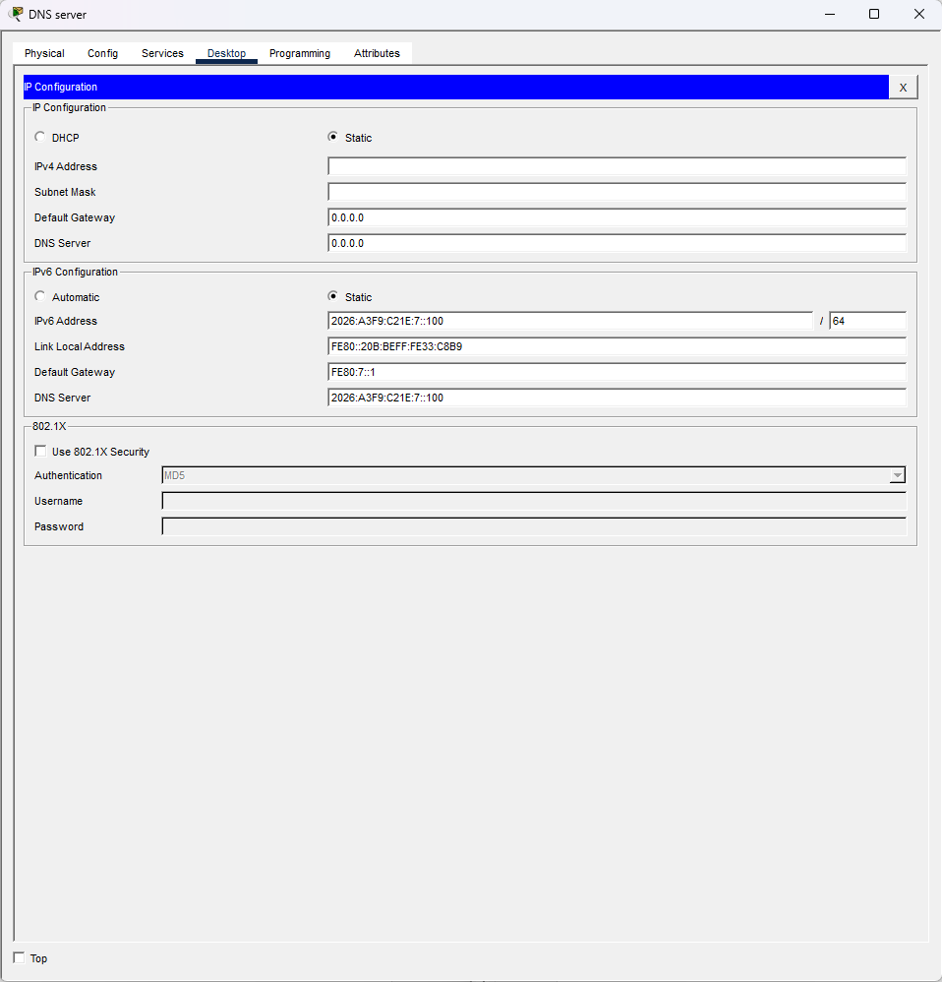

Turn off HTTP and HTTPS services
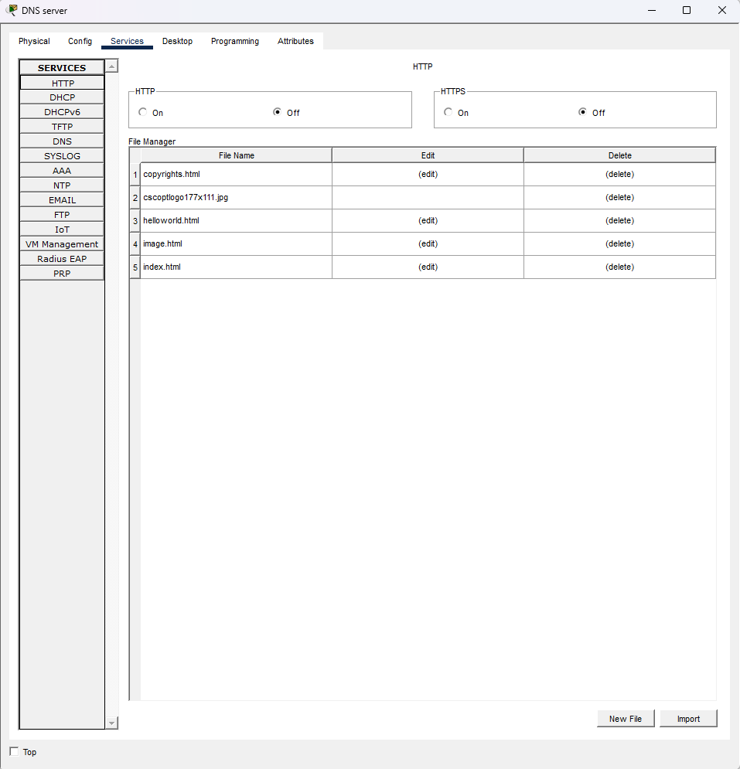

Turn on DHCPv6 service
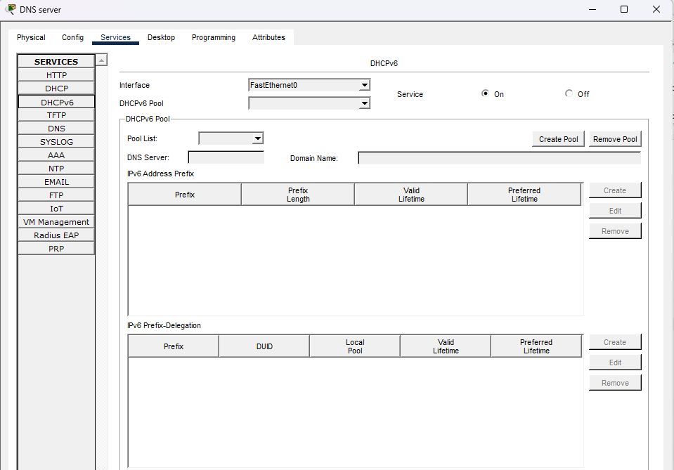
Turn on DNS service
- Name:www.mmu.edu.my
Type:AAAAA record
Address:2026:A3F9:C21E:7::200

- Name:internetserver.com
Type:AAAAA record
Address:2026:A3F9:C21E:7::100

- Name:ftp.com
Type:AAAAA record
Address:2026:A3F9:C21E:7::300

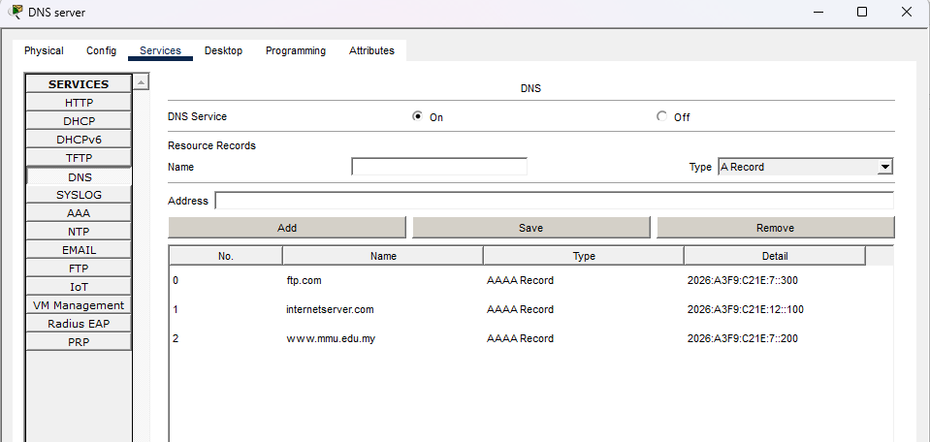

8.3 File Server Configuration
Ipv6 address:2026:A3F9:C21E:7::300/64
Default gateway:FE80:7::1
DNS Server:2026:A3F9:C21E:7::100
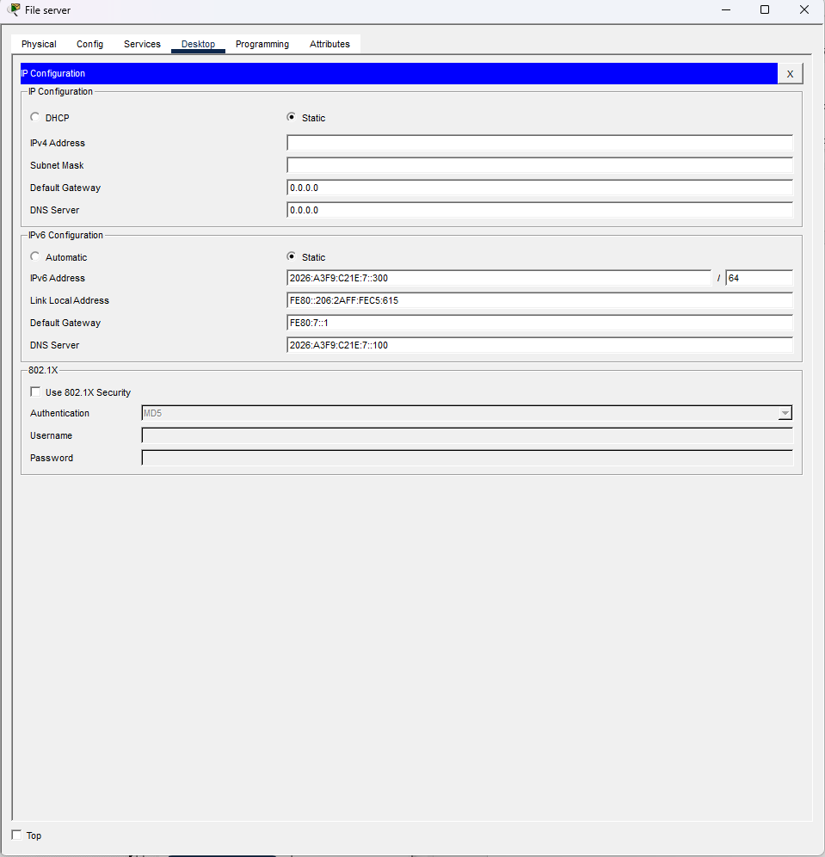

Turn on HTTP and HTTPS services
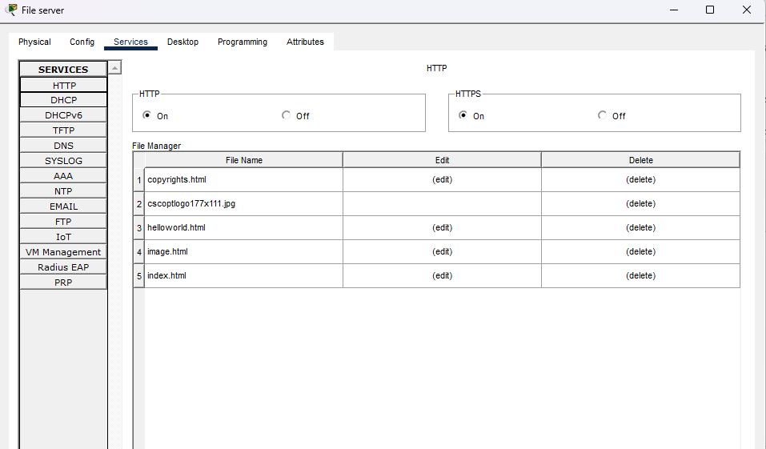
Turn off DHCPv6 service
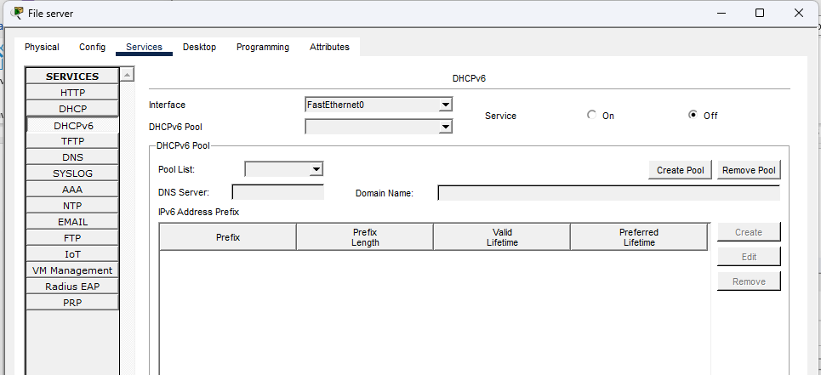

Turn off DNS service
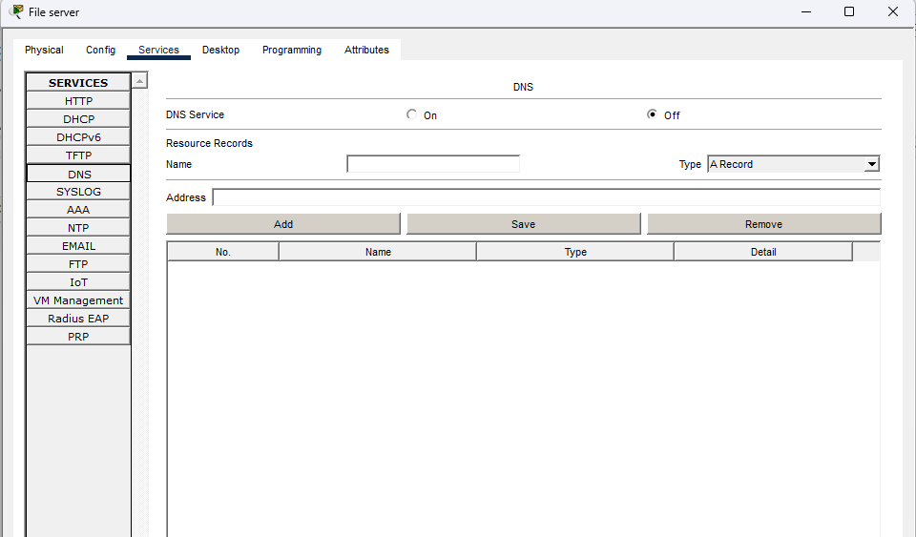
Turn on FTP service
Username: admin
Password admin123
Select Write,Read, Delete, Rename and List and click “Add”
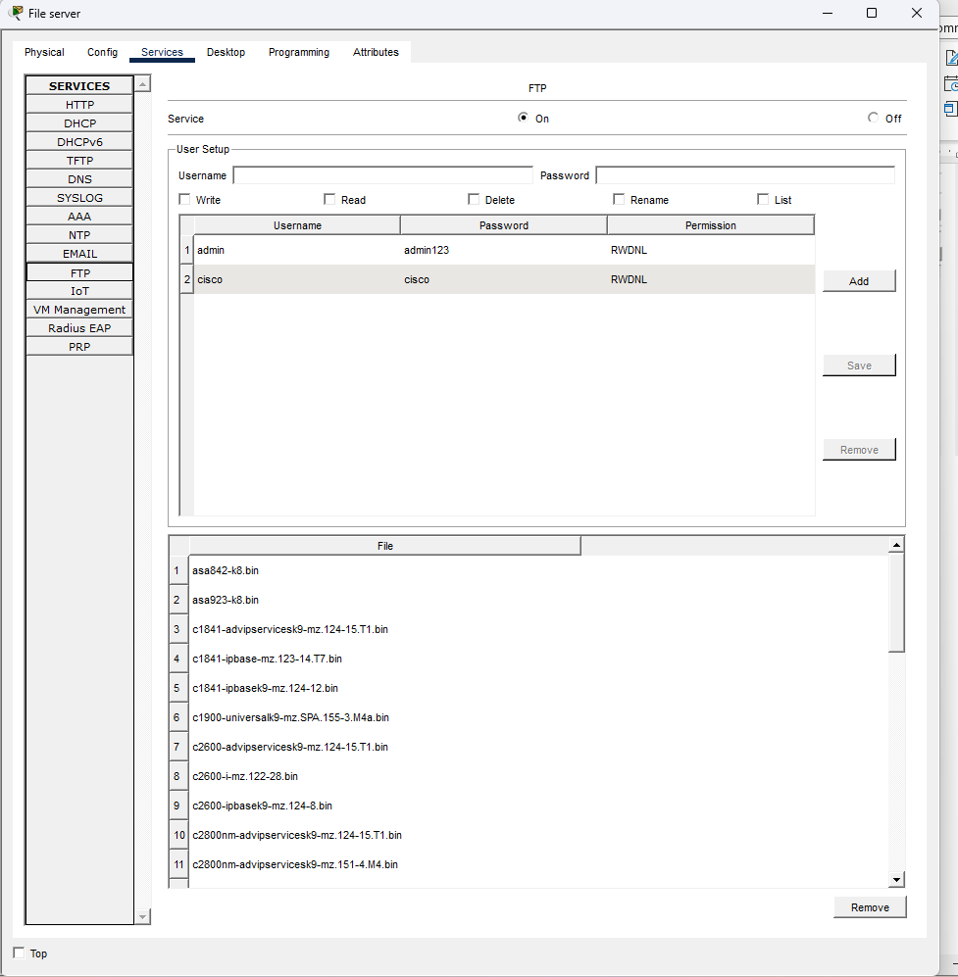

8.4 ISP Server Configuration
Ipv6 address:2026:A3F9:C21E:12::100/64
Default gateway:FE80:12::1
DNS Server:2026:A3F9:C21E:7::100
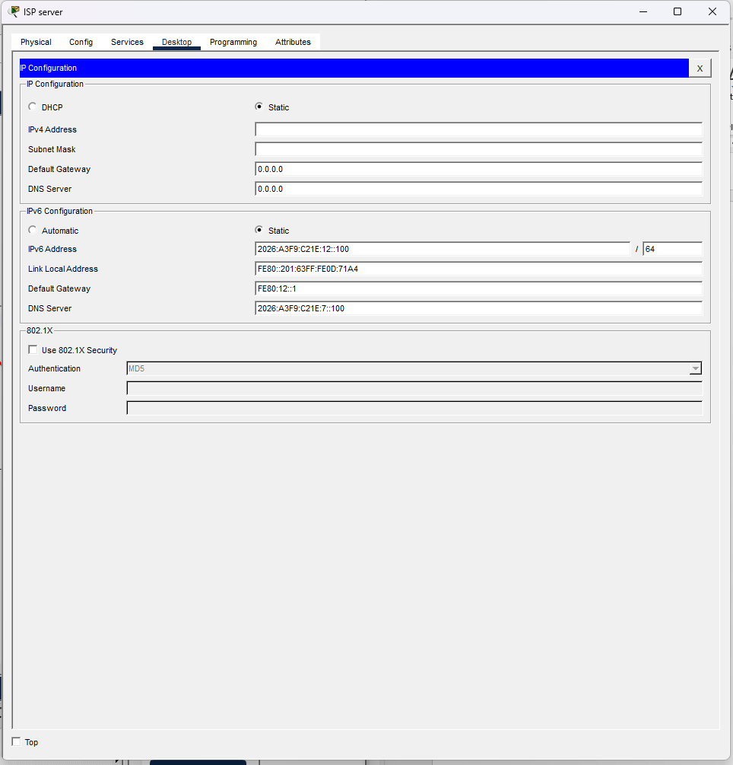

8.5 Cloud
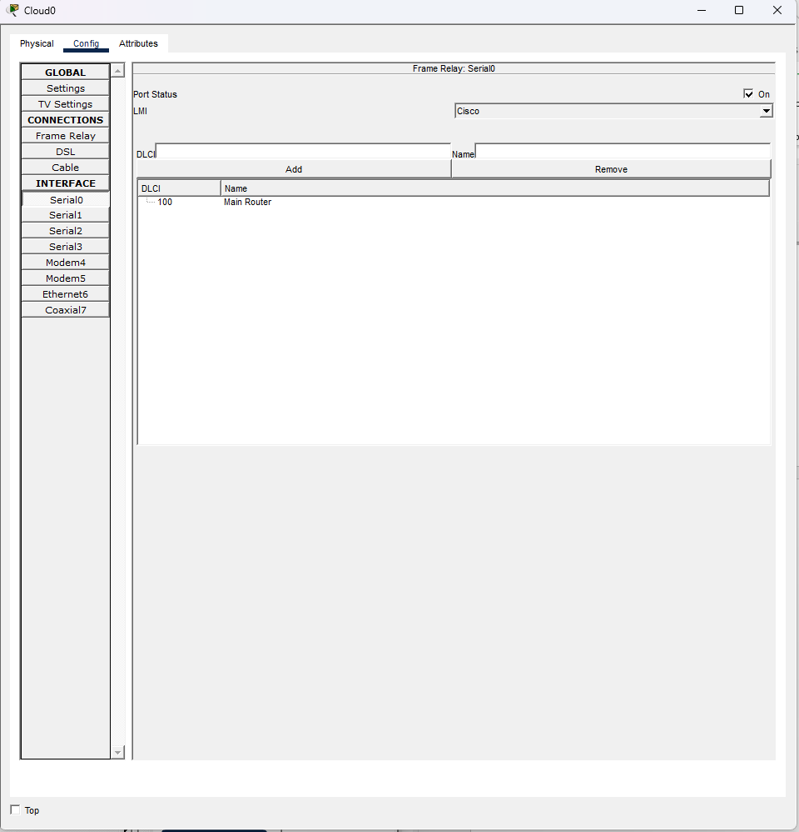
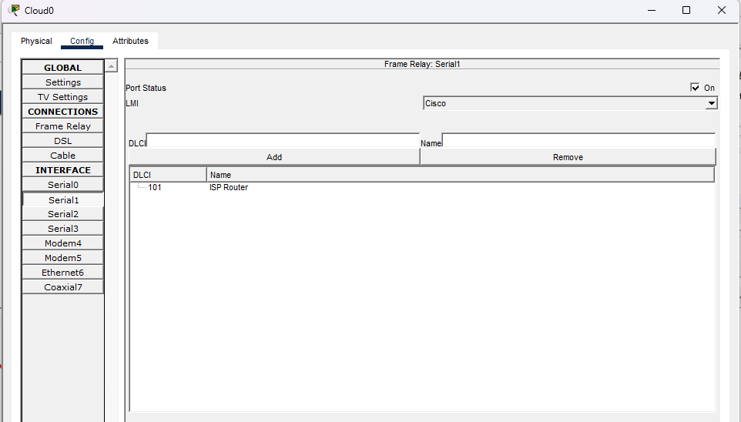

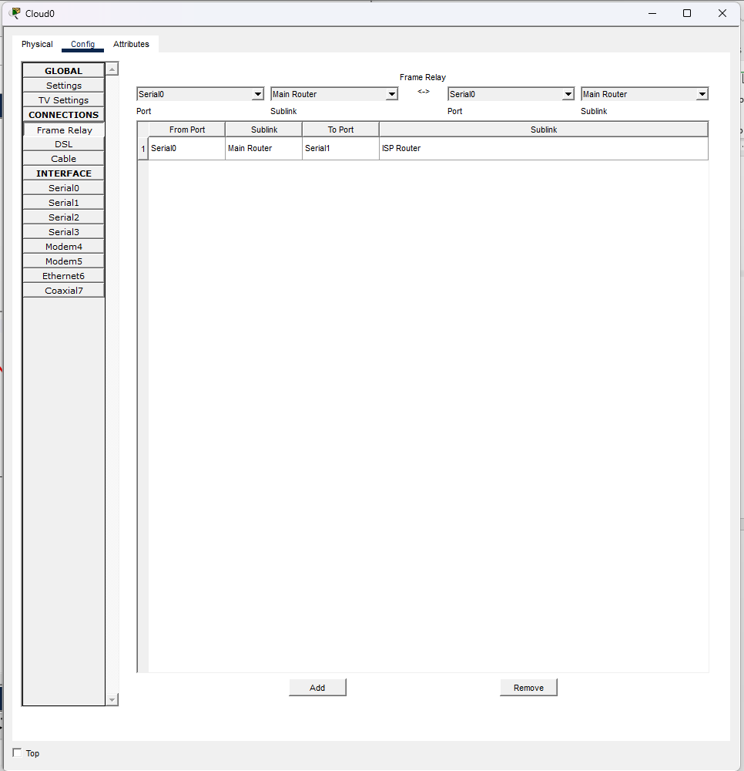

9.0 Verify Connectivity

9.1 Ping(ICMP)
1.Ping from Instructor L1 to PC3_Lab2
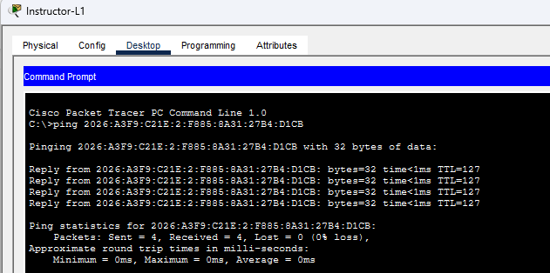
2.Ping from Instructor L2 to PC8_Lab1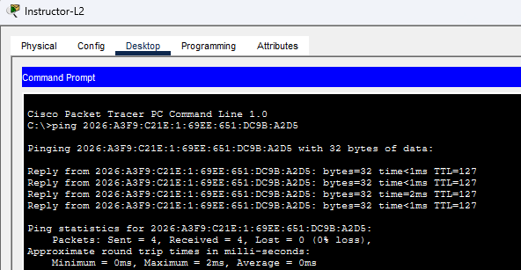

3.Ping from PC18_Lab2 to PC13_Lab1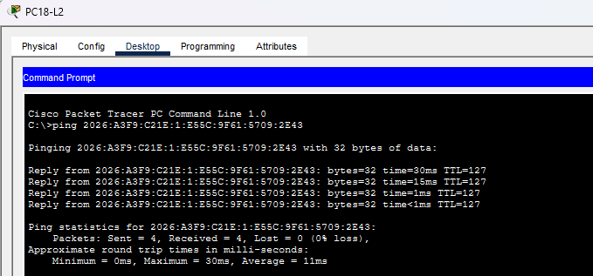
4.Ping PC14_Lab1 to File Server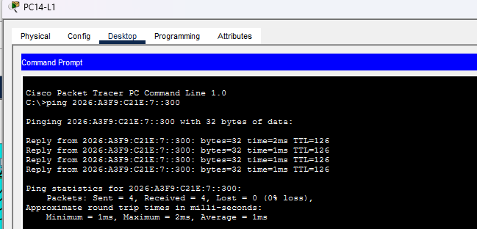
5. Ping from PC8_Lab2 to Staff3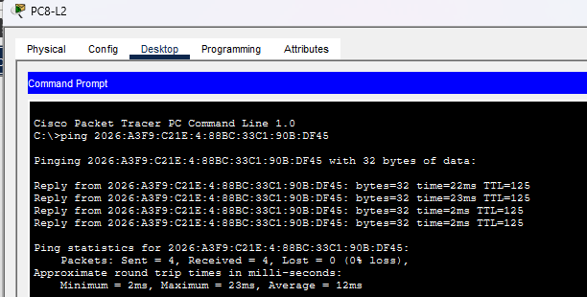
6.Ping from Intern1 to Staff1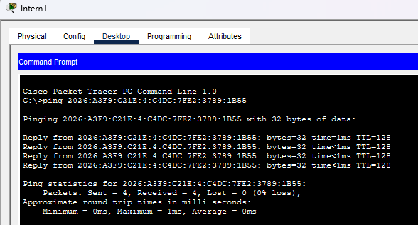
7.Ping from Sys Adm2 to Class 3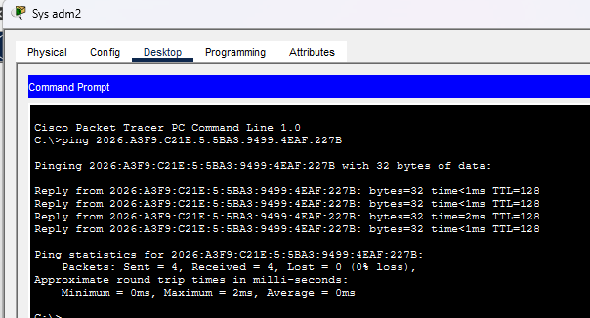
8.Ping from Class 7 to Web Server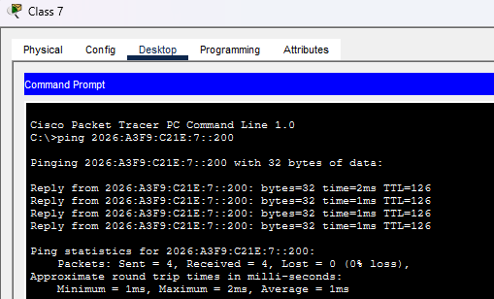
9. Ping from Intern 4 to File Server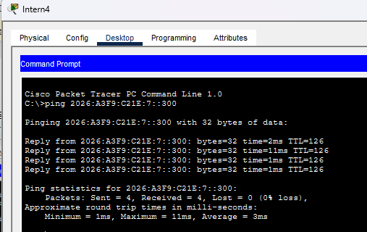
10. Ping from Staff 5 to DNS Server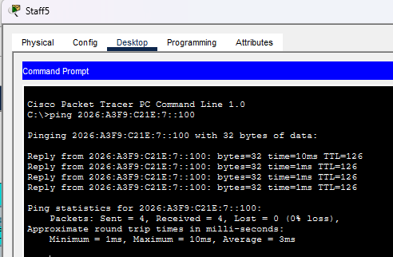

9.2 Web Browser
1. Access www.mmu.edu.my from PC21_Lab1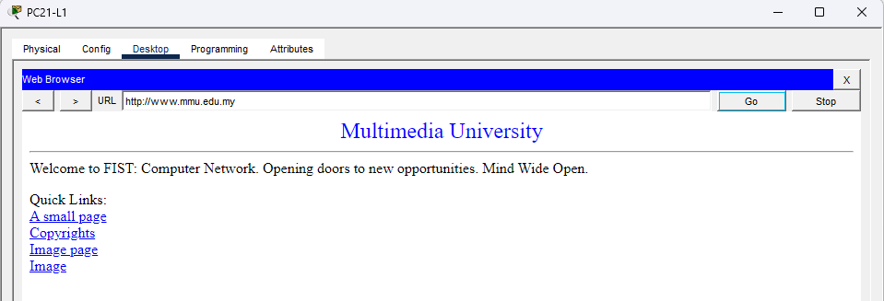
2.Access www.mmu.edu.my from PC18_Lab2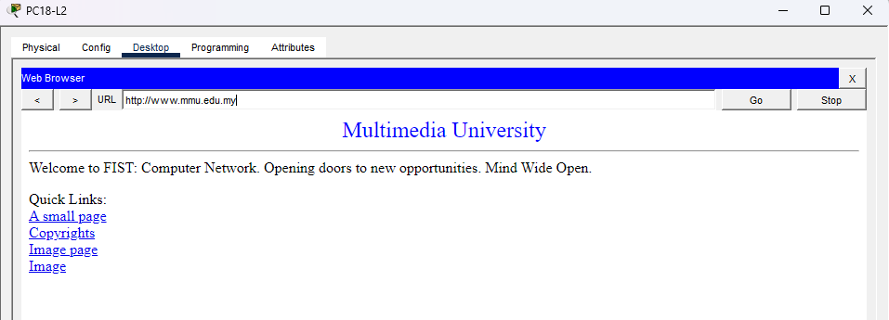
3.Access www.mmu.edu.my from Staff2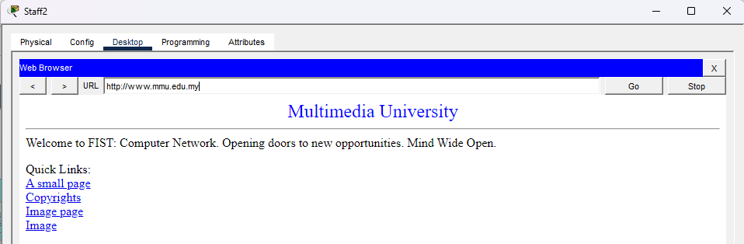
4.Access www.mmu.edu.my from Class1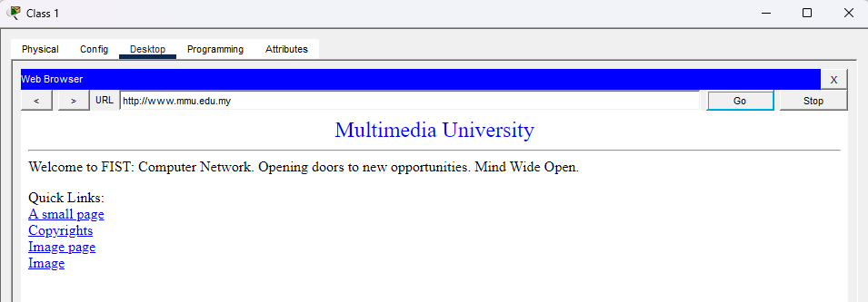
5.Access www.mmu.edu.my from Intern3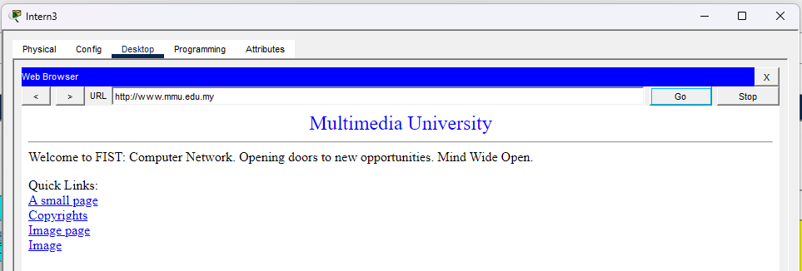

9.3 File Server
Administrator office
Create a text file in Staff2
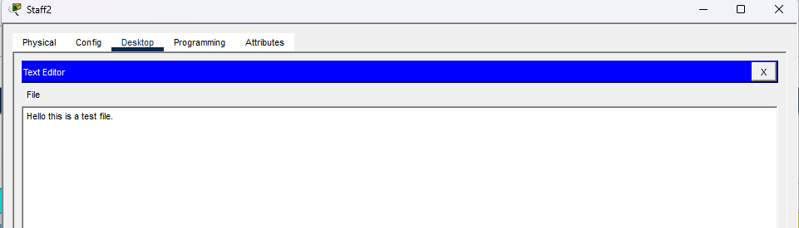
Login into ftp server in Staff2 and upload the text file(Hello.txt)
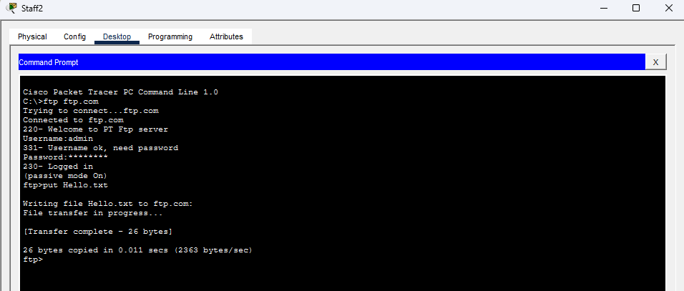
Enter the ftp server and retrieve the test file for PC12_Lab2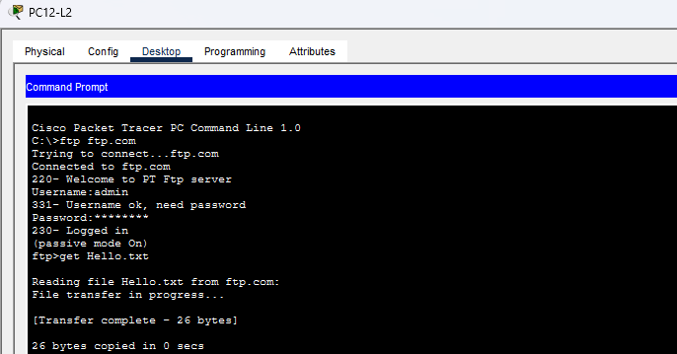
Go to “Text Editor” and click on “File” and “open” button. Select “Hello.txt”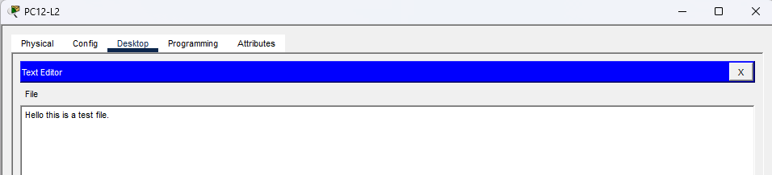

Wireless Network
Create a text file in Wireless Laptop
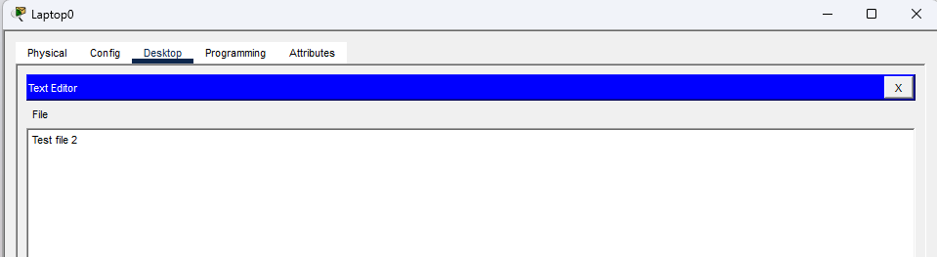
Login into ftp server in the Wireless Laptop and upload the text file (test.txt)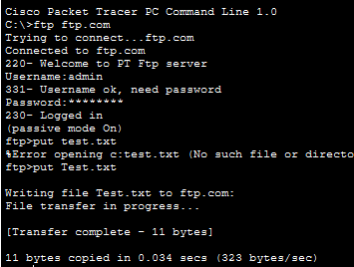
Enter ftp server and get the file from Class 3.
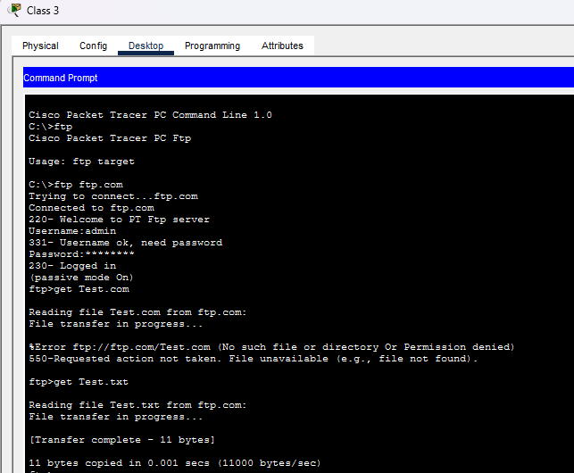
Go to text editor and see the file.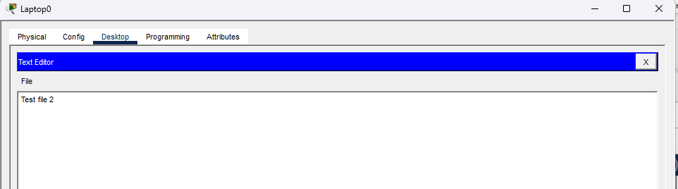

9.4 Access control
1.PC3-Lab1 can access to the internet.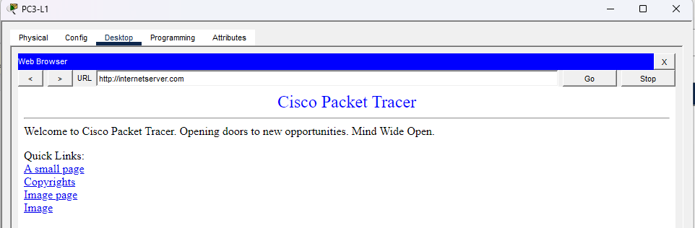
2.PC3-Lab2 can access to the internet.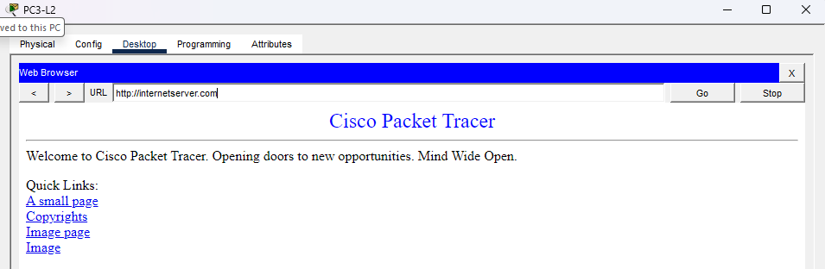
3.Staff 5 in admin office cannot access to the internet.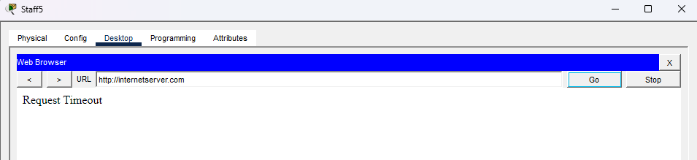
4.Intern1 in admin office cannot access to the internet.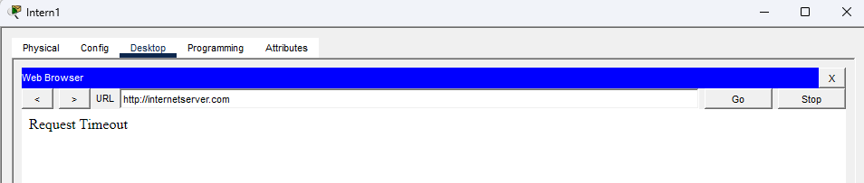

5.Class1 can access to the internet.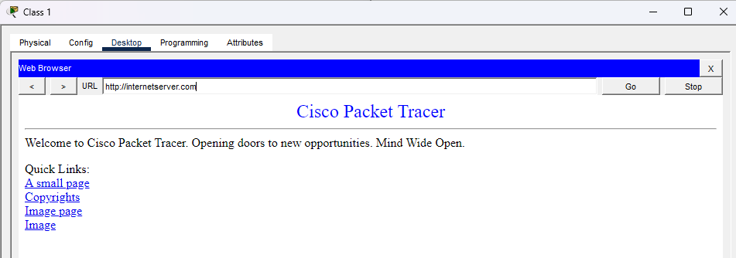
6.Sys adm1 access to the internet.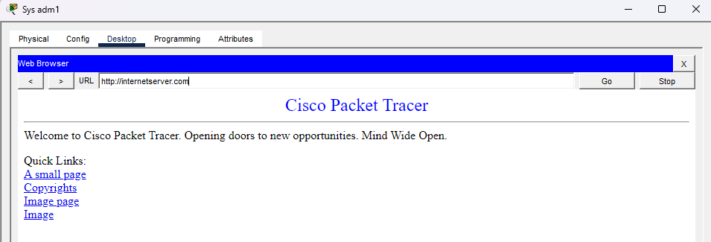

10 .0 Reference
- Configure DHCPv6 (variation in Packet Tracer): https://youtu.be/uCQw8mmQ05A
- Configure a Wireless Network: https://youtu.be/F5A9cG22Sfw
- DNS Server Cisco Packet Tracer: https://youtu.be/DfaN-YTDNyE
- https://www.cisco.com/c/en/us/support/routers/4331-integrated-services-router-isr/model.html?dtid=osscdc000283
- https://i.dell.com/sites/doccontent/business/smb/merchandizing/en/Documents/OptiPlex_7010_Technical_Guidebook_1.pdf
- https://www.dell.com/en-us/shop/desktop-computers/optiplex-tower/spd/optiplex-7010-desktop
- https://www.dell.com/support/manuals/en-us/latitude-e6430s/late6430s_om-v1/technical-specifications?guid=guid-689ea094-1adc-4409-9288-0bfdfbcd78a1&lang=en-us
- Configure Frame-relay: https://www.computernetworkingnotes.com/ccna-study-guide/how-to-configure-frame-relay-step-by-step-guide.html
- https://www.paessler.com/prtg/features
- https://www.microsoft.com/en-us/evalcenter/evaluate-windows-server-2025
- https://i.dell.com/sites/csdocuments/Shared-Content_data-Sheets_Documents/en/R710-SpecSheet.pdf
- https://www.dell.com/support/product-details/en-us/product/optiplex-7010/overview
- https://www.cisco.com/c/en/us/support/docs/routers/7000-series-routers/12222-cables.html?utm_source=chatgpt.com

