Verify Connectivity

9.1 Ping(ICMP)
1.Ping from Instructor L1 to PC3_Lab2
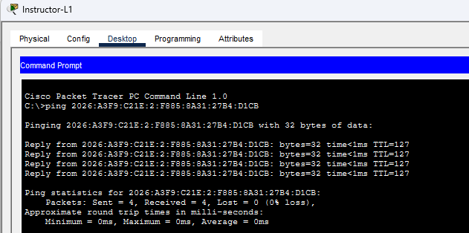
2.Ping from Instructor L2 to PC8_Lab1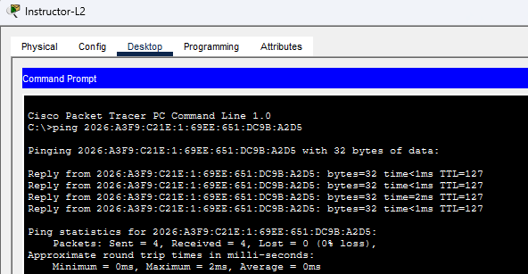

3.Ping from PC18_Lab2 to PC13_Lab1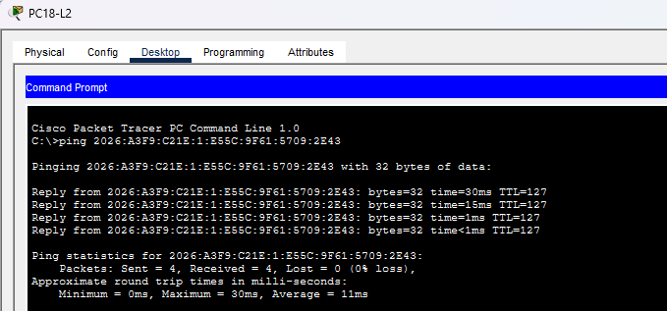
4.Ping PC14_Lab1 to File Server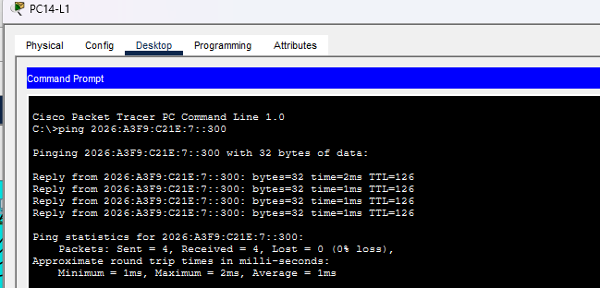
5. Ping from PC8_Lab2 to Staff3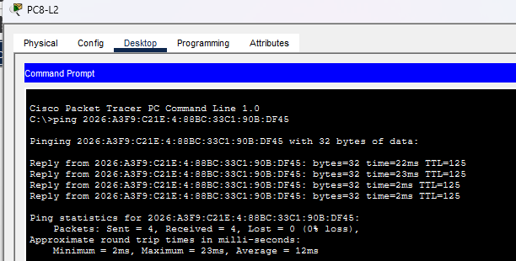
6.Ping from Intern1 to Staff1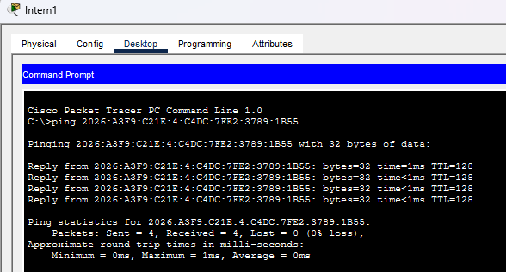
7.Ping from Sys Adm2 to Class 3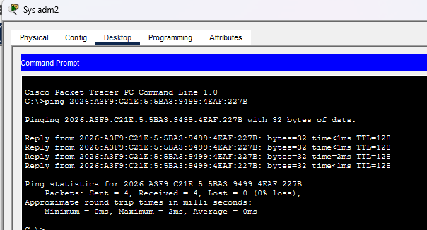
8.Ping from Class 7 to Web Server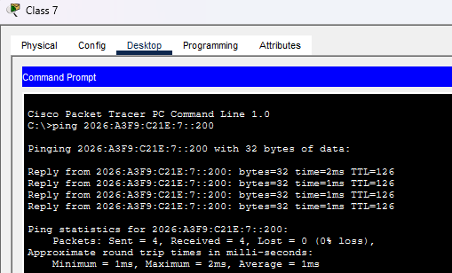
9. Ping from Intern 4 to File Server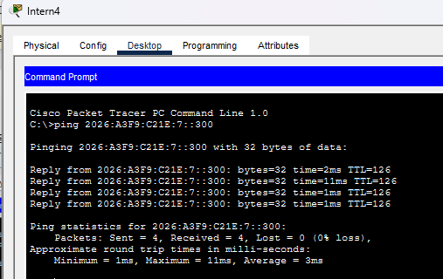
10. Ping from Staff 5 to DNS Server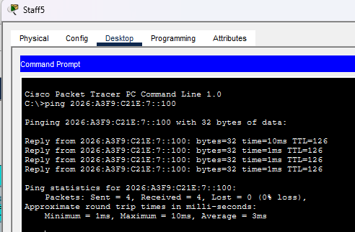

9.2 Web Browser
1. Access www.mmu.edu.my from PC21_Lab1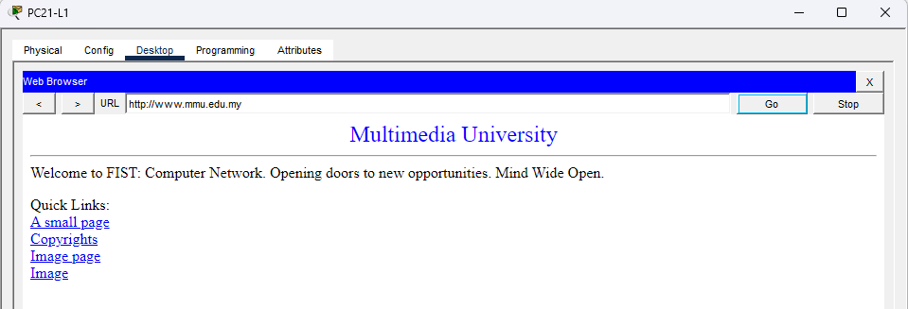
2.Access www.mmu.edu.my from PC18_Lab2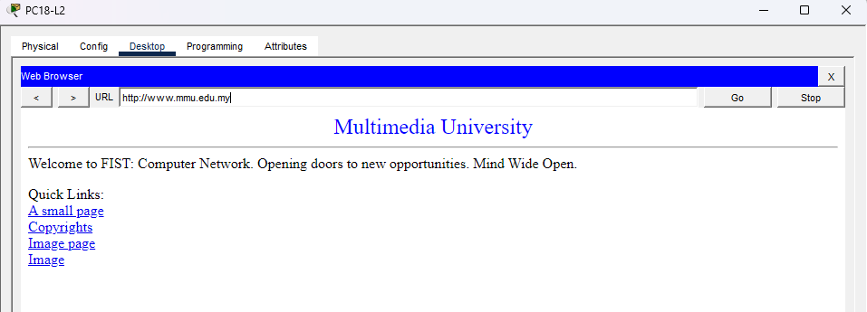
3.Access www.mmu.edu.my from Staff2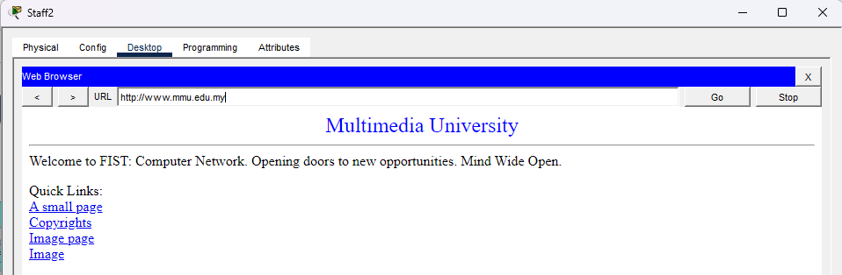
4.Access www.mmu.edu.my from Class1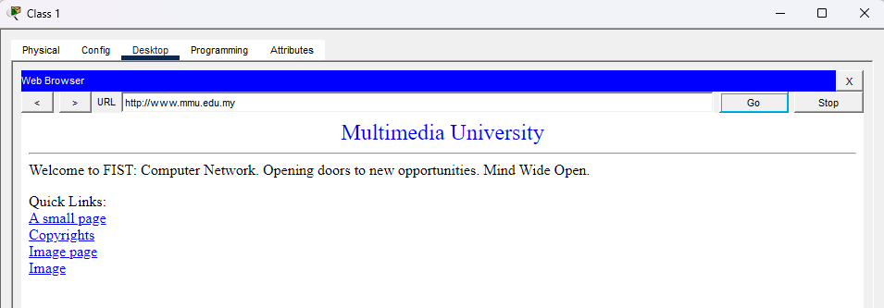
5.Access www.mmu.edu.my from Intern3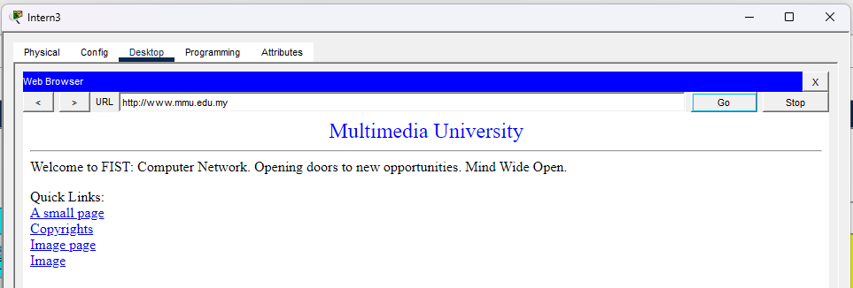

9.3 File Server
Administrator office
Create a text file in Staff2
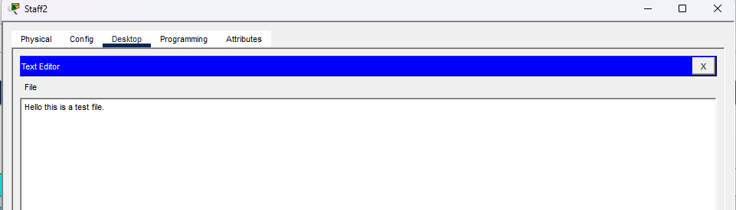
Login into ftp server in Staff2 and upload the text file(Hello.txt)
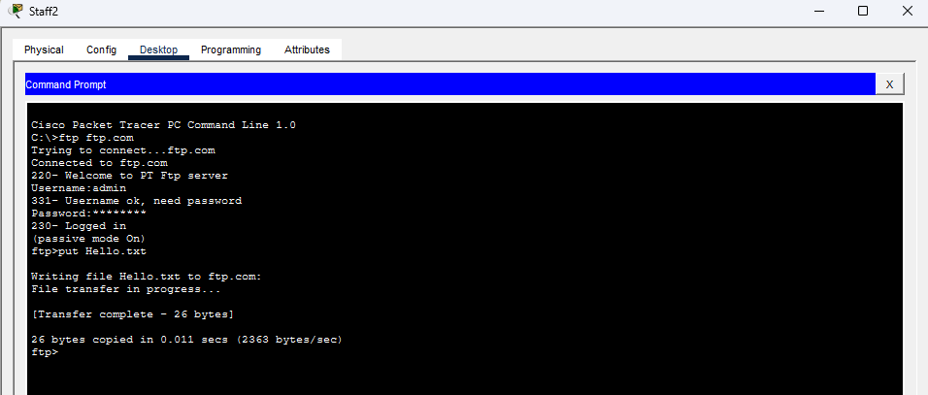
Enter the ftp server and retrieve the test file for PC12_Lab2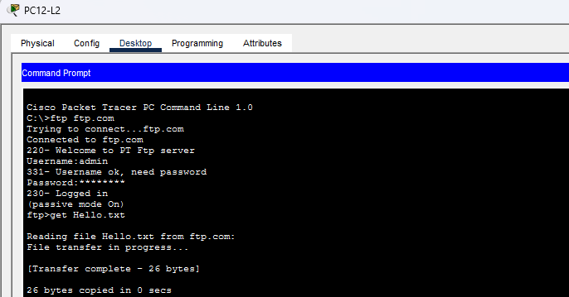
Go to “Text Editor” and click on “File” and “open” button. Select “Hello.txt”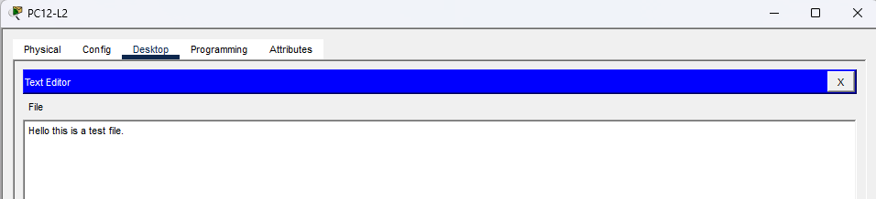

Wireless Network
Create a text file in Wireless Laptop
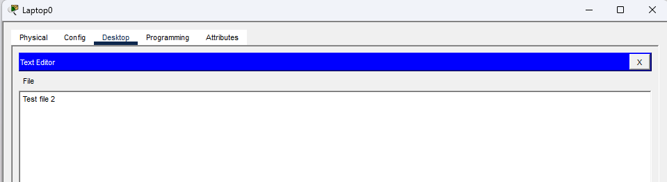
Login into ftp server in the Wireless Laptop and upload the text file (test.txt)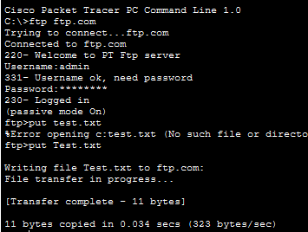
Enter ftp server and get the file from Class 3.
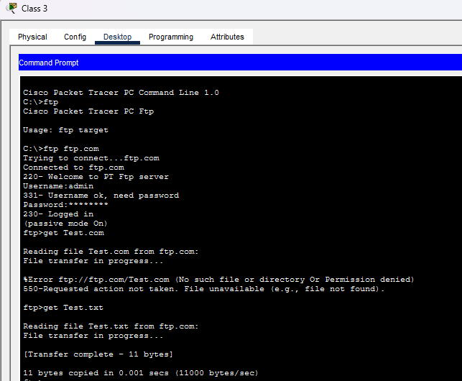
Go to text editor and see the file.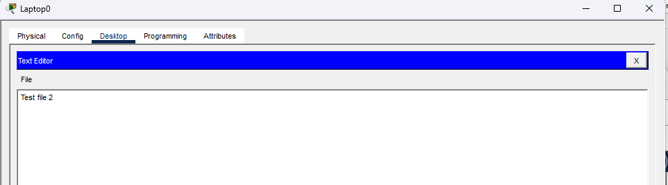

9.4 Access control
1.PC3-Lab1 can access to the internet.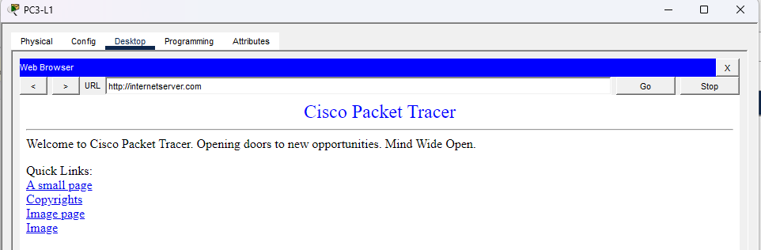
2.PC3-Lab2 can access to the internet.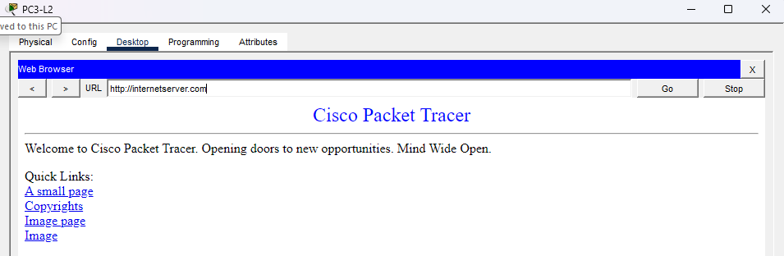
3.Staff 5 in admin office cannot access to the internet.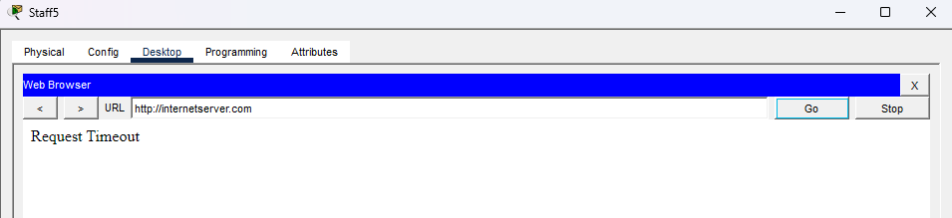
4.Intern1 in admin office cannot access to the internet.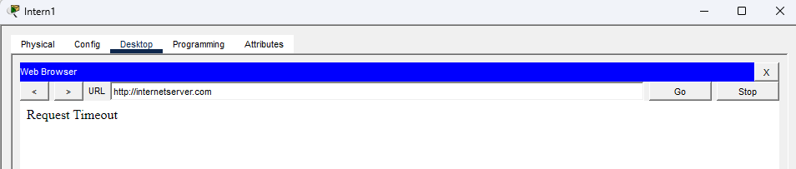

5.Class1 can access to the internet.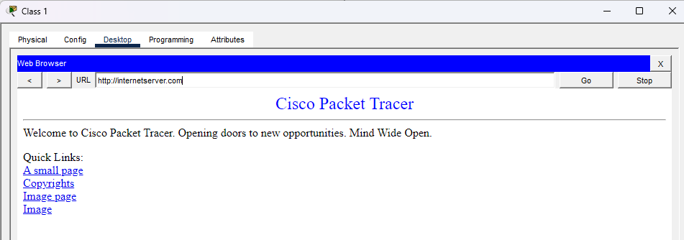
6.Sys adm1 access to the internet.