Bài 1
https://app.xmind.com/share/Cl8UTjop?xid=qAjzoHRY

Bài 2
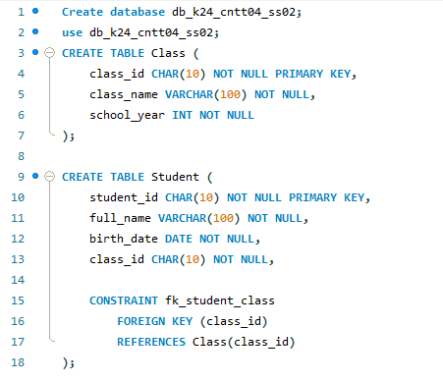
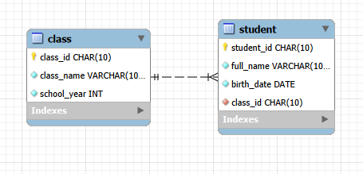

Bài 3
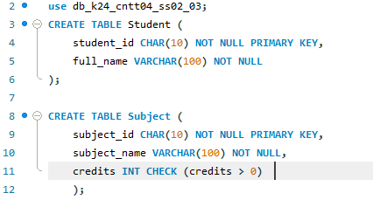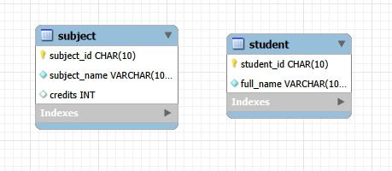

Bài 4
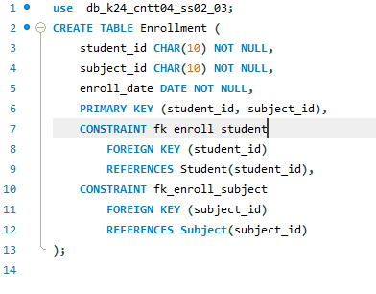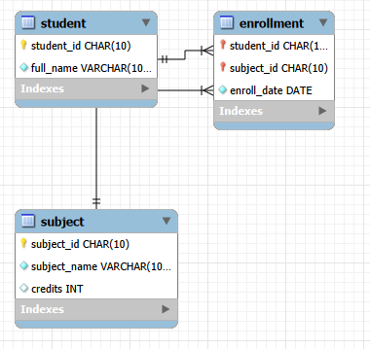

Bài 5
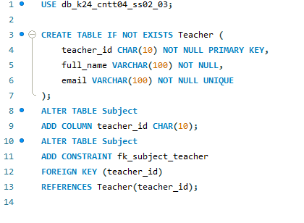
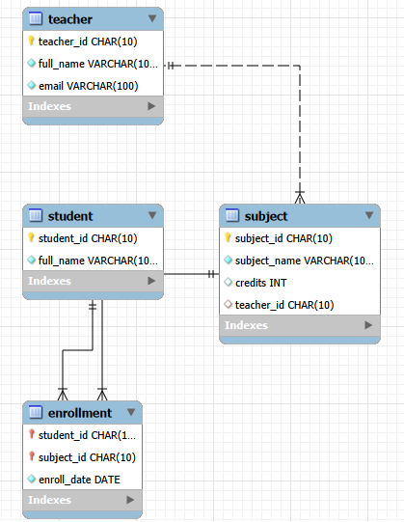

Bài 6
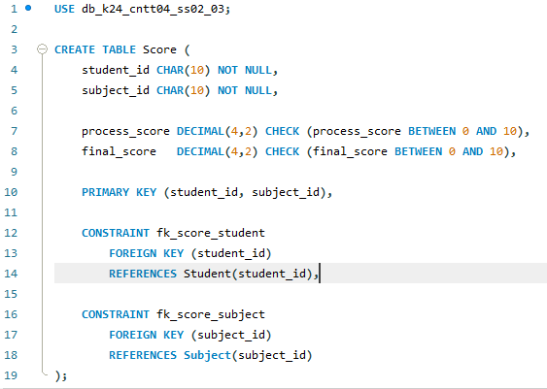
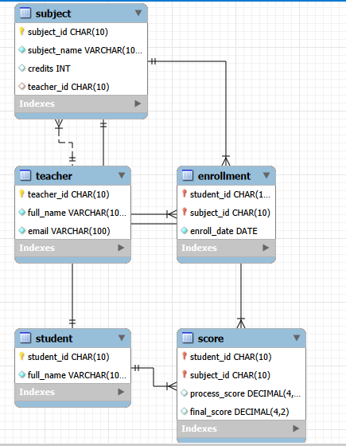

Bài 7
CREATE DATABASE db_training_management;
USE db_training_management;
CREATE TABLE Class (
class_id CHAR(10) PRIMARY KEY,
class_name VARCHAR(50) NOT NULL UNIQUE
);
CREATE TABLE Student (
student_id CHAR(10) PRIMARY KEY,
full_name VARCHAR(100) NOT NULL,
email VARCHAR(100) UNIQUE,
class_id CHAR(10),
CONSTRAINT fk_student_class
FOREIGN KEY (class_id)
REFERENCES Class(class_id)
);
CREATE TABLE Teacher (
teacher_id CHAR(10) PRIMARY KEY,
full_name VARCHAR(100) NOT NULL,
email VARCHAR(100) UNIQUE
);
CREATE TABLE Subject (
subject_id CHAR(10) PRIMARY KEY,
subject_name VARCHAR(100) NOT NULL UNIQUE,
credits INT NOT NULL CHECK (credits > 0),
teacher_id CHAR(10),
CONSTRAINT fk_subject_teacher
FOREIGN KEY (teacher_id)
REFERENCES Teacher(teacher_id)
);
CREATE TABLE Enrollment (
student_id CHAR(10) NOT NULL,
subject_id CHAR(10) NOT NULL,
enroll_date DATE NOT NULL,
PRIMARY KEY (student_id, subject_id),
CONSTRAINT fk_enroll_student
FOREIGN KEY (student_id)
REFERENCES Student(student_id),
CONSTRAINT fk_enroll_subject
FOREIGN KEY (subject_id)
REFERENCES Subject(subject_id)
);
CREATE TABLE Score (
student_id CHAR(10) NOT NULL,
subject_id CHAR(10) NOT NULL,
process_score DECIMAL(4,2)
CHECK (process_score BETWEEN 0 AND 10),
final_score DECIMAL(4,2)
CHECK (final_score BETWEEN 0 AND 10),
PRIMARY KEY (student_id, subject_id),
CONSTRAINT fk_score_student
FOREIGN KEY (student_id)
REFERENCES Student(student_id),
CONSTRAINT fk_score_subject
FOREIGN KEY (subject_id)
REFERENCES Subject(subject_id)
);

