Bài 1
https://app.xmind.com/share/xSaS62NA?xid=4dc0AQ8P

Bài 2
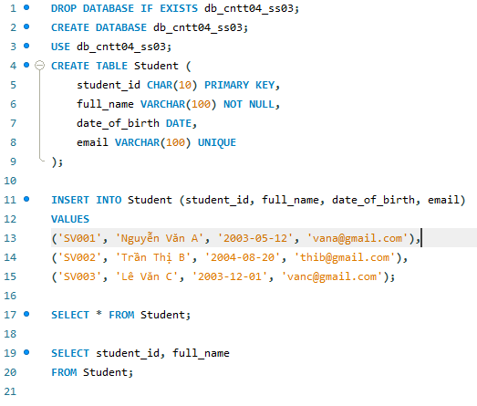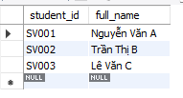

Bài 3
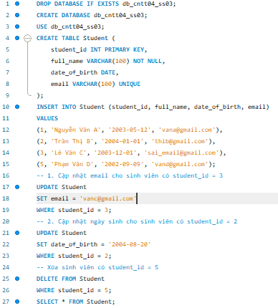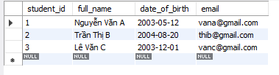

Bài 4
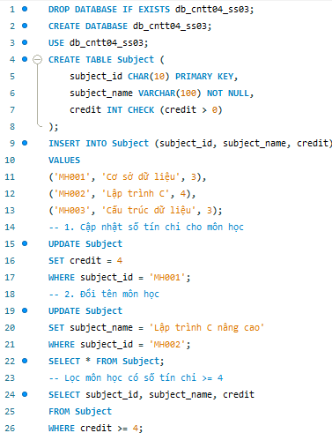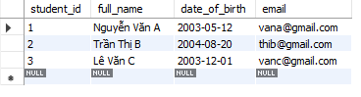

Bài 5
DROP DATABASE IF EXISTS db_cntt04_ss03;
CREATE DATABASE db_cntt04_ss03;
USE db_cntt04_ss03;
CREATE TABLE Student (
student_id INT PRIMARY KEY,
full_name VARCHAR(100) NOT NULL,
date_of_birth DATE,
email VARCHAR(100) UNIQUE
);
CREATE TABLE Subject (
subject_id CHAR(10) PRIMARY KEY,
subject_name VARCHAR(100) NOT NULL,
credit INT CHECK (credit > 0)
);
CREATE TABLE Enrollment (
student_id INT,
subject_id CHAR(10),
enroll_date DATE,
PRIMARY KEY (student_id, subject_id),
FOREIGN KEY (student_id) REFERENCES Student(student_id),
FOREIGN KEY (subject_id) REFERENCES Subject(subject_id)
);
INSERT INTO Student (student_id, full_name, date_of_birth, email)
VALUES
(1, 'Nguyễn Văn A', '2003-05-12', 'vana@gmail.com'),
(2, 'Trần Thị B', '2004-08-20', 'thib@gmail.com');
INSERT INTO Subject (subject_id, subject_name, credit)
VALUES
('MH001', 'Cơ sở dữ liệu', 3),
('MH002', 'Lập trình C', 4),
('MH003', 'Cấu trúc dữ liệu', 3);
INSERT INTO Enrollment (student_id, subject_id, enroll_date)
VALUES
(1, 'MH001', '2025-01-10'),
(1, 'MH002', '2025-01-10'),
(2, 'MH001', '2025-01-11'),
(2, 'MH003', '2025-01-11');
SELECT * FROM Enrollment;
SELECT *
FROM Enrollment
WHERE student_id = 1;

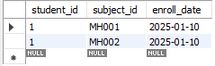

Bài 6
DROP DATABASE IF EXISTS db_cntt04_ss03;
CREATE DATABASE db_cntt04_ss03;
USE db_cntt04_ss03;
CREATE TABLE Student (
student_id INT PRIMARY KEY,
full_name VARCHAR(100) NOT NULL,
date_of_birth DATE,
email VARCHAR(100) UNIQUE
);
CREATE TABLE Subject (
subject_id CHAR(10) PRIMARY KEY,
subject_name VARCHAR(100) NOT NULL,
credit INT CHECK (credit > 0)
);
CREATE TABLE Score (
student_id INT,
subject_id CHAR(10),
mid_score DECIMAL(4,2) CHECK (mid_score BETWEEN 0 AND 10),
final_score DECIMAL(4,2) CHECK (final_score BETWEEN 0 AND 10),
PRIMARY KEY (student_id, subject_id),
FOREIGN KEY (student_id) REFERENCES Student(student_id),
FOREIGN KEY (subject_id) REFERENCES Subject(subject_id)
);
INSERT INTO Student (student_id, full_name, date_of_birth, email)
VALUES
(1, 'Nguyễn Văn A', '2003-05-12', 'vana@gmail.com'),
(2, 'Trần Thị B', '2004-08-20', 'thib@gmail.com');
INSERT INTO Subject (subject_id, subject_name, credit)
VALUES
('MH001', 'Cơ sở dữ liệu', 3),
('MH002', 'Lập trình C', 4);
INSERT INTO Score (student_id, subject_id, mid_score, final_score)
VALUES
(1, 'MH001', 7.5, 8.0),
(1, 'MH002', 6.5, 7.0),
(2, 'MH001', 8.0, 9.0),
(2, 'MH002', 7.0, 8.5);
UPDATE Score
SET final_score = 8.2
WHERE student_id = 1
AND subject_id = 'MH002';
SELECT * FROM Score;
SELECT student_id, subject_id, final_score
FROM Score
WHERE final_score >= 8;
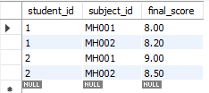

Bài 7
DROP DATABASE IF EXISTS db_cntt04_ss03;
CREATE DATABASE db_cntt04_ss03;
USE db_cntt04_ss03;
CREATE TABLE Student (
student_id INT PRIMARY KEY,
full_name VARCHAR(100) NOT NULL,
date_of_birth DATE,
email VARCHAR(100) UNIQUE
);
CREATE TABLE Subject (
subject_id CHAR(10) PRIMARY KEY,
subject_name VARCHAR(100) NOT NULL,
credit INT CHECK (credit > 0)
);
CREATE TABLE Enrollment (
student_id INT,
subject_id CHAR(10),
enroll_date DATE,
PRIMARY KEY (student_id, subject_id),
FOREIGN KEY (student_id) REFERENCES Student(student_id),
FOREIGN KEY (subject_id) REFERENCES Subject(subject_id)
);
CREATE TABLE Score (
student_id INT,
subject_id CHAR(10),
mid_score DECIMAL(4,2) CHECK (mid_score BETWEEN 0 AND 10),
final_score DECIMAL(4,2) CHECK (final_score BETWEEN 0 AND 10),
PRIMARY KEY (student_id, subject_id),
FOREIGN KEY (student_id, subject_id)
REFERENCES Enrollment(student_id, subject_id)
);
INSERT INTO Student VALUES
(1, 'Nguyễn Văn A', '2003-05-12', 'vana@gmail.com'),
(2, 'Trần Thị B', '2004-08-20', 'thib@gmail.com');
INSERT INTO Subject VALUES
('MH001', 'Cơ sở dữ liệu', 3),
('MH002', 'Lập trình C', 4),
('MH003', 'Cấu trúc dữ liệu', 3);
INSERT INTO Student (student_id, full_name, date_of_birth, email)
VALUES (3, 'Lê Văn C', '2003-11-10', 'vanc@gmail.com');
INSERT INTO Enrollment (student_id, subject_id, enroll_date)
VALUES
(3, 'MH001', '2025-01-15'),
(3, 'MH002', '2025-01-15');
INSERT INTO Score (student_id, subject_id, mid_score, final_score)
VALUES
(3, 'MH001', 7.0, 7.5),
(3, 'MH002', 6.5, 7.0);
UPDATE Score
SET final_score = 8.5
WHERE student_id = 3
AND subject_id = 'MH002';
DELETE FROM Score
WHERE student_id = 3 AND subject_id = 'MH001';

DELETE FROM Enrollment
WHERE student_id = 3 AND subject_id = 'MH001';
SELECT
s.student_id,
s.full_name,
sub.subject_name,
sc.mid_score,
sc.final_score
FROM Student s
JOIN Score sc ON s.student_id = sc.student_id
JOIN Subject sub ON sc.subject_id = sub.subject_id
ORDER BY s.student_id;
