# Overview of the function

The function below allows you to pass in your connection parameters, for SQL Server trusted connections (I can extend this if you need to specify user name and password for SQL Server databases). The function is made up of below:

library(ggplot) library(DBI) library(odbc) library(dplyr)

write_table_sql <- function(driver, server, db, trusted="True",

schema = "dbo", tbl, append=FALSE, overwrite = TRUE, tbl_name, ...){

params <- list(driver=driver, server=server,

database=db, trusted=trusted, db_schema=schema, db_tbl=tbl, append_bool=append,

overwrite_bool=overwrite, table_name=tbl_name, ...)

cat("Establishing connection to:", server, "\n") con <- dbConnect(odbc(),

Driver = driver , Server = server , Database = db,

Trusted_Connection = "True")

if(tbl_name == "" | !is.character(tbl_name) | length(tbl_name)

Stepping through the function we have:

Input parameter:

**SQL Server driver** - the driver to connect the function to the database. The connection strings website should help you to navigate between these functions. **SQL Server server** - the name of the server to connect to

**SQL Server database** (db) i.e. the database you want to connect to

**SQL Server schema** - the default schema is **dbo** and is defaulted, but this allows you to save the tables against any table schema

The R (**tbl**) object - normally a data.frame or a tibble to pass into it

**Append** - this is defaulted to FALSE, but to make the query an append query switch this to TRUE and the overwrite function to FALSE

**Overwrite** - set to TRUE by default, meaning a new table will be created everytime the function is run

tbl_name - the name to give the table in SQL server

Input params (**params**) - this essentially saves everything that the user enters into the function as a list

Connection object (**con**) - this passes the inputs into the dbConnect function from the

**odbc** package

Timings - a system.time wrapper is wrapped around the odbc::dbWriteTable function to

time how long the table takes to write to the SQL database

The parameters list gets updated with the timings and returned to the user

That is the entirety of the function, but this saves on retyping and having to instantiate the connection object before saving to the database.

**Using the *write_table_sql()* function**

The function has been created. What I am going to do now is load in the brilliant NHSRdatasets package and we are going to load the **ons_mortality()** data package. This contains deaths at an aggregate level:

library(ggplot)

mort_ons <- NHSRdatasets::ons_mortality

I have the relevant dataset. I need to store this in my SQL server database, using a trusted connection. This is how simple it is now with the wrapper function:

mort_sql_list <- write_table_sql(driver="SQL Server",

server="localhost\\SQLEXPRESS", db="RDatabase",

schema="data", tbl=mort_ons, append=TRUE, overwrite=FALSE, tbl_name="onsMortality")

Here I pass in:

The SQL drive

The server name - this will vary dependent on your installation The database

The schema, as stated, this defaults to dbo, if custom schemas have not been created in SQL

The tbl - which is the R data.frame or tibble object Append = TRUE

Overwrite is set to FALSE

The tbl_name is the table for the SQL server table Running this, the following is returned:

Establishing connection to: localhost\SQLEXPRESS Writing to database - please wait...

Finished writing to database: RDatabase in 0.63 seconds.

> print(mort_sql_list)

$input_params

$input_params$driver

[1] "SQL Server"

$input_params$server

[1] "localhost\\SQLEXPRESS"

$input_params$database

[1] "RDatabase"

$input_params$trusted

[1] "True"

$input_params$db_schema

[1] "data"

$input_params$db_tbl

# A tibble: 18,803 x 5

category_1 category_2 counts date week_no

|  |  |  |  |  |  |  |  |
| --- | --- | --- | --- | --- | --- | --- | --- |
| 1 | Total | deaths | all | ages | 12968 | 2010-01-08 | 1 |
| 2 | Total | deaths | all | ages | 12541 | 2010-01-15 | 2 |
| 3 | Total | deaths | all | ages | 11762 | 2010-01-22 | 3 |
| 4 | Total | deaths | all | ages | 11056 | 2010-01-29 | 4 |
| 5 | Total | deaths | all | ages | 10524 | 2010-02-05 | 5 |
| 6 | Total | deaths | all | ages | 10117 | 2010-02-12 | 6 |
| 7 | Total | deaths | all | ages | 10102 | 2010-02-19 | 7 |
| 8 | Total | deaths | all | ages | 10295 | 2010-02-26 | 8 |
| 9 | Total | deaths | all | ages | 9981 | 2010-03-05 | 9 |
| 10 | Total | deaths | all | ages | 9792 | 2010-03-12 | 10 |

# ... with 18,793 more rows

$input_params$append_bool

[1] TRUE

$input_params$overwrite_bool

[1] FALSE

$input_params$table_name

[1] "onsMortality"

$run_time [1] 0.63

# Accessing individual parameters from the function (params)

To access individual parameters you use the dollar notation to access fields:

mort_sql_list$input_params$table_name

[1] "onsMortality"

# Checking the data has made it to SQL Server

I navigate to my SQL Server instance, set on my localhost in this instance, and can find the data under the relevant table name **onsMortality**:

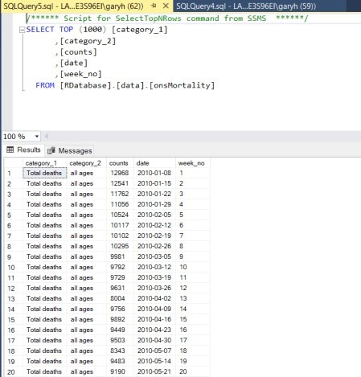

As you can see the R function has worked. What is great is that I tested this with 50 million records and 12 columns and the DBI function took 24 minutes, whereas with RODBC this take 1 hour plus.

# Conclusion

This function is ready to be dropped into your projects and please have a play to add the functionality to the function to get it to work with none trusted connections i.e. those that require a user ID and password.

I hope you find this function useful, and it does really speed the process up.