A regression that has Fourier terms is called **dynamic harmonic regression**. This harmonic structure is built of the successive Fourier terms that consist of sine and cosine terms to form a periodic function.

These terms could catch seasonal patterns delicately.

, , ,

, , …

**m** is for the seasonal periods. If the number of terms increases, the period would converge to a square wave. While Fourier terms capture the seasonal pattern, the ARIMA model process the error term to determine the other dynamics like prediction intervals.

We will examine the regression models with K values from 1 to 6 and plot them down to compare corrected Akaike’s information criterion(**AICc**) measurement, which should be minimum. We will set the **seasonal parameter** to **FALSE**; because of that Fourier terms will catch the seasonality, we don’t want that the auto.arima function to search for seasonal patterns, and waste time. We should also talk about the transformation concept to understand **the lambda parameter** we are going to use in the models.

**Transformation**, just like differentiation, is a mathematical operation that simplifies the model and thus increases the prediction accuracy. In order to do that it stabilizes the variance so that makes the pattern more consistent.

These transformations can be automatically made by the **auto.arima function** based on the optimum value of the **lambda parameter** that belongs to the Box-Cox transformations which are shown below, if the lambda parameter set to “**auto**“.

 ; if

 ; if **otherwise**

#Comparing with plots plots <- list()

for (i in seq(6)) {

fit <- train %>%

auto.arima(xreg = fourier(train, K = i), seasonal = FALSE, lambda = "auto")

plots[[i]] <- autoplot(forecast(fit, xreg=fourier(train, K=i, h=18))) + xlab(paste("K=",i," AICC=",round(fit[["aicc"]],2))) +

ylab("") + theme_light()

}

gridExtra::grid.arrange( plots[[1]],plots[[2]],plots[[3]],

plots[[4]],plots[[5]],plots[[6]], nrow=3)

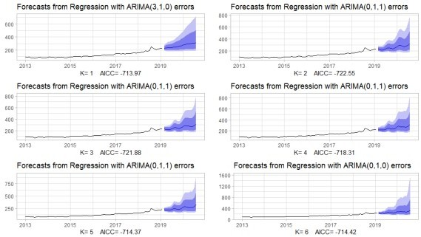

You can also see from the above plots that the more K value the more toothed point forecasting line and prediction intervals we get. It is seen that after the K=3, AICC values increase significantly. Hence, K should be equals to 2 for the minimum AICC value.

#Modeling with Fourier Regression fit_fourier <- train %>%

auto.arima(xreg = fourier(train,K=2), seasonal = FALSE, lambda = "auto")

#Accuracy

f_fourier<- fit_fourier %>% forecast(xreg=fourier(train,K=2,h=18)) %>% accuracy(test)

f_fourier[,c("RMSE","MAPE")]

|  |  |  |  |
| --- | --- | --- | --- |
| # |  | RMSE | MAPE |
| #Training | set | 8.586783 | 4.045067 |
| #Test set |  | 74.129452 | 17.068118 |

#Accuracy plot of the Fourier Regression

fit_fourier %>% forecast(xreg=fourier(train,K=2,h=18)) %>% autoplot() +

autolayer(test) + theme_light() + ylab("")

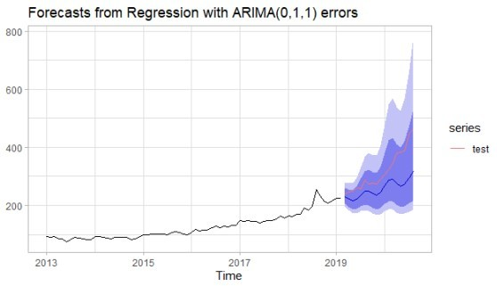

The reason we choos the non-seasonal process was that our data had a very weak seasonal pattern, but the pairs of Fourier terms have caught this weak pattern very subtly. We can see from the above results that the Fourier regression is much better than the non-seasonal ARIMA for RMSE and MAPE accuracy measurements the test set.

Since we are also taking into account the seasonal pattern even if it is weak, we should also examine the **seasonal ARIMA** process. This model is built by adding seasonal terms in the non-seasonal ARIMA model.



 : non-seasonal part.  : seasonal part.

: the number of observations before the next year starts; **seasonal period**.

The seasonal parts have term non-seasonal components with backshifts of the seasonal period. For instance, we take  model for monthly data, m=12. This process can be written as:



 for **p = 1**,  for **P=1**,

 for **first difference**(d=lag1),  for **seasonal difference**(D=lag12),  for **q**=1,

 for **Q**=1.

#Modeling the Arima model with transformed data fit_arima<- train %>%

auto.arima(stepwise = FALSE, approximation = FALSE, lambda = "auto") #Series: .

#ARIMA(3,1,2) with drift

#Box Cox transformation: lambda= -0.7378559

#Coefficients:

|  |  |  |  |  |  |  |
| --- | --- | --- | --- | --- | --- | --- |
| # | ar1 | ar2 | ar3 | ma1 | ma2 | drift |
| # | 0.8884 | -0.8467 | -0.1060 | -1.1495 | 0.9597 | 3e-04 |
| #s.e. | 0.2463 | 0.1557 | 0.1885 | 0.2685 | 0.2330 | 2e-04 |

#sigma^2 estimated as 2.57e-06: log likelihood=368.02 #AIC=-722.04 AICc=-720.32 BIC=-706.01

Despite the seasonal parameter set to **TRUE** as default, **the auto.arima function** couldn’t find a model with seasonality because the time series data has a very weak seasonal strength level. we set to **lambda parameter** to “**auto**“ It makes the data transformed with =-0.7378559.

#Accuracy of the Arima model with transformed data fit_arima %>% forecast(h=18) %>%

autoplot() + autolayer(test) + theme_light()

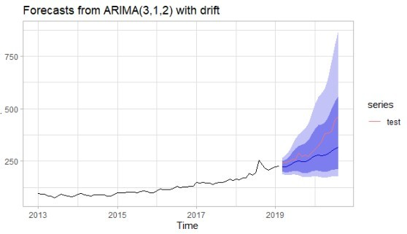

f_arima<- fit_arima %>% forecast(h =18) %>% accuracy(test)

f_arima[,c("RMSE","MAPE")]

# RMSE MAPE

#Training set 9.045056 3.81892

#Test set 67.794358 14.87034

The RMSE and MAPE values of the Arima model without transformation were 94.788638 and 20.878096 respectively. We can easily confirm from the above results that the transformation improves the accuracy if the time series have an unstabilized variance.

**Conclusion**

The time-series data with weak seasonality like our data has been modeled with dynamic harmonic regression, but the accuracy results were worst than Arima models without seasonality.

In addition to that, the transformed data has been modeled with the Arima model more accurately than th one not transformed; because our data has the variance that has changed with the level of time series. Another important thing is that when we take a look at the accuracy plots of both the Arima model and Fourier regression, we can clearly see that as the forecast horizon increased, the prediction error increased with it.