# Use Skimr for Data Quality

## Exploratory Data Analysis

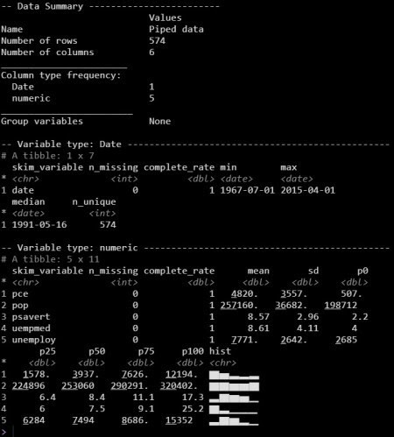

The Data Quality Report from skimr

# Rapid Data Quality Checks in R

## Automatic Data Quality Reporting

**Data Scientists spend 80% of their time** understanding data, exploring it, wrangling and preparing for analysis.

This is way too long!

**We can speed this up.** One tool I use in EVERY SINGLE DATA PROJECT is called skimr. It’s my go-to.

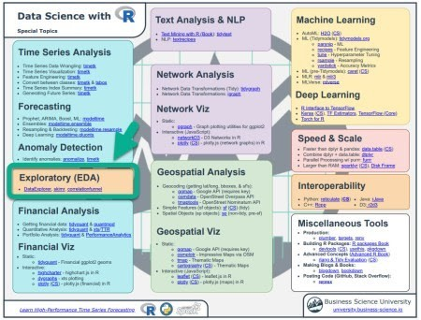

It consolidates the most important R packages (ones I use every day) into one cheatsheet. Here’s where skimr is located.

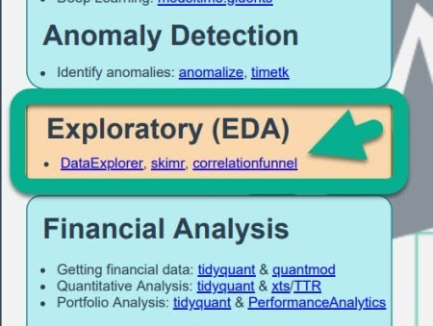

# How Skimr Works

## Automatic Data Quality Reporting

One of the coolest features of Skimr is the ability to **create a Data Quality Report in 1 line of code**. This automates:

Date Profiling

Works with Numeric, Categorical, Text, Date, Nested List Columns, and even Dplyr Groups

Ultimately, this saves the Data Scientist SO MUCH TIME. 

# Missing Data, Categorical & Numeric Reporting (Starwars)

The “starwars” data set has a 87 starwars characters with various attributes. This is a messy data set containing a lot of missing values and nested list-columns.



### Overall Data Summary

Number of Rows/Columns, Data Types by Column, Group Variables.

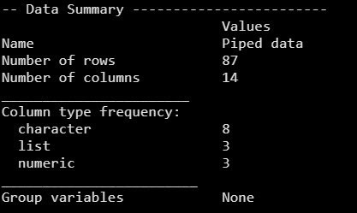

### Character Summaries

Missing / completion rate, number of unique observations, and text features.

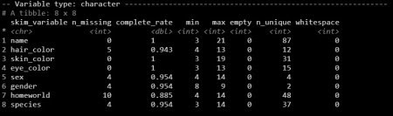

### List Summaries (nested column)

Number of unique elements in each list.

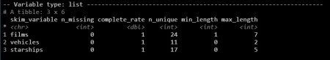

### Numeric Summaries

Missing/completion rates and distributions.

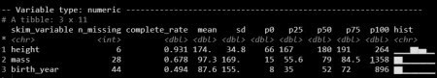

# Time Series Reporting (Economics)

The “economics” data set has a date feature called “Date” and several numeric features. We’ll focus on the date feature.



### Date Summaries

Missing/completion rates, min/max dates, and the number of unique dates.



# Grouped Time Series Reporting (Economics Long)

The “economics_long” data set has been pivoted so each time series from “economics” is stacked on top of each other – perfect for a groupwise skim analysis.



### Grouped Date Summaries

Each of these are provided by group: Missing/completion rates, min/max dates, and the number of unique dates.

