We can use the rLFT (Linear Feature Tools) *R* package to calculate a convexity measure at fixed sample points along a route (for a fascinating discussion of the curvature/convexity metric, see *Albeke, S.E. et al. Measuring boundary convexity at multiple spatial scales using a linear ‘moving window’ analysis: an application to coastal river otter habitat selection Landscape Ecology 25 (2010): 1575-1587).

By filtering on high absolute convexity sample points, we can do a little bit of reasoning around the curvature at each point to make an attempt at identifying the start of a corner:

library(rLFT)

stepdist = 10

window = 20

routeConvTable <- bct(utm_routes[1,],

# distance between measurements step = stepdist,

window = window, ridName = "Name")

head(routeConvTable)

We can then use the convexity index to highlight the sample points with a high convexity index:

corner_conv = 0.1

tight_corners = routeConvTable[abs(routeConvTable$ConvexityIndex)

>corner_conv,]

tight_corners_zoom1 = tight_corners$Midpoint_Y>4964000 & tight_corners$Midpoint_Y<4965000

ggplot(data=trj[zoom1, ],

aes(x=x, y=y)) + geom_path(color='grey') + coord_sf() + geom_text(data=tight_corners[tight_corners_zoom1,],

aes(label = ConvexityIndex, x=Midpoint_X, y=Midpoint_Y),

size=2) + geom_point(data=tight_corners[tight_corners_zoom1,],

aes(x=Midpoint_X, y=Midpoint_Y,

color= (ConvexityIndex>0) ), size=1) + theme_classic()+

theme(axis.text.x = element_text(angle = 45))

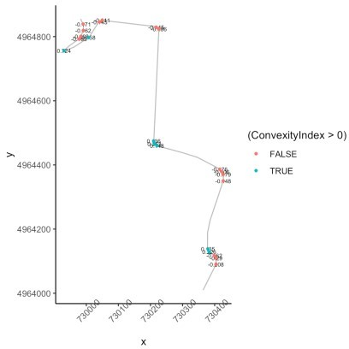

High convexity points along a route

We can now do a bit of reasoning to find the start of a corner:

cornerer = function (df, slight_conv=0.01, closeby=25){ df %>%

mutate(dirChange = sign(ConvexityIndex) != sign(lag(ConvexityIndex))) %>% mutate(straightish = (abs(ConvexityIndex) < slight_conv)) %>% mutate(dist = (lead(MidMeas)-MidMeas)) %>%

mutate(nearby = dist < closeby) %>% mutate(firstish = !straightish &

((nearby & !lag(straightish) & lag(dirChange)) | # We don't want the previous node nearby (!lag(nearby)) ) & !lag(nearby) )

}

tight_corners = cornerer(tight_corners)

Let’s see how it looks, labeling the points as we do so with the distance to the next sample point:

ggplot(data=trj[zoom1,],

aes(x=x, y=y)) + geom_path(color='grey') + coord_sf() + ggrepel::geom_text_repel(data=tight_corners[tight_corners_zoom1,],

aes(label = dist,

x=Midpoint_X, y=Midpoint_Y), size=3) +

geom_point(data=tight_corners[tight_corners_zoom1,], aes(x=Midpoint_X, y=Midpoint_Y,

color= (firstish) ), size=1) + theme_classic()+

theme(axis.text.x = element_text(angle = 45))

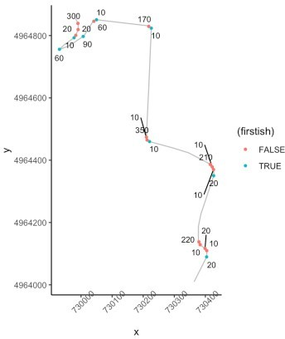

Corner entry

In passing, we note we can identify the larg gap distances as "straights" (and then perhaps look for lower convexity index corners along the way we could label as "flowing" corners, perhaps).

Something else we might do is number the corners:

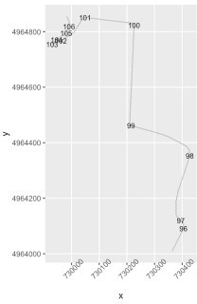

Numbered corners

There’s all sorts of fun to be had here, I think!