Connection to Bootstrap

A bootstrap distribution is “often an (asymptotic) confidence distribution”, and a CD random variable generated from a confidence/compatibility distribution is related to and has similar theoretical properties as a bootstrap estimator. Let’s regenerate models/visualisations and compare it with our confidence distribution.

# Bootstrapped parameter estimates

extrafont::loadfonts(device = "win") library(tidyverse)

character_visualization <- readr::read_csv("https://raw.githubusercontent.com/ rfordatascience/tidytuesday/master/data/2020/2020-06-30/character_visualization.csv")

xmen_bechdel <- readr::read_csv("https://raw.githubusercontent.com/rfordatascience/tidytuesday/ master/data/2020/2020-06-30/xmen_bechdel.csv")

locations <- readr::read_csv("https://raw.githubusercontent.com/rfordatascience/tidytuesday/ master/data/2020/2020-06-30/locations.csv")

per_issue <- character_visualization %>% group_by(issue) %>% summarise(across(speech:depicted, sum)) %>% ungroup()

x_mansion <- locations %>% group_by(issue) %>%

summarise(mansion = "X-Mansion" %in% location)

locations_joined <- per_issue %>% inner_join(x_mansion)

library(tidymodels) set.seed(123)

boots <- bootstraps(locations_joined, times = 1000, apparent = TRUE)

boot_models <- boots %>% mutate(

model = map( splits,

~ glm(mansion ~ speech + thought + narrative + depicted, family = "binomial", data = analysis(.)

)

),

coef_info = map(model, tidy)

)

boot_coefs <- boot_models %>% unnest(coef_info)

boot_coefs %>%

filter(term != "(Intercept)") %>% mutate(term = fct_inorder(term)) %>% ggplot(aes(estimate, fill = term)) + geom_vline(

xintercept = 0, color = "gray50",

alpha = 0.6, lty = 2, size = 1.5

) +

geom_histogram(alpha = 0.8, bins = 25, show.legend = FALSE) + facet_wrap(~term, scales = "free") +

labs(

title = "Which issues contain the X-Mansion as a location?",

subtitle = "Comparing the top 25 characters' speech, thought, narrative portrayal, and total depictions",

caption = "Data from the Claremont Run Project"

)

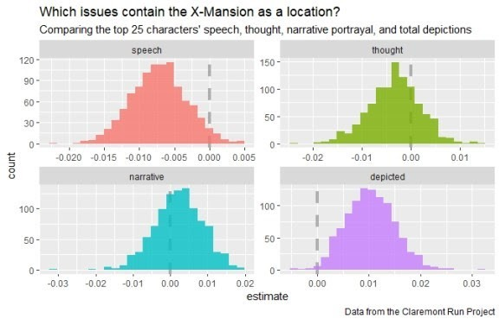

# Confidence/Compatibility distribution based parameter estimates

library(ggdist) library(hrbrthemes)

model1 <- glm(mansion ~ speech + thought + narrative + depicted family = "binomial", data = locations_joined)

model1 %>% broom::tidy() %>%

filter(term != "(Intercept)") %>% ggplot(aes(y = term, fill = term)) + stat_dist_halfeye(

aes(dist = "student_t", arg1 = df.residual(model1), arg2 = estimate, arg3 = std.error)) +

geom_vline(xintercept = 0, color = "gray50", alpha = 0.6, lty = 2, size = 1.5)

+

scale_x_continuous(breaks = scales::pretty_breaks(n = 10)) +

labs(x = "", y = "", fill = "Term", title = "Confidence distribution for model

parameters") + ggthemes::scale_fill_few() +

theme_ipsum_rc(grid = "XY", axis = "xy") + theme(legend.position = "none")

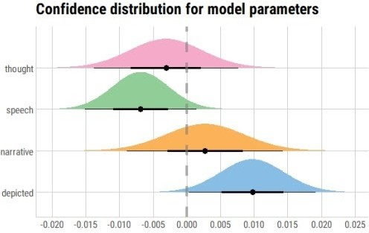

# Very similar, if not exactly the same!

bechdel_joined <- per_issue %>% inner_join(xmen_bechdel) %>%

mutate(pass_bechdel = if_else(pass_bechdel == "yes", TRUE, FALSE))

set.seed(123)

boots <- bootstraps(bechdel_joined, times = 1000, apparent = TRUE)

boot_models <- boots %>% mutate(

model = map( splits,

~ glm(pass_bechdel ~ speech + thought + narrative + depicted, family = "binomial", data = analysis(.)

)

),

coef_info = map(model, tidy)

)

boot_coefs <- boot_models %>% unnest(coef_info)

boot_coefs %>%

filter(term != "(Intercept)") %>% mutate(term = fct_inorder(term)) %>% ggplot(aes(estimate, fill = term)) + geom_vline(

xintercept = 0, color = "gray50", alpha = 0.6, lty = 2, size = 1.5

) +

geom_histogram(alpha = 0.8, bins = 25, show.legend = FALSE) + facet_wrap(~term, scales = "free") +

labs(

title = "Which Uncanny X-Men issues pass the Bechdel test?",

subtitle = "Comparing the top 25 characters' speech, thought, narrative portrayal, and total depictions",

caption = "Data from the Claremont Run Project"

)

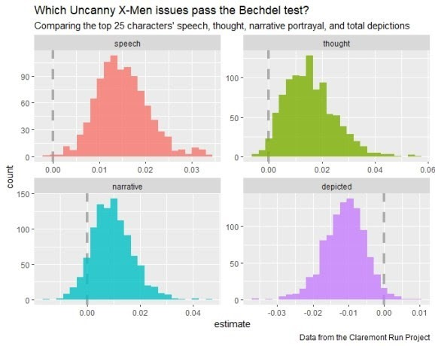

Versus…

model2 <- glm(pass_bechdel ~ speech + thought + narrative + depicted family = "binomial", data = bechdel_joined)

model2 %>% broom::tidy() %>%

filter(term != "(Intercept)") %>% ggplot(aes(y = term, fill = term)) + stat_dist_halfeye(

aes(dist = "student_t", arg1 = df.residual(model1), arg2 = estimate, arg3 = std.error)) +

geom_vline(xintercept = 0, color = "gray50", alpha = 0.6, lty = 2, size = 1.5)

+

scale_x_continuous(breaks = scales::pretty_breaks(n = 10)) +

labs(x = "", y = "", fill = "Term", title = "Confidence distribution for model

parameters") + ggthemes::scale_fill_few() +

theme_ipsum_rc(grid = "XY", axis = "xy") + theme(legend.position = "none")

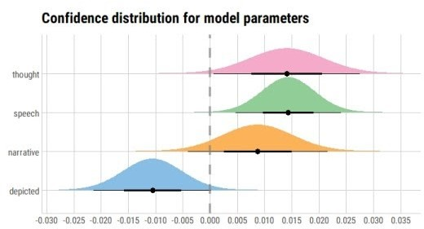

An alternative way of presenting this would be as follows:

model2 %>% broom::tidy() %>%

filter(term != "(Intercept)") %>% ggplot(aes(y = term, fill = term)) + stat_dist_gradientinterval(

aes(dist = "student_t", arg1 = df.residual(model1), arg2 = estimate, arg3 = std.error)) +

geom_vline(xintercept = 0, color = "gray50", alpha = 0.6, lty = 2, size = 1.5)

+

scale_x_continuous(breaks = scales::pretty_breaks(n = 7)) +

labs(x = "", y = "", fill = "Term", title = "Confidence distribution of model

parameters",

subtitle = "Using gradient intervals") + ggthemes::scale_fill_few() + hrbrthemes::theme_ipsum_rc() + theme(legend.position = "none")

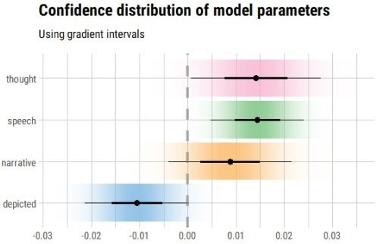

So, an interesting concept and useful alternative! Yet, the utility of ggdist is not limited to frequentist uncertainty visualisations: it also has geoms for visualising uncertainty in Bayesian models or sampling distributions.

The concept of a confidence/compatibility distribution was an interesting find for me, as somebody who was trained in ML but now prefers (and is continuously learning and trying to utilise) statistics for majority of data science projects.