We’ll also use sf for working with spatial data, dplyr for data manipulation, and ggplot2 for plotting.

library(rnoaa) library(rnaturalearth) library(sf) library(ggplot2) library(dplyr)

Let’s get some ice data! We’ll use the sea_ice() function to grab data on ice extent for every 5 years from 1980 to 2020 (year = seq(1980, 2020, 5)), in September (month = "Sep"), and for the Arctic (North) (pole = "N").

ice <- sea_ice(year = seq(1980, 2020, 5), month = "Sep", pole = "N")

ice is a list, with each list item corresponding to a year. Let’s take a brief look at what we’ve got, by scanning the head() of the first two years worth of data.

head(ice[[1]])

long lat order hole piece id group

|  |  |  |  |  |  |  |
| --- | --- | --- | --- | --- | --- | --- |
| 1 125000 | 2100000 | 1 | FALSE | 1 | 0 | 0.1 |
| 2 150000 | 2100000 | 2 | FALSE | 1 | 0 | 0.1 |
| 3 150000 | 2075000 | 3 | FALSE | 1 | 0 | 0.1 |
| 4 125000 | 2075000 | 4 | FALSE | 1 | 0 | 0.1 |
| 5 125000 | 2100000 | 5 | FALSE | 1 | 0 | 0.1 |

6 -175000 2025000 1 FALSE 1 1 1.1

head(ice[[2]])

long lat order hole piece id group

|  |  |  |  |  |  |  |
| --- | --- | --- | --- | --- | --- | --- |
| 1 125000 | 2100000 | 1 | FALSE | 1 | 0 | 0.1 |
| 2 150000 | 2100000 | 2 | FALSE | 1 | 0 | 0.1 |
| 3 150000 | 2075000 | 3 | FALSE | 1 | 0 | 0.1 |
| 4 125000 | 2075000 | 4 | FALSE | 1 | 0 | 0.1 |
| 5 125000 | 2100000 | 5 | FALSE | 1 | 0 | 0.1 |

6 -175000 2025000 1 FALSE 1 1 1.1

Each year is a ‘fortified’ data frame which you could plot using geom_polygon(). But I want to get the projection right, so let’s bind the rows together (adding year as a parameter) and convert to an sf object. We’ll transform to EPSG 3411 which refers to the NSIDC Sea Ice Polar Stereographic North projection commonly used to map the Arctic.

ice_sf <- ice %>% bind_rows(.id = "year") %>%

mutate(year = factor(year, labels = seq(1980, 2020, 5))) %>% st_as_sf(coords = c("long", "lat"), crs = 3411)

ice_sf

Simple feature collection with 13639 features and 6 fields Geometry type: POINT

Dimension: XY

Bounding box: xmin: -2550000 ymin: -3250000 xmax: 2350000 ymax: 4950000 Projected CRS: NSIDC Sea Ice Polar Stereographic North

First 10 features:

year order hole piece id group geometry

1 1980 1 FALSE 1 0 0.1 POINT (125000 2100000)

|  |  |  |  |  |  |  |  |  |
| --- | --- | --- | --- | --- | --- | --- | --- | --- |
| 2 1980 | 2 | FALSE | 1 | 0 | 0.1 | POINT | (150000 | 2100000) |
| 3 1980 | 3 | FALSE | 1 | 0 | 0.1 | POINT | (150000 | 2075000) |
| 4 1980 | 4 | FALSE | 1 | 0 | 0.1 | POINT | (125000 | 2075000) |
| 5 1980 | 5 | FALSE | 1 | 0 | 0.1 | POINT | (125000 | 2100000) |
| 6 1980 | 1 | FALSE | 1 | 1 | 1.1 | POINT | (-175000 | 2025000) |
| 7 1980 | 2 | FALSE | 1 | 1 | 1.1 | POINT | (-150000 | 2025000) |
| 8 1980 | 3 | FALSE | 1 | 1 | 1.1 | POINT | (-150000 | 2e+06) |
| 9 1980 | 4 | FALSE | 1 | 1 | 1.1 | POINT | (-175000 | 2e+06) |

10 1980 5 FALSE 1 1 1.1 POINT (-175000 2025000)

This results in a collection of points, so we’ll want to summarize() the data into multipoints by year and group, and then st_cast() into polygons.

ice_sf <- ice_sf %>% group_by(year, group) %>%

summarize(do_union = FALSE, .groups = "drop") %>% st_cast(to = "POLYGON")

ice_sf

Simple feature collection with 1013 features and 2 fields Geometry type: POLYGON

Dimension: XY

Bounding box: xmin: -2550000 ymin: -3250000 xmax: 2350000 ymax: 4950000 Projected CRS: NSIDC Sea Ice Polar Stereographic North

# A tibble: 1,013 x 3 year group geometry

<fct> <fct> <POLYGON [m]>

|  |  |  |  |  |  |  |  |  |  |
| --- | --- | --- | --- | --- | --- | --- | --- | --- | --- |
| 1 | 1980 | 0.1 | ((125000 2100000, 150000 2100000, 150000 2075000, 125000 2075000… | | | | | | |
| 2 | 1980 | 1.1 | ((-175000 2025000, -150000 2025000, -150000 2e+06, -175000 2e+06… | | | | | | |
| 3 1980 | | 2.1 | ((-1350000 | 1900000, | -1250000 | 1900000, | -1250000 | 1875000, | -1275000… |
| 4 1980 | | 3.1 | ((-1250000 | 1875000, | -1225000 | 1875000, | -1225000 | 1850000, | -1250000… |
| 5 1980 | | 4.1 | ((-1200000 | 1875000, | -1175000 | 1875000, | -1175000 | 1850000, | -1200000… |
| 6 1980 | | 5.1 | ((425000 1800000, 450000 1800000, 450000 1775000, 425000 1775000… | | | | | | |
| 7 1980 | | 6.1 | ((-350000 1675000, -325000 1675000, -325000 1650000, -350000 165… | | | | | | |
| 8 1980 | | 7.1 | ((-2e+06 1650000, -1975000 1650000, -1975000 1600000, -2e+06 160… | | | | | | |
| 9 1980 | | 8.1 | ((750000 1625000, 875000 1625000, 875000 1600000, 850000 1600000… | | | | | | |

10 1980 9.1 ((-2075000 1525000, -2050000 1525000, -2050000 1500000, -2075000…

# … with 1,003 more rows

Let’s take a peak at what we’ve got

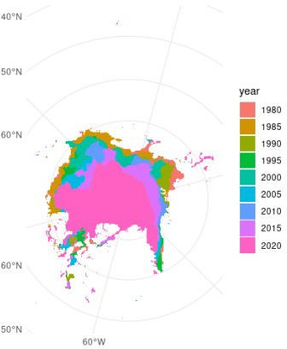

Oooo very nice! But a couple of points could be improved

It’s a bit hard to understand the context because there’s no land

Some points up around ~45 degrees North look *highly* improbable for sea ice I think we can do better than ggplot2 default colours 

First we’ll crop out that questionable data. We can see the extent of the data with st_bbox(). st_bbox(ice_sf)

xmin ymin xmax ymax

-2550000 -3250000 2350000 4950000

It seems like that high ymax value is probably the culprit. In the figure above, the y extents (circular axes) look roughly symmetrical. So, let’s do a rough crop and see where it gets us. Note that I’m also using st_make_valid() to fix a bit of ring self-intersection that pops up as an error otherwise.

ice_sf <- ice_sf %>% st_make_valid() %>%

st_crop(xmin = -2550000, ymin = -3250000, xmax = 2350000, ymax = 3500000)

Warning: attribute variables are assumed to be spatially constant throughout all

geometries

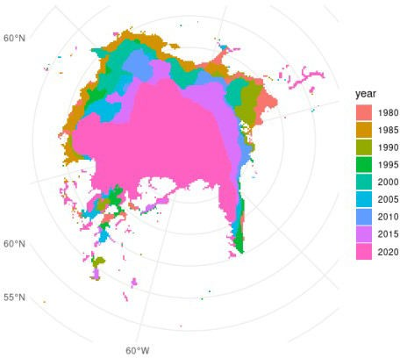

Much better! There are definitely more precise and sophisticated ways of filtering or cropping spatial data, but this will do for now.

Next, let’s get the coastline spatial data using rnaturalearth’s function ne_coastlines(). We’ll get medium quality, return it as sf, then transform and crop to match the projection and extent of our ice data.

coast <- ne_coastline(scale = "medium", returnclass = "sf") %>% st_transform(crs = st_crs(ice_sf)) %>% st_crop(st_bbox(ice_sf))

Warning: attribute variables are assumed to be spatially constant throughout all

geometries

Now let’s take another stab at mapping, using the coastline data as well as viridis scales.

ggplot() + theme_minimal() +

geom_sf(data = ice_sf, aes(fill = year), colour = NA) + geom_sf(data = coast) +

scale_fill_viridis_d(option = "inferno", begin = 0.1, end = 0.9)

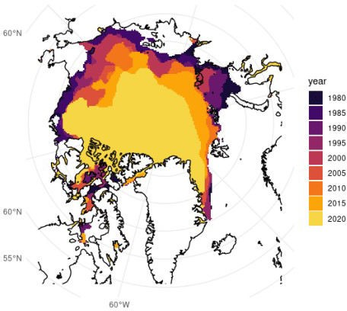

From here, it’s very apparent how much the ice extent in September has changed over the years. There’s been a fair amount of reduction especially along Russia’s (top and top right) and Alaska’s (left) coasts, and among Canada’s Arctic Archipelago (bottom left).

This isn’t great news, and it’s not new news, but as World Ocean Day is about calls to action, specifically for protecting 30% of the planet’s land and ocean by 2030, it’s always worth the reminder that conservation is important.

 **Leopard seals**

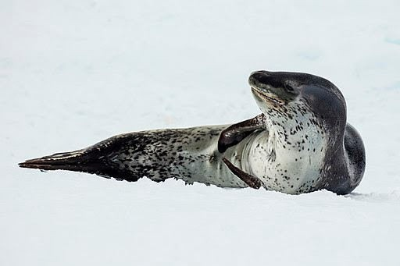

*Andrew Shiva / Wikipedia / CC BY-SA 4.0*

In addition to rnaturalearth, sf, dplyr, and ggplot2 which we loaded above, we’ll use lubridate to handle date/times, and the rOpenSci package rinat, for accessing species observations from the citizen science project iNaturalist. rinat .

library(rinat) library(lubridate)

We’ll use get_inat_obs() from rinat, then will select() columns for dates, descriptions and coordinates. We’ll filter() out records without a date and those farther away from Antarctica, convert to proper dates, and extract the year().

seals <- get_inat_obs(taxon_name = "leopard seal") %>% select(scientific_name, datetime, description, latitude, longitude) %>% filter(datetime != "") %>%

mutate(datetime = ymd_hms(datetime) year = year(datetime)) glimpse(seals)

Rows: 99

Columns: 6

$ scientific_name <chr> "Hydrurga leptonyx", "Hydrurga leptonyx", "Hydrurga le…

$ datetime <dttm> 2021-05-25 00:09:12, 2021-05-07 01:56:37, 2020-01-12 …

$ description <chr> "Identified as Owha. Unfortunately she was scared off …

$ latitude <dbl> -36.87974, -36.77027, -63.39282, -64.15940, -63.19452,…

$ longitude <dbl> 174.66350, 174.66345, -54.59607, -60.92037, -57.31312,…

$ year <dbl> 2021, 2021, 2020, 2020, 2020, 2019, 2018, 2019, 2012, …

Alright, we have 59 observations of leopard seals around Antarctica, let’s see where they’re from. As before, we’ll turn this into spatial data by using the longitude and latitude columns as our coordinates. Because we’re dealing with Lon/Lat (GPS data), we’ll specify the starting crs as EPSG 4326, which refers to the World Geodetic System (WGS84). We’ll end by transforming to a projection more appropriate for the Antarctic, EPSG 3412.

seals_sf <- seals %>%

st_as_sf(coords = c("longitude", "latitude"), crs = 4326) %>% st_transform(3412)

Let’s get a land mass to plot our points on, for context.

antarctic <- ne_countries(returnclass = "sf") %>% st_transform(3412) %>% # CRS for the Antarctic st_make_valid() %>% # To avoid intersection errors st_crop(st_bbox(seals_sf)) # Crop to our data

Warning: attribute variables are assumed to be spatially constant throughout all

geometries

Finally, let’s take a look!

ggplot() +

geom_sf(data = antarctic, fill = "grey") + geom_sf(data = seals_sf, aes(colour = year)) + scale_colour_viridis_c(end = 0.85)

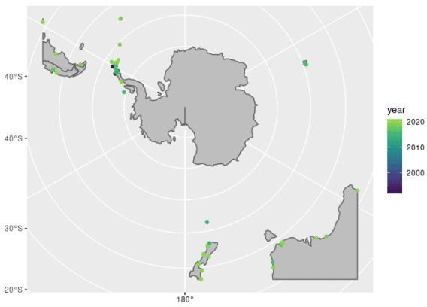

Looks like most observations are around the Antarctic Peninsula, let’s take a closer look! (Here I got the starting limits from the information in seals_sf and then just trial-and-errored until I got the window I wanted).

ggplot() +

geom_sf(data = antarctic, fill = "grey") + geom_sf(data = seals_sf, aes(colour = year)) + scale_colour_viridis_c(end = 0.85) +

coord_sf(xlim = c(-3099695, -1500000), ylim = c(400000, 3190715))

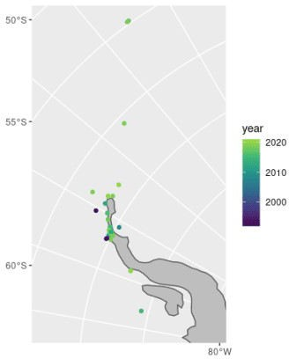

There you have it, all the leopard seal observations around the Antarctic Peninsula by year.

And let’s not forget to enjoy some of the descriptions:

filter(seals, description != "") %>% slice(1:7) %>%

pull(description)

1. "Identified as Owha. Unfortunately she was scared off by a fisherman with a piper net. "
2. "a marine mammal found at people's private dock around Herald Island"
3. "eating an adelie penguin"
4. "Eating a Gentoo penguin"
5. "Eating Gentoo penguins"
6. "Resting on the beach."
7. "The seal raised its head every time a vehicle passed on the road behind the beach.\n\nApparently it had been seen on various beaches in the area for the week preceding this observation."