A common way to represent and analyze categorical data is through contingency tables. In this tutorial, we will provide some examples of how you can analyze two-way (r x c) and three-way (r x c x k) contingency tables in R.

# Dataset

For this tutorial, we will work with the Wage dataset from the ISLR package. We will create another column of the Wage, which is categorical taking two values as Above and Below when the Wage is above or below media respectively. The format of the dataset is the following:

A data frame with 3000 observations on the following 11 variables.

**year**: Year that wage information was recorded

**age**: Age of worker

**marit1**: A factor with levels 1. Never Married 2. Married 3. Widowed 4.

Divorced and 5. Separated indicating marital status

**race**: A factor with levels 1. White 2. Black 3. Asian and 4. Other indicating race

**education**: A factor with levels 1. < HS Grad 2. HS Grad 3. Some College 4.

College Grad and 5. Advanced Degree indicating education level

**region**: Region of the country (mid-atlantic only)

**jobclass**: A factor with levels 1. Industrial and 2. Information indicating type of job

**health**: A factor with levels 1. <=Good and 2. >=Very Good indicating health level of worker

**health_ins**: A factor with levels 1. Yes and 2. No indicating whether worker has health insurance

**logwage**: Log of workers wage

**wage**: Workers raw wage

# Two-Way Tables

Two-way tables involve two categorical variables, X with r categories and Y with c. Therefore, there are r times c possible combinations. Sometimes, both X and Y will be response variables, in which case it makes sense to talk about their joint distribution. On other occasions, Y will be the response variable and X will be the explanatory variable. In this case, it does not make sense to talk about the joint distribution of X and Y. Instead, we focus on the conditional distribution of Y given X.

Let’s start analyzing the data. At the beginning we can see the relationship between wage_cat and Jobclass.

library(ISLR) library(tidyverse) library(Rfast) library(MASS)

# create the wage_cat variable which takes two values

# such as Above if the wage is above median and Below if # the wage is below median

Wage$wage_cat<-as.factor(ifelse(Wage$wage>median(Wage$ wage),"Above","Below"))

# Examine the Wage vs Job Class

# you could use also the command xtabs(~jobclass+wage_cat, data=Wage) con1<-table(Wage$jobclass,Wage$wage_cat)

con1

Output:

Above Below

1. Industrial 629 915
2. Information 854 602

## Mosaic plots

The most proper way to represent graphically the contingency tables are the mosaic plots:

mosaicplot(con1

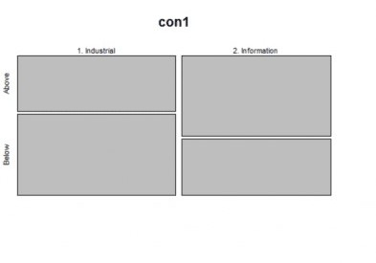

From the mosaic plot above we can easily see that in the Industrial sector the percentage of people who are below the median are more compared to those who work in the Information industry.

## Proportions of the Contingency Tables

We can get the proportions of the Contingency Tables, on overall and by rows and columns. Let’s see how we can do it:

# overall prop.table(con1)

# by row

prop.table(con1, margin = 1)

# by column

prop.table(con1, margin = 2)

Output:

* # overall
* prop.table(con1)

Above Below 1. Industrial 0.2096667 0.3050000

2. Information 0.2846667 0.2006667

>

* # by row
* prop.table(con1, margin = 1)

Above Below 1. Industrial 0.4073834 0.5926166

2. Information 0.5865385 0.4134615

>

* # by column
* prop.table(con1, margin = 2)

Above Below 1. Industrial 0.4241403 0.6031641

2. Information 0.5758597 0.3968359

## Rows and Columns Totals

We can add the rows and columns totals of the contingency tables as follows:

|  |  |  |  |
| --- | --- | --- | --- |
| addmargins(con1)  Output: | Above | Below | Sum |
| 1. Industrial | 629 | 915 | 1544 |
| 2. Information | 854 | 602 | 1456 |
| Sum | 1483 | 1517 | 3000 |

## Statistical Tests

We can apply the following statistical tests in order to test if the relationship of these two variables is independent or not.

### Chi-Square Test

Let’s run Chi-Square Test in R:

chisq.test(con1)

Output:

Pearson's Chi-squared test with Yates' continuity correction

data: con1

X-squared = 95.504, df = 1, p-value < 2.2e-16

As we can see the p-value is less than 5% thus we can reject the null hypothesis that the jobclass is independent to median wage.

### Fisher’s Exact Test

When the sample size is low, we can apply the Fisher’s exact test instead of Chi-Square test.

fisher.test(con1)

Output:

Fisher's Exact Test for Count Data

data: con1

p-value < 2.2e-16

alternative hypothesis: true odds ratio is not equal to 1

95 percent confidence interval:

0.4177850 0.5620273

sample estimates:

odds ratio 0.4847009

Again, we see that we reject the null hypothesis.

### Log Likelihood Ratio

Another test that we can apply is the Log Likelihood Ratio using the MASS package:

loglm( ~ 1 + 2, data = con1)

Output:

Call:

loglm(formula = ~1 + 2, data = con1)

Statistics:

X^2 df P(> X^2)

Likelihood Ratio 96.73432 1 0

Pearson 96.21909 1 0

Again, we rejected the null hypothesis.

Notice that if we run the same analysis by comparing the **wage median** versus **race** and the **wage median** vs **education**, we find tha there is a statistical significance difference in both cases.

con2<-table(Wage$education,Wage$wage_cat)

con2 mosaicplot(con2 chisq.test(con2)

con3<-table(Wage$race,Wage$wage_cat) con3

mosaicplot(con3 chisq.test(con3)

Output

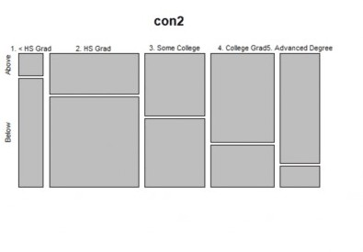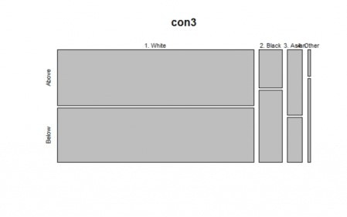

# Three-Way Tables

Let’s say that now we want to create contingency tables of three dimensions such as **wage median**, **race** and **jobclass**

con4<-xtabs(~jobclass+wage_cat+race, data=Wage)

ftable(con4)

Output:

race 1. White 2. Black 3. Asian 4. Other

jobclass wage_cat

1. Industrial Above 558 32 36 3

Below 767 79 50 19

1. Information Above 701 70 77 6

Below 454 112 27 9

Let’s say that we want to change the share of the rows and columns.

con4%>%ftable(row.vars=c("race", "jobclass"))

Output:

wage_cat Above Below

race jobclass

|  |  |  |  |  |
| --- | --- | --- | --- | --- |
| 1. White | 1. | Industrial | 558 | 767 |
|  | 2. | Information | 701 | 454 |
| 2. Black | 1. | Industrial | 32 | 79 |
|  | 2. | Information | 70 | 112 |
| 3. Asian | 1. | Industrial | 36 | 50 |
|  | 2. | Information | 77 | 27 |
| 4. Other | 1. | Industrial | 3 | 19 |
|  | 2. | Information | 6 | 9 |

Let’s say now we want to get the probabilities by row:

con4%>%ftable(row.vars=c("race", "jobclass"))%>%prop.table(margin = 1)%>%round(2)

Output:

wage_cat Above Below

race jobclass

|  |  |  |  |  |
| --- | --- | --- | --- | --- |
| 1. White | 1. | Industrial | 0.42 | 0.58 |
|  | 2. | Information | 0.61 | 0.39 |
| 2. Black | 1. | Industrial | 0.29 | 0.71 |
|  | 2. | Information | 0.38 | 0.62 |
| 3. Asian | 1. | Industrial | 0.42 | 0.58 |
|  | 2. | Information | 0.74 | 0.26 |
| 4. Other | 1. | Industrial | 0.14 | 0.86 |
|  | 2. | Information | 0.40 | 0.60 |

# Cochran-Mantel-Haenszel (CMH) Methods

We are dealing with a 2x2x4 table where the **race** has 4 levels. We want to test for conditional independence and homogeneous associations with the K conditional odds ratios in 2x2x4 table. With the CMH Methods, we can combine the sample odds ratios from the 4 partial tables into a

single summary measure of partial association. In our case, we have the wage_cat (Above, Below) the jobclass (Industrial, Information) and the race (White, Black, Asian, Other). We want to investigate the association between **wage_cat** and **jobclass** while controlling for **race**.

The null hypothesis is that **wage_cat** and **jobclass** are conditionally independent, given the **race**, which means that the odds ratio of wage_cat and jobckass is 1 for all races versus at least one odds ratio is not 1.

\(H_0: θ=1\) for race is White, Black, Asian and Other.

Using the Rfast package we can get the odds ratio for each race:

#get the 4 odds ratio for (i in 1:4) {

print(odds.ratio(con4[,,i])$res[1])

}

Output:

odds ratio 0.471169

odds ratio 0.6481013

odds ratio 0.2524675

odds ratio 0.2368421

As we can see, the odds ratios are not close to 1, so we expect to reject the null hypothesis. Let’s run the CHM test:

#CMH Test mantelhaen.test(con4

Output:

Mantel-Haenszel chi-squared test with continuity correction

data: con4

Mantel-Haenszel X-squared = 104.45, df = 1, p-value < 2.2e-16 alternative hypothesis: true common odds ratio is not equal to 1

95 percent confidence interval:

0.4003835 0.5381067

sample estimates:

common odds ratio

0.4641649

As expected, we rejected the null hypothesis since the p-value is less than 5%.