# Correlation Analysis

The correlation coefficient r measures the strength and direction of a linear relationship,

1 indicates a perfect positive correlation.

-1 indicates a perfect negative correlation.

0 indicates that there is no relationship between the different variables.

Values between -1 and 1 denote the strength of the correlation, as shown in the example below. In this tutorial, we will explain the different ways of executing correlation plots in R

# Cormorant Package

library(corrmorant) library(tidyverse) library(dplyr)

We are selecting only quantitative variables for further analysis

mpg<-select(mpg,displ,cyl,cty, hwy corrmorant(mpg, style = "binned") +

theme_dark() +

labs(title = "Correlations")

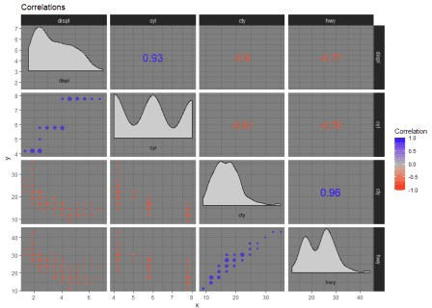

Customized Plot from ggcorrm

ggcorrm(data = mpg) + lotri(geom_point(alpha = 0.5)) + lotri(geom_smooth()) + utri_heatmap() +

utri_corrtext() +

dia_names(y_pos = 0.15, size = 3) +

dia_histogram(lower = 0.3, fill = "grey80", color = 1) + scale_fill_corr() +

labs(title = "Correlation Plot")

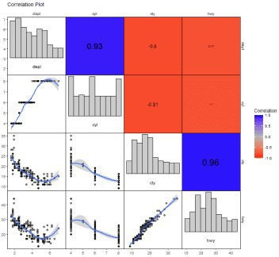

**Visualize correlation matrix using corrplot**

Following plots, correlation coefficients are colored according to the value. The correlation matrix can be also reordered according to the degree of association between variables.

library(corrplot) library(RColorBrewer) M <-cor(mpg)

corrplot(M, method="circle")

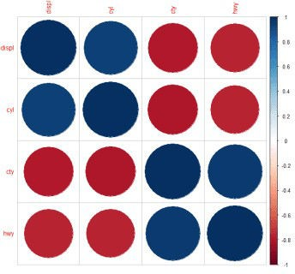

corrplot(M, method="pie")

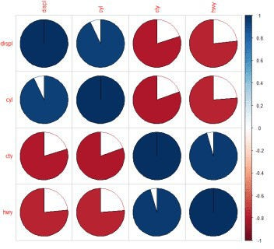

corrplot(M, method="color")

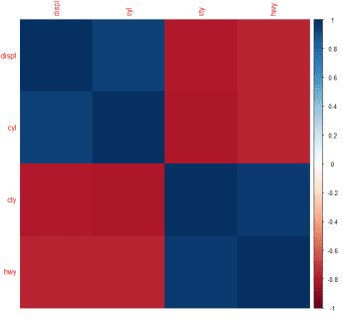

corrplot(M, method="number")

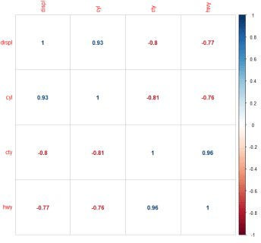

There are three types of layout :

“full” (default) : display full correlation matrix

“upper”: display upper triangular of the correlation matrix “lower”: display lower triangular of the correlation matrix

corrplot(M, type="upper")

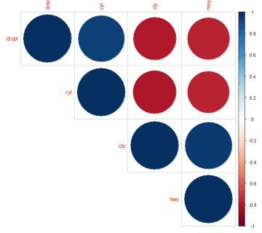

corrplot(M, type="lower")

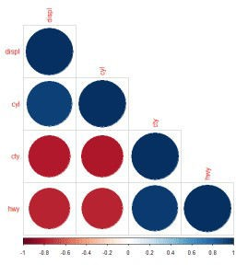

corrplot(M, type="upper", order="hclust")

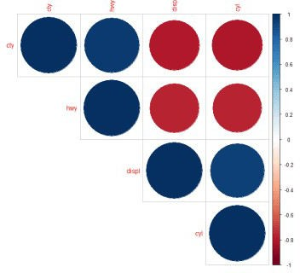

**Using different color spectrum**

col<- colorRampPalette(c("red", "white", "blue"))(20) corrplot(M, type="upper", order="hclust", col=col)

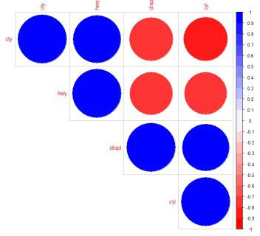

Change background color to lightblue

corrplot(M, type="upper", order="hclust", col=c("black", "white"), bg="lightblue")

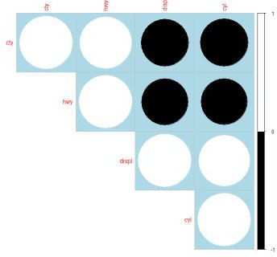

Changing the color of the plot

corrplot(M, type="upper", order="hclust", col=brewer.pal(n=8, name="PuOr"))

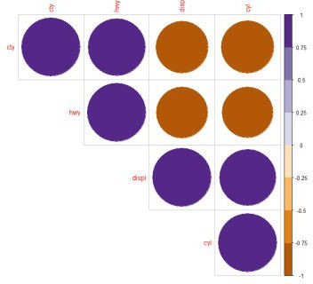

Changing the color and the rotation of text labels

corrplot(M, type="upper", order="hclust", tl.col="black", tl.srt=45)

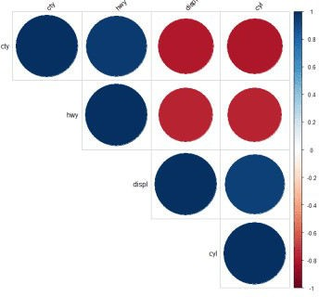

Customize the corrplot

col <- colorRampPalette(c("#BB4444", "#EE9988", "#FFFFFF", "#77AADD", "#4477AA"))

Specialized the insignificant value according to the significant level corrplot(M, type="upper", order="hclust",

p.mat = p.mat, sig.level = 0.01) corrplot(M, method="color", col=col(200),

type="upper", order="hclust",

addCoef.col = "black", # Add coefficient of correlation tl.col="black", tl.srt=45, #Text label color and rotation

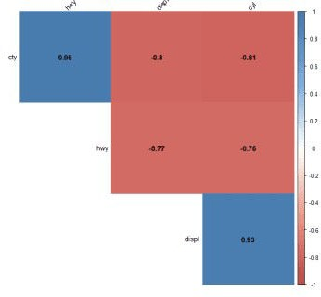

# sjPlot Package

sjp.corr( data, title = NULL, axis.labels = NULL, sort.corr = TRUE, decimals = 3, na.deletion = c("listwise", "pairwise"), corr.method = c("pearson", "spearman", "kendall"), geom.colors = "RdBu", wrap.title = 50, wrap.labels = 20,sjp.corr 65 show.legend = FALSE, legend.title = NULL, show.values = TRUE, show.p = TRUE, p.numeric = FALSE )

sjplot is very useful for small number of variables.

library(sjPlot)

sjp.corr(mpg,title ="Spearman Correlation",decimals =2)

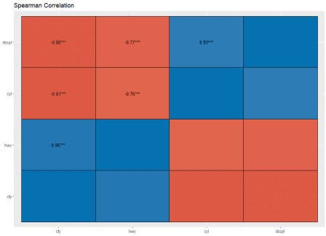

# PerformanceAnalytics Package

library(PerformanceAnalytics)

chart.Correlation(mpg, histogram=TRUE, pch="+")

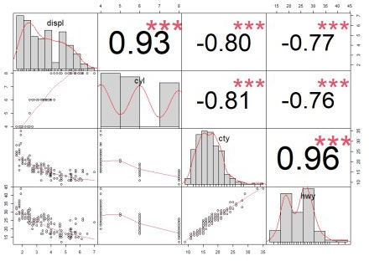

Correlation plots are the best way to show the pattern and relationship.