**Esquisse**

{esquisse} is an addin developed by a French company called [dreamRs](https://www.dreamrs.fr/). Here is how they define it:

This addin allows you to interactively explore your data by visualizing it with the ggplot2 package. It allows you to draw bar plots, curves, scatter plots, histograms, boxplot and sf objects, then export the graph or retrieve the code to reproduce the graph.

With this addin you can easily create beautiful graphs from the [{ggplot2}](https://statsandr.com/blog/graphics-in-r-with-ggplot2/) and the best part according to me is that you can retrieve the code to reproduce the graph. Compared to the default {graphics} package, it is true that graphs from the {ggplot2} package look usually better but the code is also longer and more complex. With this addin, you can draw graphs from the {ggplot2} package by dragging and dropping variables of interest in an user-friendly and interactive window, and then use the generated code in your script.

For the sake of illustration, let’s say wee want to create a scatter plot of the variables Sepal.Length and Petal.Length of the dataset iris and color the points by the variable Species. For this, follow these steps:

1. load the dataset and rename it:

dat <- iris

1. install the package {esquisse}. This must be done only once

install.packages("esquisse")

1. open the ‘ggplot2’ builder from the RStudio Addins menu:

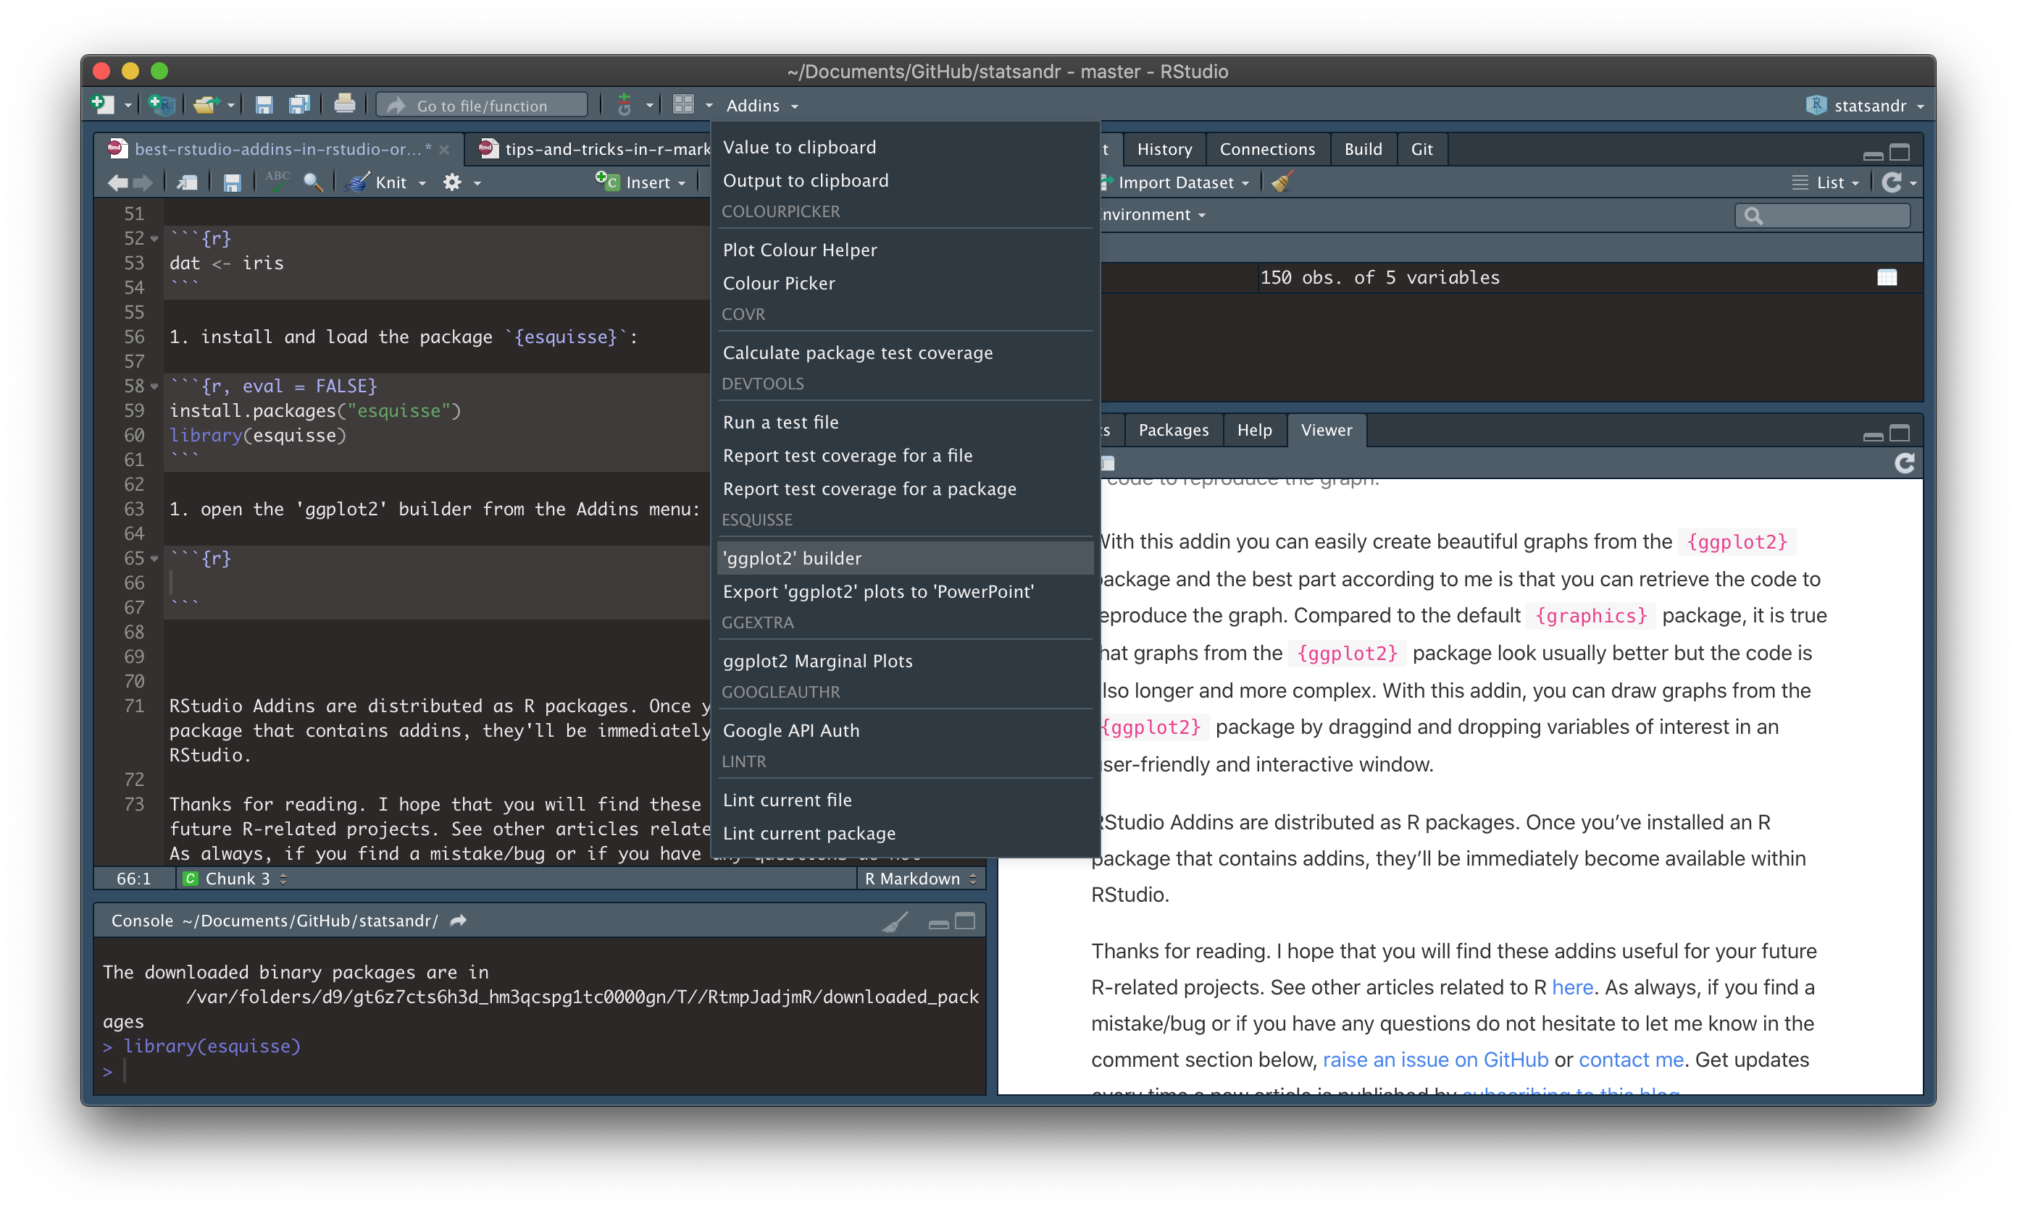

Step 3: Open ‘ggplot2’ builder from the RStudio addins menu

1. Select the dataset you want to work on (in this case dat) and click on “Validate imported data” after checking that the number of observations and variables are correct (green box):

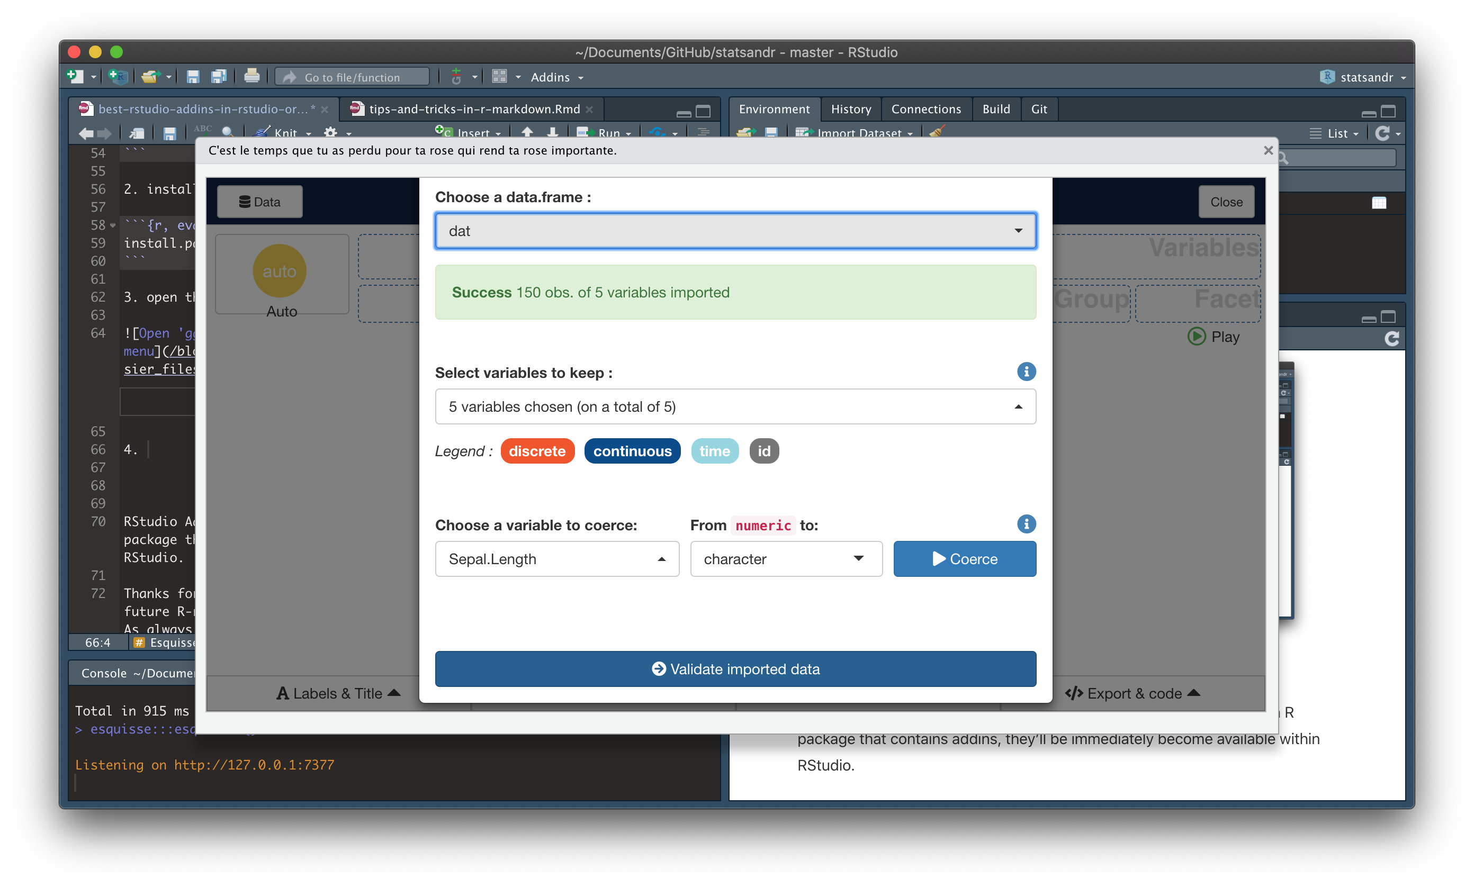

Step 4: Select dataset and validate the imported data

1. Drag and drop the variables of interest in the corresponding areas. In this case, we would like to draw a scatter plot of the variables Sepal.Length and Petal.Length and color points based on the variable Species:

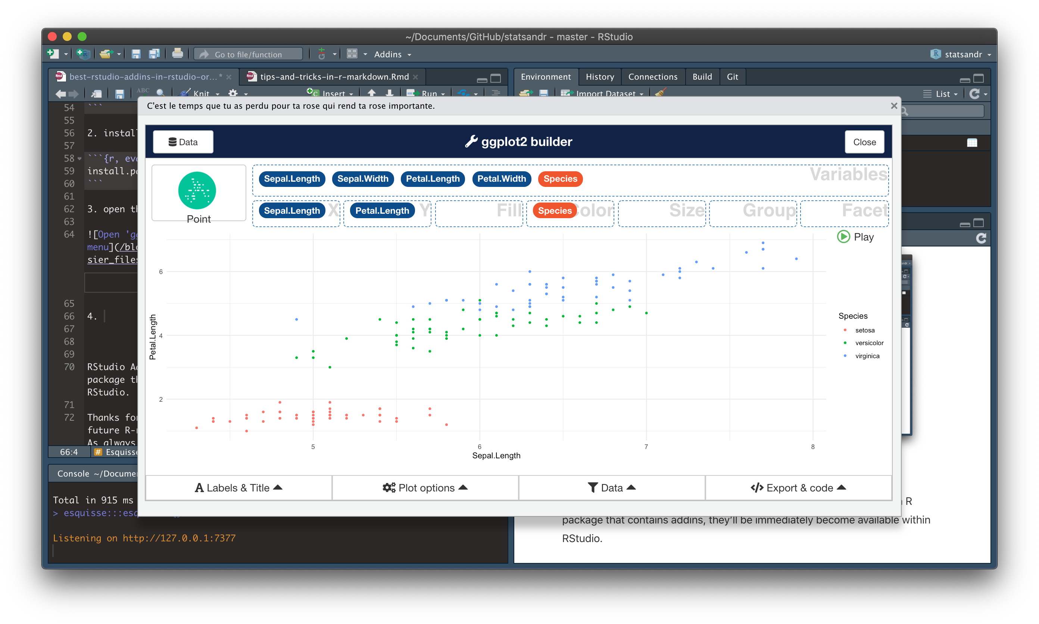

Step 5: Drag and drop the variables in the corresponding areas

1. Click on “</> Export & code” at the bottom right of the window. You can either copy the code and paste it where you want to place it in your script, or you can click on “Insert code in script” to place the code where your cursor is located in your script:

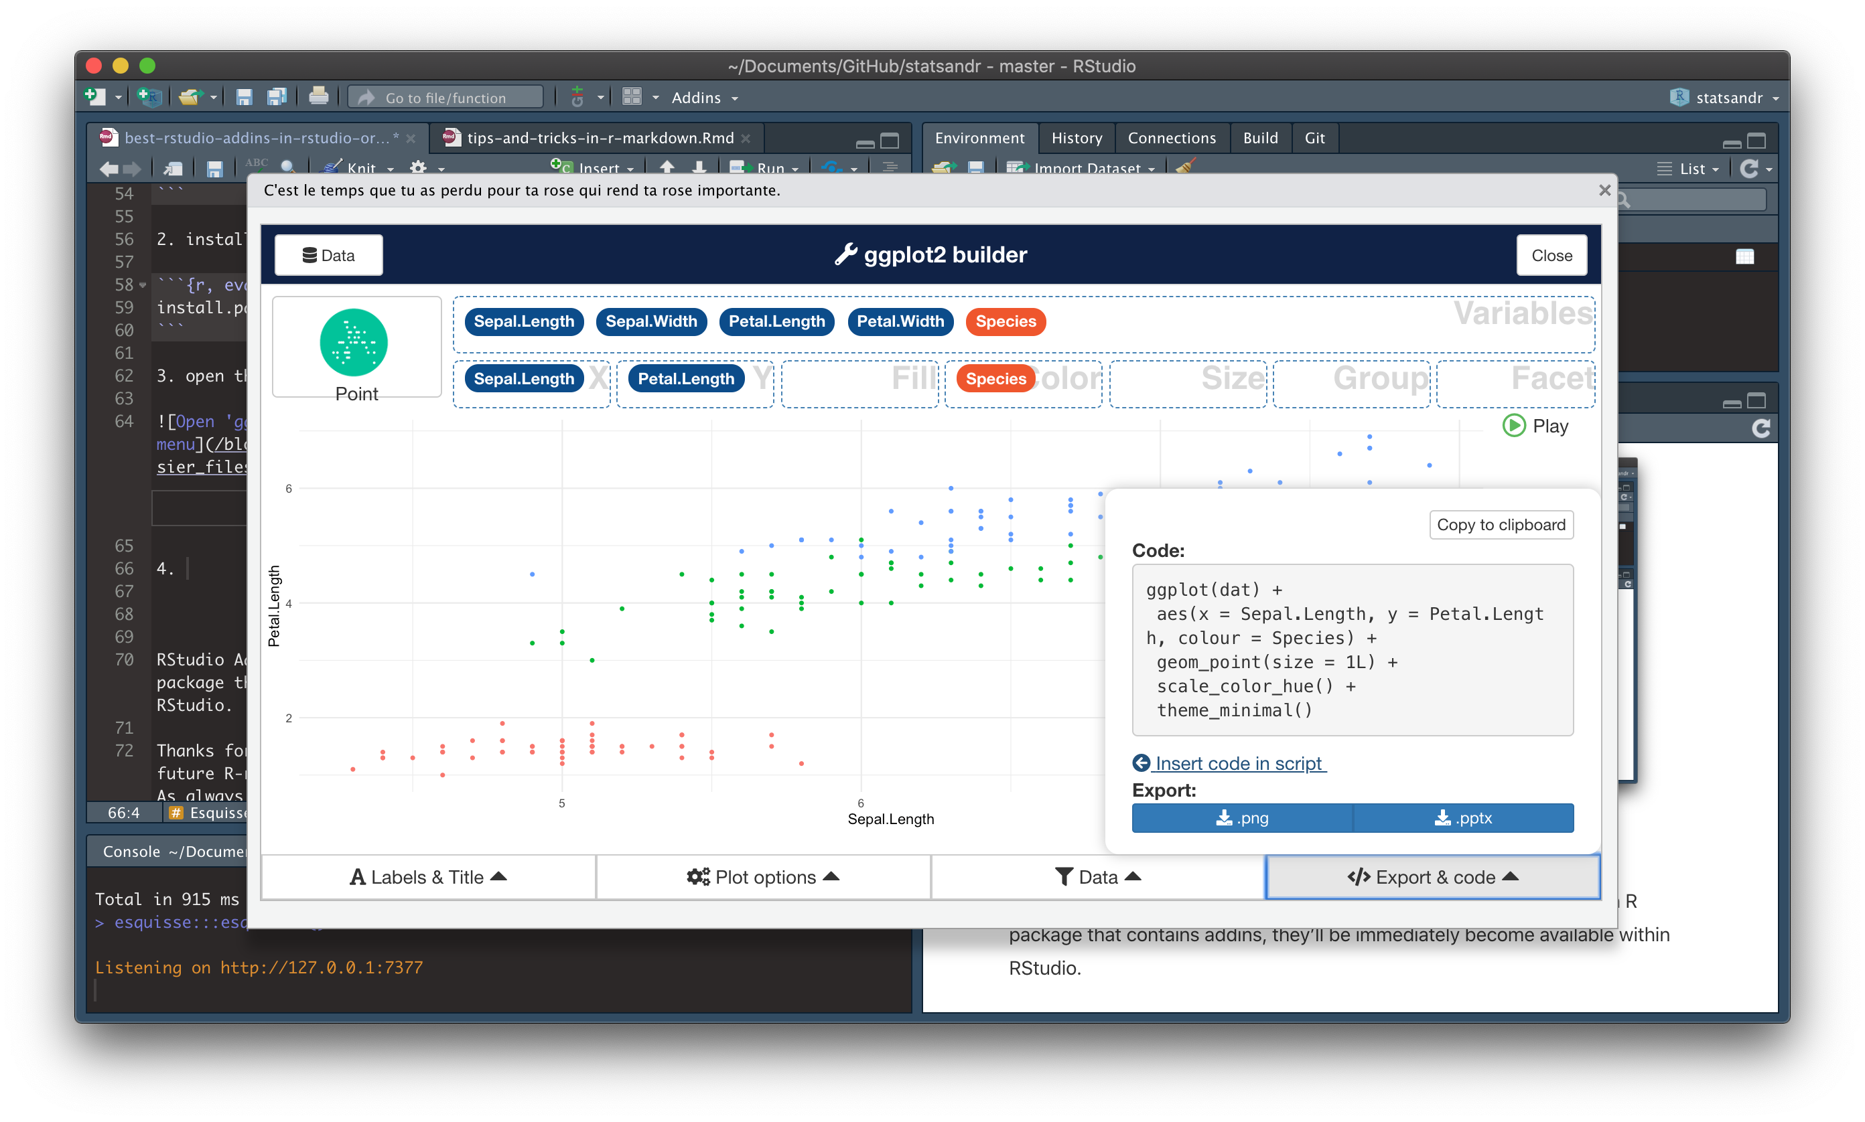

Step 6: Retrieve the code to use it in your script

If you chose the second option, the code should appear where your cursor was located. Many different options and customizations are possible (e.g., axis labels, colors, legend position, theme, data filtering, etc.). For this, use the buttons located at the bottom of the window (“Labels & title”, “Plot options” and “Data”). You can see the changes instantly in the window, and when the plot corresponds to your needs, export the code into your script. I will not go into more details regarding the different types of plots and the customizations, but make sure to try other types of plots by moving variables and customize it to see what is possible.