Below, we look at a few classic methods of doing this:

Logistic regression

Regression/Partitioning Trees

Linear Discriminant Functions

There are other methods that we will examine but these are probably the easiest to understand.

In these examples, we will use the Demographic and Health Survey Model Data. These are based on the DHS survey, but are publicly available and are used to practice using the DHS data sets, but don’t represent a real country.

In this example, we will use the outcome of contraceptive choice (modern vs other/none) as our outcome. library(haven)

dat<-url("https://github.com/coreysparks/data/blob/master/ZZIR62FL.DTA?raw=true") model.dat<-read_dta(dat)

Here we recode some of our variables and limit our data to those women who are not currently pregnant and who are sexually active.

library(dplyr)

##

## Attaching package: 'dplyr'

## The following objects are masked from 'package:stats': ##

## filter, lag

## The following objects are masked from 'package:base': ##

## intersect, setdiff, setequal, union

model.dat2<-model.dat%>% mutate(region = v024,

modcontra= as.factor(ifelse(v364 ==1,1, 0)), age = v012,

livchildren=v218, educ = v106, currpreg=v213,

knowmodern=ifelse(v301==3, 1, 0), age2=v012^2)%>%

filter(currpreg==0, v536>0)%>% #notpreg, sex active

dplyr::select(caseid, region, modcontra,age, age2,livchildren, educ, knowmodern) knitr::kable(head(model.dat2))

**caseid region modcontra age age2 livchildren educ knowmodern**

|  |  |  |  |  |  |
| --- | --- | --- | --- | --- | --- |
| 1 1 2 | 2 0 | 30 900 | 4 | 0 | 1 |
| 1 4 2 | 2 0 | 42 1764 | 2 | 0 | 1 |
| 1 4 3 | 2 0 | 25 625 | 3 | 1 | 1 |
| 1 5 1 | 2 0 | 25 625 | 2 | 2 | 1 |
| 1 6 2 | 2 0 | 37 1369 | 2 | 0 | 1 |
| 1 6 3 | 2 0 | 17 289 | 0 | 2 | 0 |

**using caret to create training and test sets.**

We use an 80% training fraction library(caret)

## Loading required package: lattice ## Loading required package: ggplot2

set.seed(1115)

train<- createDataPartition(y = model.dat2$modcontra , p = .80, list=F)

model.dat2train<-model.dat2[train,]

## Warning: The `i` argument of ``[`()` can't be a matrix as of tibble 3.0.0. ## Convert to a vector.

## This warning is displayed once every 8 hours.

## Call `lifecycle::last_warnings()` to see where this warning was generated.

model.dat2test<-model.dat2[-train,]

table(model.dat2train$modcontra)

##

## 0 1

## 4036 1409

prop.table(table(model.dat2train$modcontra))

##

## 0 1

## 0.7412305 0.2587695

summary(model.dat2train)

|  |  |  |  |  |  |  |  |  |  |
| --- | --- | --- | --- | --- | --- | --- | --- | --- | --- |
| ## | caseid | |  | region | modcontra |  | age | age2 |  |
| ## | Length:5445 | | Min. | :1.000 | 0:4036 | Min. | :15.00 | Min. : | 225.0 |
| ## | Class | :character | 1st Qu.:1.000 | | 1:1409 | 1st Qu.:21.00 | | 1st Qu.: | 441.0 |
| ## | Mode | :character | Median :2.000 | |  | Median :29.00 | | Median : | 841.0 |
| ## |  |  | Mean :2.164 | |  | Mean :29.78 | | Mean : | 976.8 |
| ## |  | | 3rd Qu.:3.000 | | 3rd Qu.:37.00 | | | 3rd Qu.:1369.0 | |
| ## |  | | Max. :4.000 | | Max. :49.00 | | | Max. :2401.0 | |
| ## | livchildren | | educ | | knowmodern | | |  | |
| ## | Min. : 0.000 | | Min. :0.0000 | | Min. :0.0000 | | |  | |
| ## | 1st Qu.: 1.000 | | 1st Qu.:0.0000 | | 1st Qu.:1.0000 | | |  | |
| ## | Median : 2.000 | | Median :0.0000 | | Median :1.0000 | | |  | |
| ## | Mean : 2.546 | | Mean :0.7381 | | Mean :0.9442 | | |  | |
| ## | 3rd Qu.: 4.000 | | 3rd Qu.:2.0000 | | 3rd Qu.:1.0000 | | |  | |
| ## | Max. :10.000 | | Max. :3.0000 | | Max. :1.0000 | | |  | |

# Logistic regression for classification

Here we use a basic binomial GLM to estimate the probability of a woman using modern contraception. We use information on their region of residence, age, number of living children and level of education.

This model can be written: \[ln \left ( \frac{Pr(\text{Modern Contraception})}{1-Pr(\text{Modern Contraception})} \right ) = X' \beta\]

Which can be converted to the probability scale via the inverse logit transform:

\[Pr(\text{Modern Contraception}) = \frac{1}{1+exp (-X' \beta)}\]

glm1<-glm(modcontra~factor(region)+scale(age)+scale(age2)+scale(livchildren)+factor(educ), data=model.dat2train[,-1], family = binomial)

summary(glm1)

##

## Call:

## glm(formula = modcontra ~ factor(region) + scale(age) + scale(age2) + ## scale(livchildren) + factor(educ), family = binomial, data = model.dat2train[,

|  |  |  |  |  |  |  |  |  |
| --- | --- | --- | --- | --- | --- | --- | --- | --- |
| ## | -1]) |  | |  | | | | |
| ## |  |  | |
| ## | Deviance | Residuals: | |
| ## | Min | 1Q Median | | 3Q | Max | | | |
| ## | -1.4073 | -0.7103 -0.5734 | | 1.0669 | 2.3413 | | | |
| ## |  |  | |  |  | | | |
| ## | Coefficients: | |  |  | |  |  |  |
| ## |  | | Estimate | Std. Error | | z value | Pr(>|z|) |  |
| ## | (Intercept) | | -1.91240 | 0.06807 | | -28.095 | < 2e-16 | *** |
| ## | factor(region)2 | | 0.38755 | 0.08534 | | 4.541 | 5.60e-06 | *** |
| ## | factor(region)3 | | 0.62565 | 0.09531 | | 6.564 | 5.23e-11 | *** |
| ## | factor(region)4 | | 0.30066 | 0.09454 | | 3.180 | 0.001471 | ** |
| ## | scale(age) | | 0.63678 | 0.26540 | | 2.399 | 0.016425 | * |
| ## | scale(age2) | | -0.98328 | 0.26194 | | -3.754 | 0.000174 | *** |
| ## | scale(livchildren) | | 0.17004 | 0.05408 | | 3.144 | 0.001665 | ** |
| ## | factor(educ)1 | | 0.43835 | 0.10580 | | 4.143 | 3.43e-05 | *** |
| ## | factor(educ)2 | | 1.38923 | 0.08646 | | 16.068 | < 2e-16 | *** |
| ## | factor(educ)3 | | 1.54061 | 0.16086 | | 9.577 | < 2e-16 | *** |
| ## | --- | |  |  | |  |  |  |

## Signif. codes: 0 '***' 0.001 '**' 0.01 '*' 0.05 '.' 0.1 ' ' 1 ##

## (Dispersion parameter for binomial family taken to be 1) ##

## Null deviance: 6226.5 on 5444 degrees of freedom ## Residual deviance: 5629.0 on 5435 degrees of freedom ## AIC: 5649

##

## Number of Fisher Scoring iterations: 4

We see that all the predictors are significantly related to our outcome

Next we see how the model performs in terms of accuracy of prediction. This is new comparison to how we typically use logistic regression.

We use the predict() function to get the estimated class probabilities for each case

tr_pred<- predict(glm1, newdata = model.dat2train, type = "response") head(tr_pred)

## 1 2 3 4 5 6

## 0.22002790 0.31137928 0.15091505 0.20389088 0.08726724 0.18808481

These are the estimated probability that each of these women used modern contraception, based on the model.

In order to create classes (uses modern vs doesn’t use modern contraception) we have to use a **decision rule**. A decision rule is when we choose a cut off point, or *threshold* value of the probability to classify each observation as belonging to one class or the other.

A basic decision rule is if \(Pr(y=\text{Modern Contraception} |X) >.5\) Then classify the observation as a modern contraception user, and otherwise not. This is what we will use here.

tr_predcl<-factor(ifelse(tr_pred>.5, 1, 0)) library(ggplot2)

pred1<-data.frame(pr=tr_pred, gr=tr_predcl, modcon=model.dat2train$modcontra)

pred1%>%

ggplot()+geom_density(aes(x=pr, color=gr, group=gr))+ggtitle(label = "Probability of Modern Contraception", subtitle = "Threshold = .5")

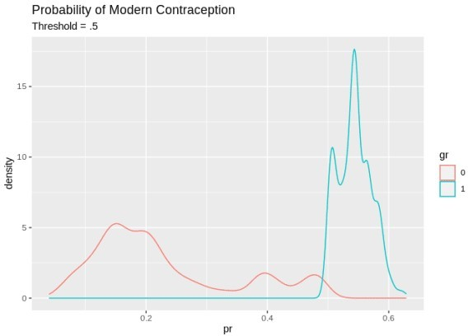

pred1%>%

ggplot()+geom_density(aes(x=pr, color=modcon, group=modcon))+ggtitle(label = "Probability of Modern Contraception", subtitle = "Truth")

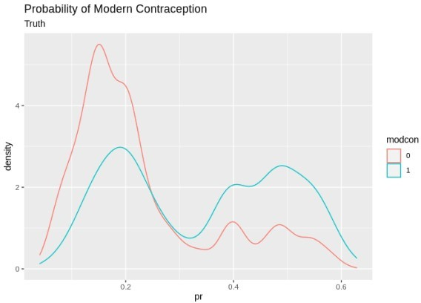

Next we need to see how we did. A simple cross tab of the observed classes versus the predicted classes is called the **confusion matrix**.

table( tr_predcl,model.dat2train$modcontra)

|  |  |  |  |
| --- | --- | --- | --- |
| ## |  | | |
| ## | tr_predcl | 0 | 1 |
| ## | 0 | 3761 | 1142 |
| ## | 1 | 275 | 267 |

This is great, but typically it’s easier to understand the model’s predictive ability by converting these to proportions. The confusionMatrix() function in caret can do this, plus other stuff.

Lots of information on the predictive accuracy can be found from this 2×2 table: Generally, we are interested in overall accuracy, sensitivity and specificity. confusionMatrix(data = tr_predcl,model.dat2train$modcontra )

## Confusion Matrix and Statistics ##

## Reference

|  |  |  |  |  |
| --- | --- | --- | --- | --- |
| ## | Prediction | 0 | 1 | |
| ## | 0 | 3761 | 1142 | |
| ## | 1 | 275 | 267 | |
| ## |  |  |  | |
| ## | Accuracy : | | | 0.7398 |
| ## | 95% CI : | | | (0.7279, 0.7514) |
| ## | No Information Rate : | | | 0.7412 |
| ## | P-Value [Acc > NIR] : | | | 0.6046 |
| ## |  | | |  |
| ## | Kappa : | | | 0.1517 |
| ## |  | | |  |
| ## | Mcnemar's Test P-Value : | | | <2e-16 |
| ## |  | | |  |

## Sensitivity : 0.9319

## Specificity : 0.1895

## Pos Pred Value : 0.7671

## Neg Pred Value : 0.4926

## Prevalence : 0.7412

## Detection Rate : 0.6907 ## Detection Prevalence : 0.9005 ## Balanced Accuracy : 0.5607 ##

## 'Positive' Class : 0 ##

Overall the model has a 73.9% accuracy, which isn’t bad! What is bad is some of the other measures. The sensitivity is really low 267/(267+1142) = .189, so we are only predicting the positive class (modern contraception) in 19% of cases correctly. In other word the model is pretty good at predicting if you don’t use modern contraception, 3761/(3761+275)= .931, but not at predicting if you do.

We could try a different decision rule, in this case, I use the mean of the response as the cutoff value. tr_predcl<-factor(ifelse(tr_pred>.258, 1, 0)) #mean of response

pred2<-data.frame(pr=tr_pred, gr=tr_predcl, modcon=model.dat2train$modcontra) pred2%>%

ggplot()+geom_density(aes(x=pr, color=gr, group=gr))+ggtitle(label = "Probability of Modern Contraception", subtitle = "Threshold = .258")

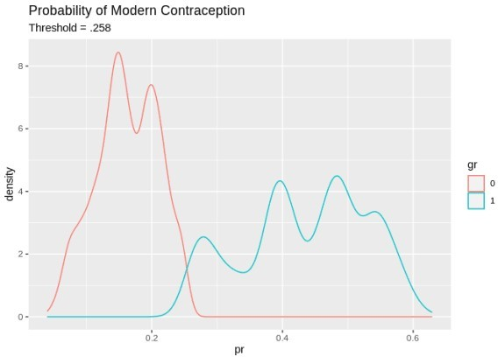

pred2%>%

ggplot()+geom_density(aes(x=pr, color=modcon, group=modcon))+ggtitle(label = "Probability of Modern Contraception", subtitle = "Truth")



confusionMatrix(data = tr_predcl,model.dat2train$modcontra, positive = "1" )

## Confusion Matrix and Statistics ##

## Reference

|  |  |  |  |  |  |
| --- | --- | --- | --- | --- | --- |
| ## | Prediction | 0 | 1 | | |
| ## | 0 | 2944 | 577 | | |
| ## | 1 | 1092 | 832 | | |
| ## |  |  |  | | |
| ## | Accuracy : | | | 0.6935 |  |
| ## | 95% CI : | | | (0.681, | 0.7057) |
| ## | No Information Rate : | | | 0.7412 |  |
| ## | P-Value [Acc > NIR] : | | | 1 |  |
| ## |  | | |  |  |
| ## | Kappa : | | | 0.2859 |  |
| ## |  | | |  |  |
| ## | Mcnemar's Test P-Value : | | | <2e-16 |  |
| ## |  | | |  |  |
| ## | Sensitivity : | | | 0.5905 |  |
| ## | Specificity : | | | 0.7294 |  |
| ## | Pos Pred Value : | | | 0.4324 |  |
| ## | Neg Pred Value : | | | 0.8361 |  |
| ## | Prevalence : | | | 0.2588 |  |
| ## | Detection Rate : | | | 0.1528 |  |
| ## | Detection Prevalence : | | | 0.3534 |  |
| ## | Balanced Accuracy : | | | 0.6600 |  |
| ## |  | | |  |  |
| ## | 'Positive' Class : | | | 1 |  |
| ## |  | | |  |  |

Which drops the accuracy a little, but increases the specificity at the cost of the sensitivity. Next we do this on the test set to evaluate model performance outside of the training data pred_test<-predict(glm1, newdata=model.dat2test, type="response")

pred_cl<-factor(ifelse(pred_test>.28, 1, 0))

table(model.dat2test$modcontra,pred_cl)

## pred_cl

|  |  |  |
| --- | --- | --- |
| ## | 0 | 1 |
| ## | 0 746 | 262 |
| ## | 1 160 | 192 |

confusionMatrix(data = pred_cl,model.dat2test$modcontra )

## Confusion Matrix and Statistics ##

## Reference

|  |  |  |  |  |
| --- | --- | --- | --- | --- |
| ## | Prediction | 0 | 1 | |
| ## | 0 | 746 | 160 | |
| ## | 1 | 262 | 192 | |
| ## |  |  |  | |
| ## | Accuracy : | | | 0.6897 |
| ## | 95% CI : | | | (0.6644, 0.7142) |
| ## | No Information Rate : | | | 0.7412 |
| ## | P-Value [Acc > NIR] : | | | 1 |
| ## |  | | |  |
| ## | Kappa : | | | 0.2609 |
| ## |  | | |  |
| ## | Mcnemar's Test P-Value : | | | 8.806e-07 |
| ## |  | | |  |
| ## | Sensitivity : | | | 0.7401 |
| ## | Specificity : | | | 0.5455 |
| ## | Pos Pred Value : | | | 0.8234 |
| ## | Neg Pred Value : | | | 0.4229 |
| ## | Prevalence : | | | 0.7412 |
| ## | Detection Rate : | | | 0.5485 |
| ## | Detection Prevalence : | | | 0.6662 |
| ## | Balanced Accuracy : | | | 0.6428 |
| ## |  | | |  |
| ## | 'Positive' Class : | | | 0 |
| ## |  | | |  |

# Regression partition tree

As we saw in the first working group example, the regression tree is another common technique used in classification problems. Regression or classification trees attempt to

library(rpart) library(rpart.plot)

rp1<-rpart(modcontra~factor(region)+(age)+livchildren+factor(educ), data=model.dat2train,

method ="class",

control = rpart.control(minbucket = 10, cp=.01)) #lower CP parameter makes for more compliacted

tree summary(rp1)

## Call:

## rpart(formula = modcontra ~ factor(region) + (age) + livchildren + ## factor(educ), data = model.dat2train, method = "class", control = rpart.control(minbucket = 10,

## cp = 0.01))

## n= 5445

|  |  |  |  |  |  |  |
| --- | --- | --- | --- | --- | --- | --- |
| ## |  | | | | | |
| ## |  | CP | nsplit | rel error | xerror | xstd |
| ## | 1 | 0.04009936 | 0 | 1.0000000 | 1.0000000 | 0.02293618 |
| ## | 2 | 0.01100071 | 2 | 0.9198013 | 0.9198013 | 0.02230305 |
| ## | 3 | 0.01000000 | 4 | 0.8977999 | 0.9169624 | 0.02227934 |
| ## |  |  |  |  |  |  |

## Variable importance

## factor(educ) livchildren age factor(region) ## 58 23 19 1

##

## Node number 1: 5445 observations, complexity param=0.04009936 ## predicted class=0 expected loss=0.2587695 P(node) =1

## class counts: 4036 1409

## probabilities: 0.741 0.259

## left son=2 (3862 obs) right son=3 (1583 obs) ## Primary splits:

## factor(educ) splits as LLRR, improve=189.73590, (0 missing)

|  |  |  |  |  |  |  |  |  |
| --- | --- | --- | --- | --- | --- | --- | --- | --- |
| ## | livchildren | < 0.5 | to | the right, | improve= | 84.51811, | (0 | missing) |
| ## | age | < 23.5 | to | the right, | improve= | 52.42664, | (0 | missing) |

## factor(region) splits as LLRL, improve= 36.53020, (0 missing) ## Surrogate splits:

|  |  |  |  |  |  |  |  |  |
| --- | --- | --- | --- | --- | --- | --- | --- | --- |
| ## | livchildren | < 0.5 | to | the right, | agree=0.772, | adj=0.215, | (0 | split) |
| ## | age | < 19.5 | to | the right, | agree=0.753, | adj=0.149, | (0 | split) |

|  |  |  |  |  |  |  |  |
| --- | --- | --- | --- | --- | --- | --- | --- |
| ##  ## | factor(region) splits as LLRL, agree=0.713, adj=0.014, (0 split) | | | | | | |
| ## | Node number 2: 3862 observations | | | | | | |
| ## | predicted class=0 expected loss=0.174262 P(node) =0.7092746 | | | | | | |
| ## | class counts: 3189 673 | | | | | | |
| ## | probabilities: 0.826 0.174 | | | | | | |
| ## |  | | | | | | |
| ## | Node number 3: 1583 observations, complexity param=0.04009936 | | | | | | |
| ## | predicted class=0 expected loss=0.46494 P(node) =0.2907254 | | | | | | |
| ## | class counts: 847 736 | | | | | | |
| ## | probabilities: 0.535 0.465 | | | | | | |
| ## | left son=6 (868 obs) right son=7 (715 obs) | | | | | | |
| ## | Primary splits: | | | | | | |
| ## | livchildren < 0.5 to the right, improve=33.940940, (0 missing) | | | | | | |
| ## | age < 36.5 to the right, improve=20.441730, (0 missing) | | | | | | |
| ## | factor(region) | splits | as | LRRL, | improve= 2.382434, | (0 | missing) |
| ## | factor(educ) | splits | as | --LR, | improve= 0.556353, | (0 | missing) |

## Surrogate splits:

## age < 20.5 to the right, agree=0.749, adj=0.443, (0 split) ##

## Node number 6: 868 observations

## predicted class=0 expected loss=0.3709677 P(node) =0.1594123 ## class counts: 546 322

## probabilities: 0.629 0.371 ##

## Node number 7: 715 observations, complexity param=0.01100071 ## predicted class=1 expected loss=0.420979 P(node) =0.1313131 ## class counts: 301 414

## probabilities: 0.421 0.579

## left son=14 (14 obs) right son=15 (701 obs) ## Primary splits:

## age < 32.5 to the right, improve=9.574909, (0 missing) ## factor(educ) splits as --LR, improve=1.650766, (0 missing)

## factor(region) splits as LRRL, improve=1.324512, (0 missing) ##

## Node number 14: 14 observations

## predicted class=0 expected loss=0 P(node) =0.002571166 ## class counts: 14 0

## probabilities: 1.000 0.000 ##

## Node number 15: 701 observations, complexity param=0.01100071 ## predicted class=1 expected loss=0.4094151 P(node) =0.128742 ## class counts: 287 414

## probabilities: 0.409 0.591

## left son=30 (137 obs) right son=31 (564 obs) ## Primary splits:

## age < 16.5 to the left, improve=7.933444, (0 missing) ## factor(educ) splits as --LR, improve=2.545437, (0 missing) ## factor(region) splits as LRRL, improve=1.768127, (0 missing) ##

## Node number 30: 137 observations

## predicted class=0 expected loss=0.4379562 P(node) =0.0251607 ## class counts: 77 60

## probabilities: 0.562 0.438 ##

## Node number 31: 564 observations

## predicted class=1 expected loss=0.3723404 P(node) =0.1035813 ## class counts: 210 354

## probabilities: 0.372 0.628

rpart.plot(rp1, type = 4,extra=4, box.palette="GnBu", shadow.col="gray",

nn=TRUE, main="Classification tree for using modern contraception")

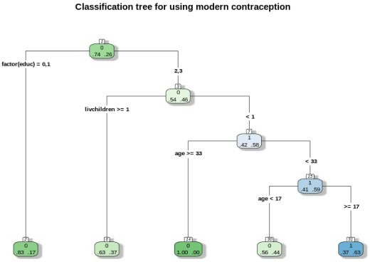

Each node box displays the classification, the probability of each class at that node (i.e. the probability of the class conditioned on the node) and the percentage of observations used at that node. From here.

predrp1<-predict(rp1, newdata=model.dat2train, type = "class")

confusionMatrix(data = predrp1,model.dat2train$modcontra )

## Confusion Matrix and Statistics ##

## Reference

|  |  |  |  |  |
| --- | --- | --- | --- | --- |
| ## | Prediction | 0 | 1 | |
| ## | 0 | 3826 | 1055 | |
| ## | 1 | 210 | 354 | |
| ## |  |  |  | |
| ## | Accuracy : | | | 0.7677 |
| ## | 95% CI : | | | (0.7562, 0.7788) |
| ## | No Information Rate : | | | 0.7412 |
| ## | P-Value [Acc > NIR] : | | | 3.566e-06 |
| ## |  | | |  |
| ## | Kappa : | | | 0.2475 |
| ## |  | | |  |
| ## | Mcnemar's Test P-Value : | | | < 2.2e-16 |
| ## |  | | |  |
| ## | Sensitivity : | | | 0.9480 |
| ## | Specificity : | | | 0.2512 |
| ## | Pos Pred Value : | | | 0.7839 |
| ## | Neg Pred Value : | | | 0.6277 |
| ## | Prevalence : | | | 0.7412 |
| ## | Detection Rate : | | | 0.7027 |
| ## | Detection Prevalence : | | | 0.8964 |
| ## | Balanced Accuracy : | | | 0.5996 |
| ## |  | | |  |
| ## | 'Positive' Class : | | | 0 |
| ## |  | | |  |

We see the regression tree is performing a little better than the logistic regression on the test case using the summary below:

pred_testrp<-predict(rp1, newdata=model.dat2test, type="class")

confusionMatrix(data = pred_testrp,model.dat2test$modcontra )

## Confusion Matrix and Statistics ##

## Reference

|  |  |  |  |  |
| --- | --- | --- | --- | --- |
| ## | Prediction | 0 | 1 | |
| ## | 0 | 947 | 263 | |
| ## | 1 | 61 | 89 | |
| ## |  |  |  | |
| ## | Accuracy : | | | 0.7618 |
| ## | 95% CI : | | | (0.7382, 0.7842) |
| ## | No Information Rate : | | | 0.7412 |
| ## | P-Value [Acc > NIR] : | | | 0.0434 |
| ## |  | | |  |
| ## | Kappa : | | | 0.2365 |
| ## |  | | |  |
| ## | Mcnemar's Test P-Value : | | | <2e-16 |
| ## |  | | |  |
| ## | Sensitivity : | | | 0.9395 |
| ## | Specificity : | | | 0.2528 |
| ## | Pos Pred Value : | | | 0.7826 |
| ## | Neg Pred Value : | | | 0.5933 |
| ## | Prevalence : | | | 0.7412 |

|  |  |  |
| --- | --- | --- |
| ## | Detection Rate : | 0.6963 |
| ## | Detection Prevalence : | 0.8897 |
| ## | Balanced Accuracy : | 0.5962 |
| ##  ## | 'Positive' Class : | 0 |
| ## |  |  |

# Linear discriminant function

Linear discriminant functions attempt to separate classes from each other using a strictly linear function of the variables. It attempts to reduce the dimensionality of the original data to a single linear function of the input variables, or the *discriminant function*. This is very similar to what PCA does when it creates a principal component, although in LDA, the function uses this linear transformation of the data to optimally separate classes.

In this case it performs better than the logistic regression but not as well as the regression tree. library(MASS)

##

## Attaching package: 'MASS'

## The following object is masked from 'package:dplyr':

##

## select

lda1<-lda(modcontra~factor(region)+scale(age)+livchildren+factor(educ), data=model.dat2train,prior=c(.74,

.26) , CV=T)

pred_ld1<-lda1$class

head(lda1$posterior) #probabilities of membership in each group

|  |  |  |  |
| --- | --- | --- | --- |
| ## |  | 0 | 1 |
| ## | 1 | 0.8153664 | 0.1846336 |
| ## | 2 | 0.7387134 | 0.2612866 |
| ## | 3 | 0.8673284 | 0.1326716 |
| ## | 4 | 0.8080069 | 0.1919931 |
| ## | 5 | 0.8976027 | 0.1023973 |
| ## | 6 | 0.8387015 | 0.1612985 |

ld1<-data.frame(ppmod= lda1$posterior[, 2],pred=lda1$class, real=model.dat2train$modcontra) ld1%>%

ggplot()+geom_density(aes(x=ppmod, group=pred, color=pred))+ggtitle(label = "Probabilities of class membership on the linear discriminant function")

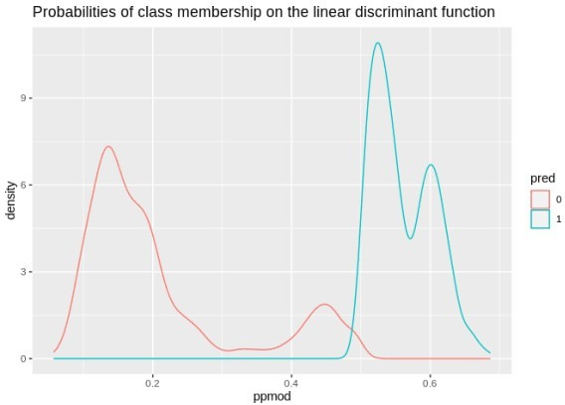

ld1%>%

ggplot()+geom_density(aes(x=ppmod, group=real, color=real))+ggtitle(label = "Probabilities of class membership and the real class")

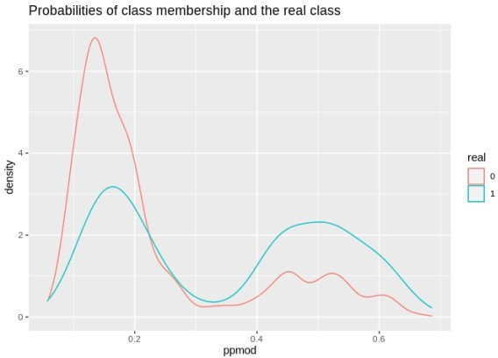

Accuracy on the training set confusionMatrix(pred_ld1,model.dat2train$modcontra ) ## Confusion Matrix and Statistics

##

## Reference

|  |  |  |  |
| --- | --- | --- | --- |
| ## | Prediction | 0 | 1 |
| ## | 0 | 3625 | 1000 |
| ## | 1 | 411 | 409 |

|  |  |  |
| --- | --- | --- |
| ## |  | |
| ## | Accuracy : | 0.7409 |
| ## | 95% CI : | (0.729, 0.7525) |
| ## | No Information Rate : | 0.7412 |
| ## | P-Value [Acc > NIR] : | 0.5318 |
| ## |  |  |
| ## | Kappa : | 0.2181 |
| ## |  |  |
| ## | Mcnemar's Test P-Value : | <2e-16 |
| ## |  |  |
| ## | Sensitivity : | 0.8982 |
| ## | Specificity : | 0.2903 |
| ## | Pos Pred Value : | 0.7838 |
| ## | Neg Pred Value : | 0.4988 |
| ## | Prevalence : | 0.7412 |
| ## | Detection Rate : | 0.6657 |
| ## | Detection Prevalence : | 0.8494 |
| ## | Balanced Accuracy : | 0.5942 |
| ## |  |  |
| ## | 'Positive' Class : | 0 |
| ## |  |  |

lda1<-lda(modcontra~factor(region)+scale(age)+livchildren+factor(educ), data=model.dat2train,prior=c(.74,

.26) )

#linear discriminant function lda1$scaling

|  |  |  |
| --- | --- | --- |
| ## |  | LD1 |
| ## | factor(region)2 | 0.4580587 |
| ## | factor(region)3 | 0.8545973 |
| ## | factor(region)4 | 0.3495414 |
| ## | scale(age) | -0.3873869 |
| ## | livchildren | 0.1025140 |
| ## | factor(educ)1 | 0.4535731 |
| ## | factor(educ)2 | 1.9263226 |
| ## | factor(educ)3 | 2.2956187 |

Accuracy on the test set

pred_ld2<-predict(lda1, model.dat2test)

confusionMatrix(pred_ld2$class, model.dat2test$modcontra)

## Confusion Matrix and Statistics ##

## Reference

|  |  |  |  |  |
| --- | --- | --- | --- | --- |
| ## | Prediction | 0 | 1 | |
| ## | 0 | 906 | 254 | |
| ## | 1 | 102 | 98 | |
| ## |  |  |  | |
| ## | Accuracy : | | | 0.7382 |
| ## | 95% CI : | | | (0.714, 0.7614) |
| ## | No Information Rate : | | | 0.7412 |
| ## | P-Value [Acc > NIR] : | | | 0.6115 |
| ## |  | | |  |
| ## | Kappa : | | | 0.2062 |
| ## |  | | |  |

## Mcnemar's Test P-Value : 1.214e-15 ##

## Sensitivity : 0.8988

## Specificity : 0.2784

## Pos Pred Value : 0.7810

## Neg Pred Value : 0.4900

## Prevalence : 0.7412

## Detection Rate : 0.6662 ## Detection Prevalence : 0.8529 ## Balanced Accuracy : 0.5886 ##

## 'Positive' Class : 0 ##