I’ll illustrate how to use the package based on the following wrapped code snippet, which creates the leaflet and tmap maps and does the following:

it loads the required files (**Alberta_Wolves.csv** and **Mountain_caribou.csv**) it iterates over the files

inside the for-loop for each file (and animal type) separately

it keeps the required columns (‘longitude’, ‘latitude’, ‘timestamp’, ‘individual_local_identifier’, ‘individual-taxon-canonical-name’)

it builds a simple features object of the input data.tables it creates a bounding box of the coordinate points

it extends the boundaries of the bounding box by 250 meters (so that points close to the boundaries are visible too)

it downloads and saves to a temporary directory the 30 meter elevation data for the Area of Interest (either for the ‘Wolves’ or for the ‘Tarandus’)

it creates a Virtual Raster (.VRT) mosaic file of the multiple downloaded Elevation

.tif files

it crops the Digital Elevation Model (DEM) using the previously created bounding box (the downloaded DEM’s cover a bigger area, because they consist of fixed grid tiles)

it saves the **tmap** of each processed input file and the **data.tables** which are required for the leaflet map

files = c(system.file('vignette_data/Alberta_Wolves.csv', package = "CopernicusDEM"),

system.file('vignette_data/Mountain_caribou.csv', package = "CopernicusDEM"))

leafgl_data = tmap_data = list()

for (FILE in files) {

cat(glue::glue("Processing of the '{basename(FILE)}' file ..."), '\n')

dtbl = data.table::fread(FILE, header = TRUE, stringsAsFactors = FALSE)

cols = c('location-long', 'location-lat', 'timestamp', 'individual- local-identifier',

'individual-taxon-canonical-name')

dtbl_subs = dtbl[, ..cols]

colnames(dtbl_subs) = c('longitude', 'latitude', 'timestamp', 'individual_local_identifier',

'individual-taxon-canonical-name')

leafgl_data[[unique(dtbl_subs$`individual-taxon-canonical-name`)]] = dtbl_subs

dtbl_subs_sf = sf::st_as_sf(dtbl_subs, coords = c("longitude", "latitude"), crs = 4326)

sf_rst_ext = fitbitViz::extend_AOI_buffer(dat_gps_tcx = dtbl_subs_sf,

buffer_in_meters = 250,

CRS = 4326,

verbose = TRUE)

#................................................................

# Download the Copernicus DEM 30m elevation data because it has # a better resolution, it takes a bit longer to download because # the .tif file size is bigger #...............................................................

dem_dir = tempdir()

dem30 = CopernicusDEM::aoi_geom_save_tif_matches(sf_or_file = sf_rst_ext$sfc_obj,

dem_dir,

parallel::detectCores(),

dir_save_tifs =

resolution = 30,

crs_value = 4326, threads =

verbose = TRUE)

TIF = list.files(dem_dir, pattern = '.tif', full.names = TRUE) if (length(TIF) > 1) {

#....................................................

# create a .VRT file if I have more than 1 .tif files #....................................................

file_out = file.path(dem_dir, 'VRT_mosaic_FILE.vrt')

vrt_dem30 = CopernicusDEM::create_VRT_from_dir(dir_tifs = dem_dir,

output_path_VRT =

file_out,

}

if (length(TIF) == 1) {

verbose = TRUE)

#..................................................

# if I have a single .tif file keep the first index #..................................................

file_out = TIF[1]

}

raysh_rst = fitbitViz::crop_DEM(tif_or_vrt_dem_file = file_out,

sf_buffer_obj = sf_rst_ext$sfc_obj, CRS = 4326,

digits = 6, verbose = TRUE)

# convert to character to receive the correct labels in the 'tmap' object

dtbl_subs_sf$individual_local_identifier = as.character(dtbl_subs_sf$ individual_local_identifier)

# open with interactive viewer tmap::tmap_mode("view")

map_coords = tmap::tm_shape(shp = dtbl_subs_sf) + tmap::tm_dots(col = 'individual_local_identifier')

map_coords = map_coords + tmap::tm_shape(shp = raysh_rst, is.master = FALSE, name = 'Elevation') +

tmap::tm_raster(alpha = 0.65, legend.reverse = TRUE)

tmap_data[[unique(dtbl_subs$`individual-taxon-canonical-name`)]] = map_coords

}

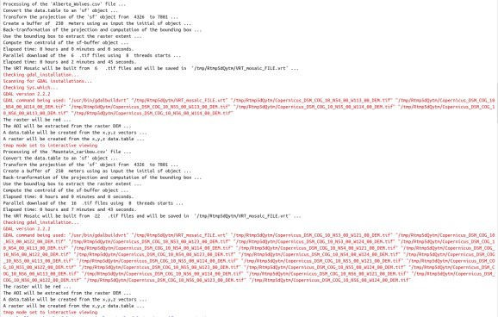

Now, based on the saved data.tables we can create first the **leaflet map** to view the data of both animal species in the same map,

#.....................................

# create the 'leafGl' of both datasets #.....................................

dtbl_all = rbind(leafgl_data$`Canis lupus`, leafgl_data$`Rangifer tarandus`)

# see the number of observations for each animal table(dtbl_all$`individual-taxon-canonical-name`)

# create an 'sf' object of both data.tables

dat_gps_tcx = sf::st_as_sf(dtbl_all, coords = c("longitude", "latitude"), crs = 4326)

lft = leaflet::leaflet()

lft = leaflet::addProviderTiles(map = lft, provider = leaflet::providers$OpenTopoMap)

lft = leafgl::addGlPoints(map = lft,

data = dat_gps_tcx, opacity = 1.0,

fillColor = 'individual-taxon-canonical-

name', lft

popup = 'individual-taxon-canonical-name')

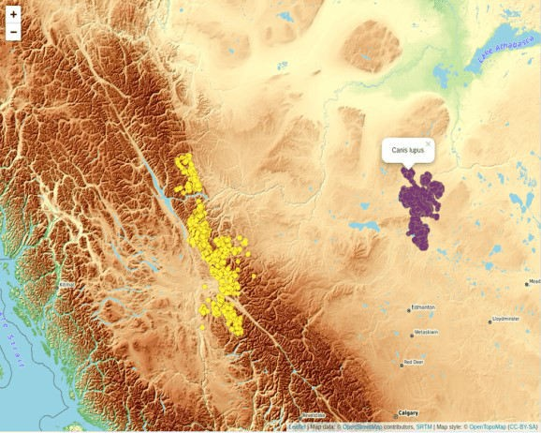

The tracking data of the *Caribou* are on a higher elevation compared to the data of the *Wolves*. This is verified by the next *tmap* which includes the Elevation legend (**layer**). The additional legend shows the **individual identifier** of the animal – for the **Tarandus** there are **138** unique id’s whereas

tmap_data$`Rangifer tarandus` # caribou

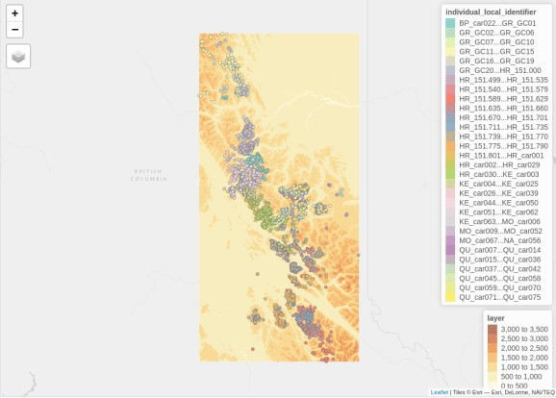

tmap_data$`Canis lupus` # wolves

for the **Wolves** only **12**,

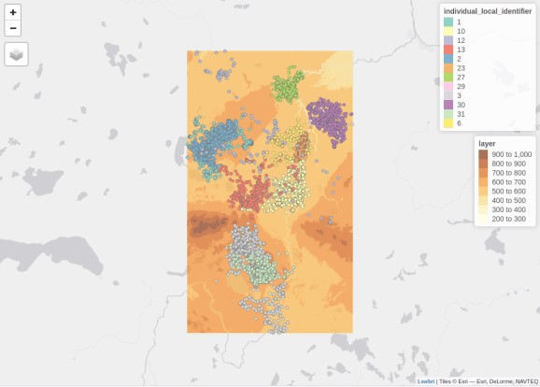

Elevation data using the **CopernicusDEM** R package can be visualized also in **3-dimensional space**. For the corresponding use case have a look to the Vignette of the fitbitViz R package which uses internally the Rayshader package (especially the **last** image of the Vignette).

# Movebank References**:**

Latham Alberta Wolves

Latham ADM (2009) Wolf ecology and caribou-primary prey-wolf spatial relationships in low productivity peatland complexes in northeastern Alberta. Dissertation. ProQuest Dissertations Publishing, University of Alberta, Canada, NR55419, 197 p. url:https://[www.proquest.com/docview/305051214](http://www.proquest.com/docview/305051214)

Latham ADM and Boutin S (2019) Data from: Wolf ecology and caribou-primary prey-wolf spatial relationships in low productivity peatland complexes in northeastern Alberta. Movebank Data Repository. \doi:10.5441/001/1.7vr1k987

Mountain caribou in British Columbia-radio-transmitter

BC Ministry of Environment (2014) Science update for the South Peace Northern Caribou (Rangifer tarandus caribou pop. 15) in British Columbia. Victoria, BC. 43 p. https://www2.gov.bc.ca/assets/gov/environment/plants-animals-and-ecosystems/ wildlife-wildlife-habitat/caribou/science_update_final_from_web_jan_2014.pdf url:https://www2.gov.bc.ca/assets/gov/environment/plants-animals-and- ecosystems/wildlife-wildlife-habitat/caribou/science_update_final_ from_web_jan_2014.pdf

Seip DR and Price E (2019) Data from: Science update for the South Peace Northern Caribou (Rangifer tarandus caribou pop. 15) in British Columbia. Movebank Data Repository. \doi:10.5441/001/1.p5bn656k