Now install/load some packages (forecast, jsonlite, ggplot2, and plotly), source the functions.R file. The workflow looks like this:

pred <- "canada-combined" %>%

get_data() %>%

process_data(

cases = "confirmed",

last = "2021-05-01") %>%

fit_model() %>%

predict_model(

window = 30,

level = 95)

1. pick a country (the available slugified country codes are explained in the source file),
2. get the data from a daily updated web interface (JSON API),
3. process the raw data: what kinds of cases (confirmed/deaths) to consider and what should be the last day of the time series,
4. fit time series model to the data,
5. forecast x days following the last day of the time series and show prediction intervals.

The [data source](https://github.com/CSSEGISandData/COVID-19) is the Center for Systems Science and Engineering (CSSE) at Johns Hopkins University. The flat files provided by the CSSE are further processed to provide a JSON API

We use exponential smoothing (ETS) as a time series forecasting method from the forecast package. There are many other time series forecasting methods (like ARIMA etc.). We picked ETS because of its ease of use for our demonstration purposes.

We can visualize the pred object as plot_all(pred) which returns a ggplot2 object like this one:

[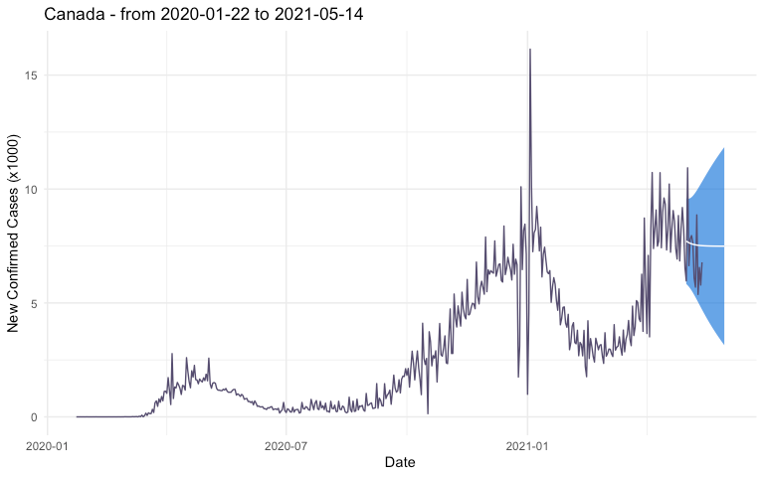](https://hosting.analythium.io/content/images/2021/05/covid-19-1.png)Daily new confirmed COVID-19 cases for Canada / © Analythium

Turn the ggplot2 object into an interactive plotly graph as ggplotly(plot_all(pred)).

**Shiny app**

Change to the 02-shiny-app folder which has the following files:

.

├── README.md

├── app

│ ├── functions.R

│ ├── global.R

│ ├── server.R

│ └── ui.R

└── covidapp.Rproj

Run the app locally as shiny::runApp("app"). It will look like this with controls for country, case type, time window, prediction interval, and a checkbox to switch between the ggplot2 or plotly output types:

[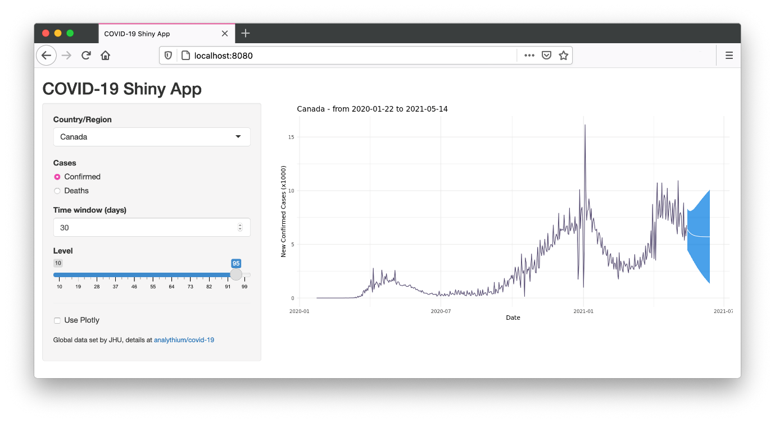](https://hosting.analythium.io/content/images/2021/05/Screen-Shot-2021-05-15-at-11.49.15-PM.png)COVID-19 Shiny app / © Analythium

Play around with the app then let's move on to putting it in a container.

**Explicit dependencies in Dockerfile**

The first approach is to use RUN statements in the Dockerfile to install the required packages. Check the Dockerfile in the 03-docker-basic folder. We use the rocker/r-ubuntu:20.04 parent image and specify the [RStudio Package Manager](https://packagemanager.rstudio.com) (RSPM) CRAN repository in Rprofile.site so that we can install binary packages for speedy Docker builds. Here are the relevant lines:

FROM rocker/r-ubuntu:20.04

...

COPY Rprofile.site /etc/R

...

RUN install.r shiny forecast jsonlite ggplot2 htmltools

RUN Rscript -e "install.packages('plotly')"

...

Required packages are installed with the [littler utility](https://cran.r-project.org/web/packages/littler/vignettes/littler-examples.html#install.r-direct-cran-installation) install.r (littler is installed on all Rocker images). You can also use Rscript to call install.packages(). There are other options too, like install2.r from littler, or using R -q -e install.packages() – -q suppresses the startup message, -e executes an expression then quits.

Build and test the image locally, use any image name you like (in export IMAGE=""), then visit http://localhost:8080 to see the app:

# name of the image

export IMAGE="analythium/covidapp-shiny:basic"

# build image

docker build -t $IMAGE .

# run and test locally

docker run -p 8080:3838 $IMAGE

**Use DESCRIPTION file**

The second approach is to record the dependencies in the DESCRIPTION file. You can find the example in the 04-docker-deps folder. The DESCRIPTION file contains basic information about an R package. The file states package dependencies and is used when installing the packages and their dependencies. The install_deps() function from the remotes package can install dependencies stated in a DESCRIPTION file. The DESCRIPTION file used here is quite rudimentary but it states the dependencies to be installed nonetheless:

Imports:

shiny,

forecast,

jsonlite,

ggplot2,

htmltools,

plotly

Use the same Ubuntu-based R image and the RSPM CRAN repository. Install the remotes package, copy the DESCRIPTION file into the image. Call remotes::install_deps() which will find the DESCRIPTION file in the current directory. Here are the relevant lines from the Dockerfile:

FROM rocker/r-ubuntu:20.04

...

COPY Rprofile.site /etc/R

...

RUN install.r remotes

COPY DESCRIPTION .

RUN Rscript -e "remotes::install_deps()"

...

Build and test the image as before, but use a different tag:

# name of the image

export IMAGE="analythium/covidapp-shiny:deps"

# build image

docker build -t $IMAGE .

# run and test locally

docker run -p 8080:3838 $IMAGE

**Use the renv R package**

The renv package is a versatile dependency management toolkit for R. You can discover dependencies with renv::init() and occasionally save the state of these libraries to a lockfile with renv::snapshot(). The nice thing about this approach is that the exact version of each package is recorded that makes Docker builds reproducible.

Switch to the 05-docker-renv directory and inspect the Dockerfile. Here are the most important lines (Focal Fossa is the code name for Ubuntu Linux version 20.04 LTS that matches our parent image):

FROM rocker/r-ubuntu:20.04

...

RUN install.r remotes renv

...

COPY ./renv.lock .

RUN Rscript -e "options(renv.consent = TRUE); \

renv::restore(lockfile = '/home/app/renv.lock', repos = \

c(CRAN='https://packagemanager.rstudio.com/all/__linux__/focal/latest'))"

...

We need the remotes and renv packages. Then copy the renv.lock file, call renv::restore() by specifying the lockfile and the RSPM CRAN repository. The renv.consent = TRUE option is needed because this is a fresh setup (i.e. not copying the whole renv project).

Tag the Docker image with :renv and build:

# name of the image

export IMAGE="analythium/covidapp-shiny:renv"

# build image

docker build -t $IMAGE .

# run and test locally

docker run -p 8080:3838 $IMAGE

**Comparison**

We built the same Shiny app in three different ways. The sizes of the three images differ quite a bit, with the :renv image being 40% bigger than the other two images:

$ docker images --format 'table {{.Repository}}\t{{.Tag}}\t{{.Size}}'

REPOSITORY TAG SIZE

analythium/covidapp-shiny renv 1.7GB

analythium/covidapp-shiny deps 1.18GB

analythium/covidapp-shiny basic 1.24GB

The :basic image has 105 packages installed (try docker run analythium/covidapp-shiny:basic R -q -e 'nrow(installed.packages())'). The  :deps image has remotes added on top of these, the :renv image has remotes, renv and BH as extras. BH seems to be responsible for the size difference, this package provides Boost C++ header files. The COVID-19 app works perfectly fine without BH. In this particular case, this is a price to pay for the convenience of automatic dependency discovery provided by renv.

The renv package has a few different snapshot modes. The default is called "implicit". This mode adds the intersection of all your installed packages and those used in your project as inferred by renv::dependencies() to the lockfile. Another mode, called "explicit", only captures packages that are listed in the project DESCRIPTION file. For the COVID-19 app, both these resulted in identical lockfiles. You can use renv::remove("BH") to remove BH from the project or use the "custom" model and list all the packages to be added to the lockfile.

If you go with the other two approaches, explicitly stating dependencies in the Dockerfile or in the DESCRIPTION file, you might end up missing some packages at first. These approaches might need a few iterations before getting the package list just right.

Another important difference between these approaches is that renv pins the exact package versions in the lockfile. If you want to install versioned packages, use the remotes::install_version() function in the Dockerfile. The version-tagged Rocker images will by default use the MRAN snapshot mirror associated with the most recent date for which that image was current.

**Summary**

You learnt the basics of dependency management for Shiny apps with Docker. Now you can pick and refine an approach that you like most (there is no need to build the same app multiple ways).