# Setup

To be able to run this code, be sure to have the tidyverse installed. The {wesanderson} package contains beautiful palettes for visualizations.

# Load required packages library(tidyverse) library(wesanderson)

# Streamgraphs

This first geom, geom_stream(), creates a streamplot (which I’ve also seen called stream graphs). The streamplot is an area graph that usually centers around a central axis and allows us to see large fluctuations over time.

{ggstream} also has other options available to customize the streamgraphs, such as creating an area chart.

library(ggstream)

ggplot(blockbusters, aes(year, box_office, fill = genre)) + geom_stream() +

scale_fill_manual(values = wes_palette("Darjeeling2")) + theme_minimal()

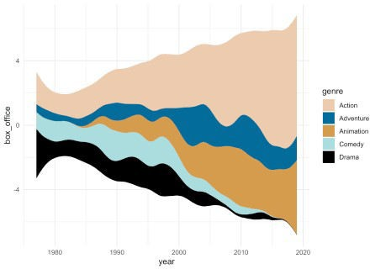

# Ridgeline Plots

The {ggridges} package by Claus O. Wilke package also has a variety of geoms;. Ridgeline plots show the distribution of a numeric value for different groups and can look like mountain ranges. The R-Ladies Seattle hex sticker was created using ridgelines (very appropriate for the mountainous Washington!).

# install.packages("ggridges") library(ggridges)

ggplot(blockbusters, aes(x = box_office, y = genre, fill = genre)) + geom_density_ridges(scale = 4) +

scale_fill_manual(values = wes_palette("Darjeeling2")) + theme_minimal()

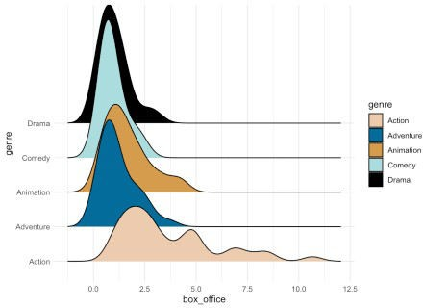

# Sankey Diagrams

Another geom by David Sjöberg is geom_sankey(). This geom creates Sankey diagrams and alluvial plots, which show flow and transfers in a system or throughout time. These plots are VERY popular on the subreddit dataisbeautiful (check it out on Mondays to see some examples).

# devtools::install_github("davidsjoberg/ggsankey") library(ggsankey)

example_dat <- mtcars %>

make_long(cyl, vs, am, gear, carb) # function in ggsankey to format data correctly

ggplot(example_dat, aes(x = x,

next_x = next_x, node = node,

next_node = next_node, fill = factor(node))) +

geom_sankey(flow.alpha = .6) + theme_minimal()

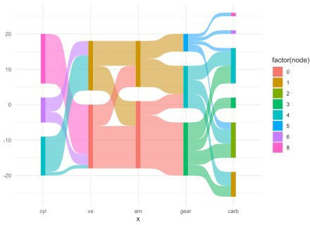

Another package for alluvial charts is {ggalluvial}. The data can be in more familiar formats than what is required for {ggsankey}.

# install.packages("ggalluvial") library(ggalluvial) ggplot(as.data.frame(UCBAdmissions),

aes(y = Freq, axis1 = Gender, axis2 = Dept)) + geom_alluvium(aes(fill = Admit), width = 1/12) + scale_fill_manual(values = wes_palette("Darjeeling2")) + theme_minimal()

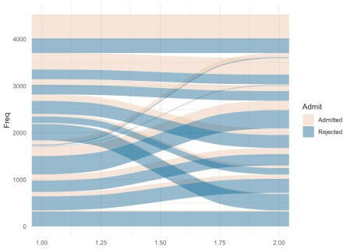

# Bump Charts

Bump plots are helpful for showing change in rank over time.

# devtools::install_github("davidsjoberg/ggbump") library(ggbump)

blockbusters2 <- blockbusters %>%

filter(genre %in% c("Action", "Comedy", "Drama")) %>% group_by(year) %>%

mutate(rank = rank(box_office)

ggplot(blockbusters2, aes(year, rank, color = genre)) + geom_point(size = 7) +

geom_bump() +

scale_color_manual(values = wes_palette("Darjeeling2")) + theme_minimal()

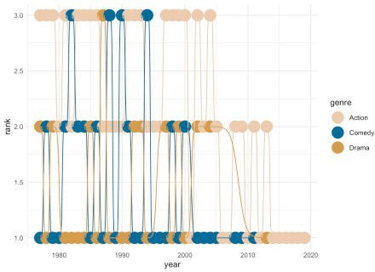

# Waffle Charts

For waffle charts, which are handy visualizations that show completion or parts of a whole, there is hrbrmstr’s {waffle}. Check out the ability to bring in other {ggplot2} functions, like facet_wrap. {waffle} also allows you to create pictograms using geom_pictogram, which replaces the squares in the ‘waffle’ with pictures.

library(waffle)

ggplot(as_tibble(Titanic), aes(fill = Sex, values = n)) + geom_waffle(n_rows = 20, color = "white") +

facet_wrap(~ Survived, ncol = 1) + scale_fill_manual(values = wes_palette("Darjeeling2")) + theme_minimal()

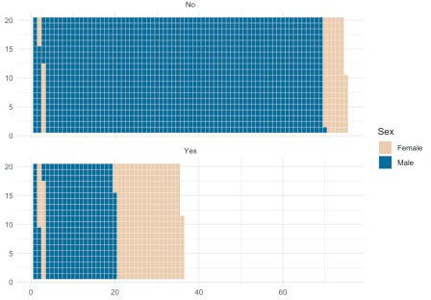

# Beeswarm Charts

Beeswarm charts, similar to jitter plots in {ggplot2}, plot individual points showing distributions without allowing the points to overlap too much.

# install.packages("ggbeeswarm") library(ggbeeswarm)

ggplot(blockbusters, aes(x = genre, y = box_office, color = genre)) + geom_quasirandom() +

theme_minimal() +

scale_color_manual(values = wes_palette("Darjeeling2")) + theme_minimal()

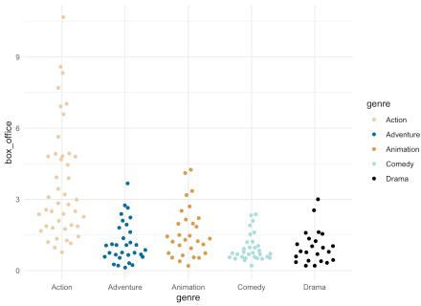

# Mosaic Charts

Mosaic charts are incredibly helpful when displaying proportions of (multiple) categories.

library(ggmosaic) ggplot(as.data.frame(UCBAdmissions)) +

geom_mosaic(aes(x = product(Admit, Dept), fill = Gender, weight = Freq)) +

scale_fill_manual(values = wes_palette("Darjeeling2")) + theme_minimal()

